**Peter Clarke, J.P., P.E.**

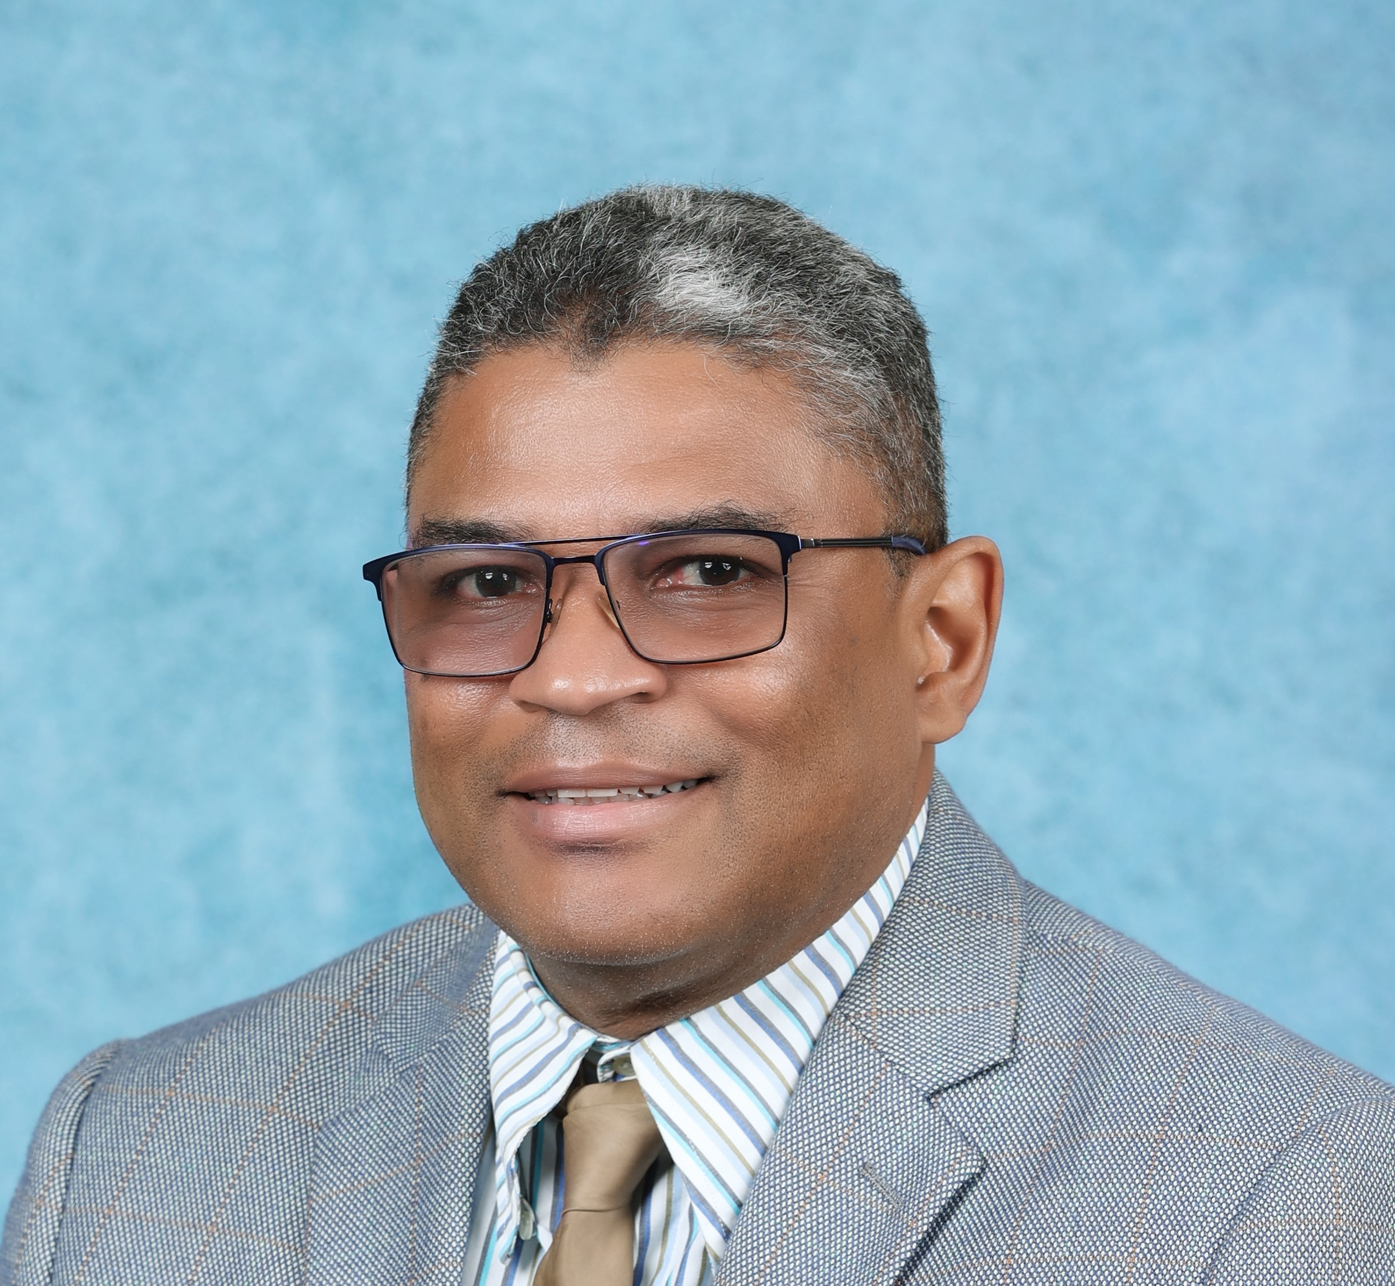

## Dewdrops, Dublin Castle, Gordon Town, PO Box 46, St Andrew, Jamaica.

## Residence: (876) 702 1313 Cellular: (876) 383 9661;

## E-mail: [petermaclarke@gmail.com](mailto:petermaclarke@gmail.com) [pclarke@wra.gov.jm](mailto:pclarke@wra.gov.jm)

## Objective: To contribute extensive experience, training and skills that will guide national and regional hydrological processes and activities in an environmentally sustainable manner, while striving for public safety and water security.

### Professional Profile

* Dynamic programme/project-management professional with 41 years of significant and progressive experience and proven leadership skills through interacting with International and Local organizations / Governmental agencies involving cross-functional implementation activities.
* Goal-driven achiever with strong organizational and analytical skills; demonstrated expertise in contract negotiation and management, and the proven ability to assume primary role in delivering components of major programmes and projects.
* Capable team player/ leader with exceptional interpersonal and collaborative skills to foster team’s performance, along with a demonstrated talent for analyzing and streamlining complex work processes for improvement opportunities.
* Motivated self-starter with the problem-solving abilities, multi-tasking talents, and strong work ethic to make a significant contribution to any organization.
* Effective communicator and negotiator with public speaking skills; especially effective dealing with fast-paced, complex projects under tight deadlines.

### Experience Summary

Peter Clarke has been employed for the past 41 years within the water sector of Jamaica, specifically in the area of water supply and hydrology. Starting his career at Carib Engineering Corporation Ltd as an Engineering Surveyor, he was responsible for the field layout/ construction management of sections of the 19-mile gravity driven Yallahs Pipeline Water Supply Project to alleviate Kingston’s water woes. Subsequently, over a 22 year period as Project Manager on numerous water supply projects across Jamaica, he has been successfully responsible for the coordination of all aspects of work necessary for the construction of scores of water supply projects, inclusive of pumping stations, reservoirs, wells, treatment plants, distribution mains, intakes, forced mains, river training works and embankment protection. Thereafter, the next ten years spent at the Rural Water Supply Ltd (RWSL), culminating as Engineering Manager, saw his involvement in the development and implementation of the national Pump & Tank Program as well as the Urban/Rural Water Supply Program that constructed water supply projects, again for scores of towns and districts island-wide.

In a managerial capacity he has filled the role of Managing Director, planning, coordinating and directing corporate strategy for Rural Water Supply Ltd., being the Lead Agent for preparation of RWSL Strategic, Operational and Corporate Plans. He has liaised with International Agencies such as CDB, IDB, JICA at the Technical Cooperation level for both project financing and project implementation. He has also realigned Corporate Operations and implemented mechanisms to conform to Public Sector Guidelines and to the Ministry of Water & Housing Strategic Plan. Rural Water Supply Ltd is an implementing agency with responsibility for island wide development and implementation of rural water supply schemes, in partnership with the National Water Commission, Private Sector, Local Authorities and community organizations. In his capacity as Engineering Manager, he vetted all final designs and coordinated the activities of Senior Project Engineers and Project Engineers in the overall implementation of:

1. the island-wide K Factor Potable Water Project Delivery Program,
2. the island-wide Pump and Tank Rehabilitation Program, and

Now, as the Managing Director (MD) of the Water Resources Authority (WRA), he is directly responsible for leading the managerial aspects and implementing the plans and programs that support the corporate policy of the WRA, as well as providing support to the Section Heads of the functional areas; water resources monitoring and data collection, planning and investigation, allocation and regulation and ICT management. With the WRA being a data-driven organization, he is tasked with ensuring that the data and information for decision making are timely, relevant & secure and meet acceptable international standards.

As the Government Hydrologist, he provides technical support to the Government of Jamaica through its Ministries, Departments & Agencies and to other stakeholders in the analysis, interpretation and use of the water resources data and information to facilitate an integrated and sustainable approach to the management and use of water resources. He conducts the research and analysis for environmental, hydrological, hydrogeological and hydro-meteorological studies and vets all related final designs.

As the national Hydrological Advisor, he is the Jamaica Government representative to the World Meteorological Organization, United Nations (UNESCO-IHP, UNEP, UNDP) World Bank, Inter-American Development Bank and Caribbean Development Bank.

### Professional Experience

***January 2019 – Present: Water Resources Authority. (WRA)***

**Managing Director** Jan. 2019 - Present

***Sept. 2016 – Jan. 2019: Water Resources Authority. (WRA)***

**Deputy Managing Director – Technical Operations** Sept. 2016 – Jan. 2019

* Program Coordinator for the Technical Activities of the Technical Services Division, inclusive of: Water resources appraisals; water resource monitoring and analysis. Assist in preparation of: National Water Resources Development Master Plan; OCG Compliance Reports; Agency Quarterly Performance Reviews; Agency Budget.

***April 2006 – Present: Rural Water Supply Ltd. (RWSL)***

**Engineering Manager – Pump & Tank Program** April 2013 – Aug. 2016

* Program Coordinator for the Pump & Tank Program (RWSL/NWC/OUR) with overall responsibility for Rehabilitation of 230 Tanks/Pump Stations to include improvements to Control Systems and Supply Services island-wide with an overall budget in excess of J$640M.

**Engineering Manager – S.E. St Catherine (Innswood) Aquifer Recharge** Sept. 2013 - Aug. 2016

* Project Leader for the Design / Project Management Team for aquifer recharge via sinkholes and well-points at Innswood Estate, inclusive of Sedimentation Basins, Wetland Beds, Water Mains and Injection Point development with an overall budget of J$1+B.

**Engineering Manager – K Factor Program** Sept. 2012 - Aug. 2016

* Program Coordinator for the K Factor Program ( RWSL / NWC / OUR) with overall responsibility for Technical Development, Preliminary Engineering Designs, Final Engineering Designs, Project Implementation & Monitoring of 26 Water Supply Projects island wide with an overall budget in excess of J$4.0B.

**Senior Project Engineer – Urban /Rural Water Supply Program** Sept. 2010 – Sept. 2012

* Team Member (Technical Guidance) for Water Sector Policy Review.
* Steering Committee Member for Water Sector Policy IDB Funding proposal.
* Senior Manager for the design and implementation of 16 major water supply projects.
* Senior Project Manager for RWSL Special Projects viz. Sugar Transformation Unit, National Housing Trust.
* Prepared and presented a revised RWSL Business Plan for Board of Directors’ review.

**Managing Director (Acting) – Rural Water Supply Limited** Nov. 2009 – Sept. 2010

* Assisted Ministry of Water & Housing with the preparation of Cabinet Submissions.
* Diversified company service-package to offer Engineering Services beyond the water sector to include infrastructural works for housing developments - road, drainage and sanitation needs.
* Completed the management of the overall elements of an operational / administrative budget in

excess of J$0.29B for F.Y.2009/2010 and in excess of J$0.24B for F.Y.2010/2011.

* Realigned Corporate Strategy and Operations and implemented mechanisms to conform to

Public Sector Guidelines and to the Ministry of Water & Housing Strategic Plan.

* Evaluated/Revised monitoring & evaluation framework to conform to Public Sector policy.
* Developed a framework to facilitate sound decision making at the executive level.
* Planned, directed and controlled the operations of RWSL in accordance with agreed Government and Board policy directives.

**Project Manager – Urban /Rural Water Supply Program** April, 2006 – Nov. 2009

* Prepared the Draft presentation of a Master Plan for Rural Water Development.
* Managed the design and implementation of 24 major water supply projects; budget s of J$0.50B.
* Steering Committee - Strategic Environmental Impact Assessment Policy – Office of The P.M.

***August 1984 – March 2006: Carib Engineering Corporation Limited (CECL)***

#### Project Manager - Carib Engineering Corporation - Ja. Water 2000/Rapid Response/ Inter-American Development Bank Rural/ Water Supply Programs May, 2000 – May, 2002

* Established the Collaborative Projects Program, NWC / CECL.
* Supervised the design and implementation of over 30 major water supply projects.
* Efficiently managed the operational element of a budget in excess of J$0.68B
* Advisor / co-designer to the IDB Technical Team for the IDB/GOJ Rural Water Supply Program.
* Established Stakeholders Initiative for communities to benefit under the IDB pilot program, outlining community obligations and assisted with the formation of Benevolent Societies.
* Researched, identified and documented deficiencies in NWC and Parish Council water systems.
* Lead Team Member for Definition and Implementation of: Tank Rehabilitation Program and Water Trucking Program; Water Augmentation for Schools Program; *10 Year Water Supply Plan*, intended to meet the MDGs.

#### Project Engineer - Carib Engineering Corporation – Tourism Sector / Water Sector Improvement Projects September 1984 – April 2002

* Design / implementation of water projects to improve service to Negril, Ocho Rios, Montego Bay.
* Supervised the civil works entailed in improving the Port Antonio and Marina water supply.
* Supervised civil works for the Yallahs Pipeline and the South Manchester Reconciliation Project.
* Supervised water supply schemes to impact upon numerous townships island wide.

### Lecturing Experience

September 2010 – Present: University of Technology (UTECH)

Subjects:- Construction Technology; Environmental Engineering; Services Engineering

September 2024 – Present: University of The West Indies (UWI)

Subjects:- Integrated Water Resources Management

September 2013 – 2018: Vocational Training Development Institute (VTDI)

Subjects:- Construction Technology; Professional Practice; Risk Management

### Academic Achievements

* + Water Sustainability & Climate - Certificate - UWI/WACEP - 2014
  + Water & Environmental Mgmt. - PostgradCert (**Credit**) - ULOBORO(GB) - 2012
  + Built Environment (Const. Mgmt.) - M.Sc. - UTECH(Ja) - 2012
  + Natural Resource Mgmt.(Environ. Mgmt) - M.Sc. (**Distinction**) - UWI(Ja) - 2009
  + Waterworks Engineering - Certificate - Saporro (Jap) - 2009
  + Waterworks Engineering - Certificate - Sendai (Jap) - 2009
  + Construction Engineering and Mgmt. - B.Sc. (**1st Cl. Hons.**) - UTECH(Ja) - 2006
  + Construction Management - Dip. (**Hons**.) - UTECH(Ja) - 2004
  + Management Information Systems - A.Sc. (**Credit**) - IMS(Ja) - 2003
  + Land Surveying - Certificate - CAST - 1984

### Academic / Professional Development Pursuits

* + *NONE*

### Academic Awards

* + WHICON Award - Best Academic Performance - UTECH(Ja) - 2006
  + Nominee - Student of the Year, All Faculties - UTECH(Ja) - 2005
  + Carib Cement Co Award - Best Academic Performance - UTECH(Ja) - 2004
  + Student of the Year - Faculty of The Built Environment - UTECH(Ja) - 2004

### Professional Registration

Environmental Engineer - # SR11/040 - Professional Engineers Registration Board (PERB)

Project Management Associate - # 1768 – International Project Management Association (IPMA)

### Professional Development

* + Corporate & Strategic Planning - Certificate, MIND Kingston (Ja) - 2021
  + Water/Wastewater Modeling - Certificate, Bentley Systems Kingston (Ja) - 2011
  + Certified Project Associate - Certificate, PMCert, ASAPM Colorado (USA) - 2009
  + General Japanese Language - Certificate, JICA Sapporro (Jap) - 2009
  + Prof. Dev. in Water Education - Certificate, UNESCO/IHP Kingston (Ja) - 2009
  + Wastewater Management - Certificate, UNESCO/IHE Kingston (Ja) - 2008
  + Claims Mgmt/Dispute Res. - Certificate, FIDIC / JCC / ECV Bridgetown (Bar)- 2007
  + Strategic Enviro. Assess. Policy - Certificate, MIND Kingston (Ja) - 2006
  + Project Management - Seminar, Ja. Inst. of Eng. Kingston (Ja) - 2004
  + Project Mgmt Practice/Principle - Cert., Univ. of New Orleans Kingston (Ja) - 2000
  + Contract Claims Avoidance - Certificate, Ja. Inst. of Eng. Kingston (Ja) - 1998

### Computer Skills

* + Microsoft: Project Power Point Publisher Word Excel
  + Languages: Fox Pro Visual Basic 6 C++ HTML Java
  + Programmes: WaterCad AutoCad WaterGems SewerGems Epanet

### Affiliations

* + St Andrew Justices of the Peace Association - Membership 2012
  + Geological Society of Jamaica - Membership 2010
  + International Project Management Association - Membership 2009
  + American Society for the Advancement of Project Management - Membership 2009
  + Caribbean Water & Wastewater Association - Membership 2006
  + Jamaica Geographical Society - Membership 2006
  + Astronomical Association of Jamaica - Membership 2004
  + Gordon Town Police Youth Club - Membership 2002
  + North America & Central America Motoring Federation - Membership 2000
  + Jamaica Motoring Club - Membership 1991
  + Jamaica Society for the Prevention of Cruelty to Animals - Membership 1990
  + St Georges College Old Boys Association - Membership 1980
  + Marlins Swim Club - Membership 1979

### Directorships / Commissions / Committees / Councils

Jamaica Millennium Motoring Club (JMMC) Kingston, Jamaica - 1994 - Present

North America Central America Motoring Federation Mexico City, Mexico - 2005 - Present

Federation Internationale de l’Automobile (FIA) Geneva, Switzerland - 2005 - Present

JICA Alumni Association of Jamaica (JAAJ) Kingston, Jamaica - 2010 - 2015

Rural Water Supply Ltd (MLGCD) Kingston, Jamaica - 2019 - Present

Land Development Utilization Commission (NEPA) Kingston, Jamaica - 2019 - Present

National Irrigation Commission (MoAF&M) Kingston, Jamaica - 2020 - Present

Science Advisory Committee Ja. Nat’l Comm. (UNESCO) Kingston, Jamaica - 2020 - Present

Integrated Water Resources Mgmt. Council (MEGJC) Kingston, Jamaica - 2020 - Present

Disaster Risk Mgmt. & Mitigation Committee (MoAF&M) Kingston, Jamaica - 2020 - Present

Drought Management Council (MEGJC) Kingston, Jamaica - 2020 - Present

Scientific Research Council (SRC) Kingston, Jamaica - 2024 - Present

### Languages

English, Spanish, Japanese (Conversational).

### Interests

Gardening, swimming, motor-sports, reading, sailing, astronomy, cycling, hiking.