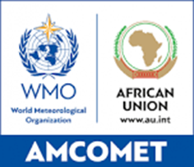

INTEGRATED AFRICAN STRATEGY ON METEOROLOGY (Weather, Water and Climate Services) (2021–2030)

IMPLEMENTATION AND RESOURCE MOBILIZATION PLAN (IRMP)

Version_1.3

March 2024

Contents

List of Abbreviations i

Part 1 IMPLEMENTATION PLAN 1

1. Background 2

2. The Implementation Plan Objectives 4

3. Premise for the Implementation Plan 5

4. Realities of Africa 7

5. Strategy Implementation Framework 8

6. Key Programmes 1

7. Positioning for Success 6

7.1. The Strategic Positioning 6

7.2. Principles for success 6

8. Institutional Arrangements 9

Setting roles and structures 9

9. Monitoring and evaluation framework 10

[Figure 1. Implementation Framework: Integrated African Strategy on   
Meteorology (2021–2030) 0](#_Toc164421343)

Figure 2. Principles for success 7

Figure 3. The monitoring and evaluation cycle 10

Figure 4. Evaluation questions, which are also applicable to frameworks for climate risk management 11

Table 1. KIA 1: Policy and legislation advocacy 3

Table 2. KIA 2: Resource Mobilization 4

Table 3. KIA 3: NMHSs critical infrastructure enhancement and operations 5

Part 2

RESOURCE MOBILIZATION PLAN

# List of Abbreviations

| **Abbreviation/Acronym** | **Description** |
| --- | --- |
| ACMAD | African Centre of Meteorological Application for Development |
| AFD | Group Agence Française de Développement |
| AfDB | African Development Bank |
| AMCOMET | African Ministerial Conference on Meteorology |
| AMDAR | Aircraft Meteorological Data Relay |
| AMESD | African Monitoring of the Environment for Sustainable Development |
| AMSAF | Africa Meteorological Satellite Application Facility |
| AU | African Union |
| AUC | African Union Commission |
| AWCF | Africa Weather, Water and Climate Fund |
| ClimSA | Climate Services and Related Application Programme |
| COP | Conference of the Parties |
| DAC | Development Assistance Committee |
| DRR | Disaster Risk Reduction |
| EU | European Union |
| EUMETSAT | European Organisation for the Exploitation of Meteorological Satellites |
| FCDO | Foreign, Commonwealth and Development Office |
| GBON | Global Basic Observing Network |
| GDP | Gross Domestic Product |
| GFCS | Global Framework for Climate Services |
| GMAS | Global Multi-hazard Alert System |
| GMES | Global Monitoring for Environment and Security |
| ICT | Information and Communications Technology |
| ISO | International Organization for Standardization |
| KIA | Key Implementation Area |
| KPI | Key Performance Indicators |
| M&E | Monitoring and Evaluation |
| MESA | Monitoring of the Environment for Security in Africa |
| MTG | Meteosat Third Generation |
| NFCS | National Framework for Climate Services |
| NFWCS | National Framework for Weather, Water, and Climate Services |
| NGO | Non-governmental Organization |
| NHS | National Hydrological Services |
| NMHSs | National Meteorological and Hydrological Services |
| NMS | National Meteorological Services |
| NSP | National Strategic Plan |
| OECD | Organization for Economic Cooperation and Development |
| PPP | Private, Public Partnership |
| PUMA | Preparation for the Use of Meteosat in Africa |
| QMS | Quality Management System |
| RC | Regional Centre |
| REC | Regional Economic Centres |
| SDG | Sustainable Development Goals |
| SOFF | Systematic Observations Financing Facility |
| SP | Strategic Pillar |
| UIP | User Interface Platform |
| UN | United Nations |
| WIPPS | WMO Integrated Processing and Prediction System |
| WIS | WMO Information System |
| WMO | World Meteorological Organization |
| WWCS | Weather, water and climate services |

# Part 1

# IMPLEMENTATION PLAN

# Background

The initial Integrated African Strategy on Meteorology (Weather and Climate Services) was adopted by the African Union Executive Council in January 2013[1] (EX.CL/Dec.744(XXII)). The Strategy was revised as requested through the Cairo Declaration during the fourth Ordinary Session of the African Ministerial Conference on Meteorology (AMCOMET 4) which took place in Cairo, Egypt in February 2019. The validation process of the revised Strategy (2021–2030) was done at the Regional Economic Communities (RECs) level involving all the African regions. The validated Strategy was later presented to the African Ministers responsible for meteorology convening as AMCOMET at its fifth Ordinary Session, which endorsed it and recommended its submission to the African Union (AU) political organs for consideration for adoption. The Strategy was adopted by the Executive Council EX.CL/Dec.1144(XL) (February 2022) and the African Union Assembly of Heads of States and Government at its thirty-fifth Ordinary Session, 5‑6 February 2022 (Assembly/AU/Dec. 819(XXXV)) together with the African Union Climate Change Climate Change and Resilient Development Strategy and Action Plan.

The revision of the Integrated African Strategy on Meteorology has been guided by a broader policy guidance, which essentially encourages the overall drive and expectations in confronting the climate change challenge. An Implementation and Resource Mobilization Plan for the original strategy was developed to support the Integrated African Strategy on Meteorology and to further provide a road map and methodology to encourage policymakers to consider weather and climate services as key components of the development of Africa through effective mainstreaming into policy and decision-making, operational activities and development plans at the national, regional, and continental levels. Considering the revision of the Strategy, there is now a need to review and revise the Implementation and Resource Mobilization Plan to ensure alignment with the most recent strategy and the emerging African priorities.

At its epicentre, the updated Integrated African Strategy on Meteorology provides Africa’s strategic road map for the long-waited action on the development and application of weather, water and climate services for the continent’s social, economic, and ecological development. The Integrated African Strategy on Meteorology is comprised of five strategic pillars that are aimed at reinforcing the unwavering devotion to addressing the wishes of African people as voiced through Agenda 2063.

The strategy aims to help attain political and decision makers’ support, enhance cooperation among African countries and promote coordinated and harmonized action on addressing development challenges related to weather, climate variability and change. It seeks to attain improvement of observation and monitoring networks and the modernization of National Meteorological and Hydrological Services (NMHSs), coupled with the enhancement of capacities of NMHSs as key outcomes. The strategy further seeks to enable AU member states fully meet their national development needs by establishing strategic building blocks that capacitates the members to improve their capabilities to develop and apply weather, water and climate services. By doing so, Members also contribute to the realization of regional and global development frameworks.

To embark on the meteorological transformation journey on the continent, the process of reviewing the Implementation and Resource Mobilization Plan will enable the actualization of the five strategic pillars embedded in the Integrated African Strategy on Meteorology (Weather, Water and Climate services). The implementation of the strategy will demonstrate the commitment of the African political leadership to the regional and global development frameworks such as: the AU Agenda 2063; the African Union Climate Change and Resilient Development Strategy and Action Plan; the Sustainable Development Goals (SDGs); the Paris Agreement on Climate Change; the Sendai Framework for Disaster Risk Reduction; the Global Framework for Climate Services (GFCS), among others.

The Implementation Plan for the Strategy also serves as a strategic tool to fast tract the holistic actioning of appropriate measures for the continent’s effective realization of its development aspirations related to continent-wide improvements of weather, water and climate services and the associated socioeconomic benefits that come along with such improvements, including supporting climate change adaptation requirements, in particular within the vulnerable societies on the continent.

The Implementation Plan, when implemented, will enable the continent to address the large gaps in the meteorological and hydrological observing networks in Africa, address the declining number of observing stations leading to compromised quality of forecast, develop early warning systems, the modernization of NMHSs as well as enhancement of capacities of NMHSs while incorporating current priorities in the meteorology fraternity. The implementation will seize an opportunity to identify and realize critical actions and quick wins.

It will further be a strategic instrument to fast track: the Abidjan Declaration; the Cairo Declaration; the Nairobi declaration on Climate Change and call to action; the Maputo Ministerial Declaration – Early Warning and Early Action; the Geneva Declaration-2019 ‘Building community for weather, climate and water actions’; the Dar es Salaam Commitment on Meteosat Third Generation (MTG) for Africa; the Early Warnings for All in Africa Action Plan; and the Africa Meteorological Satellite Application Facility (AMSAF); amongst others.

# The Implementation Plan Objectives

This revised Implementation Plan for the Integrated African Strategy on Meteorology development is a strategic instrument for realizing and actualizing the development and application of weather and climate services in the development of the social, economic, and ecological goals for the continent. As such, the Implementation Plan will help enhance cooperation among African countries and promote coordinated and harmonized action on addressing development challenges related to weather, climate variability and change.

The specific objectives for the Implementation Plan are presented as follows:

* Translate the Integrated Strategy for Meteorology Strategic Pillar into realistic action, identifying risks, with roles, responsibilities, budget, and timelines assigned;
* Set a trajectory for Africa to respond and align seamlessly with regional and global development frameworks such as the AU Agenda 2063, the African Union Climate Change and Resilient Development Strategy and Action Plan, the Sustainable Development Goals (SDGs), the Paris Agreement on Climate Change, the Sendai Framework for Disaster Risk Reduction, the Global Framework for Climate Services (GFCS), among others;
* Provide a credible road map for transforming the development and application of weather and climate services for the social, economic and ecological developmental goals;
* Help articulate practical actions to respond to the African Union’s Agenda 2063;
* Provide an enabling platform to influence the inclusion of meteorology strategic pillars, actions and associated programmes and actions into National Strategic Plans as well as National Adaptation Programmes (NAPs) and Nationally Determined Contributions (NDCs) of the Member Countries;
* Facilitate collaboration between AU member states , drive continent and regional programmes/projects and resource mobilization;
* Provide structures and processes for mobilizing resources required for the implementation of the Integrated Strategy for Meteorology in Africa;
* Provide value-adding institutional arrangements and structures to supports the implementation of the actions, programmes and projects by members states, RECs, and all relevant key stakeholders;
* Provide the budgets required for implementation to realize the goals and objectives of the strategy; and,
* Define an effective Monitoring and Evaluation framework, stipulating the key performance indicators and the targets, including the responsibilities and schedules for monitoring, evaluation and reporting.

# Premise for the Implementation Plan

While the Implementation Plan for the Integrated African Strategy on Meteorology (Weather, Water and Climate Services) will strive to actualize the cooperation amongst African countries and promote coordinated and harmonized action on addressing development challenges related to weather, climate variability and change, this should be done with the conscious reality that African nations are particularly vulnerable to extreme events due to climate change and variability, as such, urgent and adequate mitigation and adaptation policies should be put in place.

It is recalled that Africa is the most vulnerable continent to climate variability and change, aggravated by the interaction of “multiple stresses”, including high dependence on rain-fed agriculture and a weak adaptive capacity. Most countries on the continent are prone to floods, droughts, heatwaves, and storms, resulting in massive loss and damage. Furthermore, population growth in many cities in Africa and the occurrence of extreme events pose more challenges. Under a changing climate, the significant increases in temperature, sea level rise, shifts in weather patterns, and other extremes are already having adverse effects on, among others, human health, agriculture, water, natural ecosystems, and other environmental, social and economic impacts. These pose an arduous challenge to Africa’s socioeconomic development prospects, which would include, among other things:

* The realization of the AU Agenda 2063
* The African Union Climate Change and Resilient Development Strategy and Action Plan
* The United Nations (UN) Sustainable Development Goals (SDGs)
* United Nations Convention of Climate Change commitments
* The Paris Agreement and the Sendai Framework on Disaster Risk Reduction (DRR).

The unfolding circumstances heighten the need for AU member states to design robust approaches that would give direction, coherence, and collective efforts in confronting climate change challenges. In particular, there is a need to pay more attention to adaptation and invest in early warning services.

The Implementation Plan, developed holistically across the five strategic Pillars of the Integrated African Strategy on Meteorology, has its primary purpose of addressing alarming meteorological and climate services development gaps that cripple the continent to achieve its development goals.

The following urgent actions are required to be prioritized by the Implementation Plan:

* Provide for legal framework for the operationalization of the NMHSs, NMSs and NHS in the AU member states.
* Advocate for national governments to provide more support to their NMHSs for implementing basic meteorological and hydrological observing networks, data transmission, data archiving and processing infrastructure in line WMO standard operating procedures (i.e. Global Basic Observing Network (GBON), WMO Information System (WIS), WMO Integrated Processing and Prediction System (WIPPS), etc).
* Influence investment in meteorological and hydrological observing networks in Africa to improve the quality and accuracy of weather and climate products and applications.
* Address the decrease in the critical radiosonde observations – top contributors to the accuracy of numerical weather prediction models – decreased by as much as 50% between January 2015 and January 2020, primarily due to lack of funding[2].
* Strengthen Early Warning Systems for meteorological and climate hazards as key components of climate change adaptation and disaster risk reduction strategies and need to be strengthened across the continent, taking advantage of the United Nations Secretary-General’s Early Warning for all initiative. [3]
* Assist African countries in establishing and operationalizing the national framework for climate services, as weather and climate services are important for decision-making and key for sustainable development and for adaptation to climate change and variability.
* Embark on a process to enable the Regional Centres to be functioning and fully operational.
* Support countries to access MTG data and strengthen their capacity to process satellite data for their specific needs and support the Dar es Salaam Commitment on MTG for Africa and the AMSAF.
* Strengthen coordination of the implementation of the strategy spearheaded by the African Union Commission (AUC) and the AMCOMET secretariat.
* Identify the quickwins and start developing business cases to implement the quick wins (the packaging of quick win activities projects or programmes, with detailed tasks lists, milestones and associated costs defined).
* Undertake a roadshow by the AUC and AMCOMET to donors, funders and aid companies in the region and globally to support the implementation of the strategy and the required financial resources.
* Promote public-private partnership for weather, water and climate services.
* Solidify cooperation areas with development partners in areas of meteorology, climate change, sustainable management of the environment and natural resources and ensure that the programmes are implemented.
* Promote and coordinate research and innovation programmes by NMHSs and associated research institutions, academia and tertiary institutions.
* Coordinate and strengthen partnership with users, producers, national institutions, private sector, academia, civil society organizations, women associations, development partners, etc.

# Realities of Africa

The threats of climatic hazards to African populations are real and require urgent attention to safeguard our societies. While Africa is badly hit by climate change, yet less than 20% of sub-Saharan NMHSs can provide weather and climate early warning information to their people due to various challenges. The impacts of climate change, variability, extremes and tropical cyclones in Africa and the low capacity to adapt due to limited access to technology, skills development and economic resources are of a continuing great concern. Furthermore, there are alarming increases in climate refugees, forced displacements and potential resource conflicts due to a drinking water shortage or destruction of crops as a result of floods or drought.

With increasing and high precision demands for better meteorological services across different sectors much of which were not significantly impacted by meteorological events decades ago, governance and management of Meteorological services in many African countries require modernization with the private sector and other stakeholders included.

Large gaps in the meteorological and hydrological observing networks in Africa continues to be a major concern. The number of observing stations in Africa has generally declined over the last 25 years. Declining observations mean that, in many places in Africa, the quality of forecasts is not improving, even though the resolution of numerical weather prediction models has increased significantly in recent years.

To date, WMO launched the Global Multi-hazard Alert System (GMAS) but its implementation in Africa is challenging due to major observational gaps, making the availability of early accurate warnings difficult. WMO has defined new standards for observations through the Global Basic Observation Network (GBON) and has established with various partners the Systematic Observations Financing Facility (SOFF) to sustainably finance GBON. The inability to deliver data for global use has a negative impact on global and regional forecasts.

Therefore, the development and operationalization of the Integrated Strategy on Meteorology and its Implementation Plan can be used to harmonize and accelerate implementation of regional and national strategies, and also serve as a resource mobilization and optimization of use tool.

# Strategy Implementation Framework

The successful implementation of the Integrated African Strategy on Meteorology in Africa requires transformative individuals who can lead and advocate for a radical transformation in weather, water and climate services. This strategy is guided by a comprehensive policy that embodies the overall expectations in addressing the challenges of climate change on the continent. This requires unwavering determination, coupled with robust interventions, institutional structures and enabling resources. The AU should, in addition to building strategic partnerships, lead the transformation process by establishing an auspicious environment by implementing the robust decisions and interventions outlined in the strategy.

The following section demonstrates the programmes, projects and activities, derived from the strategic actions proposed within the five Strategic Pillars of the Integrated Strategy on Meteorology (Weather, Water and Climate). The strategy implementation framework model below depicts a need for an integrated implementation approach amongst all stakeholders including the African Union member states and their NMHSs, Regional Specialized Meteorological Centres, Regional Centres (RCs), enabling partners (AUC, RECs, WMO), development partners, etc. All stakeholders should work together to transport Africa to an era of improved weather and climate services development and application, leading to improved adaptation, resilience and availability of early warning services and a strategic shift towards developmental aspirations. The framework model further identifies a blended participation of funders and technical partners as enabling partners to catalyse the implementation of the Integrated Strategy on Meteorology objectives, along with the private sectors, tertiary institutions, and research institutions as catalytic partners to drive the radical phase of transformation in the continent.

The implementation framework model makes particular emphasis on ensuring that the implementation of the Strategy recognizes and incorporates contributions of the regional and global development frameworks including, but not limited to:

* EU Funded Programmes:
* Preparation for the Use of Meteosat in Africa (PUMA);
* African Monitoring of the Environment for Sustainable Development (AMESD);
* Monitoring of the Environment for Security in Africa (MESA);
* Global Monitoring for Environment and Security and Africa (GMES, and Africa);
* Climate Services and Related Application Programme (ClimSA);
* Global Climate Change Alliance Plus (GCCA+);
* Disaster Risk Governance; etc.,
* United States President’s Emergency Plan for Adaptation and Resilience (PREPARE);
* Climate for Development in Africa (ClimDev-Africa) Programme;
* MTG and AMSAF programmes;
* Abidjan Declaration, Cairo Declaration, Maputo Ministerial Declaration – Early Warning and Early Action, Geneva Declaration-2019 ‘Building community for weather, climate and water actions’, African Leaders Nairobi declaration on climate change and call to action;
* Accelerated implementation of the African Union Strategy for Gender Equality and Women’s Empowerment (2018–2028), the WMO Gender Policy and Action Plan, the African Union Gender Policy, the African Youth Charter, the AU Youth Engagement Strategy, and other Youth related policies at all African levels through the active role of Regional Associations; and,
* Agenda 2063, the AU Agenda 2063, the African Union Climate Change and Resilient Development Strategy and Action Plan, COPs, Sustainable Development Goals (SDGs), the Paris Agreement on Climate Change, the Sendai Framework for Disaster Risk Reduction, the Global Framework for Climate Services (GFCS), the African Climate Change and resilient development Strategy, the African Multi-Hazards Early warning and Early action Programme and the Early Warning for all initiative, among others.

Finally, the implementation framework model identifies the need to act on urgent tasks that include the implementation of the meteorological and hydrological observing networks in Africa, integrating with the WMO GBON, the actualization of priority cooperation areas with development partners, The Dar es Salaam Commitment on MTG for Africa and the AMSAF, amongst others.

The Implementation Plan should be used as a tool to map the roles and responsibilities of the various stakeholders to the programmes, projects and activities, and as a tool to guide the scope and how the different role players should give effect to the requirements of the Integrated Strategy on Meteorology.

Tables 1, 2 and 3 present the various interventions, which are in the form of projects, programmes and policy interventions, milestones and the corresponding roles and responsibilities.

The implementation framework further makes recommendations for identification for quick wins, which are those programmes, projects and activities that can implemented with minimal human, technical and financial resources, yielding partial or complete immediate benefits, and enabling AU member states, RECs, stakeholders and partners to transform the development and application of weather and climate services or establish enabling policies or interventions that support such developmental aspirations on the continent.

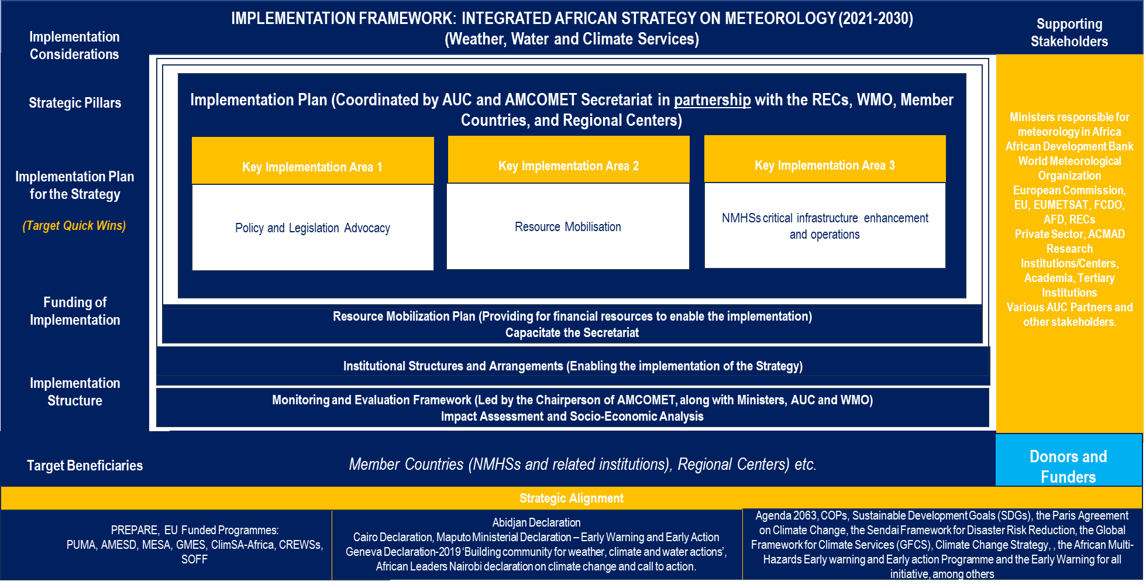

Figure 1. Implementation Framework: Integrated African Strategy on Meteorology  
(2021–2030)

# Key Programmes

The mandate of AMCOMET in Africa is about driving decision-making and policy advocacy within the meteorology and climate services. As such, the Implementation Plan for the Strategy on Meteorology and Climate Services is centred around initiating and driving action plans that promote the provisions of the AMCOMET mandate. AMCOMET plans to identify a manageable number of programmes at a continental level that will catalyse the development and application of weather, water and climate services. The successful implementation of the strategy's five pillars requires collaborative efforts and partnerships between the various member states of the AU. This involves the participation of their National Meteorological and Hydrological Services (NMHSs) as well as any other relevant ministries or entities within the member country or region. The identified programmes should therefore enable the Members and their NMHSs to realize their development aspirations. As such, AMCOMET shall focus on legislative and policy issues, high-level resource mobilization, advocacy for enhanced strengthened infrastructure in AU member states, and have a strong monitoring and evaluation mechanism to measure the progress on NMHSs development.

The Implementation Plan is structured to comprise the following Key Implementation Areas (KIAs):

1. Policy and legislation advocacy

1. Advocate for the development and promulgation of legislative framework enabling NMHSs to operate as autonomous bodies, with effective cost-recovery mechanism put into place, reciprocal Private, Public Partnership (PPP) regulations and National Strategic Plans (NSPs) compliant with provisions of WMO;
2. Advocate for NMHSs across the continent to establish the basic infrastructure for their operations as requested by WMO;
3. Advocate for a legal framework for the establishment and operationalization of the national frameworks for weather, water climate services (NFWCS), and guidelines for aligning these with the NSPs, as weather and climate services are important for decision-making and key for sustainable development and for adaptation to climate change and variability;
4. Ensure the implementation of the African Union Strategy for Gender Equality and Women’s Empowerment (2018–2028), the WMO Gender Policy and Action Plan, the African Union Gender Policy, the African Youth Charter, the AU Youth Engagement Strategy, and other youth related policies at all levels in Africa;
5. Ensure strengthened partnership with users, producers, national institutions, private sector, academia, civil society organizations, women associations, development partners, etc.

2. High-level Resource Mobilization

1. Advocate, through the AMCOMET sittings the commitment from the various Members to commit to 0.02% of the country’s Gross Domestic Product (GDP) for enabling NMHSs to develop their capacities across the weather, water and climate services (WWCS) value chain;
2. Compile business cases and cost benefit models that can be applied by Members to solicit funding in order to enhance WWCS from their respective treasury ministries in their countries, and to influence policy makers and decision makers in prioritizing WWCS in planning at all levels;
3. Establish the Joint-Africa Weather Water and Climate Funding Programme to enable Members to centralize access to all available funding sources such as SOFF, African Development Bank Group (AfDB), Green Climate Fund (GCF), Adaptation Fund (AF);
4. Convene a funding forum comprising development and technical partners, the private sector partners, and philanthropy organizations on the continent, to commit resources to support adaptation and resilience, in particular vulnerable societies, through the Corporate Social Responsibilities commitments;
5. Consider the establishment of the Africa Weather, Water and Climate Fund (AWCF) to support the NMHSs and NHS to build adaptative and resilience capacities and emergency preparedness for their AU member states.

A comprehensive Resource Mobilization Plan articulating the holistic approach to resource mobilization, typical funding instruments and various sources of resources, is presented in Part 2.

3. NMHSs critical infrastructure enhancement for operations:

1. Advocate for national governments to provide more support to their NMHSs for implementing basic meteorological and hydrological observing networks, data transmission, data archiving and processing infrastructure in line with WMO standard operating procedures (i.e. GBON, WIS, WIPPS etc);
2. Strengthen the implementation of the Aircraft Meteorological Data Relay – AMDAR programme by the NMHSs in collaboration with aviation authorities in their AU member states;
3. Create enabling platforms and forums for users and producers at regional and national levels to ensure an operational and meaningful user interface platform for ensuring that that the WWCS are user based across the continent;
4. Strengthen the NMHSs within AU member states and the Regional Centres (RCs) in generating meteorological, hydrological and climate services including early warnings as key components of climate change adaptation and disaster risk reduction;
5. Solidify partnerships on meteorology, climate change, sustainable management of the environment and natural systems, and implementation of in-situ and satellite programmes, including the MTG and AMSAF and ensure that the programmes are implemented;
6. Assist the AU member states NMHSs in implementing the Quality Management System (QMS) across their services value chain in line with the [*Guide to the Implementation of Quality Management Systems for National Meteorological and Hydrological Services and Other Relevant Service Providers*](https://library.wmo.int/records/item/50552-guide-to-the-implementation-of-quality-management-systems-for-national-meteorological-and-hydrological-services-and-other-relevant-service-providers) (WMO-1100), and also in line with the relevant ISO standard;
7. Advocate for national governments to provide support to their NMHSs for implementing the WMO Regional Association I (Africa).

The programmes, projects, activities, the key performance indicators and targets within the three KIAs, across the five pillars of the Strategy are presented below.

Table 1. KIA 1: Policy and legislation advocacy



Table 2. KIA 2: Resource Mobilization



Table 3. KIA 3: NMHSs critical infrastructure enhancement and operations



# Positioning for Success

## The Strategic Positioning

AMCOMET, as a ministerial body, needs to position and empower itself as an influencing institution to the AU member states in order to enable the countries and their NMHSs to address the alarming challenges associated with capacities of NHMSs in delivering weather, water and climate services (WWCS), and contributing to socioeconomic development. AMCOMET requires to find high-impact, practical and feasible mechanisms to fully implement the Revised Integrated African Strategy on Meteorology (Weather, Water and Climate Services) and to further provide a road map and structured methodology to encourage policy and decision makers to consider WWCS as key building blocks in the development of Africa through effective mainstreaming of WWCS into operational activities and development plans at the national, regional, and continental levels.

This strategic positioning requires that AMCOMET presents a stronger value proposition to the continent, as the trusted agent for enhancing cooperation among African countries and promoting coordinated and harmonized action on addressing development challenges related to weather, climate variability and change. This could be provided through a number of value-propositions that could include the provision of support to the AU member states on key and enabling aspects such as: policy development; legal and institutional frameworks; human and financial resources; infrastructure and technology; data processing; modelling and forecasting tools. The support should be meticulously structured to improve the meteorological and hydrological observing networks, improve early warning systems, emergency preparedness and resilience capabilities on the continent.

AMCOMET aims to use this Implementation Plan as a tool for action to position itself not only as an influencer of politics and policymakers but also as a catalyst for sustainable development in Africa. This will contribute to the realization of the pan-African vision of an integrated, prosperous, and peaceful Africa, driven by its citizens, representing a dynamic force in the global arena. The plan will contribute to the realization of regional and global development frameworks such as the AU Agenda 2063, the Sustainable Development Goals (SDGs), the Paris Agreement on Climate Change, the Sendai Framework for Disaster Risk Reduction, and the Global Framework for Climate Services (GFCS), among others.

## Principles for success

In quest to provide Africa’s strategic direction on the development and application of weather and climate services for the continent’s social, economic, and ecological development, the following strategic principles will form a basis for strategic positioning of the bureau and for the effective and efficient implementation of the integrated strategy as depicted in the diagram and points below.

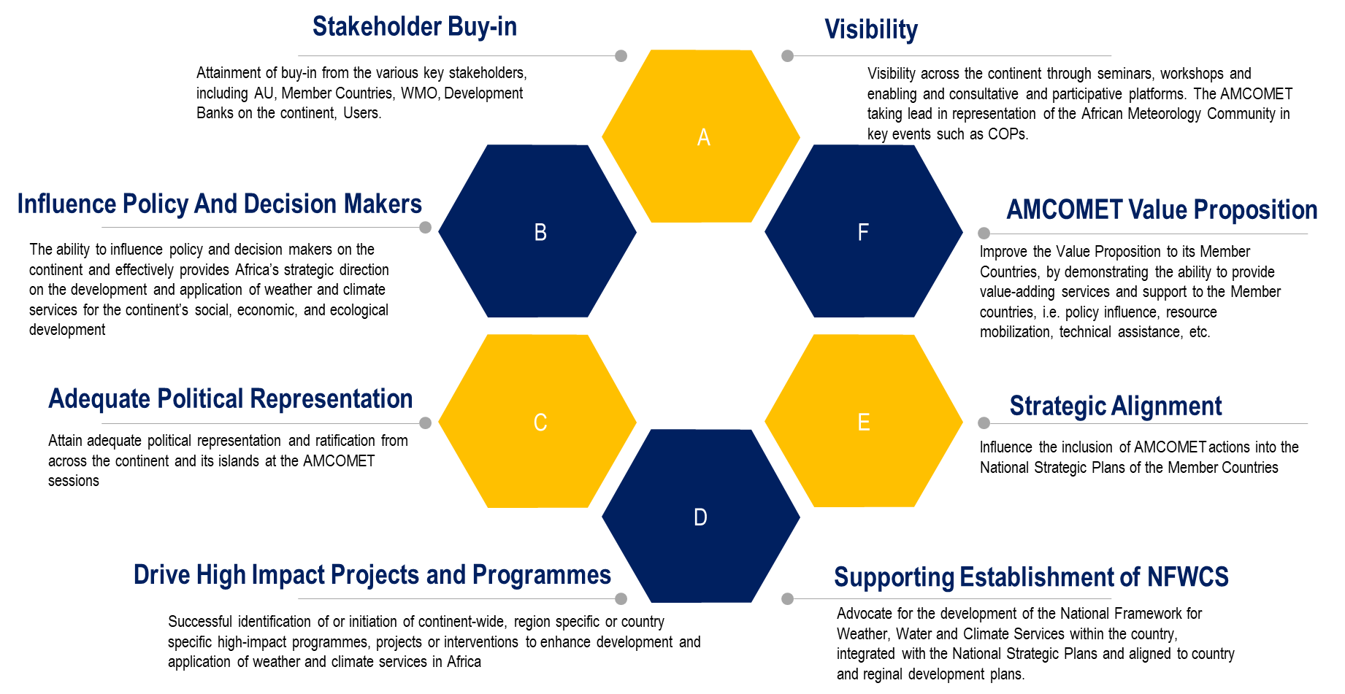

Figure 2. Principles for success

The principles for success are presented as follows:

1. Attainment of unwavering buy-in from AU member states and the various key stakeholders including, WMO, Development Banks on the continent, users, among others;
2. Visibility across the continent through digital media, seminars, workshops and enabling and consultative and participative platform;
3. Effective stakeholder engagement that enables the effective implementation of the strategy to provide Africa’s strategic direction on the development and application of weather, water and climate services (WWCS) for the continent’s social, economic, and ecological development;
4. The ability to influence policy and decision makers on the continent and to effectively provide Africa’s strategic direction on the development and application of WWCS for the continent’s social, economic, and ecological development;
5. Attain adequate political representation and ratification from across the continent and its islands at the AMCOMET sessions;
6. Successful identification of, or initiation of, continent-wide, region specific or country specific high-impact programmes, projects or interventions to enhance development and application of WWCS in Africa;
7. Improve the value proposition to AU member states by demonstrating the ability to provide value-adding services and support to the AU member states;
8. Advocate for the alignment of the African meteorology strategic agenda with the AU member states’ meteorology and climate service policies and country developmental plans and Climate Change Adaptation plans;
9. Influence the inclusion of meteorological actions into the National Strategic Plans of the member states;
10. Advocate for the development of the National Framework for Weather, Water and Climate Services within the country, integrated with the National Strategic Plans and aligned to the country and regional development plans.

# Institutional Arrangements

## Setting roles and structures

Institutional arrangements for the Integrated African Strategy on Meteorology (2021–2030) are the policies, systems, and processes that key players and implementing partners will utilize to legislate, plan and manage their activities efficiently and to effectively coordinate with others in order to fulfil their mandate. The successful design; the implementation and management of the institutional arrangements for weather, water and climate services; climate change adaptation and resilience; are all critical components of sustainable development. Setting up an institutional framework for meteorology and climate services governance in Africa is crucial to plan, legislate and manage the implementation of the strategy strategic pillars’ actions in the continent. It is without doubt that the institutional arrangement at the continental level, should identify key role players such as NMHS, AUC, RECs, WMO, RCs, development partners and other enabling and catalytic partners.

However, the role of NMHSs cannot not be ignored by the Strategy. The NMHSs play a pivotal role in the development and application of weather, water and climate services and are the epicentre of services value chain implementation, especially in translating these services into policy programmes such as national adaptation programmes and nationally determined contributions. Amongst others, major barriers in the provision of effective weather, water and climate services include issues such as funding, lack of user and producer interaction and enabling legislative and policy provisions..

# Monitoring and evaluation framework

Monitoring and evaluation (M&E) play an essential role in understanding where to focus efforts, what is working and what and is not (and perhaps more importantly, why this is the case), and how to learn from experience to know how to maximize impact. For the Integrated African Strategy on Meteorology (2021–2030), M&E can (and should) support strategic and effective weather, water and climate service development and applications in Africa. A M&E sets standards and guides monitoring, evaluation and learning for an intervention. A M&E framework for the Strategy should be adjusted to regional and national needs and refers to international agreements and agendas, while being in line with relevant monitoring and evaluation standards, principles and criteria. The M&E framework defines clear key performance indicators (KPIs defined in Tables 1, 2 and 3) and targets (targets defined in Tables 1, 2 and 3) that should be agreed among the key stakeholders for the strategy implementation, to privilege the systematic carrying out of M&E.

The M&E cycle below, shows the need for quarterly or biannual, and annual strategy implementation M&E reviews, to determine the progress, challenges, and barriers on the strategy implementation for the period under review. Annual review of the strategy implementation ensures that there is continuous and sustained momentum in implementing the Strategy, and that challenges arising are accordingly and timely addressed. The model further requires that the secretariat and partners, conduct a comprehensive mid-term strategy impact assessment, which should be done in Year 3, and the final impact assessment will be done in Year 5 to be a feeder into the next revised Strategy.

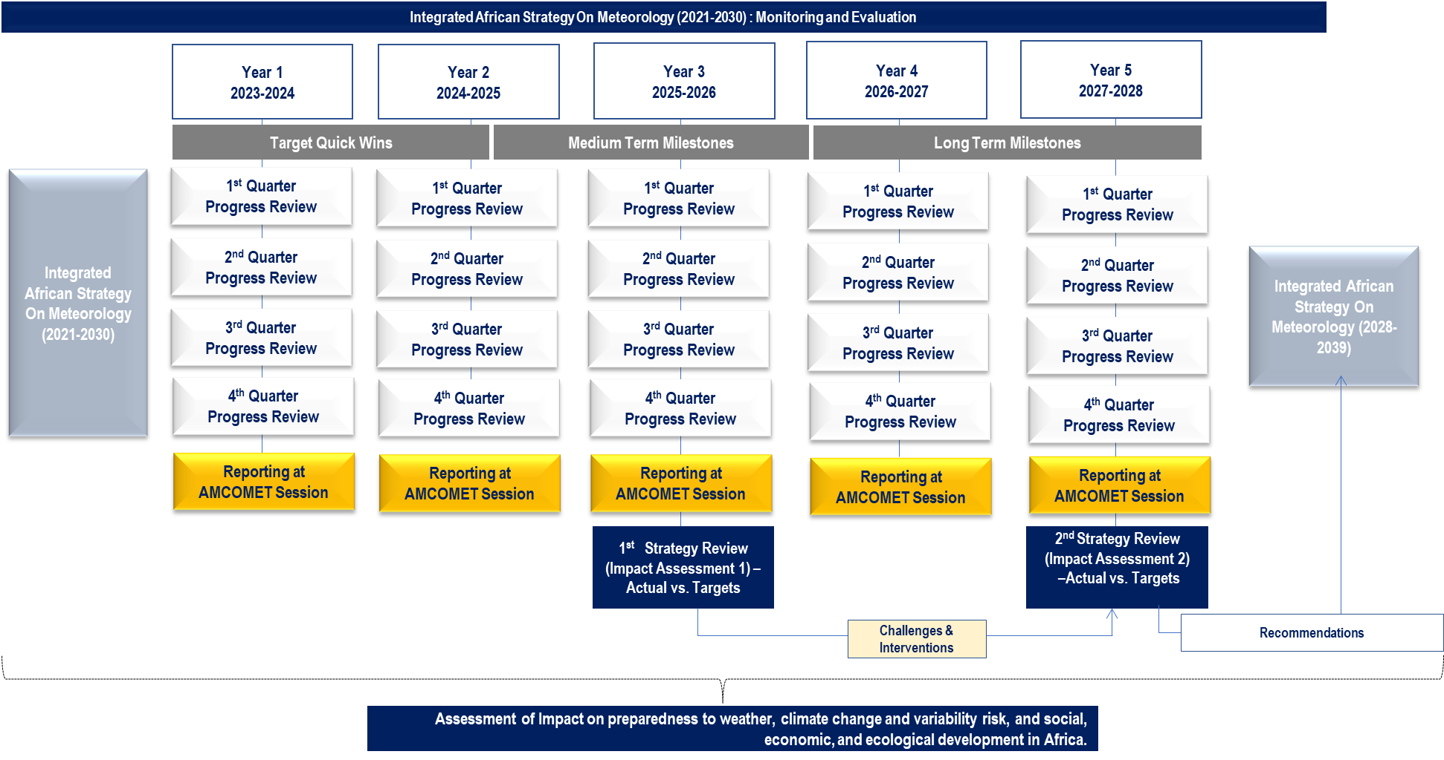

Figure 3. The monitoring and evaluation cycle

Complementing these principles for motoring and evaluation, the evaluation criteria (adopted from the Organization for Economic Cooperation and Development (OECD) Development Assistance Committee (DAC) model) provided below demonstrate a conceptual basis for meaningful evaluation questions, which are also applicable to frameworks for climate risk management. Guided by a set of questions outlined in Figure 4 below, the OECD DAC evaluation criteria pave the ground for a comprehensive and in-depth perspective on development cooperation in support of climate resilience.

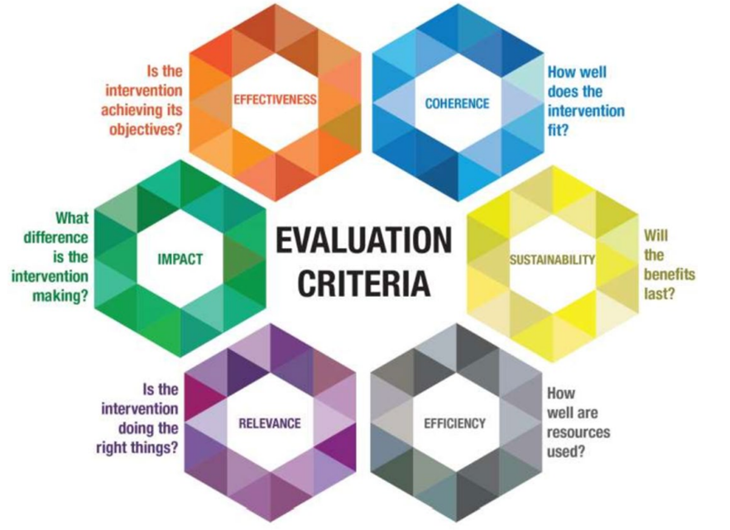

Figure 4. Evaluation questions, which are also applicable to frameworks for climate risk management

(*Source*: OECD DAC 2019)

To avoid overlaps and gaps in the activities of various parties and to ensure cross-country and cross-sectoral integration of work done, the Chair or the nominated official (i.e. Vice Chair) will chair quarterly/biannual meetings and consolidate a single report in order to submit it to the relevant stakeholders. The quarterly/biannual meetings should be attended by AUC representatives, AMCOMET representatives, Directors of NMHSs, Representatives of Regional Economic Communities, and any other relevant stakeholders. Monitoring progress will implicitly take place during these quarterly meetings. Annual M&E meetings will be chaired by the AMCOMET Chair to assess the performance and progress made by the secretariat on coordinating the strategy implementation. In these M&E meetings, the performance and progress of the strategy implementation will be monitored and assessed through the KPIs against set targets.

_____________

# Part 2

# RESOURCE MOBILIZATION PLAN

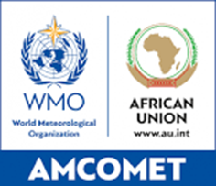

INTEGRATED AFRICAN STRATEGY ON METEOROLOGY (Weather, Water and Climate Services) – (2021–2030)

RESOURCE MOBILIZATION PLAN

VERSION_1.3

March 2024

# CONTENTS

Part 1 IMPLEMENTATION PLAN 1

Part 2  RESOURCE MOBILIZATION PLAN

CONTENTS ii

List of Abbreviations iv

1. Overview 27

2. Key focus areas 29

3. Guiding principles 30

4. Resource Mobilization Plan (RMP) approach 31

4.1. Five step approach 31

4.2. Requirements for an optimal resource mobilization process 31

4.3. Resource mobilization approach 32

5. Building an enabling partnership model 33

6. Types of financial instruments 34

7. Potential funding sources for the Strategy 35

7.1. Development banks 35

7.2. Multilateral Institutions 36

7.3. Bilateral Agencies 37

7.4. The European Development Fund (EDF) 37

7.5. Japan Fast Start Finance 37

7.6. The New Partnership for Africa's Development (NEPAD) Climate Change Fund 38

7.7. African Development Bank (AfDB) and the Africa Climate Change Fund (ACCF) 38

7.8. African Development Fund (ADF) - Climate Action Window (CAW) 38

7.9. ClimDev-Africa Special Fund (CDSF) 39

7.10. Global Climate Change Alliance (GCCA) Intra- African, Caribbean and Pacific (ACP) 39

7.11. The World Meteorological Organization (WMO) 40

7.12. Climate Risk and Early Warning Systems (CREWS) 40

7.13. Private sector 40

7.14. Development Financial Institutions (DFIs) 41

7.15. Private foundation institutions 41

7.16. Summary of the resource mobilisation pre-requisites 41

8. Resource Mobilization road map 42

Figure 1. The key steps in resource mobilisation. 32

Table 1. Selected resource mobilisation enabling partners locally, regionally and internationally. 33

Table 2. Key multilateral funds. 36

Table 3. Philanthropists and foundations supporting climate services 41

Table 4. Practical Steps to implement RMP. 42

# List of Abbreviations

|  |  |
| --- | --- |
| **Abbreviation/Acronym** | **Description** |
| AWCF | Africa Weather, Water and Climate Fund |
| AfDB | African Development Bank |
| AMCOMET | African Ministerial Conference on Meteorology |
| AU | African Union |
| ClimSA | Climate Services and Related Application Programme |
| CBO | Community-based Organization |
| EUMETSAT | European Organisation for the Exploitation of Meteorological Satellites |
| EU | European Union |
| GBON | Global Basic Observing Network |
| GFCS | Global Framework for Climate Services |
| GFCS APA | Global Framework for Climate Services Adaptation Programme in Africa |
| GPC | Global Producing Centre |
| ICT | Information and Communications Technology |
| LDCs | Least Developed Countries |
| NFCS | National Framework for Climate Services |
| NFWWCS | National Framework for Weather, Water, and Climate Services |
| NHS | National Hydrological Services |
| NMHSs | National Meteorological and Hydrological Services |
| NMS | National Meteorological Services |
| NSP | National Strategic Plan |
| NGO | Non-governmental Organization |
| OECD | Organization for Economic Cooperation and Development |
| PPP | Private, Public Partnership |
| RECs | Regional Economic Communities |
| RC | Regional Centre |
| RFWCS | Regional Framework for weather, water, and climate Services |
| SIDS | Small Island Developing States |
| SOFF | Systematic Observations Financing Facility |
| UN | United Nations |
| UNDP | United Nations Development Programme |
| UNEP | United Nations Environment Programme |
| UNDRR | United Nations Office for Disaster Risk Reduction |
| UIP | User Interface Platform |
| WB | World Bank |
| WFP | World Food Programme |
| WMO | World Meteorological Organization |

# Overview

The development of this Resource Mobilization Plan (RMP) for the Integrated African Strategy on Meteorology (the Strategy) is in line with the African Union Commission (AUC) and the World Meteorological Organization (WMO) funding mechanisms. However, cogent partnership, collaboration and coordination at continent and national levels will be essential for successful resource mobilization and implementation. Partners and key stakeholders should take advantage of existing international funding and donor opportunities, funding through the African Development Bank (AfDB), various developmental banks, private sector funding, and opportunities such as the Systematic Observations Financing Facility (SOFF), which is the financing facility that is being established by WMO and partners to sustainably finance the Global Basic Observing Network (GBON).

The government of each country need first to support their National Meteorological and Hydrological Service (NMHS) because of the national mandate of NMHSs to deliver information for the safety and security of people and their goods, as well early warning information to minimize the impacts of climate change an hydrometeorological hazards on citizen and national economies. In particular, NMHSs must be supported by their countries because of the national mandate of NMHSs to deliver information for the safety and security of people and their goods, as well as early warnings for weather and climate information to minimize the impacts of climate change, hydrometeorological hazards on citizens and national economies.

Successful implementation of the Strategy will require mobilization of adequate resources, in particular, financial resources for institutional, procedural, infrastructural and human capacity development. This requires that an RMP be developed to fund the programmes, projects and activities in the Strategy Implementation Plan. The overall objective of an RMP is to identify donor and funding partners, funding mechanisms and instruments, as well as discerning strategic approaches, capacities, and processes required to mobilize adequate resources for the implementation of the Strategy. The outcomes of RMP implementation should be: a consolidated, diversified and expanded base of resources; an efficient resource mobilization capacity; effective management of resources; effective reporting and good governance on resources mobilized.

The RMP outlines a resource mobilization approach that needs to be adopted by AMCOMET to derive maximum results when implementing the RMP. The RMP needs to be reviewed at least on an annual basis, so that it is continuously aligned to changing funding requirements and criteria at that time. In adopting the approach, there is a fundamental requirement of employing competent and experienced resource mobilization officers with strong business development and technical capabilities to develop funding proposals, business plans and business cases, coupled with the ability to competently engage with resource partners. The approach to resource mobilization should be anchored on credible and structured outreach programmes that target donors and funders to enable delivery of programmes and projects in the Strategy Implementation Plan. The approach comprises the following key stages:

* Identification of resource partners
* Engagement with resource partners
* Negotiation with resource partners
* Efficient management of resources mobilized
* Management and reporting to the resource partners.

The RMP also defines the need to establish partnership models to guide the engagement process with the resource mobilization enabling partners locally, regionally and internationally. The partners should be carefully selected, depending on the value that they can add to the strategy goals and objectives.

The RMP comprises a wide range of financing mechanisms and partnership opportunities that can be targeted by the secretariat and its partners in order to secure investments for the implementation of the Strategy.

Potential sources of funding for the Strategy include:

* The AU member states’ national government budgeting processes
* The African Union programmes
* The World Bank
* WMO Funding Facilities
* Local and international development bank investments
* Development assistance programmes of various economic groupings
* Countries that have bilateral agreements with various AU member states
* Country-specific international development funding agencies
* Overseas official development assistance programmes of national governments
* Country budgets of overseas missions and embassies
* Various climate finance funds
* Partnerships established by the African Union (AU)
* Other similar mechanisms[4].

In addition, the RMP provides an Implementation Plan that is developed to respond to the resource requirements of the Strategy Implementation Plan. The monitoring and evaluation of the RMP implementation is based on resource mobilization key performance indicators (KPI) and targets agreed to during the development of the RMP Implementation Plan.

# Key focus areas

The resource mobilization should provide capital budget and operational budgets, over short, medium to long term. The RMP does not only focus on financial resources but provides other resources, through partnership, such as infrastructure, technology and skill transfer that can enable the delivery of the Strategy’s Implementation Plan.

The RMP will focus on the following key focus areas:

* Develop a database of donor and funding partners locally, regionally and globally that can provide resources or catalyse the mobilization resources required for the implementation of the Strategy;
* Mobilization of sufficient resources to strengthen all the five pillars of the Strategy through strategic partnership with catalytic partners and stakeholders; and,
* Build organizational structures, institutional arrangements, and a good governance model comprising transparent systems and reporting frameworks.

# Guiding principles

The RMP provides the following six guiding principles for implementation of the strategy, which should be embraced and applied by all stakeholders when mobilizing resources and in engagements with resource partners at all levels:

* NMHS need to be identified as a priority sector to be able to access external funding to the countries. It is also important to include meteorology in the national development plan, DRR plan, poverty reduction plan amongst others, as they are the authoritative voice for weather and climate services and should provide the meteorological information that can reduce the impacts of hydrometeorological hazards that can pull back the vulnerable economy of most African countries;
* All resources mobilized should support the Strategy’s short-, medium- and long-term goals and objectives;
* The RMP should, amongst others, focus on mobilizing resources to help realize the AU member states’ priority needs on weather, water and climate services requirements;
* Resource partnership agreements should comply with AU, RECs and AU member states’ legal and policy frameworks;
* All resources mobilized should be formally monitored and accounted for, both internally and externally, and that there is transparency in resource management;
* Keep close relationships with funding partners, donors, and key enabling stakeholders, and build these relationships on the basis of good governance;
* The AUC, RECs and AU member states should support donor initiated and sponsored programmes only if they align with the Strategy’s overall mission and there is appropriate institutional capacity to support the implementation of such programmes.

# Resource Mobilization Plan (RMP) approach

## Five step approach

The RMP outlines a resource mobilization approach which endeavours to provide guidance for deriving optimal results in the mobilization of resources. The strategy is a dynamic document that needs to be reviewed when the Strategy is implemented to address funding requirements and criteria at that time. In adopting the approach, there is a fundamental requirement of employing competent and experienced resource mobilization officers with strong business development capabilities to develop convincing funding proposals, business plans and business cases, and further have the ability to competently engage with resource partners. The approach to resource mobilization should be anchored on credible and structured outreach initiatives that targets funders to fund various programmes and projects, those within and coordinated by the AUC, AMCOMET and WMO, which should judiciously coordinate outreach programmes and undertake interactions with resource partners to meet the funders’ requirements and mandates.

This section, therefore, focuses on how to approach resource mobilization, and presents some factors to be considered upfront before venturing into full implementation of the strategy. The resource mobilization process is described systematically through five practical key steps. While the resource mobilization steps presented represent a generic approach to attracting resources, the requirements involved in each step can differ when dealing with specific resource partners.

## Requirements for an optimal resource mobilization process

The RMP provides six key issues that need to be considered by the AMCOMET session to strengthen the process of resource mobilization. These issues need to be considered before embarking on the process of resource mobilization as they ensure that the process responds to the goals and objectives of the strategy.

The following key issues will help develop a pragmatic, integrated, coordinated and programmatic approach to resource mobilization:

* **The programme or project to be funded:** Determination of a project or programme to be funded and demonstrate how it will benefit the intended beneficiaries in relation to climate services and strategic goals;
* **A structured approach:** The programme or project must be aligned to the goals and objectives of the Strategy;
* **Resource partners’ interests:** The programme or project must fit into the resource partners funding criteria, priorities and mandate;
* **Catalytic partnerships: T**he programme or project should be supported by government and other relevant stakeholders and can where possible, benefit from a collaborative approach with partners at a country, regional or global level;
* **Planning for sustainability:** There should be a balance between a selection of projects and programmes to provide for short-, medium- and long-term resource sustainability;
* **A coordinated team approach:** The resource mobilization process must be a team effort amongst WMO, AMCOMET, AU, NMHSs and other key partners. The methodology for tracking and reporting on resource mobilization targets should be in place.

## Resource mobilization approach

Resource mobilization is about matching the goals and objectives of the AU, RECs, WMO and AU member states’ priorities.

The key steps in the resource mobilization approach are illustrated in Figure 1.

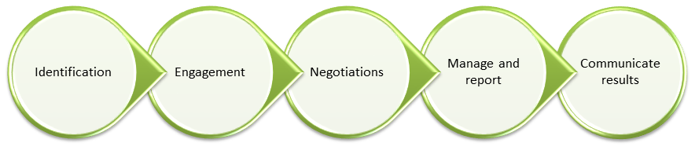

Figure 1: The key steps in resource mobilization

* **Identification:** Mobilizing funds requires detailed knowledge of resource partners, their priorities, policies, budgets, rules and procedures for audits and accountability mechanisms. In this step of the resource mobilization process, the resource partners are identified through web searches, subscribing to email circulars, broad reading on the subject, joining networks or groups such as funders and donor forums or coordination groups, and by word of mouth and informal meetings. This is not a once-off process, but a continuous one that requires updating details and specific requirements of potential resource partners.
* **Engagement:** This step requires the AUC and AMCOMET resource mobilization officials to actively and continually build strong relationships and to favourably influence decision makers regarding the programme or project for which resources are sought. It means establishing and maintaining open and regular dialogue with partners to build mutual trust and respect.
* **Negotiations:** This step involves a complex set of knowledge and skills. It is essential that appropriate support mechanisms from AU member states are in place in order to proceed successfully. The resource mobilization officers should engage legal advisers to ensure that the agreements signed are properly vetted. The outcome of this process should be signed funding agreements that will enable the release of resources.
* **Manage and report:** This step involves management of projects or programmes funded by the resource partners. In this step the AMCOMET, WMO, AUC, RECs, and AU member states should professionally manage projects or programmes and utilize the resources mobilized according to the terms and conditions of the funding partner. The AUC, RECs, and AU member states should continuously report on the progress of projects or programmes and produce resource utilization reports during AMCOMET sessions or other established programme/project governance mechanisms. This step is crucial to maintaining good relations with resource partners and forms the foundation of potential ongoing resources availability and allocations.
* **Communicate results:** This step involves communication of key messages about the project and programmes to the target audience. The preparation of a communication plan and quality communication materials are therefore important in this step. Communication will ensure that resource partners are benefitting from appropriate visibility, enhancing the probability for continued investments.

# Building an enabling partnership model

The Strategy should in its pursuit to catalyse resource mobilization, establish a partnership model comprising resource mobilization enabling partners locally, regionally and internationally. Hence, the selection of partners should depend on the value that they can add to the Strategy’s funding aspirations.

Table 4. Selected resource mobilization   
enabling partners locally, regionally and internationally

|  |  |
| --- | --- |
| **Potential partners** | **Roles or value add** |
| **Enabling partners** | Support with fundraising, provide technical assistance or political buy-in support. |
| **Developmental banks** | Share their expertise and experience on resource mobilization proposals, and resource networks regionally and globally. |
| **UN organizations** | Collaborate on fundraising preparations, expertise and technical support through United Nations Sustainable Development Cooperation Framework with countries or bilateral. |
| **Sector-based institutions** | Provide sector-based knowledge and expertise, to feed into business cases for funding. |
| **Climate change and meteorology specialists** | Advise on climate change and meteorology technical expertise and in preparation of proposals. |
| **Tertiary institutions** | Advise on climate change and meteorology technical expertise and in preparation of proposals. |
| **Corporate finance institutions and private equity firms** | To share experience and expertise on funding proposals, and other funding networks regionally and globally. |
| **Parastatals** | Provide sector specific knowledge and expertise to feed into proposals for funding. |
| **Non-governmental Organizations (NGOs) – (Civil Society Organizations)** | Provide inputs into business case and proposal writing. |
| **Business organizations** | Support in the facilitation of private sector participation in funding. |

# Types of financial instruments

There are several types of financial instruments that are available from a variety of funders, partners and donors, and can be used at various stages of the programme or project lifecycle. For example, grants, research funding and technical expertise can be used for project conceptualization, pre-feasibility and feasibility stages. Loans and commodities can be used for project prototyping and commercialization.

The following are financial instrument types that can be leveraged upon for the benefit of the Strategy:

* *Financial assistance (loans or grants).* Loans issued by the World Bank are one of the largest sources of financial assistance. Loans are also provided on a government-to-government basis as part of bilateral agreements that, in turn, reflect political commitments. Such loans are much more favourable than those from commercial banks in the sense that interest rates are lower, repayment schedules are adjusted to a country’s financial capabilities, and loans frequently have a non-reimbursable grant component.

Grants, which do not require repayment, are a much sought-after source of assistance. However, the Global Fund, for example, requires recipients to reach specific targets throughout the life of the grant. Many countries that have not been able to meet their performance goals have had funding cut off, which can cause programmatic challenges.

* *Technical expertise.* Donors can provide funds to obtain the managerial or technical expertise required for project execution, both short term (for example, two weeks to set up a laboratory instrument and to train staff in its use) or long term (for example, management of a four-year project). The work must be carried out with in-country counterparts to transfer technical competence to the recipient country and not perpetuate a relationship of dependence.
* *Research funding.* Funds are increasingly available for operational research through continued evaluation. This is in recognition of the fact that a project’s chances of success are enhanced by a clear understanding of the environment in which the project is to take place, by ongoing monitoring during project implementation, and by an impact evaluation after completion. Well-designed research proposals may be a prerequisite for funding approval.

# Potential funding sources for the Strategy

There is a wide range of financing mechanisms and partnership opportunities that can be targeted to secure additional investment for the implementation of the Strategy. The RMP provides a sample list of potential funding partners, and as such the list is not exhaustive, as there is a significant number of funding sources globally that can be explored.

The initial list of potential sources of funding for the strategy implementation include the following:

* Member State National Government budgeting processes and allocations
* Development assistance programmes of various economic groupings such as the African Union, the African, Caribbean and Pacific Group of States (ACP), the Organization for OECD etc.
* Partnerships between the AU and other Organizations and Countries
* United Nations Sustainable Development Cooperation Framework UNSDCF, UN System initiatives
* African Development Bank, Climate Action Window
* AMCOMET Facility Fund, as requested by the Cairo Declaration and AMCOMET 5
* Climate Risk and Early Warning Systems (CREWS) Trust Funding
* World Bank
* Foreign, Commonwealth & Development Office (FDCO)
* The Weather and Climate Information Services for Africa (WISER)
* Systematic Observations Financing Facility (SOFF)
* Local, regional and international development bank investments
* Countries that have bilateral agreements with AU member states
* Country-specific international development funding agencies like Global Affairs Canada, GIZ, USAID, etc.
* The overseas official development assistance programmes of national governments, country budgets of overseas missions and embassies various climate investment funds
* The Global Environment Facility (GEF), UNEP and other similar mechanisms
* Adaptation Fund
* Global Climate Fund
* Special Climate Change Fund
* Loss and damage Fund

The possible funding opportunities to be considered when implementing priority areas in RMP are discussed in the following sections.

## Development banks

Financing provided by the World Bank and Regional Development Banks (AfDB, BRICS Bank, etc.) can be structured to include financial instruments such as grants, soft loans or loans depending on the need. The Strategy should further determine the funding criteria of these institutions in order for qualifying projects and programmes within the Implementation Plan to be funded.

The WMO and various World Bank programmes have come together in recent years to significantly focus financing on modernizing the hydro- meteorological sector, including its climate aspects. The Strategy can take advantage of this opportunity in the development of projects and programmes that enhance the capacity of qualifying climate service providers to improve on the observations and monitoring infrastructure.

## Multilateral Institutions

Multilateral institutions pool resources from many donors and provide technical and commodity assistance globally or regionally through cash grants, commodity transfers, technical assistance, or loans. Multilateral institutions include initiatives from the UN agencies and related partners involved in direct country assistance and financing.

The sourcing of funds from these sources can be done through the AU member states relevant ministries, NMHSs, or any relevant institution, in particular NMHS need to be identified as a priority sector to access external funding to the countries. The Member State Treasury ministry plays a key role as signatory or guarantor (where required), given that other funding requires to be paid back if not classified as grants. Furthermore, there is an expectation that the usage of this funding be reported on a regular basis in line with the agreed reporting framework with the funder.

Table 5 presents key multilateral funds related to climate change that NMHSs, RCs and other relevant structures might approach in support of the implementation of the Strategy.

Table 5. Key multilateral funds.

| **Type of the fund** | **Description of the fund** | **Administrator** | **Area of focus** | **Website Link** |
| --- | --- | --- | --- | --- |
| **Adaptation Fund (AF)** | The Adaptation Fund is a financial instrument under the UN Framework Convention on Climate Change (UNFCCC) and its Kyoto Protocol (KP) and has been established to finance concrete adaptation projects and programmes in developing country Parties to the KP, in an effort to reduce the adverse effects of climate change facing communities, countries and sectors. | Adaptation Fund Board | Adaptation | <https://www.adaptation-fund.org/> |
| **Climate Investment Fund (CIF)** | The Climate Investment Fund provides financial resources to developing countries in order to help them mitigate and manage the challenges of climate change. This fund is channelled through the AfDB, Asian Development Bank, European Bank for Reconstruction and Development, Inter-American Development Bank, and World Bank Group. | African Development Bank | Low carbon initiatives  Climate services, infrastructure | <https://www.cif.org/> |
| **Green Climate Fund (GCF)** | The GCF was adopted as a financial mechanism of UNFCCC at the end of 2011. This fund aims to make an ambitious contribution to attaining the mitigation and adaptation goals of the international community, and it is expected to become the main multilateral financing mechanism to support climate action in developing countries over time. | Information on fast track mechanism | Adaptation, Mitigation – general, mitigation - reducing emissions from deforestation and forest degradation (REDD) | <https://www.greenclimate.fund/> |
| **Global Environment Facility (GEF)** | The GEF Trust Fund supports the implementation of multilateral environmental agreement, as well as the financial mechanism of the UNFCCC. It is the longest standing dedicated public climate change fund with climate change as one of the six focal areas supported by the GEF Trust Fund. This facility also administers several funds established under the UNFCCC including the Least Developed Countries Trust Fund (LDCF), the Special Climate Change Trust Fund (SCCF) and is interim secretariat for the Adaptation Fund[5]. | GEF | Adaptation, Mitigation - general | <https://www.thegef.org> |
| **Special Climate Change Fund (SCCF)** | The SCCF was created in 2001 to address the specific needs of developing countries under the UNFCCC. It covers the incremental costs of interventions to address climate change relative to a development baseline.   Adaptation to climate change is the top priority of the SCCF, although it can also support technology transfer and its associated capacity building activities. This fund is intended to catalyse and leverage additional finance from bilateral and multilateral sources[6]. | The Global Environment Facility (GEF) | Adaptation | <https://climatefundsupdate.org/the-funds/special-climate-change-fund/> |

## Bilateral Agencies

Bilateral agencies are linked to national governments and involve government-to-government exchanges of goods and funding on a grant basis. Countries with which AU member states have bilateral relations with and development programmes which could benefit the strategy implementation.

## The European Development Fund (EDF)

The EDF was established to promote economic, social and human development and regional cooperation and integration in the African, Caribbean and Pacific (ACP) countries and overseas countries and territories (OCTs). Climate change adaptation activities are eligible for funding as issues that need to be addressed to support economic, social and human development. The AMCOMET can consider applying for this fund through the use of the Red Cross/EU office to receive further information and support in the application process. Information on this fund can be accessed on this link: <https://eur-lex.europa.eu/EN/legal-content/glossary/european-development-fund.html>.

## Japan Fast Start Finance

In December 2009, Japan announced the Hatoyama Initiative (now commonly referred to as the Fast Start Financing (FSF)), which pledged US$ 15 billion in public and private financial assistance to help developing countries address climate change. Consisting of US$ 11 billion in public finance and US$ 4 billion in private finance, FSF is managed by Japanese Ministry of Finance and replaces the government’s previous financing mechanism known as the ‘Cool Earth Partnership’ (2008 – 2010). The AMCOMET should access this fund through the resource mobilization department at the International Federation of Red Cross and Red Crescent Societies (IFRC) secretariat. Information on this fund can be accessed on this link: <https://unfccc.int/topics/climate-finance/resources/fast-start-finance>.

## The New Partnership for Africa's Development (NEPAD) Climate Change Fund

The Fund was established in 2014 by the NEPAD Planning and Coordinating Agency with support from the Government of Germany. The fund offers technical and financial assistance to AU member states, Regional Economic Communities (RECs) and institutions that meet the eligibility criteria. The objective of the fund is to bring focus to knowledge and capacity development for better planning, coordination, and implementation of climate change activities. Furthemore, the fund will build awareness creation and capacity building for African institutions and stakeholders in the African Union member states and ensures the development of national, provincial and municipal policies and plans which support efforts to strengthening adaptation and resilience to the effects of climate change and promoting environmental sustainability. Information on this fund can be accessed on this link:<https://www.nepad.org/publication/nepad-climate-change-fund>.

## African Development Bank (AfDB) and the Africa Climate Change Fund (ACCF)

The African Development Bank (AfDB) has committed to assist Africa to cope with climate change. In 2009, the Bank Group developed its strategy of Climate Risk Management and Adaptation (CRMA). This strategy calls for increased support for capacity building of African countries to tackle climate change risks. It also ensures that all investments financed by the Bank are “climate-proof”, meaning that they are designed, installed, implemented and managed to ensure a reduction to a minimal level of adverse effects of climate change, with the most cost-effective ratio as possible.

The primary aim of ACCF is to support AU member states with their transition to climate-resilient and low carbon development. The direct beneficiaries of ACCF include African governments, NGOs, research organizations and regional institutions. The fund aims to help RMCs: (i) prepare to access greater amounts of climate finance; (ii) address climate change in their growth strategies and policies and also in developing climate-resilient and low carbon investment plans and projects; (iii) co-finance climate-resilient and low carbon projects and programmes; (iv) receive consolidated information on climate-resilient and low carbon development; (v) build the capacity of national and regional stakeholders for climate change and green growth; and (vi) prepare for and contribute to the Conferences of the Parties of the United Nations Framework Convention on Climate Change (UNFCCC) (Africa Climate Change Fund Annual Report, 2015)[7]. Information on this fund can be accessed on this link: <https://www.afdb.org/en/topics-and-sectors/initiatives-partnerships/africa-climate-change-fund>.

## African Development Fund (ADF) - Climate Action Window (CAW)

African Development Fund, administered by the AfDB, established a Climate Action Window under its sixteenth replenishment cycle. The CAW, designed to accelerate adaptation action in Africa’s Least Developed Countries, offers a unique opportunity for projects aligned with the goals of the Paris Agreement. The CAW is structured around three sub-windows: adaptation, mitigation, and technical assistance. The allocation of funding between these sub-windows is 75% for adaptation, 15% for mitigation, and 10% for technical assistance. Information on this fund can be accessed on this link:  
<https://www.afdb.org/en/topics-and-sectors/initiatives-partnerships/climate-action-window>.

## ClimDev-Africa Special Fund (CDSF)

The Climate for Development in Africa Programme (ClimDev-Africa) was designed to address climate change challenges in Africa. The programme is a joint initiative of the AfDB, the Commission of the African Union (AUC) and the United Nations Economic Commission for Africa (UNECA). The Programme has been endorsed at regional meetings of African Heads of State and Government and by Africa’s Ministers of Finance, Planning, Economic Development, and the Environment. Its purpose is to explore actions required in overcoming climate information gaps, and for analyses leading to adequate policies and decision-making at all levels. The establishment of the programme was followed by the establishment of the CDSF in August 2014 to administer its resources for demand-led interventions. The fund was capitalized at a value of Euro 33 million in 2014[8]*.*

The objective of the CDSF is to strengthen the institutional capacities of national and sub-regional bodies to formulate and implement effective climate sensitive policies. Areas of focus for the CDSF are:

* Generation and wide dissemination of reliable and high-quality climate information in Africa
* Capacity enhancement of policymakers and policy support institutions to integrate climate change information into development programmes
* Implementation of pilot adaptation practices that demonstrate the value of mainstreaming climate information into development.

Target beneficiaries are the group of policymakers including RECs, River Basin Organizations (RBOs), National Governments, parliamentarians, and African negotiators. The ultimate beneficiaries are rural communities with climate sensitive livelihoods, communities vulnerable to climate related diseases, dependent on uncertain water and other natural resources, at risk of disasters and with poor energy access. AU member states should take ClimDev phase II for resource mobilization and technical assistance. Information on this fund can be accessed on this link: <https://www.afdb.org/en/topics-and-sectors/initiatives-partnerships/climate-for-development-in-africa-climdev-africa-initiative>.

## Global Climate Change Alliance (GCCA) Intra- African, Caribbean and Pacific (ACP)

The GCCA Intra-ACP programme supports members of the African, Caribbean and Pacific Group of States (ACP) to tackle climate change as a challenge to their development, through providing technical assistance, promoting knowledge sharing, initiating regional dialogue, and facilitating regional partnership on climate change issues. Several actors collaborate to implement the GCCA Intra-ACP programme. This includes Technical Assistance to the ACP Secretariat team, who facilitate dialogue, knowledge sharing, and access to technical support. The Climate Support Facility (CSF) makes funding available for technical assistance and Regional Partners carry out projects and programmes related to climate change supported by the programme.

Through its CSF, the GCCA Intra-ACP programme offers direct technical assistance to entities located in any ACP member state, while placing special emphasis on Least Developed Countries (LDC) and Small Island Developing States (SIDS). Technical assistance includes short term and demand-driven assignments that allow beneficiaries to fill a specific capacity gap currently preventing them from achieving their goals related to climate change adaptation and mitigation.

Furthermore, the GCCA Intra-ACP programme provides assistance by providing credible means of implementation (such as climate finance, technology transfer and capacity building). The assistance provides for improving innovation and the adaptation ability of African communities to climate change, accounting for climate change, agriculture and food security, integration of climate information into planning and policy processes, and linkages to sustainable development processes.

The GCCA Intra-ACP -partners with the ClimDev to develop a programme that aims to respond to climate change and variability challenges for Africa's development, with a focus on climate sensitive sectors (i.e. agriculture, food security, water resources, energy and health). The programme provides for, amongst others, building widely available climate information, packaging and dissemination. It aims at building a credible climate science and robust observational infrastructure that can support decision-making processes across Africa[9]. The Strategy can explore funding or technical assistance from this programme*.* Information on this programme can be accessed on this link:  
<https://www.sadc.int/project-portfolio/gcca-intra-acp-programme>.

## The World Meteorological Organization (WMO)

WMO will, as a custodian for the GFCS, continue to provide significant financial and technical support to the meteorology sector at both a regional and national level. It is expected that the WMO will avail this support to the Strategy through its Resource Mobilization Office.

WMO has established the Systematic Observations Financing Facility (SOFF), which is a financing mechanism that supports countries to close the basic weather and climate observations data gap. SOFF works with countries with the most severe shortfalls in observations, prioritizing the Least Developed Countries and Small Island Developing States. By providing long-term financial and technical assistance, SOFF contributes towards a global public good. Information on this financing facility can be accessed on this link:  
<https://un-soff.org/>.

## Climate Risk and Early Warning Systems (CREWS)

The CREWS initiative is a financial mechanism which funds projects in the Least Developed Countries (LDCs) and Small Island Developing States (SIDS) to establish risk-informed early warning services. CREWS works directly with countries to increase the availability of, and access to, early warning systems. The World Bank/ Global Facility for Disaster Reduction and Recovery (GFDRR), WMO and United Nations Office for Disaster Risk Reduction (UNDRR) serve as Implementing Partners for the CREWS. Information on this fund can be accessed on this link: <https://www.crews-initiative.org/en>.

## Private sector

While much of the responsibility for driving weather, water and climate change solutions that address the needs of the poorest and most vulnerable rests with governments, it has become increasingly clear that business will be an essential partner in preparing for and responding to the impacts of a changing climate and in building a global green economy. The challenges that communities in developing countries face as a result of climate variability and climate change — such as more frequent and intense storm, water scarcity, declining agricultural productivity and poor health — also pose serious challenges for businesses. The private sector has much to contribute towards developing and implementing climate change adaptation solutions, including sector specific expertise, technology, and provision of various types of funding instruments.

Private companies traditionally have Corporate Social Responsibility (CSI) funds, that seek to uplift the neighbouring communities, and strategies can be discerned to lobby these companies to participate in the support to build climate resilience.

## Development Financial Institutions (DFIs)

The various Development Financial Institutions (DFIs) on the continent and internationally have already established green funds and public sector financing products, that can be explored by the AUC and AMCOMET.

## Private foundation institutions

Globally, philanthropists have often used their wealth for the public’s good. The funding from private foundations can be sourced by government/agencies and individual organization as long as requests are in alignment with the funding requirement. A list of some of philanthropists who support climate related work is presented in Table 3.

Table 3. Philanthropists and foundations supporting climate services

|  |  |
| --- | --- |
| **Philanthropists/Foundation** | **Foundation details** |
| John D. and Catherine T. MacArthur Foundation | This is a Chicago based foundation that provides assistance to projects and programmes that strive toward transformative change in areas of profound concern, including the existential threats of climate change. <https://www.macfound.org/> |
| Open Society Institute (OSI) and the Soros Foundations Network | The Open Society Foundations are a family of offices and foundations created by philanthropist George Soros. This foundation gives applicant flexibility in how they use its funding, while in others it makes grants for specific projects. Ultimately the kind of grants Open Society Institution makes depends on its strategy and vision of how best to allocate its budget to allow for greatest impact.  <https://www.opensocietyfoundations.org/> |
| The Rockefeller Foundation | The Rockefeller Foundation is a private foundation based in New York City. One of its focuses is on building resilient communities, i.e. making people, communities and systems better prepared to withstand catastrophic events. <https://www.rockefellerfoundation.org/> |
| Bill & Melinda Gates Foundation | The foundation was established by Bill Gates and family in the United States of America. The Bill & Melinda Gates Foundation has amongst others, a programme aimed to reduce suffering, disease, and death in countries affected by natural disasters and complex emergencies. The foundation develops and introduces innovative products and approaches that can save lives and build community resilience before an emergency occurs. <https://www.gatesfoundation.org/> |

The foundations will potentially fund projects and activities in the Strategy Implementation Plan, in particular those that help vulnerable communities to build adaptive capacities and resilience within specific sectors such as agriculture and water. Funds can be accessed through unsolicited submission of funding proposals to the specific foundation.

## Summary of the resource mobilization pre-requisites

The process of resource mobilization requires that all stakeholders fully comprehend the pre-requisites, conditions and eligibility for tapping into the various sources of funds. This will assist stakeholders to adequately plan and prepare for undertaking an effective resource mobilization process.

# Resource Mobilization road map

The resource mobilization road map is adopted from the RMP approach defined in Chapter 4. It is developed to respond to the resource requirements of the Strategy Implementation Plan. It therefore provides a systematic approach for mobilizing resources for programmes, projects and activities listed in the Strategy Implementation Plan. The resource mobilization road map consists of the following five steps and association activities as outlined in Table 4.

Table 4. Practical Steps to implement the resource mobilization road map.

|  |  |  |  |  |
| --- | --- | --- | --- | --- |
| **Step 1.**  **Identify Sources of Resources** | **Step 2.**  **Engage Resource Partners** | **Step 3.**  **Negotiate with the Resource Partners** | **Step 4.**  **Manage Projects and Reports** | **Step 5. Communicating Project Implementation Results** |
| Map resource partner interests (thematic and geographical) | Resource partner meetings | Reach an agreement on joint interests | Acknowledge resource partner’s contribution | Disseminate information on lessons learned |
| Identify where there is a match with the Strategy | Develop advocacy. tools e.g. write proposals or concept notes, project proposals | Agree on conditions of partnerships including procedures (rules and regulations) on use of resources | Ensure efficient and effective operations/ management of resources | Develop advocacy communication tools (brochures, website etc). |
| Verify resource partner is an acceptable source | Deliver presentations to resource partners | Develop and formalize legal agreements | Regularly report on resource partner's contribution | Advocate for continuous support |

______________

1. [INTEGRATED AFRICAN STRATEGY ON METEOROLOGY (2021-2030)](https://au.int/sites/default/files/documents/42792-doc-Integrated_African_Strategy_on_Meteorology_2021-2030.pdf)
2. Establishing the Systematic Observations Financing Facility, <https://www.un-soff.org/soff-action-report-2023/>
3. [Early warnings for all | UNDRR](https://www.undrr.org/early-warnings-for-all)
4. Climate Funds Update, 2019, [http://www.climatefundsupdate.org/.](http://www.climatefundsupdate.org/)
5. Climate Fund Update, 2016, <http://www.climatefundsupdate.org/data/the-funds-v2> same as below
6. Climate Fund Update, 2016, <http://www.climatefundsupdate.org/data/the-funds-v2>
7. African Development Bank Group, 2015, Supporting Africa countries to access international climate finance.
8. ClimDev-Africa,2015, <http://www.climdev-africa.org/The-ClimDev-Special-Fund>
9. Global Climate Change Alliance, 2012, https://climate.ec.europa.eu/document/download/d4d2aab2-2c72-406b-8184-d20f368c4d7e_en?filename=gcca_brochure_2012_repro_lores_en.pdf