WEATHER CLIMATE WATER | World Meteorological Organization  COMMISSION FOR WEATHER, CLIMATE, WATER AND RELATED ENVIRONMENTAL SERVICES AND APPLICATIONS  Second Session  17 to 21 October 2022, Geneva | SERCOM-2/INF. 5.8(1)
Submitted by:
Chair of SC-MMO
12.IX.2022

REVIEW OF BEST PRACTICES FOR MARINE EMERGENCY RESPONSE

Purpose of document
- This document provides a review of best practices for Marine Emergency Response (MER), which includes both Marine Environmental Emergency Response (MEER) and Search and Rescue (SAR), and their related procedures. It demonstrates an understanding of what exists, including processes for oil spills, radionuclide release and SAR, and the gaps. It explores the differences in emergency responses that occur in national or international waters. The major entities involved in these processes are summarized. Overall, the review clarifies the need for WMO to provide Members with guidance on how they, especially their NMHSs, can support and/or help respond to marine emergencies.
- Hence, this review forms the justification for a proposal to SERCOM, to develop WMO guidance material for Members involved or wishing to get involved in Marine Emergency Response. Although this report does not follow the layout of the proposed guidance document, it contains essential information that would be envisaged, and acknowledges that more work is required to develop guidance material for Members, which would be developed following agreement from SERCOM.
- This Report outlines the main areas of work in which WMO collaborates with others to provide support to a variety of agencies in the event of marine emergencies. This support is currently provided for three types of emergencies in the marine environment: spills of oil and other harmful or noxious substances; radionuclide releases; and drifting objects (including SAR activities). This adds complexity to any framework for support, since all these emergencies are managed, globally, within differing frameworks. SAR, for example, is managed within International Maritime Organization (IMO) through Search & Rescue Regions (SRRs), while oil and radioactive pollution is largely managed at national or regional levels. The fundamental common variable is the modelling of drifting substances/objects in a water body, and usually this modelling requires urgent attention in a time sensitive manner in order to provide the relevant authorities with adequate information to respond to an emergency.

- As outlined below, the initial framework for responding to marine emergencies through WMO (via the former WMO Commission for Marine Meteorology (CMM) in 1989) involved the setting up of a network of marine pollution response centres, for the provision of meteorological and oceanographic information for marine pollution emergency response operations outside waters under national jurisdiction. By 1993, the WMO CMM at its eleventh session had adopted a Marine Pollution Emergency Response Support System (MPERSS) for high seas, for which trials began in 1994. The full background and history is available at https://community.wmo.int/activity-areas/Marine/MEER#Background. The MPERRS areas are now aligned to the METAREAs within the IMO’s Global Maritime Distress Safety System (GMDSS) for the provision of maritime safety information. However, it is far from clear that this framework would be the most effective in providing support to marine emergencies. Given the above acknowledgement of the different structures in place for response, it is necessary to decide whether WMO needs to develop separate, global, frameworks for each type of emergency, to align with the responder network, or if a single framework could be adopted that attempts to encompass all systems. This would be investigated in the process of developing WMO guidance material.

- In order to provide a more efficient and effective response network, it is suggested that any WMO framework might be based on modelling capability and capacity, with a limited number of centres having a global responsibility based on a global capability for modelling all environmental incident types. Beyond this, a larger number of centres may be responsible for specific basins, with any basin currently lacking capability having opportunity for this to be enhanced by the centres with global capacity. This may be seen as being broadly similar to other frameworks already adopted, such as the World Area Forecast Centre (WAFC) concept in Aviation; and aligned with the Global Data-processing and Forecasting System (GDPFS) framework.

- At an operational scale, it is considered appropriate that, as far as radionuclide response is concerned, the centres with global capacity would be in the best position to provide a response to International Atomic Energy Agency (IAEA), while for many other emergency types, the basin level centres would be in a position to respond to the national and regional response bodies, such as Regional Marine Pollution Emergency Response Centre for the Mediterranean Sea (REMPEC).

- It will be necessary to accept that there will need to be much closer engagement with these bodies generally, although in the case of the IAEA, this may be facilitated by working closely with other areas of WMO that already have an efficient working relationship with them. At basin level, the appropriate response centres will need to foster relationships with the response bodies. In some cases, such as the REMPEC, this may already exist, but with other bodies it may be necessary to work with IMO to make and foster these relationships. This will have resource implications for WMO Members.

- Based on the review and investigation by the Standing Committee for Marine Meteorology of the WMO Services Commission in developing this Report, the following recommendations are expected to further be considered in the development of a WMO guidance material:
- Setting up response areas which are more aligned to the areas used by response authorities for each emergency type, for example the SRR used by the SAR community;
- Ensuring that capabilities match the required response, for example, using a “tiered” approach to modelling capability, with a few global centres being able to provide modelling support to any Member for all environmental emergencies;
- Building relationships with global authorities to ensure a consistent and relevant level of support and, where appropriate, building on existing relationships such as that between WMO, IAEA, IMO.

Acknowledgements
- This Report builds on the work from the draft (unfinished) ’Proposal on Future Joint Technical Commission for Oceanography and Marine Meteorology (JCOMM) Activities in MEER prepared in December 2016 by the former Joint WMO-Intergovernmental Oceanographic Commission (IOC) Technical Commission for Oceanography and Marine Meteorology (JCOMM) Task Team on support to Marine Environmental Emergency Response. In February 2017, the draft (incomplete) Proposal was submitted to the thirteenth Session of the JCOMM Management Committee (MAN-13), who considered that the work justified the need for JCOMM to support future MEER activities, and at the fifth session for JCOMM (2017) an Expert Team on Marine Environmental Emergency Response was established. However, the finalisation of the Proposal to describe the future activities on support to MEER was never completed.
- Following the disbandment of JCOMM in 2019, the WMO’s focus on MEER activities is now executed through the SERCOM’s Standing Committee for Marine Meteorology and Oceanographic Services (SC-MMO). The SC-MMO's Expert Team on Coastal Emergency Response (ET-CER) and its sub-team of experts focused on MEER and SAR reviewed the work (and the incomplete draft Report) started by JCOMM described above. The ET-CER has used the draft as a basis to revisit and refine the material into this Report, which summarizes the current status of MEER and SAR, and puts forward recommendations for WMO to consider how best to support its Members in strengthening their capacity in MEER and SAR efforts. The report forms the justification for the recommendation to SERCOM, that WMO consider producing future guidance material, to support Members in MEER and SAR.
- The authors of this current Report, include from the SC-MMO Expert Team on Coastal and Emergency Response (ET-CER) and invited experts, with support from the WMO Secretariat:
- Øyvind Breivik (Norway) - Leader TT-MEER/V-Chair ET-CER/SC-MMO
- Bruce Hackett (Norway) - Lead Author
- Arthur Allen (USA)
- Pierre Daniel (France)
- Nadao Kohno (Japan)
- Graigory Sutherland (Canada)
- Alice Soares (Portugal)
- WMO Secretariat Support (Sarah Grimes and Nayeon Kim)

These authors and the Secretariat fully acknowledge the work and contributions of the former JCOMM Task Team on MEER (2016–2017) which provided the background to the current Report.
DRAFT

Review of the Status of Marine Emergency Response, relevant to meteorological services, and WMO.

For Submission to WMO SERCOM-2 Session (October 2022)

By the SERCOM Standing Committee for
Marine Meteorology and Oceanographic Services (SC-MMO)

Executive Summary and Recommendations
This paper outlines the main areas of work in which WMO collaborates to provide support to a variety of agencies in response to marine emergencies, especially environmental (referred to as MEER – Marine Environmental Emergency Response) and Search And Rescue (SAR). This support is provided for three types of emergencies: spills of oil and other harmful or noxious substances; radionuclide releases; and drifting objects (including SAR activities). This, in itself, adds complexity to any framework for support, since these emergencies are managed, globally, within differing frameworks. SAR activities, for example, are managed within IMO through a number of Search and Rescue Regions (SRRs), while oil and radioactive pollution is largely managed at national or regional level.

The former WMO Commission for Marine Meteorology (CMM) in 1989 agreed to establish an initial framework for responding to marine pollution events through the setting up of a network of response centres for the provision of meteorological and oceanographic information for marine pollution emergency response operations outside waters under national jurisdiction. By 1993, the WMO CMM at its eleventh session had adopted a Marine Pollution Emergency Response Support System (MPERSS) for high seas, for which trials began in 1994. The full background and history is available at https://community.wmo.int/activity-areas/Marine/MEER#Background. The MPERSS areas are supported by Area Meteorological and Oceanographic Coordinators (AMOCs), that are aligned to the METAREAs within the International Maritime Organization’s (IMO) Global Maritime Distress Safety System (GMDSS) for the provision of maritime safety information. It is, however, far from clear that this framework would be the most effective for providing support to marine emergencies. Given the above acknowledgement of the different structures in place for response, it is necessary to decide whether WMO needs to develop separate, global, frameworks for each type of emergency, to align with the responder network, or if a single framework could be adopted that attempts to encompass all systems.

In order to provide a more efficient and effective response network, it is suggested that any WMO framework might be based on modelling capability and capacity, with a limited number of centres having a global responsibility based on a global capability for modelling all environmental incident types. Beyond this, a larger number of centres may be responsible for specific basins, with any basin currently lacking capability having opportunity for this to be enhanced by the centres with global capacity. This may be seen as being broadly similar to other frameworks already adopted, such as the World Area Forecast Centre concept in Aviation; and aligned with the GDPFS framework.

At an operational level, it is considered appropriate that, as far as radionuclide response is concerned, these centres with global capacity would be in the best position to provide a response to International Atomic Energy Agency (IAEA), while for many other emergency types, the basin level centres would be in a position to respond to the national and regional response bodies, such as the Regional Marine Pollution Response Centre for the Mediterranean Sea (REMPEC).

It will be necessary to accept that there will need to be much closer engagement with these bodies generally. In the case of IAEA, this may be facilitated by working closely with other areas of WMO (e.g. Nuclear and Non-nuclear Environmental Emergency Response linked to GDPFS) that already have an efficient working relationship with them.

At basin scale, the appropriate WMO Marine Emergency Response centres will need to foster relationships with the response bodies. In some cases, such as REMPEC, this may already exist, but with other bodies it may be necessary to work with IMO and others, to establish and foster these relationships.

This review presents a substantial body of evidence that the Marine Emergency Response process can be complex, with multiple elements of hazards and responses, in addition to multiple roles of national, regional and international agencies. Meteorological services play a significant role in provision of timely information, to support Marine Emergency Response. WMO’s role in supporting Members in this effort, and as well facilitating smooth engagement with relevant regional and international partners should is outlined. In developing this report, the WMO Standing Committee for Marine Meteorology and Oceanographic Services (SC-MMO) proposes to the WMO Services Commission that WMO Members would benefit from receiving guidance material to help them understand and better provide support to Marine Emergency Response.
Introduction
This report presents a review of Marine Emergency Response, which covers both environmental emergencies (known as Marine Environmental Emergency Response (MEER)) and marine SAR with relevance to meteorological services and WMO, and their roles and status in contributing to such processes. These processes can be complex and/or confusing, with their operation at various scales and under various frameworks and instruments ranging across international, regional, and national levels. WMO has for almost 40 years played a role in supporting National Meteorological and Hydrological Services (NMHSs) to respond as needed to marine emergencies, especially SAR and MEER. The former WMO CMM at its ninth session (1984) discussed WMO and meteorological services contributions to maritime SAR, with reference to the 1979 Hamburg Convention. At the time, this Convention aimed at developing an international SAR plan, so that when an accident occurs, the rescue of persons at sea would be coordinated by a SAR organization and, when necessary, by cooperation between neighbouring SAR organizations – see https://www.imo.org/en/About/Conventions/Pages/International-Convention-on-Maritime-Search-and-Rescue-(SAR).aspx.

The WMO CMM at its tenth session (1989) recognized that National Meteorological Services (NMSs) had the potential to play a significant role in ocean health, and proposed the development of a more formalized approach to the procession of meteorological and oceanographic support in marine pollution emergency response operations (See full background at https://community.wmo.int/activity-areas/Marine/MEER#Background). No single UN Agency is responsible for advancing MEER and SAR, and indeed, NMHSs often play a critical role in providing data, models, and forecasts to sister agencies, who are performing the response. Having a clear understanding of the potential role of the NMHSs in Marine Emergency Response, and guidance for them to support the process, requires a baseline understanding of MEER and SAR, the status at present, identified gaps in the process, and knowledge of the key players, or collaborators, so that the NMHSs can perform their functions to the best ability, in support of protecting and safeguarding life and property. The report follows a structure of explaining marine emergencies, outlines an overview of WMO and NMHSs roles (past and present) in the processes, considers the various international, regional, and other conventions, frameworks, agencies and programs that may play a key or supporting role, highlighting some of the gaps that need attention, and finally recommends a way forward.

Section 1.1: Overview of Marine Emergency Response – what is it, why is it important and what is the role of the meteorological service?
Marine emergency response refers to the process of responding to an emergency, related to drifting substances or objects in the water, usually the ocean, in both national and international waters. The emergency response could be for environmental reasons, i.e. MEER, and is understood as an emergency due to the threat of harm to the marine environment, e.g. an oil spill. The emergency could also relate to drifting objects or persons, which threaten life and property, e.g. SAR efforts for lost persons and/or vessels at sea. Both have a common variable in that substances, objects, animals or persons ‘drift’ in a fluid environment and there is a time sensitive need to locate and/or monitor the drift, to minimize damage to the environment and/or property and/or loss of life.

In the case of emergency response for marine pollution incidents – these can vary significantly in scale and complexity. At the occurrence of a marine pollution incident, which could be instigated through, for example, spills of oil and other noxious substances, or radionuclide releases, environmental emergencies in the marine waters can ensue. When this happens, authorities respond to remove and/or minimize the hazard. MEER is an area where multiple legislative or policy frameworks, and agencies, are involved, either in preventing, preparing, and/or responding to such emergencies. The effectiveness of a response is highly dependent on the preparedness and ability of those involved to undertake specific emergency response and management tasks. At a minimum this requires the designation of roles and responsibilities of the various stakeholders, definition of response strategies and procedures to be followed in case of an incident, in addition to training to provide the necessary knowledge and skills.

Given the nature of fluid ocean dynamics, often response to the environmental emergency involves modelling and tracking the movement of the toxic substance on/in water. The same method of modelling and tracking applies for drifting objects (e.g. lost people, vessels and even containers at sea). Due to this, the response and preparedness for SAR is often using the same predictive and response tools as for MEER. Meteorological, oceanographic and wave observations and forecasts are the forcing data in such drift modelling. Therefore, NMHSs are one of the stakeholders in emergency preparedness and response systems. In addition, meteorological data and information could also be effective in reducing the risk of incidents and emergencies if they are introduced into environmental emergency prevention programmes. Operational services of the meteorological community are important for the reduction of loss and risks in the mitigation of all kinds of disasters. Also, naturally occurring extreme events are disruptive and could trigger many kinds of accidents which can, in turn, result in spills and releases of hazardous substances to air and water, adding to the burden of emergency response to protect and secure endangered populations and contaminated environments.

The following Section 2 outlines the various types of hazards, where NMHS play a role in supporting the Marine Emergency Response.

Section 2: Responding to Marine Emergencies
This Section presents a review of current best practices for predicting the fate of the substances or objects that are the cause of the marine emergency. Currently, WMO coordinates a framework for providing analyses and forecasts of the metocean conditions (weather, sea-state, ice conditions, etc.). This support is provided through the WMO-IMO Worldwide Met‐Ocean Information and Warning Service (WWMIWS) and the IMO GMDSS for defined ocean regions outside national economic zones known as METAREAS. Within those METAREAS, designated WMO Members are responsible for providing information. In addition, pollution emergencies are addressed in MPERSS with Area Meteorological Coordinators responsible for supporting relevant met ocean information, as described in the Introduction. These Area Meteorological and Oceanographic Coordinators (AMOCS) are a very close match the METAREA zones – see Figures 2.1 and 2.2 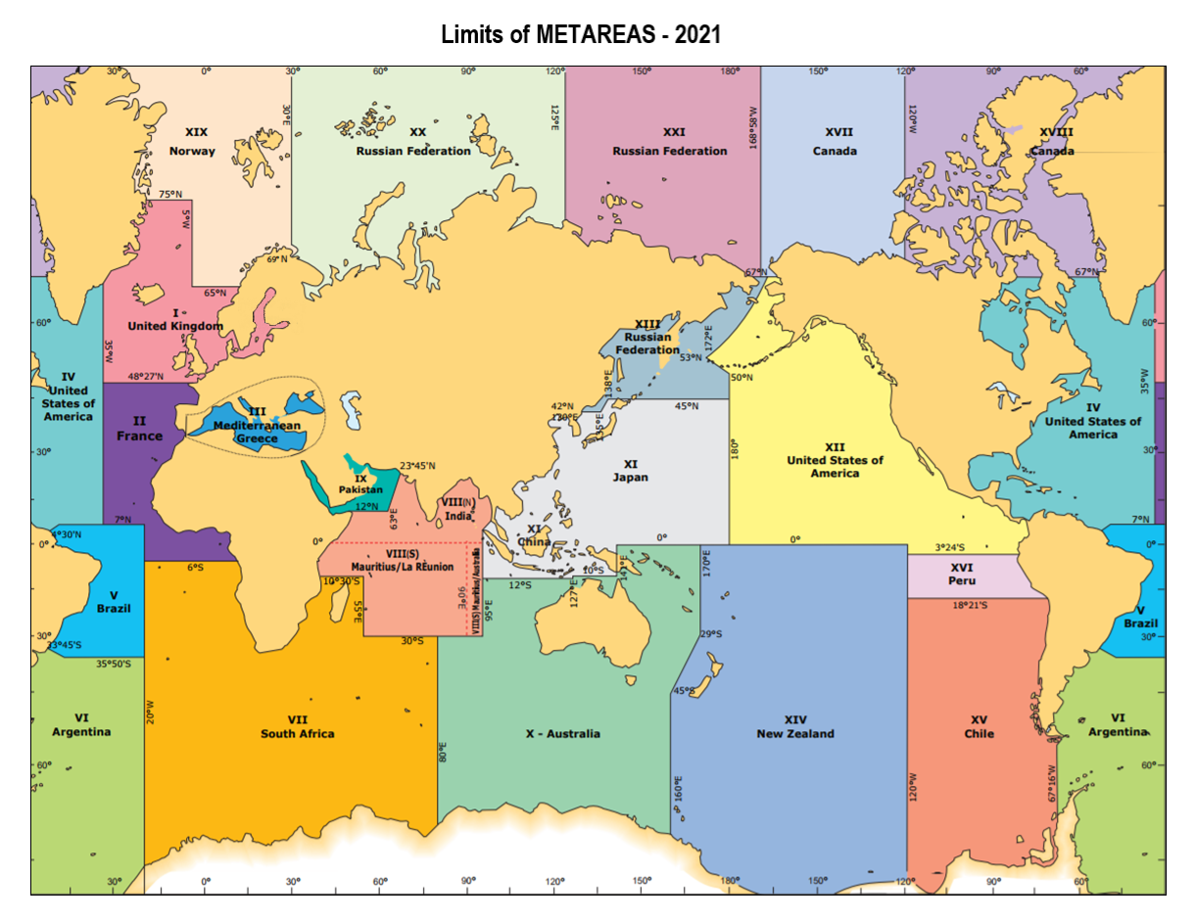
Figure 2.1 Limit of METAREAS (since 2018) (WMO 2018a) for provision of Maritime Safety Information.

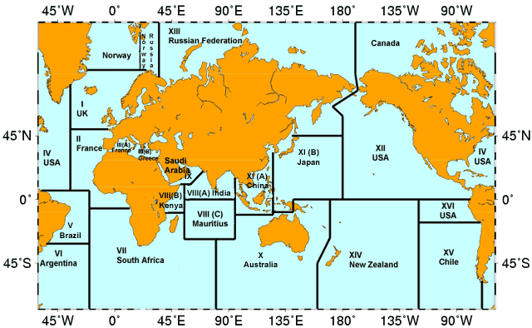
Figure 2.2: Area Meteorological and Oceanographic Coordinator (AMOC) zones, for provision of metocean information in support of marine pollution incidents. These are closely matched to the METAREA zones.
The provision of metocean support to maritime safety will not be further addressed in this report, and the reader is referred to relevant WMO guidelines and manuals: in particular, WMO (2018a), WMO (2018b), WMO (2018c), WMO (2021).

Section 2.1 gives a general overview of the methods and tools for predicting the drift of objects and substances in the ocean. It will be shown that the methods used are based on operational numerical modelling systems and can, to a large degree, be identical for a wide range of objects. Thereafter, Sections 2.2 – 2.4 describe the models and services specifically applicable for predicting the drift and fate of three important classes of marine emergency: spills of oil and other noxious substances; drifting objects (including Search and Rescue(SAR)); and radionuclide discharges.

Section 2.1: Common Aspects of Emergency Response Systems
In this section, we will first give an overview of the purpose and function of a Marine Emergency Response system. Thereafter, we will look at the elements of an operational prediction system, including a description of models used to estimate the drift and fate of objects and substances, and the sources of the metocean input data required to drive them. More specific information on, and examples of, support systems for the marine emergencies selected for this report, i.e. spread of radioactivity, oil spills and drifting objects, follows in Sections 2.2 – 2.4.

2.1.1 Basics of Marine Emergency Response

The authorities in charge of responding to maritime emergencies are required to make timely decisions about the deployment of critical and limited resources mitigating the emergency. Key inputs into the responding authority’s decision-making are drift and fate predictions, and on-scene operational conditions. The drift and fate predictions will need to be from the earliest possible start of the emergency up through to the departure of the next round of the response resources. The on-scene oceanographic and meteorological conditions in support of operations cover the period of the response resources getting to the on-scene, operations, and return from the operations to a safe base. Each emergency will have its own timeline that will dictate the hindcast, nowcast, and forecast periods of the drift and fate predictions. The type of emergency and the associated response resources will dictate the need for on-scene condition information. As the emergence unfolds, the response authorities will need the predictions and on-scene conditions updated in a timely manner.
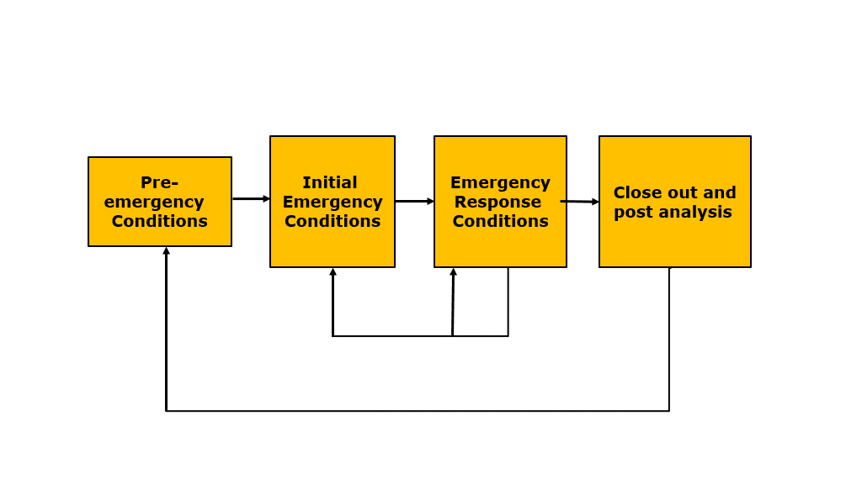
Figure 2.1.1: The emergency timeline

Marine emergencies share a common timeline. There are four phases in the timeline: pre-emergency conditions; the initial event conditions, the conditions during the response period, and the conclusion and post-event analysis, as illustrated in Figure 2.1.1. The pre-emergency conditions cover the events and conditions leading up to the actual emergency event. These are typically the root causes of the marine emergency which may include but are not limited to: extreme weather and waves, reduced visibility, shoals and currents, icing on superstructures, heavy vessel traffic, mechanical fatigue or failure, inadequate fail-safe design, human fatigue, and faulty decision-making. The initial event conditions include the probable area where the emergency occurred; the time period when the emergency might have occurred or is occurring, and the type and quantity of material or objects involve in the emergency. The conditions during the response period include the drift trajectories and fate of the material or objects from the initial probability area and time period up and through the end of the next response epoch. Also required by the response agencies for their operations are the on-scene conditions and constraints. As the response operations continue, the initial conditions are likely to be updated and refined; the next sequence of responses defined and implemented until the final stage of the timeline is obtained; the conclusion. Active migration response measures are either terminated or evolve into long-term lower-level efforts. At this point, post-event analysis maybe conducted to determine the root cause of the emergency and evaluate the response effort with the goal of lessoning the change of these type of emergency happening again or improving methods to deal with such an emergency.

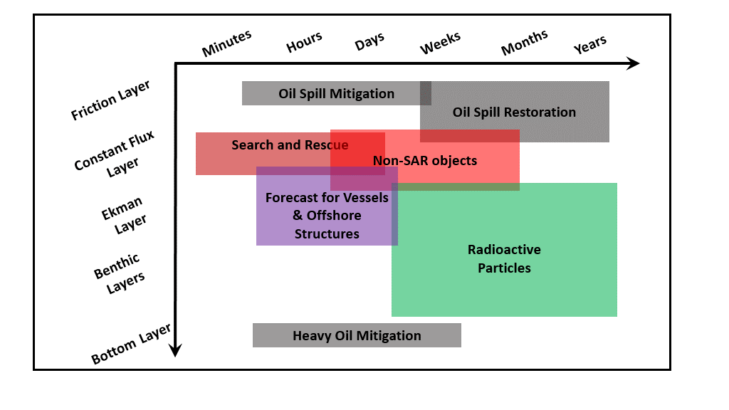
Figure 2.1.2: The relevant time and depth scales associated with various marine emergencies.

While the components of responding to marine emergencies are complicated, these can be broken down into two key aspects: one, accurate estimates of the oceanographic and meteorological conditions and two, the drift and fate model specific to the type of emergency. The latter aspect is unique to each type of emergency response, e.g. leeway tables in SAR or oil weathering or radioactive decay of radionuclides, and these will be addressed in specific sections. The former aspect, about quality estimates of meteorological and oceanographic conditions, is required for all Marine Emergency Response. It is important to keep in mind that different emergencies will require data on different spatial and temporal scales. An illustration of the relevant time and depth scales associated with various marine emergencies are shown in Figure 2.1.2. Note the spatial extent of the required data will be linearly related to the relevant temporal scales. Oil spill mitigation and restorations typically are confined the friction layer, while their timescales can range from half hour for the response to years for the restoration efforts. In contrast, the mitigation of heavy oil that sinks to the bottom is confined to the bottom boundary layer. SAR survivors and survivor craft occupy the constant flux layer of the ocean. SAR has the most immediate response timescales of minutes, but can extend out to days, but are limited by survivability. Non-SAR objects (e.g. shipping containers or their contents) can extend deeper than SAR objects and may require longer response or forecast times. Extreme weather and weather forecasts for vessels must represent conditions on the sea-surface and the lower part of the atmospheric boundary layer (also known as the constant flux layer) and the ocean wave zone, while offshore structures will need forecasts that extend deeper into the ocean mixed layer (the Ekman layer) and in shallow waters down to the benthic zones directly above the bottom boundary layer. At the longer, deeper end of the response and forecast scales are the transport of the radioactive particles and dissolved nuclides.

2.1.2 Provision of Metocean Information for Emergency Response
The success of responding to marine emergencies is strongly dependent on accurate knowledge of the meteorological and oceanographic conditions, with the spatial and temporal extent dictated by the nature of the emergency. This requires systems in place that can provide this information in a timely manner to the agencies responsible for Marine Emergency Response. The primary means for estimating meteorological and oceanographic conditions for short-term forecasts are operational prediction systems which are numerical models that can be used to predict conditions typically up to 2 to 10 days into the future. For near real-time conditions, there can also exist data-driven models in regions where sufficient observations exist, for example if the emergency is near a weather station or coastal high-resolution radar (HF radar). Finally, if the emergency extends well beyond synoptic scales, for example in the case of radioactivity, then climatology can be used to provide long-term forecasts.

2.1.2.1 Operational prediction systems

WMO Members are able to provide, both through own production and/or collaboration across the community, the kinds of observations and predictions that can support the emergency response. In particular, the NMHS network collects near real-time observations and runs operational numerical prediction models of the ocean and atmosphere ranging from local to regional up to global scales. These models are operational in the sense that they are run regularly (daily or more often) with sufficient support to handle outages and ensure that forecasts are publicly available within a specified time frame. Importantly, the outputs from the models, as well as the observational data, can be provided to users in standard formats and using accepted standards for data exchange.
There are typically three model types used to describe the metocean conditions for MEER and SAR: numerical weather prediction (NWP) models that provide meteorological conditions, ocean circulation models that provide ocean conditions such as currents, and wave models that provide information about the surface wave field. NWP models produce the basic forcing and boundary condition data for both ocean circulation and wave models. These can be run in a coupled configuration, which allows the models to rapidly exchange information across their shared boundary, or run individually. More specifically, these models provide the geophysical forcing data, i.e. the meteorological and oceanographic data, needed by the drift and fate models.
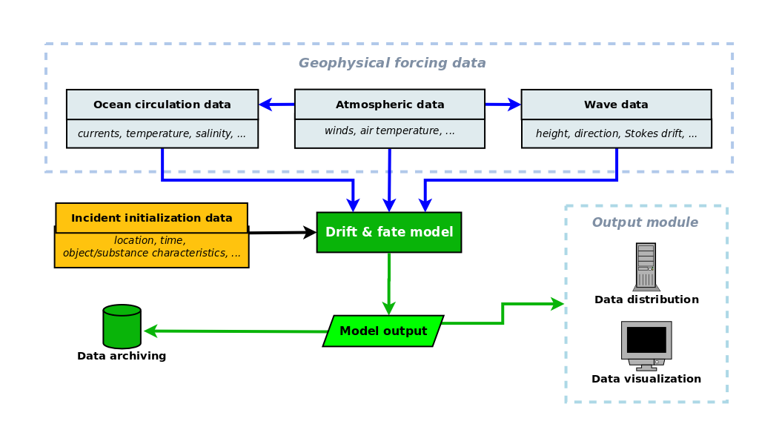
Figure 2.1.3: Schematic of a generic numerical prediction system for the drift and fate of objects and substances in the ocean.
Geophysical forcing data are usually produced by operational numerical models, although observational products and climatologies may be used. The modular concept allows flexibility in configuration of the system. For example, the drift and fate model can be an oil spill model, a radionuclide model, or a drifting object model, without seriously altering the other components and the connecting machinery. The one-to-one scheme is when all model components are run on the same computational facility using proprietary data formats.
Figure 2.1.3 is a conceptual schematic of a generic operational modelling system for drift and fate prediction. It illustrates the relationship between the ocean circulation, wave and NWP models that provide geophysical forcing data and the drift and fate model for a specific object or substance. In addition, it shows the dependence on initial conditions for the emergency incident and the importance of data delivery and archiving. Note that this is a conceptual drawing and that the actual implementation of currently active prediction systems varies greatly. The system elements shown in the figure will be further explored in the following sub-sections.

2.1.2.2 Numerical Weather Prediction (NWP)
Operational NWP data products cover the world ocean from global to very local scales, at horizontal resolutions of hundreds of meters to several kilometres, and on timescales from hours to several days (typically 10). Access to advanced computing facilities, comprehensive observation networks, as well as research-driven technological development, is generally assured by strong public demand. The NWP-related scientific literature and documentation of NWP models is voluminous, and any comprehensive description is beyond the scope of this report. What is important in the present context is that both the ocean circulation and wave models are forced by the NWP fields (winds, pressure, heat fluxes, etc.), especially at synoptic timescales. This is particularly the case for waves. Furthermore, the fate models also depend directly on meteorological parameters, e.g. air temperature for SAR object survival and oil weathering. Therefore, the accuracy of the NWP forcing data is decisive for the accuracy of the other models in the system.

2.1.2.3 Numerical Ocean Circulation Models

Ocean circulation models are also a key component of Marine Emergency Response as they provide all-important surface currents in addition to other important parameters such as sea-surface temperature. In colder climates it is also common to couple a sea-ice model with the ocean circulation model to provide estimates of the sea-ice conditions. There are also key technical details about the application of surface current data in operational oceanography, which are covered in detail by a recent review paper (Röhrs et al., 2021), and will only be touched upon briefly here.

The issue of accuracy is particularly serious for ocean circulation models, in the context of a drift and fate prediction system. As indicated elsewhere, the accuracy of NWP model is fundamental to the system (cf. Section 2.1.2.2). While the wave model predictions are closely driven by the NWP model data (cf. Section 2.1.2.4), there are physical processes in the ocean that can significantly contribute to the total current field. Topographic steering, density gradients with their accompanying instability mechanisms, and tides are processes that modify and generate current components that can match, even overwhelm, the wind-driven current component. What is more, the oceanographic mesoscale, i.e. the scale of eddies and meanders, is barely resolved by current model resolutions and there are few observations that resolve it reliably. These factors explain why the ocean circulation model data are arguably the least accurate of the three geophysical forcing components. This is a serious issue for short-term marine emergency responses, especially SAR and oil spills, which rely heavily on accurate high-resolution surface current predictions.

The use of data assimilation can greatly improve the accuracy of the mean state of the ocean, but there are limits as to how small scales the improvement extends to. It is largely dependent on the resolution of the data that are assimilated as well as the model. Jacobs et al. (2021) demonstrated that assimilation of low-resolution observations will not improve the prediction of mesoscale features even in an eddy-resolving model. It was shown in the Gulf of Mexico that using a spatial filter with an e-folding scale of 58 km on the model surface currents actually reduced the errors in the mean trajectories compared to using the full 1 km resolution model data. As noted above, the variability of these small scales is paramount for emergency response and higher-resolution models and observations are important to replicating this variability. This makes short-term prediction in the ocean a challenge (Christensen et al., 2018).

In the context of coastal response, the models here are predominantly of a limited domain to increase resolution of the coastlines and bathymetry. These often share an open boundary with an operational global model and are forced by high-resolution wind products. These coastal models can be sensitive to uncertainties on the boundaries as well as bathymetry. Some advances have been made to assimilate HF radar data (Breivik and Sætra, 2001; Sperrevik et al., 2015; Hernandez-Lasheras et al., 2021) or two-way nesting in narrow channels (Herzfield and Rizwi, 2019; Ding et al., 2021) to improve the accuracy and resolution in coastal regions. There is some potential with newer high-resolution altimetry products such as SWOT (Carrier et al., 2016) and the wave glider 5 Hz Sea-Surface Height (SSH) product (Penna et al., 2018) that may also lead to constraining more of the small scale variability.
If ocean observations are accessible in near real-time then it is possible to use statistical methods to create short-term predictions on the order of 24 to 48 hours. These have traditionally been developed with HF radar installations (Barrick et al., 2012; Solabarrieta et al., 2021) as these observations provide surface currents on a grid. It is also common to deploy drifters during emergency response operations as these data can be used to “track” the marine emergency, given that their drift characteristics are similar to the object or material one wishes to track. The deployment of these drifters also provides a quick assessment of the numerical model output in the region that can be qualitatively related to the uncertainty in the prediction of the local surface currents.

Tidal currents are another source of current variability, especially in the coastal context, and sometimes have their own inverse model independent of the ocean circulation models (Egbert and Erofeeva, 2002; Carrière et al, 2016). While tidal motion is present in satellite altimetry data, often these signals are small relative to the dynamic sea level height and are often filtered out of the signal. However, since the constituents of the barotropic tide are stationary, many passes can be used to create an inverse model for tidal heights and currents (Egbert and Erofeeva, 2002; Carrière et al, 2016). These models are sensitive to accuracy in coastlines and bathymetry, but once the constituent data are calculated then it is trivial to create a time series for any time period.

2.1.2.4 Numerical Wave Models

Wave models are intimately linked with the meteorological models, but the role of waves in Marine Emergency Response is large and so we will briefly touch on some aspects. Accurate knowledge of the wave field is very important for response operations, whether they be SAR operations or oil spill mitigation, as the wave field greatly influences their safety and success. As pointed out in Section 2.1.2.2, the meteorological forcing from NWP models is dominant for wave models, which means that the accuracy of a wave model is largely determined by the accuracy of the NWP model driving it. This is particularly the case for wind waves, which are very important in the drift and fate models. On the other hand, swell prediction is less dependent on surface winds in a regional wave model, and more dependent on the lateral boundary conditions.

Waves are important for the Lagrangian transport of material as they introduce an extra Lagrangian drift, also known as the Stokes drift, which is dependent on the wave steepness and is typically about 1 to 1.5% of the 10 meter wind speed at the surface and decreases rapidly with depth. This Stokes drift must be added to the Eulerian currents obtained from gridded data products to obtain the Lagrangian velocity. Waves can also directly impact large objects that are similar in scale to the dominant wavelength, such as container ships, either by breaking or by reflection. This is an additional factor to be taken into account for some SAR operations.

Waves, through wave breaking, are also important for the entrainment and vertical mixing of oil and other material that is slightly or neutrally buoyant such as marine plastics (Reisser et al., 2015). This vertical mixing can influence the horizontal transport of oil (Röhrs et al., 2018) due to the high shear near the ocean surface. The time that the material will be below the surface will depend on the balance between the downward turbulent momentum flux from the surface, predominantly through breaking waves, and the positive buoyancy of the material.

2.1.2.5 Data Systems for Maritime Emergency Response

The advent of operational numerical models for ocean circulation and waves, driven by operational meteorological models, led to the first numerical drift trajectory modelling for oil spill and SAR objects. In these early efforts, the drift trajectory module was embedded within the ocean circulation model. The oceanographer(s) responsible for the model ran the trajectory module on request by the response organization, which had provided a rather limited set of initial conditions to the modellers. A slight variation of this one-to-one system was for the modellers to provide in a single specific format the current and wind fields to the response organization’s own trajectory model. In both these schemes the region of drift prediction is limited to the region of the ocean circulation model. Nowcasts and forecasts are limited to the capabilities of the models, and hindcasts are also limited by in-house archive capabilities. The one-to-one scheme of model data delivery is illustrated in Figure 2.1.3.
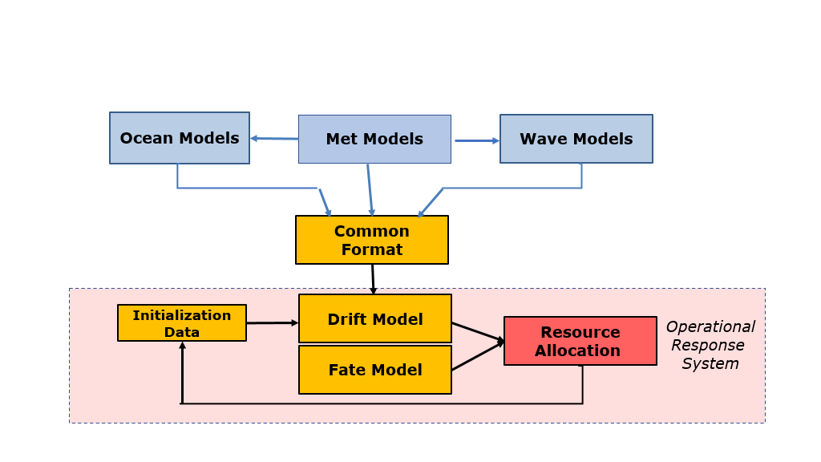
Figure 2.1.4: Schematic of a numerical drift and fate prediction system with the drift and fate model(s) independent of the geophysical forcing data. The latter must be delivered in a specified format.

With the increase in the availability of operational oceanographic models, a second scheme was implemented. In this scheme, the trajectory and fate models are run independently of the oceanographic and meteorological models. However, those input models must provide their outputs to the trajectory and fate model in a specified format, e.g. GNOME Data Formats (https://cordc.ucsd.edu/projects/mapping/documents/GNOME_data_formats.pdf), or a limited set of formats as illustrated in Figure 2.1.4. In this scheme the number of regions accessible by the operational fate and trajectory model has increased over the one-to-one scheme. However, the hindcasts, nowcasts, and forecasts are still limited to the capabilities of the oceanographic and meteorological models.
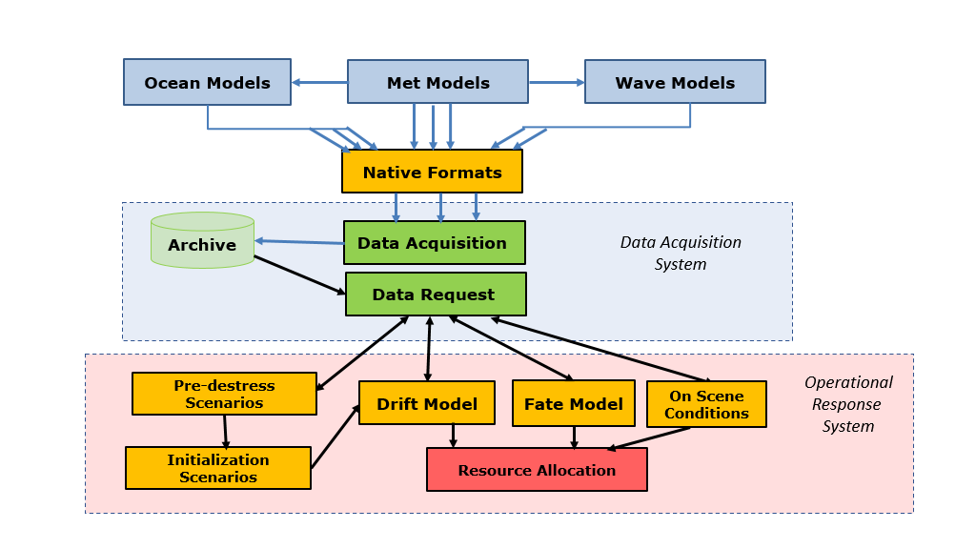
Figure 2.1.5: Schematic of a numerical drift and fate prediction system with the drift and fate model(s) independent of the geophysical forcing data
The latter are here managed by a Data Acquisition System that maintains an updated data repository that is always ready to deliver forecast and hindcast data to the drift and fate model(s).

A third scheme was developed to address the shortcomings of the above two schemes. In this scheme there is a data accessing, archiving and retrieval system that is completely independent of both the oceanographic and meteorological models and the fate and trajectory models, as illustrated in Figure 2.1.5. The output files of the oceanographic and meteorological models are accessed in their native formats on the models’ schedules, where the nowcast fields are archived and the most recent forecast fields overwrite the current forecast field. Therefore, the necessary wind and current fields are archived not by the producers but by this data acquisition system. The operational fate and trajectory model, and if available the pre-distress model, then make data requests to the data acquisition system for a specified data cube (product type / latitude-longitude box / time period). The data acquisition system then returns only data in the fate and trajectory models’ format for the specified data cube. The on-scene conditions and some pre-distress modules make requests for time series from a specified location.

More recently, the increasing implementation of internationally accepted protocols for data access, governance and documentation in the atmospheric and oceanographic communities is making more geophysical forcing data available. These protocols attempt to enforce the FAIR principles: FAIR data are data that are Findable, Accessible, Interoperable, and Reusable (Wilkinson et al., 2016). The basic premise of FAIR data is making data easily accessible and increasingly useful to more users, anywhere. In tandem with this development, several national, regional and global production centres for meteorological and oceanographic data have matured into efficient public data services and are actively implementing data policies and data management facilities following the FAIR principles. A relevant example is the WMO Information System (WIS 2.0; https://community.wmo.int/activity-areas/wis/wis2-implementation) for operational meteorological and wave data provided by the Regional Specialized Meteorological Centres (RSMC) network; inclusion of global numerical ocean prediction products is under consideration. For operational ocean circulation and wave data, examples include the Copernicus Marine and Environmental Monitoring Service (https://marine.copernicus.eu) and some participants in the OceanPredict collaboration (https://www.godae-oceanview.org/science/ocean-forecasting-systems/system-descriptions). In terms of the data flow schemes shown in Figures 2.1.4 and 2.1.5, these services represent alternative sources of geophysical forcing data that can deliver data to local repositories and, in many cases, allow streaming of data cubes on request, thereby reducing the need for storing large amounts of data locally.

2.1.3 Operational Transport models – Fate and Drift Behaviour

A numerical approach is also applied to the operational prediction of the drift and fate of substances and objects in the ocean. These models are formulated for a specific class of substances or objects, but all are dependent on input data that describe the meteorological and oceanographic conditions, i.e. geophysical forcing data. In contrast to operational ocean and weather prediction models, operational transport models are typically run on demand in response to a specific request. Furthermore, these prediction models are often run by private or other public providers within the relevant sectors, e.g. offshore oil industry, coast guard. These models typically can be run both forwards in time, to produce forecasts for remedial action, and backwards in time, in order to be able to predict the source of a marine emergency.

Originally, operational transport models used a very limited (1–11) number of simulated particles to represent the oil or SAR objects. About each particle, a circle of uncertainty was assigned, that grew either with time or either path-line or straight-line distance from the origin. Then the circled area was boxed, and this was the response location. These methods contained numerous simplifications that included: constant or uniform currents or winds, one type of drift object or oil, no fate modelling, and limited resource optimization procedures. However, these methods could be implemented by using historical or simple environmental information with basic manual navigational tools on paper navigational charts. With the development of personal computers, these ‘manual’ methods were then programmed with the use of electronic charts.

By far the most common method for fate and drift behaviour is based on the Lagrangian Particle Tracking (LPT) model (van Sebille et al, 2018, Dagestad et al, 2018), also referred to as the Monte Carlo method. This type of model assumes that the material can be decomposed into several hundred to thousands of particles, or in the cases of SAR they represent a decomposition of the probability of the search object. These particles are then advected from their individual points and time of origin using the best estimates for the currents, winds and waves to the time of interest. The best estimate meteorological and oceanographic parameters are interpolated to the particle location and time. There are inevitable errors associated with the interpolation, with the errors depending on the scale of the input data grid. This error is especially large in coastal areas, depending on the accuracy and resolution of the coastline in the prediction system. Also, the choice of advection scheme for the particle can introduce uncertainties; the most popular choice, due to it being robust and producing a small error, is the Runge-Kutta fourth order scheme (Nordam and Duran, 2020).

It is also straightforward to add a stochastic component to the motion of each particle (Griffa, 1996) to simulate sub-grid dispersion and other model uncertainties. A “random walk” method with constant diffusivity is the most common method to simulate small scale dispersion, but higher order stochastic methods, such as the “random flight” model, can also be used. Both models add a stochastic component at each advection time step.

There is another Lagrangian method in which the trajectories are calculated along streamlines, which are the instantaneous velocity contours, rather than along path-lines. Examples of this type of LPT are ARIANE (Blanke and Raynaud, 1997) and TRACMASS (Döös et al., 2013). This approach is designed to work efficiently with model output on a C-grid and is not reliant on interpolation or advection schemes as it analytically calculates the particle trajectory across grid cells. Using streamlines assumes steady state, or at least piece-wise steady state, and the trajectories are calculated for each model output. This method also requires the full 3-dimensional non-divergent velocity field and any surface divergence, which is common in the ocean, can lead to a large vertical component of the streamline. This approach also complicates the addition of any component that can lead to divergence, such as the addition of a leeway component or stochastic diffusion. Due to these constraints, these streamline advection models are not typically used operationally for short-term predictions but remain useful if larger scale predictions are required.

In addition to the two Lagrangian approaches, a Eulerian approach, which calculates the advection-diffusion equation for a tracer concentration (Ivorra et al., 2021), is also sometimes employed. Eulerian transport models are well-suited for simulations over long periods where diffusion would require Lagrangian transport models to have a prohibitive number of particles. Eulerian transport models also suffer from excessive numerical diffusion, especially at the slick edges, although recent advances are addressing this shortcoming (Ivorra et al., 2021).

2.1.4 Expected developments for improved services

In the preceding sub-sections, the current best practices in constructing operational prediction systems for the drift and fate of objects and substances in the ocean have been presented. The focus has been on the elements common to systems specialized for oil spills, drifting objects and radionuclide dispersion: geophysical forcing data and the models that produce them, and transport models that estimate how the objects and substances move, spread and diffuse. It has been shown that there are well-established models and services that can be deployed and utilized by new actors and for new classes of objects and substances. The current section presents some important developments that aim to improve the efficiency of prediction services and the quality of their products.

1. Improved ocean circulation forcing data. Improving the accuracy of the ocean circulation models is undoubtedly the single factor that would most improve the quality of any transport modelling system. This is a major area of oceanographic research and development that is actively being pursued around the world. It encompasses not only model development, but also the deployment and maintenance of observation systems and development of the data assimilation schemes that tie them together. As such, it cannot be carried forward solely by services providing predictions of the drift and fate of objects and substances. Those services can, in principle, find the best available ocean circulation data for their particular area from a variety of sources, from global models to near coastal models – most often in nested combination. In practise, however, individual operational services will continue to rely primarily on their established sources of forcing data, for reasons of reliability. Use of other forcing datasets will provide an alternative or supplement to their nominal forcing datasets.

2. Multinational collaboration for model development. Since the development of numerical model codes and data assimilation schemes is very demanding, not only for ocean circulation but also for the atmosphere, waves and transport, the development of open community model codes supported by distributed development groups has become well-established. Several of the model codes have been mentioned above. This is especially advantageous in the context of the deployment drift and fate prediction systems in developing maritime nations. An important requirement for model development is the identification of benchmark tests and cases. In the present context, it is especially valuable to establish a few well-described real cases for which geophysical forcing and verification data are readily available.

3. Access to geophysical forcing data. If alternative forcing data are to provide a viable supplement, then they must be readily available with reasonable reliability. Suitable technological solutions for data access and transfer are available (ftp, OpENDAP, API, etc.) and a growing number of data providers are making their operational data accessible online and through machine-machine interfaces, e.g. WIS 2.0. It is now possible to download data from numerical prediction models for the atmosphere, waves and the ocean for any part of the world ocean, freely. There is a caveat: mixing ocean circulation, wave and meteorological datasets from different sources can result in inconsistent forcing data; consistent data are where the meteorological data applied are the same as were used to force the wave and ocean circulation models. The lack of consistency is a source of uncertainty in the drift prediction that is difficult to estimate.

Overall, the availability of useful geophysical forcing data is improving and is making it more and more possible to implement drift and fate services in new areas as well as to improve existing services. Still, for many emergency responders and NHMSs, operationally reliable provision of geophysical forcing data through an RSMC type of network would be beneficial.

4. Uncertainty information. The accuracy estimate of drift and fate predictions is potentially useful for responders, but difficult for the producers to provide. For one thing, it is hard to quantify the accuracy in numbers, whether they come from a theoretical combination of the accuracies of the forcing data or from direct comparisons of model predictions and drift observations in real events. For another, it is a challenge to convey the uncertainty information to the users in an effective manner.

A commonly used approach to the problem is the use of ensemble prediction methods, wherein several different but equally realistic simulations of the same situation are run. The distribution of the results gives information about the most probable prediction and about its uncertainty; a narrow distribution indicates higher certainty than a wider distribution. In NWP, wave and ocean circulation forecasting, two avenues of implementation are currently being pursued:
(a) Ensembles generated by the same model using various perturbations of the model system (initial conditions, boundary conditions, model parameters, etc.). Typically, 30–100 ensemble members are run in order to attain sufficient statistical significance. Consequently, this type of ensemble is computationally expensive, and the ensemble production is usually performed at somewhat lower resolution than the main deterministic model run.

(b) Multi-model Ensemble (MME) methods attempt to combine simulations run with different model codes, usually by collating output from several existing prediction systems that cover the same area. The number of ensemble members is much smaller (<10), so the focus is more on qualitative assessment of differences rather than statistical uncertainty. The computational cost is less than for the first type, and it is distributed.

Ensemble methods of the first type have been in use in NWP for several years. More recently, they have trickled down to wave and ocean circulation prediction. Even so, it is still a challenge to translate the probabilities into readily understandable information for users.

5. Ocean surface data. The response to most marine emergency incidents is focused on the ocean surface or the near-surface layer (approximately, the uppermost meter). Many ocean circulation modelling systems do not provide data calculated specifically for that layer. Typically, an average over the upper few meters is calculated, either a fixed interval over the whole model area or an interval that varies with the bottom depth. In some model formulations, the average over a time-varying upper layer thickness is calculated. The drift and fate models for MEER and SAR are dependent on accurate knowledge of the near-surface layer, preferably with a finely resolved profile of the currents. Lacking such data from the numerical ocean model output, the near-surface variables can be determined by post-processing the model output, using a priori assumptions about the distribution of the variables in the upper model layer. Such calculations can be done in the transport model or prior to ingestion in the transport model. The major providers of global and regional circulation data should be encouraged to provide near-surface data and/or provide best-practise algorithms for calculating near-surface profiles.

Section 2.2: Spills of oil and other noxious substances
Noxious and hazardous substances are here defined as substances that are potentially harmful to persons or to the marine environment. They may be both naturally occurring (e.g. petroleum) or man-made (e.g. polychlorinated biphenyls, PCBs). Substances can be noxious either due to their toxic chemical characteristics or due to the extreme concentrations that occur when they are spilled into the ocean. Accidents involving petroleum products, both raw and refined oil, have received the most attention in the context of damaging spill incidents, and procedures for emergency response have been developed primarily for oil spills. Models for the drift and fate of oil in the ocean and the prediction systems built around them are described in this Section.

The lessons learned from developing and applying oil spill drift and fate prediction tools have encouraged the application of those tools to other noxious substances, such as sewage. It should be noted that the distinction between noxious substances described here and drifting objects described in Section 2.3 is not always sharp; for example, some drifting objects, such as plastics, may be considered noxious. In the present context, however, the distinction is based on what tools are deemed most applicable. Spilled fluids and very small objects, such as ash, would typically be handled with oil spill type tools, while larger floating objects, whose individual drift characteristics can be estimated, could be handled by drifting object methods (cf. Section 2.3).

As indicated above, the present Section will deal almost exclusively with oil spill response methods, keeping in mind that they serve as a model for other noxious substances.

2.2.1 Background

Spills of oil on the ocean have occurred since the advent of industrial activities which have led to the building of major facilities along the coast (e.g. refineries), at sea (e.g. offshore oil platforms) and maritime transport. The need for remedial response arose already in the 1960s and 1970s after major oil spills in connection with the boom in tanker transport and offshore oil production. Public concerns about the environmental damage to coastlines, the seabed and wildlife from major oil spills (for example, Torrey Canyon in 1967, the Ekofisk Bravo blowout in 1977 and Amoco Cadiz in 1978) led to the development of emergency response capabilities in the major industrialized maritime countries.

However, ever larger tankers put into service, new oil fields opening, and pipelines laid on the seabed have increased the spill risk. Severe oil spill incidents occurred in the late 1980s: Odyssey in 1988, Exxon Valdez in 1989, Khark 5 in 1989, and ABT Summer 1991. (In 1991, one of the largest oil spills took place in the Persian Gulf during Gulf War II.) Those spill incidents led to the International Convention on Oil Pollution Preparedness, Response and Cooperation (OPRC) of IMO. The parties are required to establish measures for dealing with pollution incidents, either nationally or in cooperation with other countries. Even though the number of spill incidents is decreasing, huge spills still happen occasionally, such as the Prestige wreck in 2002, the Deepwater Horizon oil spill in 2010 and the Sanchi oil tanker collision in 2018. The MV Wakashio oil spill in 2020, in which great environmental damage occurred in Mauritius, is a recent case which was outlined Daniel and Virasami 2021, and explains well the various actors involved in responding to such an emergency. In 2019, Grande America container vessel travelling between Hamburg and Casablanca that caught fire and capsized, led to both oil slicks, and hazardous chemical substances in the ocean, and similarly, several meteorological services were involved in providing information to the response authorities. Most recently, the Tongan volcanic eruption in January 2022 demonstrated a cascading impact of multi-hazards from the initial eruption, triggering a basin wide tsunami wave across the Pacific Ocean, where waves approaching the Peru coast damaged an oil facility, leading to an oil spill.

Although such large spills result in serious damage to the local environment, they do not occur often. In reality, most spill cases involve small amounts of oil and they occur frequently (almost daily). Although the amount of each spill is rather small, the total amount and the cumulative impact on the affected areas are significant, especially in heavily trafficked areas. It is difficult to detect small spills, which makes the response and building reliable statistics difficult.

The response to oil spill incidents includes: the discovery, monitoring and assessment of the spill; procurement and deployment of equipment to reduce the scope of the spill (e.g. physical restraints, chemical treatment); remedial actions like the clean-up of coastlines, bottom sediments and wildlife; and legal and financial repercussions.

From the outset, prediction of the drift of substances spilled in the ocean has been based on local knowledge of currents, wind and wave conditions, tidal charts and static current charts, as available. In many countries, this is, in reality, still the case. Over the last few decades, more sophisticated prediction systems have been developed, first in the major industrialized coastal countries. As described in Section 2.1, these systems are based on numerical models that utilize available numerical forecasts of winds, currents and waves to calculate the likely drift and spreading of a spilled substance.

From a handful of pioneering services in the 1980s, there are today public service oil spill forecasting services in operation in most of the developed maritime countries and more are under development. Since nation-states are responsible for the protection of their coasts and of resources in their exclusive economic zones, oil spill forecasting is primarily implemented as a national public service. Regional or other trans-boundary services are feasible and are being actively explored, e.g. MPERSS and regional examples presented in Section 2.2.2.1 below. However, actively operational services for public good at the global scale are few: for example, MétéoFrance is running one. On the other hand, there are a number of commercial providers delivering special services to, for example, oil companies, and some have an international scope (see Hackett et al., 2009, for an example).

2.2.2 Review of existing capabilities

There are two approaches for oil spill models, namely Eulerian and Lagrangian models. The first type calculates the behaviour of oil slicks using an advection-diffusion equation for a tracer concentration on a finite difference model grid. The second type supposes oil slicks represented by a large number of particles and calculates the behaviour of the particles. Most oil spill simulation models use the LPT model, since it is more cost-effective than the Eulerian model.

Oil spills in the ocean are governed by very wide variety of processes: advection, spreading, diffusion, vertical mixing, evaporation, emulsification, dispersion, oil dissolution, photo-oxidation, biodegradation and so on. In oil spill modelling, it is difficult to include all of those processes and usually only the dominant processes are considered. The process selection depends on the target situation and local requirements, but advection, spreading, diffusion, evaporation and emulsification are considered essential in most oil spill drift and fate models.

The physical processes determining the evolution of oil in the ocean, including advection, diffusion and vertical mixing, are basically in common with other drifting substances and objects; these processes and how they are implemented in drift and fate modelling are described in Section 2.1.2.

Oil-specific processes are handled in the oil drift and fate model. Spreading is based on Fay’s three-phase theory (Fay, 1971), but is often modified to include other factors, like shear diffusion, in recent models. Evaporation, emulsification and other weathering processes depend on the characteristics of the oil and can vary strongly between oil types. There are several ways to estimate evaporation, from empirical bulk formula (e.g. Stiver and Mackay, 1984; Fingas, 2015) to complicated pseudo-component models (e.g. Jones, 1997). Emulsification, especially water-in-oil emulsion, drastically changes oil characteristics which, in turn, impacts removal operations.

Much effort has been dedicated to oil spill model development, and state-of-the-art oil spill modelling systems are able to simulate the basic behaviour of oil slicks to a quite satisfactory level. However, there is still room for further improvement on specific processes. For a comprehensive overview of the science and technology of marine oil spills, the reader is referred to Fingas (2017) and Davidson et al. (2008). For a more detailed overview of oil spill modelling and prediction systems (including their histories), see for example Spaulding (1988), Reed et al. (1999), Hackett et al. (2006), Jones et al (2016), Zodiatis et al. (2017), and Keramea et al. (2021).

In oil spill models, oil slicks are expressed as passive tracers, the movement is basically dependent on physical environment conditions. As discussed in Section 2.1.2, the geophysical forcing data, which are provided by numerical models for the atmosphere, ocean circulation and waves, are key factors for the accuracy of oil spill simulations. Therefore, improvement of those models – in particular ocean circulation model (cf. section 2.1.2.3) – is crucial in advancing the skill of oil spill drift and fate predictions.

The model setting and performance are also dependent on the target. If a large oil spill incident occurs offshore, a wider region is required for the simulation, so that all potentially affected areas will be included. It will also require long-range predictions, including chemical weathering. On the other hand, a limited area could be sufficient for minor spills, although high-resolution detailed information will be required. In this case, weathering processes might even be unnecessary if remedial action can be carried out quickly.

As noted in Section 2.1, the numerical models for the geophysical forcing produce data that contain errors, which in turn propagate into the results of the oil drift and fate model, which also has its own inaccuracies. For the emergency responders, information about the uncertainties in the predictions can be valuable. The use of ensemble prediction methods is one approach that is gaining traction in modern oil spill prediction.

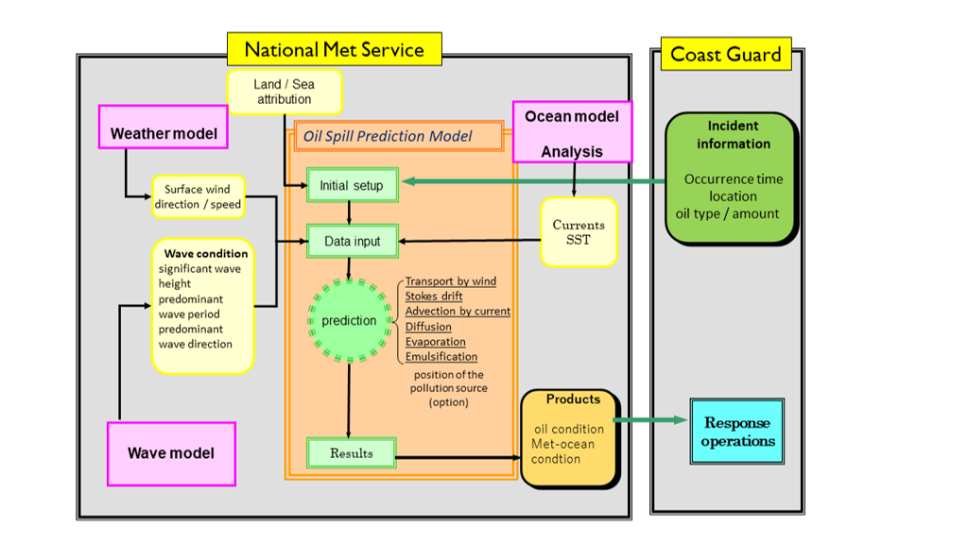
Figure 2.2.1: Outline of an oil spill prediction operation exemplified by the system at JMA.

A typical oil spill prediction operation is indicated in Figure 2.2.1. Once an oil spill incident is reported, relevant information about the spill necessary for initializing the oil spill model is acquired or estimated. The oil spill prediction is then conducted with the available input data, and the predicted results are provided to the disaster response authorities.

Spill characteristics vary from incident to incident, i.e. the amount of oil, whether it is a simultaneous or continuous spill, and the location (sea-surface, deep water, fixed point, floating vessel, etc.). How to set the initial conditions is dependent on the system and the information provided. As for monitoring, oil slicks have long been detected and tracked from aircraft and ships. In the last couple of decades, satellite-based Synthetic Aperture Radar has proven to be a powerful tool for analysing the spill situation, and the results can be used as input in some advanced oil spill models (Klemas 2010; Zodiatis et al. 2012).

Rapid and reliable access to the required forcing data is essential for an operational oil spill prediction system, so it is common that such systems are run by NMHSs, or a close affiliate, using in-house operational forcing data. On the other hand, over the past decade it has become easier for anyone to access candidate geophysical forcing datasets over the internet, due to improved technology and a trend toward less restrictive data policy (cf. Section 2.1.2.5).

At the start and end of the production chain is the important task of communication with responders and other users, including dissemination of results. In most national services this is tasked to a team of duty operators with 24/7/365 availability. They run the forecast models, deliver results to users in agreed forms and consult with in-house experts for interpretation and advisories. In some cases, users are offered a web-based online service so that they can perform their own simulations and download results directly to, for instance, their onboard ECDIS.

2.2.2.1 Multinational efforts on oil spill monitoring and forecasting

Best practices of coordination and integration at multinational level have been developed in several regional seas for supporting the management of oil spill forecasting. Here follow some currently active examples, although not an exhaustive list:

North Sea
In the North Sea area, the Northwest Shelf Operational Oceanography System (NOOS; http://noos.cc) – a regional alliance – is working to develop and employ best practices among the national oil spill forecasting services. As an example, the Swedish oil drift forecasting system Seatrack Web (STW; Ambjorn, 2007) covers the needs of not only national users but also international users in the Baltic Sea and a part of the North Sea. It is the official HELCOM drift model/forecasting and hindcasting system which is used for calculating the fate of oil spills. It is available online for national authorities and certain research organizations. A further example is the OSERIT (Oil Spill Evaluation and Response Integrated Tool, Legrand and Duliere, 2014), first developed in Belgium, which is now serving the needs of EMSA-CSN (European Maritime Safety Agency – CleanSeaNet) in the North Sea. NOOS-Drift is a transnational MME system that can produce drift forecasts on demand. It enables improving the end-users’ trust in the drift model results and helps guide them in their decision-making process, a real need expressed by users. NOOS-Drift includes a set of quantified indicators for drift trajectory accuracy, estimated from the spread of the participating drift model forecasts. It helps to discriminate which differences are due to different trajectory models and which are due to different forcing data. It benefits from operational oceanographic forecasts provided by the Copernicus Marine Environmental Monitoring Service (CMEMS). The service domain is the whole European Northwest Shelf Seas, with a focus on the territorial waters and exclusive economic zones of Belgium, France and Norway.

Mediterranean Sea
In the Mediterranean Sea the MONGOOS (Mediterranean Oceanography Network for Global Ocean Observing System (GOOS)) operational oceanography community and NMHSs followed a concept of integration of the existing national meteorological and oceanographic forecasting systems and CMEMS to establish a dedicated online data repository, thereby facilitating access to all these data for their use with well-established oil spill models in the region. A multi-model oil spill prediction service has been set up, known as MEDESS-4MS (Mediterranean Decision Support System for Marine Safety). The MEDESS-4MS (Zodiatis et al., 2016) is also integrated with data from the oil spill monitoring platforms, including the satellites, and offers a range of service scenarios, multi-model data access and interactive capabilities to serve the needs of REMPEC (Regional Marine Pollution Emergency Response Centre for the Mediterranean Sea), EMSA-CSN and national users such as Coast Guards. MEDESS-4MS did not lead to an operational system, but served as a precursor for the development of similar systems such as NOOS-Drift.

Western North Pacific Ocean
In the Western North Pacific, oil spill responses have been mainly conducted by domestic agencies like the Coast Guard in many countries. However, the severe spill case of Nakhodka in 1997 raised awareness of the importance of systematic spill prediction and response. The Japan Coast Guard (JCG) and the Japan Meteorological Agency (JMA) contracted a cooperative framework to enhance the response capacity. JMA developed an oil spill simulation model (JMA, 2002), which provides spill predictions to member countries in the framework of MPERSS too. Once an oil spill is reported, JCG provides accident condition data (location, time, oil type and spilled amount, etc.), and JMA produces spill forecasts. The forecasts are delivered to JCG, along with meteorological and oceanographic conditions to support response activities. During a recent spill incident in 2021, predictions like those shown in Figure 2.2.2 were provided to the JCG. The Nakhodka case was also a trigger for enhancing an international framework: the Northwest Pacific Action Plan (NOWPAP) of the UN Environment Programme (UNEP), whose members are China, Japan, Rep. of Korea, and Russia. In 2000, NOWPAP established the Marine Environment Emergency Preparedness and Response Regional Activity Centre (MERRAC). Its responsibilities include maintaining and updating the contact details for NOWPAP member countries involved in marine pollution prevention and response and recording spill incidents of oil and hazardous and noxious substances.

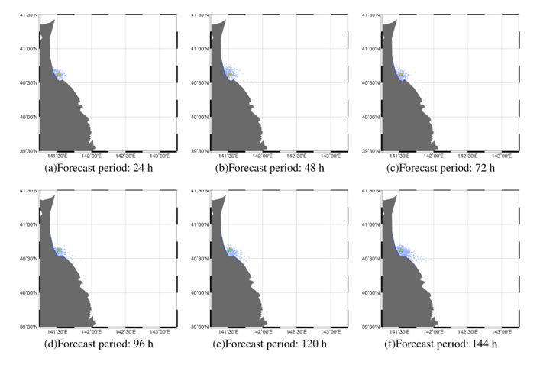
Figure 2.2.2: Example of an oil spill forecast product produced by JMA and delivered to the Japan Coast Guard, which is the responsible response agency.
The oil slick is represented by a cloud of particles (blue dots).

2.2.3 Expected developments for improved services

In the preceding sub-sections, the current best practices in operational oil spill prediction have been presented. It has been shown that there are well-established models and services that can be deployed and utilized by new actors and regions. With reference to the general developments listed in Section 2.1.4, the current section presents some important developments that aim to improve the efficiency of oil spill prediction services and the quality of their products.

1. Multinational collaboration for oil spill model development. Operational oil spill modelling started as a cottage industry that produced proprietary model codes for use in a commercial market. Only in the last decade has collaboration on model development and the development of open – even community – codes made real headway. The development of open community model codes is especially advantageous in the context of deployment of spill models in developing maritime nations. A few collaborative efforts of this type have been established, but there is scope for expanding the development framework.

An important requirement for model development is the identification of benchmark tests and cases. It would be especially valuable to establish a few well-described real oil spill cases for which forcing and validation data are readily available.

2. Multinational collaboration for improved services. The advantage of collaboration between national drift prediction services has already been mentioned in the context of multi-model ensemble forecasting (MME). Beyond the exchange of model outputs, there is potential advantage in collaboration on other links in the production chain. For example, robust exchange of forcing data, initial conditions (detection data), agreed file formats, visualization methods, archiving of test case data, etc.

Another aspect of multinational collaboration is support of development in maritime nations that currently lack adequate spill prediction services of their own. Alternatively, sharing services at regional level is feasible, given the improving access to forcing data and drift model codes, and can be a cost-effective way forward. While all of the world ocean can be covered by global systems run in a few developed countries, the need for detailed information near the coast implies that there is ultimately a need for drift prediction services at local scales in support of local response to emergencies.

3. Specific oil spill model functionalities. Spill fate models have been developed with somewhat different functionalities depending on the most important local requirements. However, there is a movement toward more comprehensive model capabilities. The following is a list of model capabilities that have been seen limited implementation, but that should be made more widely available:
- characteristics of noxious substances other than oil,
- oil in sea-ice,
- coupling of substance drift model to ship drift model,
- subsurface source (and 3-dimensional modelling)
- reinitialization of spill geometry according to observations,
- include tidal currents in areas where available ocean model data do not,
- inverse (backward) calculation option,
- include access to climatological forcing data for long-range (weeks to months) prediction.

4. Standard framework for spill information exchange. Currently, there are no standards for how oil spill information is formatted and exchanged. Schemes vary among national services and regional alliances. The differences may come from specific requirements, but it is desirable to define a common standard that is independent of specific forecasting systems. This can promote cooperation between information providers and users, as well as facilitating collaboration among forecast producers at national, regional and international levels.

2.2.4 Review of user requirements for Metocean information for spills of oil and other noxious substances

User requirements

International organization | IMO
International documentation | INTERNATIONAL CONVENTION RELATING TO INTERVENTION ON THE HIGH SEAS IN CASES OF OIL POLLUTION CAUSALITIES, (1969) and PROTOCOL RELATING TO INTERVENTION ON THE HIGH SEAS IN CASE OF POLLUTION BY SUBSTANCES OTHER THAN OIL (1973) aims to confer power on the Coastal State to intervene on the high seas in the event of a pollution causality threatening to damage, or damaging its coastline or related interests.  http://www.imo.org/en/About/Conventions/ListOfConventions/Pages/International-Convention-Relating-to-Intervention-on-the-High-Seas-in-Cases-of-Oil-Pollution-Casualties.aspx  INTERNATIONAL CONVENTION FOR THE PROTECTION OF POLLUTION FROM SHIPS (MARPOL 73/78) aims to eliminate marine pollution by oil and other harmful substances, and sewage and garbage. Improvement of control of operational discharges of oil and reduction of the amount of oil released through accidents are the most important issues in the Emergency Prevention Preparedness and Response (EPPR)-area. Certain valuable areas are designated MARPOL-Special Areas. The Arctic Area has not yet been designated as such an area.  INTERNATIONAL CONVENTION ON OIL POLLUTION PREPAREDNESS, RESPONSE AND COOPERATION (OPRC 1990) and PROTOCOL ON THE PREPAREDNESS, RESPONSE AND COOPERATION ON POLLUTION INCIDENTS BY HAZARDOUS AND NOXIOUS SUBSTANCES (OPRC-HNS Protocol 2000) cover two of the areas in EPPRs purview but also discusses contingency planning, training and cooperation in research programmes.
Any international coordination boundaries | Nil, deferred to Coastal State.
Responsibility for responding | National
Operational response requirements | Safety and efficiency of clean-up crews, assessment of lifetime for oil to disperse, forecast movement of oil.
How is the incident reported | Ships are responsible for reporting oil spill to the national authority.
How is the response coordinated | The national authority is responsible for initiating their response plan and arranging for metocean information support.

Section 2.3: Accidents related to persons and objects
Accidents involving persons and objects floating and drifting at the ocean surface are handled in a similar manner. Indeed, the targets are often collectively referred to as drifting objects. However, the primary motivation for developing response procedures for drifting objects has always been related to persons, i.e. SAR. Therefore, this Section will deal primarily with SAR response methods. More recently, the lessons learned from developing SAR tools have encouraged the application of those tools to other classes of drifting objects such as floating cargo containers lost at sea.

2.3.1 Background

Introduction to SAR response and modelling

SAR response is primarily concerned with finding maritime survivors and survivors’ craft and saving the survivors. SAR also shares and crossovers with oil spill response with the drift predictions of potentially dangerous floating objects like shipping containers and disabled vessels.
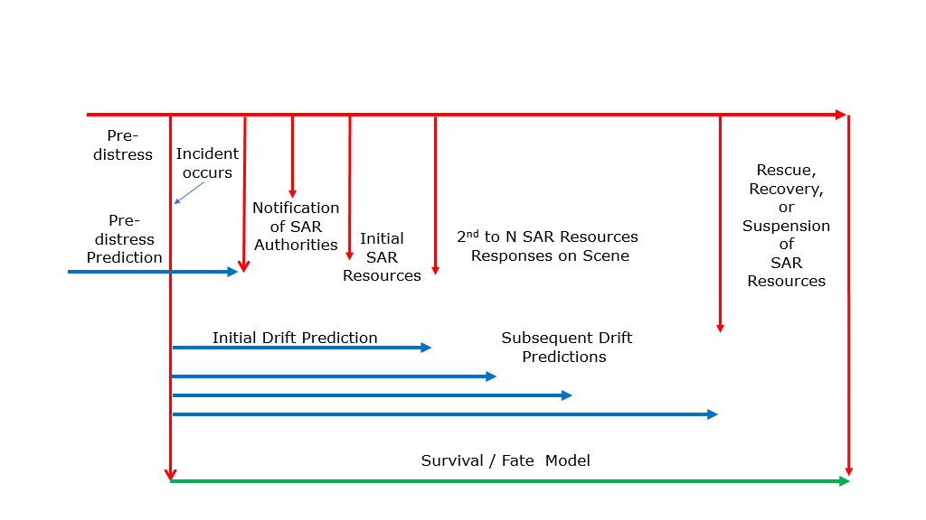
Figure 2.3.1: SAR timeline

The response time of the SAR authorities to enable resources on-scene is the shortest of all the marine emergencies. In Figure 2.3.1 a generalized SAR time is illustrated that contains all the major events of the SAR timeline, ranging from minutes to days (and sometimes longer). However, not every SAR incident contains all these elements, but all contain the time of the incident, notification of SAR authorities, and response by the SAR resources to the incident. Often, the SAR incident is resolved successfully with the initial response and lives are saved. However, there are some SAR incidents that run the full spectrum of the SAR timeline due to some combination of: complex pre-distress motion; uncertainty in the time of incident; significant delays in notification; limited information by third party reporting sources; areas remote from response resources; and hard to detect but favourable survival conditions and craft, that lead to multiple cycles of planning and subsequent search efforts until the case is resolved or suspended.
The initiation of a SAR case begins with notification of the SAR authorities who need to address three primary questions:

- when did the incident occur
- where did the incident occur
- what are number and types of SAR objects?
These three questions combined are the initial conditions or the possible scenarios for a particular SAR case. If the reporting source is from the distress vessel itself, then the uncertainty in when, where, and what can often be very precise or limited. However, with third party reporting sources, there can be considerable uncertainty in the scenario or possible scenarios. There are many scenarios, but most can be captured by a limited set of scenario types. The most fundamental area scenario is a bivariate normal distribution about the last known position (LKP), where the distribution reflects the uncertainty in the position system and any additional uncertainties (e.g. misreporting, time delay). The second basic scenario is a well-formed polygon covered by a uniform distribution (the area scenario). The area scenario works well when the originating craft (e.g. a fishing boat) frequents a known region (e.g. fishing grounds). A voyage scenario is the transit between a series of points (LKPs) or areas with the possible time periods of activity within the areas (e.g. loitering, fishing). Voyages can either be environmentally interactive (influenced by metocean conditions) or not (no direct influence from metocean conditions). Other, more specialized, scenarios are used for flare observations; single or crossing lines from radio direction reporting high-sites; and dead reckoning from an LKP. In these scenarios, there is also uncertainty about the time of incident. Again, if there is direct reporting, this uncertainty is reduced. In other cases, the uncertainty in time can extend from the last know time the vessel was safe up until a notification was delivered by a third party. This can be from hours to a day or more. In some SAR cases, there is uncertainty about the object being searched for: upright or swamped or capsized life-raft or craft, with or without persons-on-board; person-in-the-water (PIW) in a life jacket, survival suit, deceased, or swimming. Environmentally interactive scenarios take into account the impact of the metocean conditions on either the voyage itself, the probability of an originating craft becoming a SAR object, the distribution of an aircraft incident (break-up in flight or loss of fuel leading to controlled gliding), or trajectory modification due to limited propulsion (e.g. an active swimmer or paddler). A voyage scenario mimics the voyage of the originating craft along a series of track-lines from start to end where each track line has uniform probability of turning into the distressed drift object. However, ‘hazards’ can be introduced to increase the probability of generating a distress drift object particle as the originating craft transits the time and location of the hazard. A hazard can either be permanent or temporary. For example, three aircraft scenarios have been prototyped to account for the three principal types of aircraft incidents: a loss-of-control at altitude that generates a LKP distribution as a function of the altitude at incident; a break-up in flight with the scattering of debris by the dynamics and wind field profile to the sea-surface; and an aircraft running out of fuel and gliding on a heading or towards a destination, but affected by the upper-level winds. The last type of interactive scenario is a swimmer (typically scuba or skin diver) in distress who actively swims on a heading towards a destination. The Active Swimmer Scenario has both a swim vector, which is impacted by the waves, plus a current drift vector; it may be reverted to a passive PIW, e.g. at night. All these scenarios require access to metocean data to be implemented.

Once scenarios are provided to the trajectory model and probability drift predictions are returned, the SAR planners can proceed to plan the search efforts of each of the search units. For the first search epoch, a SAR planner is quite capable of planning an optimized search effort for the available resources, accounting for the different capabilities of the search units and their sensors, on-scene conditions, and the search objects that each unit might focus their efforts on. If, however, the initial search effort is unsuccessful, and subsequent search efforts are required, then a SAR planning tool is required to account for the initial unsuccessful search effort and update the probability distribution, which will need a new drift update. In order to plan and account for search effort, environmental data are required based upon which parameters influence the performance of the sensors. These data parameters include, but are not limited to, visibility, precipitation, air and sea-surface temperatures, wind speed, wave height, white capping percentage, sun angle, moon phase and cloud cover.

Not all searches are successful, and the SAR planner must at some point consider whether to continue or suspend the search (“Active Search Suspended Pending Further Developments” or ACTSUS). This decision is a critical juncture for the victims, their families, and the SAR authorities. Predictions of the survivor’s deteriorating physiological condition and future survival time are essential to the SAR planner during the search. The SAR planner uses these predictions to optimize the search resources, and for consideration along with other aspects of the search to make the ACTSUS decision (Turner et al, 2009). Fate models for estimating survival at sea are at the present time limited to physiological heat generation versus heat loss. These hypothermic models of survivability rely on air and sea-surface temperatures, along with wind speed, relative humidity, waves, and solar radiation for the environmental input parameters, and are needed for 5 days beyond the time of the incident (Tipton et al., 2022).

Since the incident has occurred prior to notification, drift predictions will be needed from the earliest possible time up until the next set of resources conclude their search efforts. The drift trajectory model will need the initial conditions, i.e. the scenarios and drift objects, and the projected timeline of the resources.

When the notification of SAR incident comes to the SAR authorities, their immediate goal is to trigger SAR resources as soon as possible, with an initial or preliminary tasking, whether a drift prediction is available and necessary or not. This requires that the turn-around time from the SAR authorities’ request or need for a drift prediction to the delivery of that drift prediction is operationally acceptable to the SAR authorities. Of the three general schemes for data systems (Section 2.1.2) for SAR emergencies, the first or third systems are employed. The one-to-one data system has been and is still widely used to support SAR drift trajectory calculations. The limitation of this approach is that SAR controllers are typically limited in the scope and complexities of the input scenarios.

2.3.2 Review of existing capabilities

In the following, the focus will be primarily on SAR response methods since they are certainly the most comprehensive and well-established and form the basis for treating all other drifting objects. Responses to non-SAR drifting objects are more specific to regions and industries and are not (yet) covered by global frameworks similar to those for SAR. Non-SAR objects are, however, increasingly in the public awareness and more object classes are now being addressed by various response agencies, e.g. cargo containers, plastics, pumice and ash. Non-SAR objects are briefly discussed at the end of this section.

2.3.2.1 Search and Rescue (SAR)

With the advent of high-resolution operational ocean models and the continued improvement of NWP, the potential for making more detailed predictions of the fate of drifting objects has grown tremendously in the past two decades (Breivik et al., 2013). However, although the improved weather forecasts led to better forcing, drift models have remained somewhat impervious to the advances in ocean modelling and numerical weather forecasting. This can perhaps best be understood in light of the large uncertainties in the drift properties of SAR objects as well as the accuracy of the forcing data used.

Firstly, without a proper estimate of the basic drift properties and their associated uncertainties, forecasting the drift and expansion of a search area remains difficult. An important change came when the direct method for measuring the leeway of a drifting object became common practice (Allen and Plourde, 1999; Allen, 2005; Breivik et al., 2011; Hodgins and Mak, 1995; Hodgins and Hodgins, 1998). The direct method measures the object’s motion relative to the ambient water using a current meter. Current meters small enough and flexible enough to be towed or attached directly to a SAR object started to become available in the 1980s, and since then almost all field experiments on SAR objects have employed a direct measurement technique (Allen and Plourde, 1999; Breivik et al., 2011). The direct method, together with a rigorous definition of leeway as the motion of the object induced by wind (10 m reference height) and waves relative to the ambient current (between 0.3 and 1.0 m depth), and finally the decomposition of leeway coefficients in downwind and crosswind components, makes it possible to follow a rigorous procedure for conducting leeway field experiments. See Allen and Plourde (1999); Breivik and Allen (2008); Breivik et al. (2011) for further details.

Secondly, as with oil spill prediction modelling, there is a crucial dependence on the accuracy of the wind and current data. Again, it is the currents that are the least accurate and represent the larger source of uncertainty in the drift predictions. The skill of ocean current forecasting is discussed in more detail in Section 2.1.2.3.

It was not until the 2000s that all the necessary components required for fully stochastic modelling using high-quality drift coefficients and detailed current and wind forecasts were in place. The first operational leeway model to employ the United States Coast Guard (USCG) table of drift coefficients (Allen and Plourde, 1999) with high-resolution ocean model current fields and near-surface wind fields went operational in 2001 (see Hackett et al. 2006; Breivik and Allen 2008; Davidson et al. 2009). The modern era of SAR planning involving the Bayesian posterior updates after the search began in 2007 when USCG launched the Search and Rescue Optimal Planning System (SAROPS), see Kratzke et al. (2010). SAROPS employs an environmental data server that obtains wind and current predictions from a number of sources. It recommends search paths for multiple search units that maximize the increase in probability of detection from an increment of search. As with CASP, it computes Bayesian posterior distributions on object location accounting for unsuccessful search and object motion. Recent developments in the Mediterranean Sea (Coppini et al. 2016) demonstrated the operational capability to support SAR operation through the implementation of the Leeway model with the CMEMS. The service called Ocean-SAR is available for users at the website www.ocean-sar.com.

Although the level of sophistication and detail has grown dramatically in the past two decades, the uncertainties in SAR predictions remain stubbornly high. The fundamental challenge of estimating and forecasting search areas in the presence of large uncertainties remains essentially the same, even though certain error sources have been diminished. The slow progress that has been made over the past decades in reducing the rate of expansion of search areas (perhaps the single best estimate of improvement) is an unavoidable consequence of SAR planning being affected by a variety of errors in the current fields, the wind fields, missing physical processes (e.g. wave effects, see Breivik and Allen 2008; Röhrs et al. 2012), the uncertainty in the LKP and not least from poor estimates of the real drift properties of the object. Indeed, sometimes the type of object may not even be known, effectively making the modelling exercise into an ensemble integration spanning a range of object categories. All these error sources accumulate and make SAR planning as much art as science, where rescuers still often rely as much on their “hunches” as on the output of sophisticated prediction tools. The fact that most SAR cases occur near the shoreline and in partially sheltered waters (Breivik and Allen, 2008) compounds the difficulties as the resolution of operational ocean models in many places of the world is still insufficient to resolve nearshore features.

Throughout the past two decades these advances and obstacles to further progress have been presented mainly through a series of workshops organized on "Technologies for Search and Rescue and other Emergency Marine Operations" (2004, 2006, 2008 and 2011) organized by the French marine research institute IFREMER with support from the Norwegian Meteorological Institute, USCG, the French-Norwegian Foundation and the Joint WMO-IOC Technical Commission for Oceanography and Marine Meteorology (JCOMM).

2.3.2.2 Marine Debris and Hazards to Navigation

Similar to typical SAR objects and oil spills, floating marine debris may need to be tracked to enable clean-up or to mitigate their danger to vessels. These objects include shipping containers lost overboard, the floating contents of damaged shipping containers, plastic trash transported into the ocean from rivers or thrown overboard, debris from aircraft crashes and sinking vessels, excessive sargassum, as well as natural debris from floods or flooded rivers (e.g. tree trunks) and from volcanoes (pumice and ash). Other than shipping containers, the direct measurement of the leeway characteristics of marine debris has not been possible due to their typical size (i.e. smaller than the present generation of current meters). However, a technique suggested by Sutherland et al. (2020) might be applied in specific cases to back out the leeway of the drift objects in question.

The response to non-SAR objects is closer to the response to oil spills than to SAR craft and survivors. This is due to the diversity of non-SAR objects and lack of knowledge of their leeway characteristics. Furthermore, the goal is mitigation of damage and a focus on clean-up, rather than the saving of lives. Many of these objects don’t deteriorate very fast or at all, except for shipping containers that eventually sink and dead whales that bloat, deflate, or are consumed before sinking or beaching. As with oil spill modelling, many thousands of objects can be involved in an incident, therefore generating a distribution of the actual objects that can be compared with the modelled particle distribution.

2.3.3 Expected developments for improved services

In the preceding sub-sections, the current best practices in operational prediction of drifting persons and objects have been presented. It has been shown that there are well-established models and services that can be deployed or accessed and utilized by new actors and regions. With reference to the general developments listed in Section 2.1.4, the current section presents some important developments that aim to improve the efficiency of prediction services and the quality of their products.

- Continued field work is crucial to expand the taxonomy of search objects and to revisit objects that have only been studied with older field methods.
- Higher horizontal resolution forcing data is still a major issue given that most SAR cases occur near the coast (Breivik et al., 2013). Increased model resolution for operational data helps the system to “see” more details of the coastal waters (islands, fjords, etc.), and also holds the promise of producing more realistic motion of the objects.
- Deployment of HF coastal radars. Since SAR operations tend to occur near the coast, there is also potential benefit in using observed current fields from HF radar. These observations may be used directly or blended with ocean model results to give a short-range forecast, although their time horizon is limited to about 24 hours (see e.g. Barrick et al., 2012). What is more, the data may be assimilated into the ocean model to improve the current forecasts.
- Ensemble modelling of surface currents are increasingly used to get a handle on the uncertainty associated with the forcing fields. The aim and benefits are similar to those described in Section 2.3.2.1. As most operational SAR models are ensemble (particle) based, spreading ensemble members on a variety of forcing fields is straightforward. Ensembles of wind fields would also be useful, but the uncertainties are smaller in the first 48 hours, and most searches require relatively short forecasts.
- Multinational collaboration for improved services. The advantage of collaboration between national drift prediction services has already been mentioned in connection with oil spill (cf. Section 2.2.3 §2). The same benefits may be attained for SAR operations, particularly at regional level since most of them take place near the coast.
- Hindcast services – Backwards trajectory is important for rescue teams to ascertain the movement of an object between its LKP and current time. Compilation of analysis fields of winds and currents at regular time steps may assist authorities to quickly determine the most likely search areas.

2.3.4 Review of user requirements for Metocean information for SAR and Drifting Objects

User requirements

International organization | IMO
International documentation | International Convention for the Safety of Life at Sea, 1974 (SOLAS) (the Safety Convention)  International Convention on Maritime Search and Rescue, 1979 (the SAR Convention).  The International Aeronautical and Maritime Search and Rescue Manual (IAMSAR) outlines the procedures for coordinating SAR operations. The Manual defines the drift characteristics of objects in relation to the effects of winds and currents.
Any international coordination boundaries | Both the IMO and the International Civil Aviation Organization (ICAO) sponsor global SAR plans, allocating SRRs to nations.  SRR were developed by the ICAO and IMO in consultation with member nations, and often reflect existing flight regions and proximity to countries.  A SAR Authority is responsible for the coordination of SAR during a maritime or aviation distress situation in their allocated SRR.
Responsibility for responding | Joint Rescue Coordination Centre (JRCC) or designated national authority.
Operational response requirements | Safety and efficiency of search crews, assessment of person survival time, forecast movement of object or person.
How is the incident reported | Ships are responsible for reporting person overboard to the national authority. Missing vessels or persons may be reported to the JRCC through the GMDSS.
How is the response coordinated | The JRCC or designated national authority is responsible for coordinating the search operation and arranging for metocean information to support drift assessments and search planning.

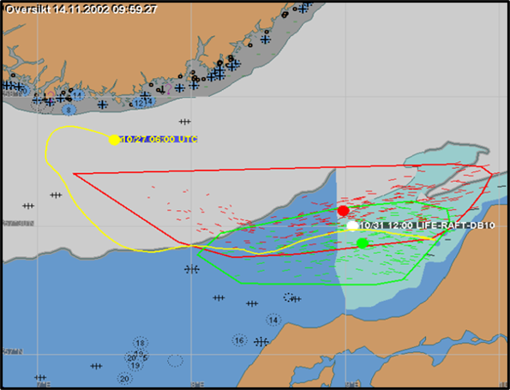

Figure 2.3.2: Example of output from a drifting object model forecasting the drift of a life-raft using an ensemble of drifting particles.
Shown is a snapshot after 102 hrs drift. The small red and green line segments indicate the position of ensemble particles and their trajectory over a period of 1 hour. Red and green colours indicate the two leeway angles. The yellow circle is the initial position, and the yellow line shows trajectory of the centroid of the particle cloud over the full forecast period (5 days). The red and green polygons are convex hull estimates of the search areas for each leeway angle.

Section 2.4: Radionuclide Discharges

2.4.1 Background
The IAEA established the Incident and Emergency Centre (IEC) in 2005 to provide round-the-clock assistance to its Member States in dealing with nuclear and radiological events, including security-related threats, by coordinating the efforts, contributions and actions of experts within the IAEA, Member States and international organizations. IEC is the global focal point for international emergency preparedness, communication and response to nuclear and radiological incidents and emergencies, regardless of whether they arise from accident, negligence or deliberate act. It is the world’s centre for the coordination of international emergency preparedness and response assistance.
In 2012, the IEC conducted a gap analysis of internally identified capabilities to respond, assess and predict during radiological or nuclear events or emergencies, with a particular focus on accident scenarios for nuclear power plants. In the period following the Fukushima accident, it became clear that it would be an advantage to have marine modelling capabilities accessible in the IEC as part of the normal emergency response arrangements. This was due to the concerns over the large amounts of contaminated water released into the ocean.
In 2013 the IEC conducted a consultancy meeting titled “Marine and aquatic modelling during nuclear power reactor accidents 29 July to 31 July and JCOMM Task Team meeting 1 August 2013”. This consultancy invited experts on marine and aquatic modelling to Vienna to discuss the use of such capabilities during a response to a radiological release event. The consultancy explored available methods for doing this type of modelling, discussed existing expert groups and organizations in the field, and drafted proposals for future action for the IEC to improve its capabilities in this area (both in the short and long-term). The consultancy discussed the characteristics of the services and types of output from marine models that could be provided to a technical team in the IEC during an event in order for them to provide useful analysis and insight on the potential evolution of marine pollution. In addition, the consultancy meeting discussed what types of information could be provided by the IEC to Member States for their own planning and understanding purposes during an event.
The meeting discussed options for accessing oceanographic modelling capabilities in IEC during a radioactive release event. Participants agreed that the most ideal option for the IEC at this stage is to organize an external expert capability, hosted externally and available when needed. The implementation of this agreement may be similar to the existing agreement between IEC and WMO to support meteorological modelling. Such protocols may be implemented through RANET, depending on the identified marine modelling expert organizations.
During the meeting, the group of experts discussed what general recommendations could be provided to the IEC to be used as guidance during any future cooperation with organizations with existing marine modelling capabilities to establish working arrangements. The recommendations made are presented in Annex 1.

2.4.2 Review existing capabilities

A marine modelling system for the simulation of radioactive material dispersion consists of ocean circulation model and radionuclide dispersion model. The ocean circulation model provides the structure of the ocean, such as currents, eddies, and water densities from the sea-surface to the bottom. The radionuclide dispersion model calculates the movement of the materials based on the ocean structure by the circulation model, taking the information of release source term (time of release, quantity, and chemical form of material) both for a direct release into the sea and from the atmospheric deposition.

In Japan, several groups conducted simulations of oceanic dispersion after the Fukushima accident. Though each group used a different set of models and showed different results, by reviewing them, it was found that the weak southward current along the Fukushima coast determined the initial transport direction, and that mesoscale eddy-like structures and surface current systems contributed to the dispersion in areas beyond the continental shelf. Among them, Japan Atomic Energy Agency (JAEA) carried out the simulation and validation of Cs137 dispersion to describe its medium to long-term transition in the ocean, using a nuclear dispersion model (GEARN) developed by JAEA and an ocean circulation model (MOVE/MRI.COM, 1/10◦ for north-western Pacific) developed by Meteorological Research Institute (MRI/JMA). It shows that the directly released Cs137 advances eastward along the Kuroshio Extension, being mixed and diluted by mesoscale eddies, and arrives at 170⁰W after one year.

In the USA, the National Centre of Environmental Prediction (NCEP) of the National Weather Service (NWS) used particle tracing to predict the movement of radionuclides in the ocean shortly after the nuclear accident near Fukushima. Daily nowcast/forecast fields from 1/12° HYbrid Coordinate Ocean Model (HYCOM), implemented at NCEP as the Global Real-Time Ocean Forecast System (RTOFS-Global), were used to track inert particles at the ocean surface, assuming that the surface behaviour is reasonably represented by the ocean mixed layer, and that the radionuclides are mostly contained in and distributed by the upper mixed layer of the ocean. The focus was on producing actionable information for a governmental Inter-agency Working Group (IWG) in near real-time using available resources.

With the particle tracing information, NCEP produced estimates of the retention time of radionuclides near the coast, as well as the dispersion timescale of these materials through the Pacific Ocean, particularly by persistent current systems like the Kuroshio and its extension, and the Oyashio. This helped identify both potentially safe areas in the Pacific, and areas of potential exposure on the timescales of weeks to months. Using particle tracking combined with atmospheric deposition of radionuclides, a first guess at the contamination of ocean surface water was produced.

First particle tracking products were routinely delivered to the IWG within four weeks of the first significant release of radionuclides The first quantitative offshore contamination estimates were made available to the IWG in approximately 6 weeks (H. Tolman et al., 2013).

In France, the SIROCCO group (from CNRS and University of Toulouse) performed, at the request of the IAEA, simulations using the 3D SIROCCO ocean circulation model to investigate the dispersion in seawater of radionuclides released by the Fukushima nuclear accident. The model uses a stretched horizontal grid with a variable horizontal resolution, from 600m near Fukushima, to 5 km offshore. The initial fields and the lateral open boundary conditions are provided by the 1/12° Mercator global system. The SIROCCO group was the first to publish on the web results on marine dispersion of radionuclides (Estournel et al., 2012).

From 2012 to 2014, the Science Council of Japan organized an inter-comparison of atmospheric and oceanic dispersion models that simulated the future of radioactive releases from Fukushima. The findings were published in late 2014 (Science Council of Japan, 2014). They are freely available on http://cesd.aori.u-tokyo.ac.jp/cesddb/scj_fukushima/index_j.html.

The report concludes that, although there are similarities between the different simulated dispersions, significant differences are found between models concerning distributions in space and time that result from different approaches and source terms applied. It is not possible to identify which model produces the results closest to measurements. The variability of marine circulation in the mixing zone between the Kuroshio and Oyashio east of Fukushima largely explains this variability due to the presence of unstable eddies.

This inter-comparison shows that there are currently several models able to perform simulations of the drift of radionuclides in the ocean. The differences between the simulations on a limited dispersal period (from March to June 2011) illustrate how their use is hazardous for assessing the dispersion of radionuclide releases in the medium term. The measurements on samples at sea remain the only reliable way to estimate the dispersion in this area.

The estimates of the source term for the Fukushima simulations are highly variable. The estimated direct discharge to the sea in April 2011 remains a subject of debate between the different investigators. Many assessments were performed on inputs of 137Cs. Atmospheric deposition on the sea-surface accounted for amounts of about the same size, but with a wide distribution in the North Pacific in the first months after the accident.

The IAEA – MODARIA Working Group on Modelling of marine dispersion and transfer of radionuclides accidentally released from land-based facilities published a paper on models applied to simulate 137 Cs marine dispersion after recent nuclear accidents (Periáñez et al., 2014). State-of-the-art dispersion models were applied to simulate 137 Cs dispersion from the Chernobyl nuclear power plant disaster fallout on the Baltic Sea and from Fukushima Daiichi nuclear plant releases in the Pacific Ocean after the 2011 tsunami. A wide variety of models were used, from box to fully three-dimensional models, and all included water/sediment interactions. Agreement between models was very good in the Baltic. In the case of Fukushima, results from models could be considered to be in acceptable agreement only after a model harmonization process consisting of using exactly the same forcing (water circulation and parameters) in all models. It was found that the dynamics of the considered system (magnitude and variability of currents) was essential in obtaining a good agreement between models. The difficulties in developing operative models for decision-making support in these dynamic environments were highlighted.
They defined three stages to be considered after an emergency, each of them requiring specific modelling approaches. They are the emergency, the post-emergency and the long-term phases.

1. Emergency phase: The temporal scale of the simulation extends from hours to a few days and the spatial scale to be solved from tens to a few hundred km. In this case a very rapid response (in matter of seconds to a few minutes) should be given by the model to decide, for instance, if swimming must be immediately banned in a beach, or the area where fishing should be banned. This rapid response may be achieved using data on forecast of currents and waves diffusivity from operational marine models and using Lagrangian models to predict the transport of radioactivity. The temporal horizon of such water current and wave prediction is limited by the temporal scale of weather forecasts, which is about 7–10 days. Examples of this approach are given by Periáñez and Pascual-Granged (2008), Estournel et al. (2012), Duffa et al. (2016), Garraffo et al. (2016), and Maderich et al. (2016). Marine product contamination can also be estimated using biota dynamic models, as was done by Duffa et al. (2016). In this initial stage, the model output would also help to develop sampling strategies for monitoring.

2. Post-emergency phase: the temporal scale extends to a few weeks and the spatial one to the order of 100 – 1000 km. We may consider a desalination plant that produces fresh water for irrigation a few hundred km from the nuclear facility. It should be decided if taking seawater should be stopped. In this phase, there is more time to provide an answer than in the first phase. However, the use of short-term ocean forecasts is not viable. The potential solution is using data from analogous periods of previous years and the formation of ensemble of radioactivity predictions to estimate future contamination of water, sediments and biota. With respect to the dispersion model, both Lagrangian and Eulerian approaches could be used (for instance Kawamura et al., 2011, Simonsen et al (2017) and Periáñez et al., 2012). Interactions with suspended matter and seabed sediments have been shown to affect the transport pattern after the Fukushima accident (Choi et al., 2013; Min et al, 2013).

3. Long-term phase: this phase would imply the assessment of the long-term consequences of the accident, including transfers of radionuclides to sediments and biota, as well as evaluating the potential role of sediments as a source of contamination once radionuclide concentrations in seawater have decreased (Periáñez, 2003). This assessment may be carried out with Eulerian models, in which these complex processes are more easily included than in Lagrangian systems and coupled dynamic biota models (Vives i Batlle et al., 2016). Ocean current fields are obtained from time-averaging of ocean circulation model outputs. Simulations over several months may be carried out for spatial scales of some hundreds of km. For even longer-term assessments (years to decades and thousands of km), some authors recommend using box models (Lepicard et al., 2004; Iosjpe et al., 2009). For such timescales, the computational cost of using 3-D models becomes prohibitive and the results are not better than cheaper box models.

In any case, for highly dynamic environments, it was found that model output is extremely sensitive to the model that is used to predict the ocean circulation. Thus, the ocean circulation model should be selected with great care and after a detailed comparison with local measurements of currents. In this sense, Duffa et al. (2016) indicate that high-resolution local forecasts of marine circulation should be used for emergency modelling. Although global ocean circulation models produce realistic pictures of the general circulation in the ocean, their outputs differ in the local scale in dynamic environments, due, at least in part, to their relatively coarse spatial resolution.

Overall, models to be used for radionuclude release emergencies in the marine environment should be carefully tuned for each particular location, i.e. for each nuclear facility for which it is decided to have a modelling tool to support decision-making after a potential emergency occurring there. In other words, we cannot be a priori confident in generic models which import ocean forecasts of currents if a highly dynamic environment is involved.

2.4.3 Developments for improved services

As has been shown above there are useful models for the drift and fate of radioactivity in the ocean. Prediction services can readily be adapted from existing drift and fate services for, e.g. oil spills, and can be deployed and utilized by new actors and for new regions. With reference to the general developments listed in Section 2.1.4, the current section presents some important developments that aim to improve the efficiency of radionuclide dispersion prediction services and the quality of their products.

1. Access to source data, radionuclide field measurements, and development of inverse technique for evaluation of source term. The information of release source term (location and time of release, duration and quantity of release, and chemical form of radioactive material) both for a direct release into the sea and from the atmospheric deposition is a key element. This implies that the output of atmospheric simulations is available more easily.

2. Uncertainty information. For radioactive material drift and dispersion prediction modelling, both single model ensemble and MME methods are viable. For example, given the improvements in data access described above, it is quite feasible to obtain a suite of forcing data sets to force the same radioactive material drift and dispersion model. Conversely, in some areas there are already a number of operational radioactive material drift and dispersion prediction systems that overlap geographically; agreements need to be made about performing forecasts for events within the common area.

3. Multinational collaboration for model development. The development of open community model codes is especially advantageous in the context of deployment of radioactive material drift and dispersion models in developing maritime nations. An important requirement for model development is the identification of benchmark tests and cases. It would be especially valuable to establish a few well-described real cases for which forcing and validation data are readily available.

4. Multinational collaboration for improved services. The advantage of collaboration between national drift prediction services has already been mentioned in connection with the Fukushima accident above, and in the more formal context of multi-model ensemble forecasting (MME; cf. Section 2.1.4). Beyond the exchange of model outputs, there is potential advantage in collaboration on other links in the production chain. For example, robust exchange of forcing data, initial conditions (detection data), agreed file formats, visualization methods, archiving of test case data, etc.

With reference to Section 2.1.4, another aspect of multinational collaboration is support of development in maritime nations that currently lack adequate radioactive material drift and dispersion prediction services of their own. Sharing services at regional level is a feasible alternative, given the improving access to geophysical forcing data and drift model codes, and can be a cost-effective way forward. While all of the world ocean can be covered by global systems run in a few developed countries, the need for more detailed information near the coast implies that there is ultimately a need for drift prediction services at local scales in support of local response to emergencies. A regionalized support system, along the lines of the RSMC network, could be an effective instrument for WMO support to developing Member States, especially for radionuclide emergency response.

5. Specific model functionalities. Radioactive material drift and dispersion models have been developed with somewhat different functionalities depending on the most important local requirements. However, there is a movement toward more comprehensive model capabilities. The following is a list of model capabilities that have seen limited implementation, but that should be made more widely available:
- Radioactive material in sea-ice
- Combination of direct release into the sea (surface or subsurface) and atmospheric deposition
- Development of radionuclides’ database including 137Cs, 134Cs, 90Sr, 131I, T, 99Tc, etc., that provides the parameters of interaction with particulate material, biota and humans in the water column and atmosphere/sea water/sediment interfaces
- Reinitialization of radioactive material volume and location according to observations
- Transfers to the biological and sedimentary compartments
- Include tidal currents in areas where available ocean model data do not
- Include access to climatological geophysical forcing data for long-range (weeks to months) prediction
- Standards for radioactive material drift and dispersion model data exchange

2.4.4 Review of user requirements for Metocean information for emergency response to Radionuclide Dispersion

User requirements

International organization | IAEA
International documentation | IAEA, WMO and IMO are part of the Joint Radiation Emergency Management Plan of the International Organizations (EPR-JPLAN). IAEA and WMO have a specific form to request information from an RSMC for Nuclear Environmental Emergency Response.
Any international coordination boundaries | Nil. Deferred to Coastal States.
Responsibility for responding | IAEA or designated national authority.
Operational response requirements | Safety and efficiency of response crews, forecast movement of particles.
How is the incident reported | In the framework of the Convention on Early Notification of a Nuclear Accident, the IAEA informs the WMO Secretariat and DCPC Offenbach (Germany) of the status of the emergency.
How is the response coordinated | The IAEA or designated national authority is responsible for arranging for information to support drift assessments.

Section 3: WMO Activities and Roles in support of Marine Emergency Response
WMO is a United Nations “specialized agency” with the authoritative voice for climate, weather, water and environment-related matters, especially linked to sustainable development and safety of people and property.

This section outlines the way in which WMO, and its Emergency Response Activities (ERA) support network, is currently configured and how it interacts with existing response activities. For a full outline of the Marine Emergency Response (including both MEER and SAR) at WMO since inception, see https://community.wmo.int/activity-areas/Marine/MEER.

Section 3.1 Marine Pollution Emergency Response
The WMO specifications for the MPERSS were approved by the WMO Commission for Marine Meteorology at its eleventh session (Lisbon, April 1993) and endorsed by the Commission at its twelfth session (Havana, March 1997). See https://community.wmo.int/activity-areas/Marine/MEER#MPERSS.

Marine Pollution Emergency Response Support System (MPERSS)

The MPERSS for the high seas was created with the primary objective of putting in place a coordinated, global system for the provision of meteorological and oceanographic information for marine pollution emergency response operations outside waters under national jurisdiction. The world’s ocean has been divided into Marine Pollution Incident (MPIs) areas that are similar as those METAREAS for the IMO’s GMDSS http://weather.gmdss.org/) and Area Meteorological & Oceanographic Coordinators (AMOCs) have been identified for all of them to provide marine pollution related products and services.

An AMOC is a national service which has accepted responsibility for coordinating the provision of regional meteorological information and oceanographic information as appropriate, which is issued to support marine pollution emergency response operations in the designated area for which the Service (or Services) has accepted responsibility. The AMOC is also available to provide relevant support and advice for waters under national jurisdiction within its area if so requested by the countries concerned.

The support supplied by an AMOC shall include:

(a) Basic meteorological forecasts and warnings tailored for the area(s) concerned;

The support supplied by an AMOC may also include:

(b) Basic oceanographic forecasts for the area(s) concerned;
(c) The observation, analysis and forecasting of the values of specific meteorological and oceanographic variables required as input to models describing the movement, dispersion, dissipation and dissolution of marine pollution;
(d) In some cases, the operation of these models; and
(e) In some cases, access to national and international telecommunications facilities;
(f) Other operational support.

The issued information may have been prepared solely by the AMOC, or by another supporting Service, or a combination of both, on the basis of an agreement between the Services concerned. The location and contact (telephone, email, telex, telefax, etc.) details of any marine pollution emergency response operations authority (or authorities) responsible within the designated MPI area should be maintained on the MPERSS website (which is currently under review).

Role of the WMO Services Commission (SERCOM)

The WMO SERCOM is the intergovernmental body of WMO experts enabled to work in service and application activities supporting Member and Member needs. It comprises of several Standing Committees, of which one – the SC for Marine Meteorological and Oceanographic Services (SC-MMO) – includes focus on supporting and enabling Members in MEER and SAR. It’s Expert Team on Coastal and Emergency Response is tasked to develop technical advice and guidance material on MEER Information services, and data-processing and forecasting systems as well monitor the operations of the GDPFS Specialized Centres for MEER, establishing standards and maintaining product in collaboration with the Infrastructure Commission (INFCOM) team leading on GDPFS. A close liaison with relevant partners, such as IMO and IAEA, is fostered to ensure the coordinated support of all the main players in the process of preparedness and response to emergencies.

3.1.1 WMO Nuclear and Non-nuclear Environmental Emergency Response

WMO’s nuclear and non-nuclear environmental Emergency Response Activities includes, in general terms, the broad area of the application of specialized atmospheric dispersion-modelling techniques to track and predict the spread of airborne hazardous substances in the event of an environmental emergency. This kind of specialized application depends directly on the operational infrastructure of the NWP systems that are implemented and maintained at many of WMO’s GDPFS of global, regional and National Meteorological Centres.

This framework of GDPFS centres was established to assist NMHSs, their respective national agencies, as well as relevant international organizations (primarily, the IAEA), to respond effectively to environmental emergencies with large-scale dispersion of airborne hazardous substances. Following the Chernobyl nuclear power plant accident in 1986, the WMO activities have focused its operational arrangements and support on nuclear accidents; and more recently, WMO has expanded its activities to also include meteorological support in emergency response to the dispersion of smoke from large fires, ash and other emissions from volcanic eruptions, and chemical releases from industrial accidents.

Nuclear Emergency Response Activities

WMO has in place operational international arrangements with the IAEA to trigger specialized meteorological support to environmental emergency response related to nuclear accidents and radiological emergencies, when needed. WMO plays an important role in this connection through its unique NWP capability for simulating and predicting the movement and dispersal of radioactive materials in the atmosphere.

WMO has implemented and maintains a system of 10 specialized numerical modelling centres called RSMCs which are prepared at all times to provide highly specialized computer-based simulations of the atmosphere that predicts the long-range movement of airborne radioactivity. These specialized centres, representing complete global coverage 24 hours a day, every day, are located in the National Meteorological Centres at Exeter (United Kingdom), Toulouse (France), Melbourne (Australia), Montreal (Canada), Washington (USA), Beijing (China), Obninsk (Russian Federation), Offenbach (Germany), Vienna (Austria) and Tokyo (Japan). The system also includes a telecommunication gateway at Offenbach (Germany) to provide the notification and real-time information linkage between the Incident and Emergency Centre of IAEA (IAEA-IEC) and WMO. When requested, these centres provide the specialized products within three hours to National Meteorological Centres, and the IAEA.

Good planning in advance of an emergency can substantially improve the response. To this end, the Joint Radiation Emergency Management Plan of the International Organizations was developed. It is maintained by the IAEA and includes the international organizations that are party to the International Convention on Early Notification of a Nuclear Accident and to the Convention on Assistance in the Case of a Nuclear Accident or Radiological Emergency, as well as some international organizations that participate in the activities of the Interagency Committee on Response to Nuclear Accidents.

WMO is a party to these Conventions and participates in the regular review and maintenance of the Joint Plan, including the Convention Exercise programme.

Non-nuclear environmental emergency responses

WMO has expanded the scope and capabilities of its Emergency Response Activities to include non-nuclear environmental emergencies – the area of chemical incidents and emergencies is one under exploration and development.

Many NMHSs have a national responsibility to provide meteorological support to chemical accident emergency response. The services range from weather observations, forecasts and warnings provided to field operations, to the provision of specialized products and expert advice on the atmospheric dispersal of pollutants. Some governments are investing and cooperating in science and technology and reviewing operational arrangements to enhance their respective level of security measures, including in the areas of environmental monitoring in complex environments and numerical modelling and simulations for detection, assessment and prediction of atmospheric transport of hazardous materials. All these aspects contribute to the management of risk in the context of disaster prevention and mitigation.

Role of WMO Infrastructure Commission (INFCOM)

The WMO INFCOM is the intergovernmental body of WMO experts enabled to work in infrastructure (including observation, instrumentation and data) activities supporting Member and Member needs. It comprises of several Standing Committees, of which one – the SC for Earth System Monitoring and Predicting (SC-ESMP) includes focus on the GDPFS. Their Expert Team on Emergency Response Activities (ET-ERA) is responsible for ensuring that the procedures for ERA, both nuclear and non-nuclear, are adequate and meet Members and international organizations (i.e. IAEA and Comprehensive Nuclear-Test-Ban Treaty Organization (CTBTO)) needs, as well a possible update as necessary for the Manual on the GDPFS (WMO-No. 485). They offer support in education and training of users on the use and interpretation of ERA products, and their strengths and weaknesses. As well, NMHS are provided assistance in developing their ERA capabilities for supporting national agencies in their preparedness, planning, response and recovery activities. Their focus to test new products especially for methods of atmospheric transport and dispersion-modelling fosters improvements. As well, improvements are sought in the collective ability of all RSMCs, the IAEA, CTBTO, the RTH Offenbach and NMHSs in the environmental ERA to fulfil the operational requirements according to adopted standards and procedures stated in the Manual on GDPFS.

RECOMMENDATIONS AND CONCLUSION
This report has reviewed the state-of-the-art of Marine Emergency Response (MER), acknowledging that both MEER and drifting objects (especially for SAR) rely on similar methods. It has outlined the multi-dimensional needs for both ocean and atmospheric forcing data to support the metocean modelling. The report also outlines the role of NMHS and other agencies – national, regional and international, including WMO – who all have a stake in the complex but very important process of responding to an emergency at sea or along the coast.

The review demonstrates the complex landscape within which this operates with legislation, international and national commitments, plus various roles and responsibility in the responding chain. NMHS play a significant role in this, and WMO can strengthen its role and the role of NMHS, in this process, through offering guidance on best practice to assist Members involved in marine emergency. At present, there is no guidance material available for Members and as such, this report demonstrates where WMO SERCOM could add value through the development of relevant guidance material.

_______________________

Annexes: 3

Annex 1

Recommendations from the 2013 IEC Meeting

(“Marine and aquatic modelling during nuclear power reactor accidents 29 July to 31 July and JCOMM Task Team meeting 1 August 2013”)

- The IEC should develop a concept of operations for the use of marine modelling during a radiological or nuclear event covering:
- The envisioned use of marine modelling during an emergency
- The scope of capability desired from marine models within the first 24 hours, week and month (as capabilities may increase over time during an event)
- How models will be presented to the public and technical audiences
- How the use of marine models and marine measurements will be managed during an event
- The output of marine models should be in a simplified format that is easy to understand by the IEC technical team.
- IEC technical team will require specific training on the interpretation of such models in order to properly convey the associated uncertainties (this is not dissimilar to the current training on plume models).
- Models could be rerun during an event with new information at fixed intervals (such as twice a day or daily).
- It was noted that the movement of marine models is generally slower than plume models and therefore requesting data at too rapid a frequency may not provide useful information (i.e. <4h).
- It is feasible for the IEC to use marine models in order to provide general awareness on where material may go during an event (similar to how meteorological models are currently used within the IEC)
- The setup currently used by the IEC for receiving meteorological support from the RSMCs from the WMO would be useful to use as a basis for establishing similar marine modelling arrangements
- The additional level of support possible by 24/7 contact with these centres would be very useful for the IEC to maintain with any marine modelling capability to assist with the interpretation of such models
- Additional support from a 24/7 contact would be useful if the IEC requires any specialized modelling during an event
- The current approach of the IEC with plume modelling (using a 1 Bq/h illustrative source term) can be successfully applied to marine modelling for situational awareness purposes
- Discussions with external organizations that may be providing such support (i.e. JCOMM) could be used to help define the scope of any such future service
- Models which address both a point (direct to sea) and deposition (i.e. from a plume) should be available during an event as the dispersion profile may be very sensitive to coastal distance
- Marine models are very sensitive to the resolution of the data; it is recommended to use high-resolution modelling capabilities where they are available
- The resolution required for a model to be useful is driven by the scenario, such as what is required when modelling near a coastline
- When tidal effects are important, the input/output frequency of a model may need to be as frequent as one hour
- The IEC should consider the potential use of risk mapping (e.g. provision of a probability map of future distribution based on historical data) as a product to be provided during an event
- The implementation of a marine modelling capability in the IEC should address how results are archived and eventually provided to other internal departments within the Agency for longer-term analysis
- Full capabilities of such models will need to be evaluated once implemented and made available to the IEC
- The IEC will need to determine how to most effectively work into the existing decision-making process the use of any marine modelling capability

_______________________

Annex 2

International, Global and Regional Frameworks and Programs relevant to MEER and SAR

This Annex outlines the context of the variety of Frameworks and Programmes that may influence WMO's support for Members’ response to marine environmental emergencies and SAR.

Conventions and associated activities relevant to MEER and SAR

1.1.1 The International Maritime Organization (IMO) and Conventions

The IMO is a UN specialized agency with a focus on safety and security of international shipping and preventing pollution from ships. It is responsible for two International Conventions directly relevant to MEER and SAR. For both, WMO contributes to the work and meetings of IMO, and is joint sponsor of several mandatory documents, especially relating to maritime safety.

International Convention for the Prevention of Pollution from Ships (MARPOL)

The International Convention for the Prevention of Pollution from Ships (MARPOL) is the main international convention covering prevention of pollution of the marine environment by ships from operational or accidental causes.
The MARPOL Convention was adopted on 2 November 1973 at the IMO. The Protocol of 1978 was adopted in response to a spate of tanker accidents in 1976–1977. As the 1973 MARPOL Convention had not yet entered into force, the 1978 MARPOL Protocol absorbed the parent Convention. The combined instrument entered into force on 2 October 1983. In 1997, a Protocol was adopted to amend the Convention and a new Annex VI was added which entered into force on 19 May 2005. MARPOL has been updated by amendments through the years.

The Convention includes regulations aimed at preventing and minimizing pollution from ships – both accidental pollution and that from routine operations – and currently includes six technical Annexes. Special Areas with strict controls on operational discharges are included in most Annexes:

Annex | Regulations for the:
I | Prevention of pollution by oil
II | Control of pollution by noxious liquid substances in bulk
III | Prevention of pollution by harmful substances carried by sea in packaged form
IV | Prevention of pollution by sewage from ships
V | Prevention of pollution by garbage from ships
VI | Prevention of air pollution from ships

The IMO’s Marine Environment Protection Committee (MEPC) which consists of all IMO Member States, is empowered to consider any matter within the scope of the IMO that is concerned with prevention and control of pollution from ships, covered by MARPOL. This also includes oil, chemicals carried in bulk, sewage, garbage and emissions from ship (such as air pollutants and greenhouse gas emissions). Ballast water management, anti-fouling systems, ship recycling, pollution preparedness and response and identification of special areas and sensitive sea areas are also considered. In particular, it is concerned with the adoption and amendment of conventions and other regulations and measures to ensure their enforcement.

The MEPC was first established as a subsidiary body of the IMO Assembly and raised to full constitutional status in 1985. Several Sub-Committees support the MEPC work, of which the Sub Committee on Pollution Prevention and Response (PPR) has most direct relevant to the MEER agenda.

International Safety of Life at Sea (SOLAS)

The International Convention for the SOLAS includes all IMO Member States as well as those countries which are party to conventions such as SOLAS even if they are not IMO Member States.

The Maritime Safety Committee (MSC) is the highest technical body of the IMO, and similar to MEPC, it consists of all IMO Member States. The functions of the MSC are to “consider any matter within the scope of the Organization concerned with aids to navigation, construction and equipment of vessels, manning from a safety standpoint, rules for the prevention of collisions, handling of dangerous cargoes, maritime safety procedures and requirements, hydrographic information, log-books and navigational records, marine casualty investigations, salvage and rescue and any other matters directly affecting maritime safety”.

The MSC is also required to provide machinery for performing any duties assigned to it by the IMO Convention or any duty within its scope of work which may be assigned to it by or under any international instrument and accepted by the IMO. It also has the responsibility for considering and submitting recommendations and guidelines on safety for adoption by the Assembly. The expanded MSC adopts amendments to conventions, such as the SOLAS. The MSC has several Sub-Committees to support its mandate, of which the Navigation, Communication, Search and Rescue (NCSR) is one in which WMO participates as an observer. This is the body that, among many topics, covers the IMO-WMO Worldwide MetOcean Information and Warning System (WWMIWS) and it's met ocean Maritime Safety Information (MSI) provided my WMO’s METAREAS. While SAR is not directly in MSI discussions, its scope is still considered for responding SAR requests, where weather information is critical to the process. For WMO’s role in WWMIWS and SAR see (link to WMO website).

1.1.2 Regional Marine Pollution Emergency Response Centre for the Mediterranean Sea (REMPEC)

The objective of REMPEC (www.rempec.org) is to contribute to preventing and reducing pollution from ships and combating pollution in case of emergency. In this respect, the mission of REMPEC is to assist the Contracting Parties in meeting their obligations under Articles 4(1), 6 and 9 of the Barcelona Convention; the 1976 Emergency Protocol; the 2002 Prevention and Emergency Protocol and implementing the Regional Strategy for Prevention of and Response to Marine Pollution from Ships, adopted by the Contracting Parties in 2005 which key objectives and targets are reflected in the Mediterranean Strategy for Sustainable Development (MSSD). The Centre will also assist the Contracting Parties which so request in mobilizing the regional and international assistance in case of an emergency under the Offshore Protocol, should this instrument enter into force.
REMPECs main fields of action for the prevention of pollution of the marine environment from ships and the development of preparedness for and response to accidental marine pollution and cooperation in case of emergency consist of:
- Strengthening the capacities of the coastal States in the region with a view to preventing pollution of the marine environment from ships and ensuring the effective implementation in the region of the rules that are generally recognized at the international level relating to the prevention of pollution from ships, and with a view to abating, combating and, to the fullest possible extent, eliminating pollution of the marine environment from shipping activities, including pleasure crafts;
- Developing regional cooperation in the field of the prevention of pollution of the marine environment from ships, and facilitating cooperation among Mediterranean coastal States in order to respond to pollution incidents which result or may result in a discharge of oil or other hazardous and noxious substances, and which require emergency actions or other immediate response;
- Assisting coastal States of the Mediterranean region which so request in the development of their own national capabilities for response to pollution incidents which result or may result in a discharge of oil or other hazardous and noxious substances and facilitating the exchange of information, technological cooperation and training;
- Providing a framework for the exchange of information on operational, technical, scientific, legal and financial matters, and promoting dialogue aimed at conducting coordinated action at the national, regional and global levels for the implementation of the Prevention and Emergency Protocol; and
- Assisting coastal States of the region, which in cases of emergency so request, either directly or by obtaining assistance from the other Parties, or when possibilities for assistance do not exist within the region, in obtaining international assistance from outside the region.

1.1.3 European Maritime Safety Agency (EMSA)

The European Maritime Safety Agency is one of the EU's decentralized agencies. Based in Lisbon, the Agency provides technical assistance and support to the European Commission and Member States in the development and implementation of EU legislation on maritime safety, pollution by ships and maritime security. It has also been given operational tasks in the field of oil pollution response, vessel monitoring and in long-range identification and tracking of vessels.
A major political impetus to the setting up of EMSA in 2003 was the fallout from the Erika (1999) and the Prestige (2002) accidents and their resulting oil spills. These incidents resulted in huge environmental and economic damage to the coastlines of Spain and France. They also acted as a reminder to decision-makers that Europe needed to invest in better preparation for a large-scale oil spill, i.e. above-and-beyond the resources available at individual Member State level.
EMSA undertakes a number of mainly preventive, but also reactive tasks, in certain key areas in order to meet its objectives.

Firstly, the Agency has been tasked with assisting the Commission in monitoring the implementation of EU legislation relating, among others, to ship construction and planned maintenance, ship inspection and the reception of ship waste in EU ports, certification of marine equipment, ship security, the training of seafarers in non-EU countries and Port State Control.

Secondly, the Agency operates, maintains and develops maritime information capabilities at EU level. Significant examples are the SafeSeaNet vessel tracking system, to enable the EU-wide tracking of vessels and their cargoes; and the EU LRIT Cooperative Data Centre, to ensure the identification and tracking of EU flagged ships worldwide.

In parallel, a marine pollution preparedness, detection and response capability has been established, including a European network of stand-by oil spill response vessels as well as a European satellite oil spill monitoring and vessel detection service (CleanSeaNet), both with the aim of contributing to an effective system for protecting EU coasts and waters from pollution by ships.
Finally, the Agency provides technical and scientific advice to the Commission in the field of maritime safety and prevention of pollution by ships in the continuous process of evaluating the effectiveness of the measures in place, and in the updating and development of new legislation. It also provides support to, and facilitates cooperation between, the Member States and disseminates best practices. As a body of the European Union, the Agency sits at the heart of the EU maritime safety network and collaborates with many industry stakeholders and public bodies, in close cooperation with the Commission and the Member States.

International and/or Regional Programs of Relevance to MEER and SAR

The International Atomic Energy Agency (IAEA) and WMO’s Emergency Response Activities

The IAEA is an intergovernmental agency focused on scientific and technical cooperation in the nuclear field. This includes working towards safe, secure and peaceful uses of nuclear science technology. Given the high risk of nuclear hazards, it plays a role in environmental emergency response, especially through safeguarding measures and monitoring of hazards substances. This has a direct link to WMO's ERA, which involves the application of specialized atmospheric dispersion-modelling techniques to track and predict the spread of airborne hazardous substances in the event of an environmental emergency, as indicated in Section 1.2.

The IAEA carries out R&D activities addressing marine pollution at its Marine Environmental Studies Laboratory. The Laboratory’s work focuses on developing and validating analytical methods for the measurement of contaminants in marine samples. This is potentially an important element of any future emergency response system for radioactivity in the ocean.

The Global Ocean Observing System (GOOS)
GOOS is a collaborative platform with six key components that help define ocean observing requirements, coordinate observing networks, and ensure the flow of data and forecasts. Co-sponsored by the IOC, the WMO, the UNEP and the International Science Council (ISC), it supports a community encompassing all those playing a role in the observing system: international, regional, and national observing programs, governments, UN agencies, research organizations, and individual scientists. By working together on ocean observing tools and technology, the free flow of data, information systems, forecasts, and scientific analysis, this global community can leverage the value of all these investments.
Expert panels synthesize requirements and provide guidance on observing system design with the intent to strengthen and expand implementation, promoting best practice. A forecasting systems team is also focused on improving the capacity and quality of ocean forecasts, which has a direct relevance for modelling and production services linked to ocean drift and floating objects – and therefore MEER and SAR. Aside from WMO being a co-sponsor of GOOS, the GOOS community also collaborates on mutual activities with the WMO’s INFCOM and SERCOM respectively), including to progress ocean prediction capabilities for meteorological services. The joint WMO-IOC Collaborative Board (JCB) provides strategic advice to both the IOC and WMO to encourage the cross coordinating of these activities.

Others of relevance to Marine Emergency Response

There are a number of regional alliances which are set up to prevent, react to, and manage, marine emergencies, especially environmental. These are generally geographically based, ranging from the Caribbean across to Asia and the Far East. In general, these work closely with the Environmental Division of the IMO. The best use of resource in engaging with these, and in providing a more cohesive response mechanism, may be to work with IMO directly.

_______________________

Annex 3

References

Allen, A. A. (2005). Leeway divergence. COAST GUARD RESEARCH AND DEVELOPMENT CENTER, GROTON CT.

Allen, A., Plourde, J. V., 1999. Review of Leeway: Field Experiments and Implementation. Tech. Rep. CG-D-08-99, US Coast Guard Research and Development Center, 1082 Shennecossett Road, Groton, CT, USA, available through http://www.ntis.gov.

Ambjorn, C. (2007). SeatrackWeb, forecasts of oil spills, a new version, Environ. Res. Eng. Manage., 3, 60–66.

Azevedo, A., Oliveira, A., Fortunato, A.B. and Bertin, X., (2009). Application of an Eulerian-Lagrangian oil spill modeling system to the Prestige accident: trajectory analysis. Journal of Coastal Research, pp.777-781.

Barrick, D., Fernandez, V., Ferrer, M. I., Whelan, C., Breivik, Ø., 2012. A short-term predictive system for surface currents from a rapidly deployed coastal HF radar network. Ocean Dynam 62, 725–740, doi:10.1007/s10236–012–0521–0.

Blanke, B., & Raynaud, S. (1997). Kinematics of the Pacific equatorial undercurrent: An Eulerian and Lagrangian approach from GCM results. Journal of Physical Oceanography, 27(6), 1038-1053.

Breivik, Ø., A Allen, C Maisondieu, M Olagnon, 2013. Advances in Search and Rescue at Sea, Ocean Dynam, 63(1), 83-88, doi:10.1007/s10236, arXiv:1211.0805.

Breivik, Ø., Allen, A., Maisondieu, C., Roth, J.-C., Forest, B. (2012a). The Leeway of Shipping Containers at Different Immersion Levels. Ocean Dynam 62, 741–752, doi:10.1007/s10236–012–0522–z, arXiv:1201.0603.

Breivik, Ø., Allen, A. A. (2008). An operational search and rescue model for the Norwegian Sea and the North Sea. J Marine Syst 69 (1–2), 99–113, doi:10.1016/j.jmarsys.2007.02.010, arXiv:1111.1102.

Breivik, Ø., Allen, A. A., Maisondieu, C., Roth, J. C. (2011). Wind-induced drift of objects at sea: The leeway field method. Appl Ocean Res 33, 10 pp, doi:10.1016/j.apor.2011.01.005, arXiv:1111.0750.

Breivik, Ø., Bekkvik, T. C., Ommundsen, A., Wettre, C. (2012b). BAKTRAK: Backtracking drifting objects using an iterative algorithm with a forward trajectory model. Ocean Dynam 62, 239–252, doi:10.1007/s10236–011–0496–2, arXiv:1111.0756.

Carrier, M. J., Ngodock, H. E., Smith, S. R., Souopgui, I., & Bartels, B. (2016). Examining the Potential Impact of SWOT Observations in an Ocean Analysis–Forecasting System, Monthly Weather Review, 144(10), 3767-3782. Retrieved Jul 4, 2022, from https://journals.ametsoc.org/view/journals/mwre/144/10/mwr-d-15-0361.1.xml

Choi, Y., S. Kida, and K. Takahashi, 2013, The impact of oceanic circulation and phase transfer on the dispersion of radionuclides released from the Fukushima Dai-ichi Nuclear Power Plant, Biogeosciences, 10, 4911–4925, 2013, doi:10.5194/bg-10-4911-2013

Christensen, K. H., Breivik, Ø., Dagestad, K. F., Röhrs, J., & Ward, B. (2018). Short-term predictions of oceanic drift. Oceanography, 31(3), 59-67.

Coppini, G., Jansen, E., Turrisi, G., Creti, S., Shchekinova, E.Y., Pinardi, N., Lecci, R., Carluccio, I., Kumkar, Y.V., D'Anca, A. and Mannarini, G. (2016). A new search-and-rescue service in the Mediterranean Sea: a demonstration of the operational capability and an evaluation of its performance using real case scenarios. Natural Hazards and Earth System Sciences, 16(12), pp.2713-2727.

Dagestad, K-F, J Röhrs, Ø Breivik, and B Ådlandsvik (2018). OpenDrift v1.0: a generic framework for trajectory modeling, Geosci Model Dev, 11(4), pp 1405-1420, doi:10.5194/gmd-11-1405-2018

Daling, P. S., Moldestad, M. Ø., Johansen, Ø., Lewis, A., and Rødal, J. (2003). Nor-
wegian testing of emulsion properties at sea – the importance of oil type and release
conditions. Spill Science & Technology Bulletin, 8(2):123–136.

Daniel, P., and R. Virasami (2021): Oil spill management and salvage in the Indian Ocean. In Bulletin Vol. 70 (1), World Meteorological Organisation, Geneva.

Davidson, W. F., K. Lee and A. Cogswell (Eds.) (2008). Oil Spill Response: A Global Perspective. Proceedings of the NATO CCMS Workshop on Oil Spill Response, Dartmouth, Nova Scotia, Canada, 11-13 October 2006. Springer Science and Business, Dordecht, 365 pp.

Davidson, F. J. M., Allen, A., Brassington, G. B., Breivik, Ø., Daniel, P., Kamachi, M., Sato, S., King, B., Lefevre, F., Sutton, M., Kaneko, H., 2009. Applications of GODAE ocean current forecasts to search and rescue and ship routing. Oceanography 22 (3), 176–181, doi:10.5670/oceanog.2009.76

Duffa, C., Bailly du Bois, P., Caillaud, M., Charmasson, S., Couvez, C., Didier, D., Dumas, F., Fievet, B., Morillon, M., Renaud, P., Thebault, H., 2016. Development of emergency response tools for accidental radiological contamination of French coastal areas. J. Environ. Radioact. 151, 487–494.

Döös, K., Kjellsson, J., & Jönsson, B. (2013). TRACMASS—A Lagrangian trajectory model. In Preventive methods for coastal protection (pp. 225-249). Springer, Heidelberg.

Egbert, G. D., & Erofeeva, S. Y. (2002). Efficient inverse modeling of barotropic ocean tides. Journal of Atmospheric and Oceanic technology, 19(2), 183-204.

Estournel, C., Bosc, E., Bocquet, M., Ulses, C., Marsaleix, P., Winiarek, V., Osvath, I., Nguyen, C., Duhaut, T., Lyard, F., Michaud, E., Auclair, F., 2012. Assessment of the amount of Cesium-137 released into the Pacific Ocean after the Fukushima accident and analysis of its dispersion in Japanese coastal waters. J. Geophys. Res. Oceans. 117 (C11014).

Fay, J. A. (1971) Physical processes in the spread of oil on a water surface, in Proceedings of the International Oil Spill Conference, vol. 1971. Washington, DC: American Petroleum Institute, pp. 463–467. doi: 10.7901/2169-3358-1971-1-463

Fingas M. (Ed.) (2015) Oil and petroleum evaporation, Ch. 7. in Handbook of oil spill science and technology, 207. John Wiley and Sons Inc.

Fingas, M. (Ed.) (2017). Oil spill science and technology, 2nd edition. Gulf professional publishing.

Garraffo, Z., Kim, H., Mehra, A., Spindler, T., Rivin, I., Tolman, H.L., 2016. Modeling of ¹³⁷Cs as a tracer in a regional model for the Western Pacific, after the Fukushima–Daiichi nuclear power plant accident of March 2011. Wea. Forecasting. 31, 553–579.

Griffa, A. (1996). Applications of stochastic particle models to oceanographic problems. In Stochastic modelling in physical oceanography (pp. 113-140). Birkhäuser Boston.

Hackett, B., Breivik, Ø., Wettre, C., 2006. Forecasting the drift of objects and substances in the oceans. In: Chassignet, E. P., Verron, J. (Eds.), Ocean Weather Forecasting: An Integrated View of Oceanography. Springer, pp. 507–524.

Hackett, B., E. Comerma, P. Daniel and H. Ichikawa, 2009: Marine oil pollution prediction.
Oceanography, 22 (3), 168-175.

Hernandez-Lasheras, J., Mourre, B., Orfila, A., Santana, A., Reyes, E., & Tintoré, J. (2021). Evaluating high-frequency radar data assimilation impact in coastal ocean operational modelling. Ocean Science, 17(4), 1157-1175.

Hodgins, D.O. and R.Y. Mak, 1995. "Leeway Dynamic Study Phase I Development and Verification of a Mathematical Drift Model for Four-person Liferafts." Prepared for Transportation Development Centre, Transport Canada Report # TP 12309E.

Hodgins, D. O., Hodgins, S. L. M., 1998. Phase II Leeway Dynamics Program: Development and Verification of a Mathematical Drift Model for Liferafts and Small Boats. Tech. Rep., Canadian Coast Guard, Nova Scotia, Canada.

Iosjpe, M., Karcher, M., Gwynn, J., Harms, I., Gerdes, R., Kauker, F., 2009. Improvement of the dose assessment tools on the basis of dispersion of the 99 Tc in the Nordic Seas and the Arctic Ocean. Radioprotection 44 (5), 531–536.

Ivorra, B., S. Gomez, J. Carrera, A. Ramos (2021). A compositional Eulerian approach for modeling oil spills in the sea. Ocean Engineering, Volume 242, 110096, ISSN 0029-8018. https://doi.org/10.1016/j.oceaneng.2021.110096.

Jacobs, G., D’Addezio, J. M., Ngodock, H., & Souopgui, I. (2021). Observation and model resolution implications to ocean prediction. Ocean Modelling, 159, 101760.

JMA (2002) Marine Pollution transport model. in Outline of the operational numerical weather prediction at the Japan Meteorological Agency.
https://warp.da.ndl.go.jp/info:ndljp/pid/246209/www.jma.go.jp/jma/jma-eng/jma-center/nwp/outline-nwp/pdf/ol6_7.pdf

JMA (2021) Oil Spill Prediction Model. in Outline of the operational numerical weather prediction at the Japan Meteorological Agency.
https://www.jma.go.jp/jma/jma-eng/jma-center/nwp/outline2022-nwp/pdf/outline2022_05.pdf

Jones, R. K. (1997). A simplified pseudo-component oil evaporation model.

Jones, C, K-F Dagestad, O Breivik, B Holt, J Rohrs, K Christensen, M Espeseth, C Brekke, S Skrunes (2016). Measurement and Modeling of Oil Slick Transport, J Geophys Res: Oceans, 121(10), pp 7759-7775, doi:10.1002/2016JC012113

Kawamura, H., Kobayashi, T., Furuno, A., In, T., Ishikawa, Y., Nakayama, T., Shima, S., Awaji, T., 2011. Preliminary numerical experiments on oceanic dispersion of 131 I and 137 Cs discharged into the ocean because of the Fukushima Daiichi nuclear power plant disaster. J. Nucl. Sci. Technol. 48, 1349–1356.

Klemas,V. 2010. Tracking oil slicks and predicting their trajectories using remote sensors and models: Case studies of the sea Princess and Deepwater Horizon oil spills. J. Coast. Res., 26(5), 789–797.

Kratzke, T. M., Stone, L. D., Frost, J. R., 2010. Search and Rescue Optimal Planning System. In: Proceedings of the 13 International Conference on Information Fusion. IEEE, p. 8 pp.

Legrand, S., and V. Duliere, 2014: OSERIT: a downstream service dedicated to the Belgian Coast Guard Agencies. In Proceedings of the Sixth International Conference on EuroGOOS, 4-6 October 2011, Sopot, Poland, eds. H. Dahlin, N.C. Flemming and S.E. Petersson, 181-188. EuroGOOS AISBL, Brussels, Belgium.

Lepicard, S., Heling, R., Maderich, V., 2004. POSEIDON/RODOS model for radiological assessment of marine environment after accidental releases: application to coastal areas of the Baltic, Black and North seas. J. Environ. Radioact. 72 (1–2), 153–161.
Maderich, V., Brovchenko, I., Dvorzhak, A., Ievdin, Y., Koshebutsky, V., Periañez, R., 2016. Integration of 3D model THREETOX in JRODOS-HDM, implementation studies and model validation on marine Fukushima scenarios. Radioprotection (Special issue)

Min et al, 2013, Marine dispersion assessment of 137Cs released from the Fukushima nuclear accident, Marine Pollution Bulletin 72 (2013) 22–33, http://dx.doi.org/10.1016/j.marpolbul.2013.05.008
Keramea, P., Spanoudaki, K., Zodiatis, G., Gikas, G., Sylaios, G. (2021) Oil Spill Modeling: A Critical Review on Current Trends, Perspectives, and Challenges. J. Mar. Sci. Eng. 9, 181. https://doi.org/10.3390/

Nordam, T., & Duran, R. (2020). Numerical integrators for Lagrangian oceanography. Geoscientific Model Development, 13(12), 5935-5957.

Penna, N. T., Morales Maqueda, M. A., Martin, I., Guo, J., & Foden, P. R. (2018). Sea surface height measurement using a GNSS wave glider. Geophysical Research Letters, 45(11), 5609-5616.

Periáñez, R., 2003. Redissolution and long-term transport of radionuclides released from a contaminated sediment: a numerical modelling study. Estuar. Coast. Shelf Sci. 56, 5–14.

Periáñez, R., Pascual-Granged, A., 2008. Modelling surface radioactive, chemical and oil spills in the strait of Gibraltar. Comput. Geosci. 34, 163–180.

Periáñez, R., Suh, K.-S., Min, B.-I., 2012. Local scale marine modelling of Fukushima releases. Assessment of water and sediment contamination and sensitivity to water circulation description. Mar. Pollut. Bull. 64, 2333–2339.

Periáñez R., R. Bezhenar, M. Iosjpe, V. Maderich, H. Nies, I. Osvath, I. Outola, G. de With (2014). A comparison of marine radionuclide dispersion models for the Baltic Sea in the frame of IAEA MODARIA program. Journal of Environmental Radioactivity 139, 66-77.

Reed, M., Johansen, Ø., Brandvik, P. J., Daling, P. S., Lewis, A., Fiocco, R., Mackay,
D., and Prentki, R. (1999). Oil spill modeling towards the close of the 20th century:
overview of the state of the art. Spill Science & Technology Bulletin, 5(1):3–16.

Reisser, J., Slat, B., Noble, K., du Plessis, K., Epp, M., Proietti, M., de Sonneville, J., Becker, T., and Pattiaratchi, C. (2015): The vertical distribution of buoyant plastics at sea: an observational study in the North Atlantic Gyre, Biogeosciences, 12, 1249–1256, https://doi.org/10.5194/bg-12-1249-2015.

Röhrs, J., Christensen, K., Hole, L., Broström, G., Drivdal, M., Sundby, S., 2012. Observation based evaluation of surface wave effects on currents and trajectory forecasts. To appear in Ocean Dynam, 14 pp, doi:10.1007/s10236–012–0576–y.

Röhrs, J., Dagestad, K.-F., Asbjørnsen, H., Nordam, T., Skancke, J., Jones, C. E., and Brekke, C. (2018). The effect of vertical mixing on the horizontal drift of oil spills, Ocean Sci., 14, 1581–1601, https://doi.org/10.5194/os-14-1581-2018.

Röhrs, J., Sutherland, G., Jeans, G., Bedington, M., Sperrevik, A. K., Dagestad, K. F., Gusdal, Y., Mauritzen, C., Dale, A. and LaCasce, J.H (2021). Surface currents in operational oceanography: Key applications, mechanisms, and methods. Journal of Operational Oceanography, 1-29.

Schwab, D. J., Bennett, J. R., & Lynn, E. W. (1984). " PATHFINDER": A Trajectory Prediction System for the Great Lakes (No. 414). National Oceanic and Atmospheric Administration, Environmental Research Laboratories, Great Lakes Environmental Research Laboratory.

Shibata T., T. Nakajima, Y. Igarashi, H. Tsuruta, M. Ebihara, T. Hattori, M. Hoshi, T. Ishimaru, K. Masumoto, P. Bailly du Bois, M. Bocquet, D. Boust, I. Brovchenko, I. Choe, T. Christoudias, D. Didier, H. Dietze, P. Garreau, H. Higashi, K. T. Jung, S. Kida, P. Le Sager, J Lelieveld, V. Maderich, Y. Miyazawa, S. U. Park, D. Quélo, K. Saito, T. Shimbori, Y. Uchiyama, P. van Velthoven, V. Winiarek, and S. Yoshida. A review of the model comparison of transportation and deposition of radioactive materials released to the environment as a result of the Tokyo Electric Power Company's Fukushima Daiichi Nuclear Power Plant accident. Technical report, Sectional Committee on Nuclear Accident Committee on Comprehensive Synthetic Engineering, Science Council of Japan, September 2014.

Spaulding M.L. (1988). A state-of-art review of oil spill trajectory and fate modeling, Oils & Chemical pollution, 4, 39-55.

Sperrevik, A. K., Christensen, K. H., & Röhrs, J. (2015). Constraining energetic slope currents through assimilation of high-frequency radar observations. Ocean Science, 11(2), 237-249.

Stiver, W, and Mackay, D. (1984). Evaporation rate of spills of hydrocarbons and petroleum mixtures. Environmental Science & Technology, 834.

Sutherland, G., Soontiens, N., Davidson, F., Smith, G.C., Bernier, N., Blanken, H., Schillinger, D., Marcotte, G., Röhrs, J., Dagestad, K.F. and Christensen, K.H. (2020). Evaluating the leeway coefficient of ocean drifters using operational marine environmental prediction systems. Journal of Atmospheric and Oceanic Technology, 37(11), 1943-1954.

Tipton, M., McCormack, E., Elliott, G., Cisternelli, M., Allen, A., & Turner, A. C., (2022). Survival Time and Search Time in Water: Past, Present and Future. TB-D-21-00612, Available at SSRN: https://ssrn.com/abstract=3986715 or http://dx.doi.org/10.2139/ssrn.3986715.

Tolman H., Z. Garaffo, A. Mehra, I. Rivin and T. Spindler, 2013. Ocean Plume Modeling for the Fukushima Dai’ichi Event: Particle tracing. NOAA/NWS/NCEP technical note.
Solabarrieta, L., Hernández-Carrasco, I., Rubio, A., Campbell, M., Esnaola, G., Mader, J., Jones, B.H. and Orfila, A. (2021). A new Lagrangian-based short-term prediction methodology for high-frequency (HF) radar currents. Ocean Science, 17(3), pp.755-768.

Turner, A.C., Lewandowski, M., Parker, J., McClay, T. (2009). Recommendations for the U.S. Coast Guard Survival Prediction Tool. U.S. Coast Guard, New London CT, USA.

van Sebille. E., S. M. Griffies, R. Abernathey, T. P. Adams, P. Berloff, A. Biastoch, B. Blanke, E. P. Chassignet, Y. Cheng, C. J. Cotter, E. Deleersnijder, K. Döös, H. F. Drake, S. Drijfhout, S. F. Gary, A. W. Heemink, J. Kjellsson, I. M. Koszalka, M. Lange, C. Lique, G. A. MacGilchrist, R. Marsh, C. G. M, Adame, R. McAdam, F. Nencioli, C. B. Paris, M. D. Piggott, J. A. Polton, S. Rühs, S. H.A.M. Shah, M. D. Thomas, J. Wang, P. J. Wolfram, L. Zanna, J. D. Zika (2018). Lagrangian ocean analysis: Fundamentals and practices, Ocean Modelling, Volume 121, 49-75, ISSN 1463-5003, https://doi.org/10.1016/j.ocemod.2017.11.008.

Vives i Batlle, J., Beresford, N., Beaugelin-Seiller, K., Bezhenar, R., Brown, J., Cheng, J.J., Cujic, M., Dragovic, S.S., Duffa, C., Fievet, B., Hosseini, A., Jung, K.T., Kamboj, S., Keum, D.K., Kryshev, A., Le Poire, D., Maderich, V., Min, B.I., Periáñez, R., Sazykina, T., Suh, K.S., Yu, C., Wang, C., Heling, R., 2016. Inter-comparison of dynamic models for radionuclide transfer to marine biota in a Fukushima accident scenario. J. Environ. Radioact. 153, 31–50.

Wilkinson, M., Dumontier, M., Aalbersberg, I. et al. (2016). The FAIR Guiding Principles for scientific data management and stewardship. Sci Data, 3, 160018. https://doi.org/10.1038/sdata.2016.18

WMO (1984): Commission For Marine Meteorology Abridged Final Report Of The Ninth Session, World Meteorological Organisation, Geneva.

WMO (2006): Joint WMO/IOC Technical Commission for Oceanography and Marine Meteorology (JCOMM) - Second session: abridged final report with resolutions and recommendations (WMO-No 995). World Meteorological Organisation, Geneva.

WMO (2018a): Manual on Marine Meteorological Services (WMO-No. 558), Volume I – Global Aspects, World Meteorological Organization, Geneva.

WMO (2018b): Guide to Marine Meteorological Services (WMO-No. 471), World Meteorological Organization, Geneva.

WMO (2018c): Guide to Wave Analysis and Forecasting (WMO-No. 702), World Meteorological Organization, Geneva.

WMO (2021): Sea-ice Information and Services (WMO-No. 574), World Meteorological Organisation, Geneva.

Zodiatis, G., R. Lardner, D. Solovyov, X. Panayidou, and M. De Dominicis. 2012. Predictions for oil slicks detected from satellite images using MyOcean forecasting data. Ocean Sci., 8, 1105–1115. doi: 10.5194/os-8-1105-2012.

Zodiatis, G., De Dominicis, M., Perivoliotis, L., Radhakrishnan, H., Georgoudis, E., Sotillo, M., Lardner, R.W., Krokos, G., Bruciaferri, D., Clementi, E., Guarnieri, A., Ribotti, A., Drago, A., Bourma, E., Padorno, E., Daniel, P., Gonzalez, G., Chazot, C., Gouriou, V., Kremer, X., Sofianos, S., Tintore, J., Garreau, P., Pinardi, N., Coppini, G., Lecci, R., Pisano, A., Sorgente, R., Fazioli, L., Soloviev, D., Stylianou, S., Nikolaidis, A., Panayidou, X., Karaolia, A., Gauci, A., Marcati, A., Caiazzo, L., and Mancini, M. (2016). The Mediterranean Decision Support System for Marine Safety dedicated to oil slicks predictions, Deep-Sea Research Part II, http://dx.doi.org/10.1016/j.dsr2.2016.07.014.

Zodiatis, G., R. Lardner, T.M. Alves, Y. Krestenitis, L. Perivoliotis, S. Sofianos, and K. Spanoudaki (2017). Oil Spill forecasting (prediction), in THE SEA: THE SCIENCE OF OCEAN PREDICTION, J. Mar. Res., 75, 923–953, 2017.

Annex 3.1 Relevant websites

https://www.imo.org/
https://www.imo.org/en/About/Conventions/Pages/International-Convention-for-the-Prevention-of-Pollution-from-Ships-(MARPOL).aspx
https://www.imo.org/en/KnowledgeCentre/ConferencesMeetings/Pages/SOLAS.aspx
https://www.rempec.org/en
https://www.emsa.europa.eu/
https://www.iaea.org/
https://www.goosocean.org/
https://community.wmo.int/activity-areas/Marine/MEER#Background
http://weather.gmdss.org/
https://hab.ioc-unesco.org/
https://data.hais.ioc-unesco.org/
https://community.wmo.int/activity-areas/Marine/MEER#MPERSS
http://weather.gmdss.org/
https://public.wmo.int/en/governance-reform/infrastructure-commission
https://public.wmo.int/en/governance-reform/services-commission

_______________________

https://www.bbc.com/news/world-europe-47574143
https://www.bbc.com/news/world-latin-america-60180226
Note that Harmful Algal Blooms (HAB) are not considered in this review due to HAB forecasting being approached differently from marine emergency tracking/modelling on the basis that HAB forecasting uses a coupled ocean circulation-ecosystem model, which is less mature (and less accurate) than MEER and SAR modelling at present.
See page 114, Final Report JCOMM-II with resolutions and recommendations, WMO N°995

