WEATHER CLIMATE WATER | World Meteorological Organization  COMMISSION FOR WEATHER, CLIMATE, WATER AND RELATED ENVIRONMENTAL SERVICES AND APPLICATIONS  Second Session  17 to 21 October 2022, Geneva | SERCOM-2/INF. 5.5(1a)
Submitted by:
Chair of SC-CLI
14. IX.2022

ROADMAP FOR THE IMPLEMENTATION OF A
QUALITY MANAGEMENT SYSTEM (QMS) IN CLIMATE SERVICES

Introduction
The World Meteorological Organization (WMO), through its programmes and activities, is dedicated to ensuring the highest possible quality of all meteorological, climatological, hydrological, marine, and related environmental data, products, and services supporting the protection of life and property, safety on land, at sea and in the air, sustainable economic development, and protection of the environment. To achieve this goal, WMO is committed to the adoption and implementation of an organization-wide quality management approach, associated with meeting the WMO's main objectives and strategic priorities. A QMS is an end-to-end system covering all activities from raw measurements and observations to services delivered to end-users. It seeks to improve quality and performance so that customer expectations can be met or exceeded, taking into account the National Meteorological and Hydrological Service (NMHS) context as well as interested party (stakeholder) expectations and requirements. It is an important part of the climatological practices of NMHSs and plays a key role in driving quality through the whole value chain, from the selection and installation of instrumentation, data storage, and quality control to the production of climatological products and services and the evaluation of the value to end-users.
A QMS ensures that all the activities necessary to design, develop and deliver a product or service are conducted effectively and efficiently. It focuses on product and service quality, and on the means to achieve it. It is possible to achieve consistent quality by utilizing quality assurance and quality control of functions and products. A system is driven by meeting customer and applicable statutory and regulatory requirements and facilitating opportunities to enhance service delivery. Although quality control and quality assurance have long been familiar concepts within NMHSs for ensuring data accuracy and consistency, the broader concept of a QMS, which also incorporates quality planning, quality objectives, risk mitigation and quality improvement, is less familiar and less widely exploited. The imperatives that drive the adoption of a QMS to the delivery of products and services by NMHSs include the:
- Need for compliance with regulatory requirements;
- Need for the development of sound and consistent management practices; and
- Increasing pressure to meet stakeholder and customer requirements and expectations.
Since its establishment in 2009, the Global Framework for Climate Services (GFCS) has been recognized as a vehicle for identifying and aligning investments to support the implementation of the climate services value chain more coherently, through several international climate-related projects and related applications initiatives. In 2022 and 2023, the WMO Executive Council and World Meteorological Congress will consider measures to enhance the visibility, effectiveness and implementation of the GFCS. QMS, for climate services, will ensure that the services delivered to the user community will exhibit high standards, consistency and reliability across sectors, nations and regions.
A key QMS function is quality assuring Member climate services capacity data. A climate services checklist developed by the mechanism for WMO contributions to the GFCS, based on WMO criteria should it become regulatory, would provide a means through which climate services capacity levels can be certified based on WMO Regulations. Due to the proliferation of private sector services, governments could certify services and service providers as regulators.
This Roadmap is intended to provide NMHSs with guidelines and best practices for implementing a QMS in their climate services within the internationally recognized ISO 9001 Quality Management Systems – Requirements Standard Framework. It outlines three options, ranging from an ISO certification of compliance of the management system of the entire NMHSs, or a specific programme to a WMO facilitated pathway for the compliance of climate services to WMO regulatory requirements. The latter option is formulated based on the exigencies of time, procedural limitations, and available resources.

Background
The WMO Guide to the Implementation of Quality Management Systems (QMS) for National Meteorological and Hydrological Services and Other Relevant Service Providers (WMO-No. 1100 (2017)), provides a generic detailed description of the implementation of a QMS in a meteorological service, regardless of the specific technical programme or area of work. The above guide and the ISO 9001 standards should be used when implementing a QMS in an NMHS. It supplements the general documentation provided in the ISO 9000 standards and other publications, focusing on the needs and processes for the provision of climate services and products within the NMHSs, including those related to climate data, climate monitoring, climate prediction and service delivery.
In addition to WMO-No. 1100, the Guidelines on Quality Management in Climate Services, (WMO-No. 1221 (2018)) guides how to apply the ISO process approach across climate service domains, encompassing climate data, climate monitoring, climate prediction and service delivery.
- Resolution 19 (EC-69) – WMO Quality Policy Statement and its Annex (Policy Statement)
Resolution 19 (EC-69) and its Annex on the WMO Quality Policy Statement reflects the evolving requirements and nature of the QMS Framework, recognizing that the quality assurance, reliability and consistency of the information and services delivered to users become key success factors in view of the growing competition in the provision of meteorological, hydrological, and climatological services.
WMO, through its Programmes and activities, is dedicated to ensuring the highest possible quality of all meteorological, climatological, hydrological, marine, and related environmental data, products, and services and in particular, those supporting the protection of life and property, safety on land, at sea and in the air, sustainable economic development, and protection of the environment. To achieve this goal, WMO is committed to the adoption and implementation of an organization-wide quality management approach, associated with meeting the WMO's main objectives and strategic priorities.
The quality management approach provides WMO Members’ NMHSs and other relevant stakeholders with a framework to assist in:
(a) Understanding their purpose and the context in which they operate both nationally and internationally;
(b) Planning and instigating their strategic direction;
(c) Identifying and providing the appropriate resources to achieve planned objectives;
(d) Achieving the consistent management of the delivery of high-quality products and services; and
(e) Evaluating and reviewing organizational practices, procedures, and processes to drive continual improvement.
This WMO Quality Policy is underpinned by relevant WMO regulatory and guidance material and sustained through compliance with national and international regulatory requirements and the practical application of the principles of quality management:
(a) Customer focus;
(b) Leadership;
(c) Engagement of people;
(d) Process approach;
(e) Improvement;
(f) Evidence-based decision-making; and
(g) Relationship management.
- Resolution 20 (EC-69) and its Annex – Amendment to Technical Regulations (WMO-No. 49), VOLUME I – General Meteorological Standards and Recommended Practices (Quality Management Provisions)
Resolution 20 (EC-69) on the Amendment to Technical Regulations, Volume I: General Meteorological Standards and Recommended Practices (WMO-No. 49), identifies the need to enhance the WMO regulatory and guidance material on quality management in line with existing requirements and strategic directions, such as the WMO Strategy for Service Delivery (WMO-No. 1129).

Options for climate services quality management certification

Option 1 (ISO 9001)
ISO 9001 Quality Management Systems – Requirements Standard (ISO 9001), is the only Standard within the ISO 9001 family of Standards that an organization can achieve certification of compliance via a third party (external) audit from an accredited Quality Management Systems certification body. ISO 9001 provides the overarching framework for ensuring sound and consistent management in any technical programme or process, that leads to producing outputs and delivering them to the user community – it is the overarching, all-embracing Standard. It is a generic Standard and can be applied to any organization both private and public sector. Regardless of what products or services are being provided by an organization, it ensures the consistent management of the processes, practices and procedures that underpin the production of the product and services and the resources required to meet the recognized and agreed international management standards provided by ISO 9001 and that has been certified by an internationally accredited certification body.
ISO 9001 has been successfully adopted by a considerable number of WMO Members in their provision of aviation meteorological services to meet the International Civil Aviation Organization (ICAO) Annex 3 and the Technical Regulations, Volume II: Meteorological Service for International Air Navigation (WMO-No. 49) requirements. The Standard provides a holistic and valuable approach to how NMHSs should manage their activities.
There is no Joint ISO–WMO agreed document concerning the delivery of climate services, however, ISO 9001 will provide the critical framework for ensuring sound management in any technical programme or process that leads to producing outputs and delivering them to the user community – it is the overarching, all-embracing Standard. The WMO – No. 1221 (2018) elaborates the ISO 9001 framework in the context of the climate services value chain.
Figure 1 (below), provides a hierarchal overview of the accreditation and certification structure that provides certification to NMHSs. Note: ISO does not provide either accreditation or certification services.
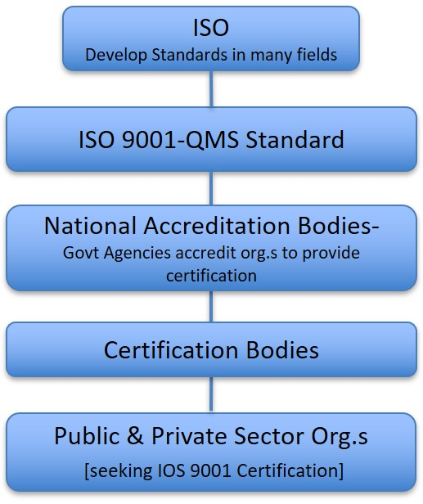
Figure 1: Hierarchal overview of the accreditation and certification structure
that provides certification to NMHSs.

Option 2 (A Joint ISO–WMO Climatological Standard)
In terms of the delivery of climate services, a Joint ISO–WMO agreed climate services standard does not currently exist. ISO 9001 provides the overarching framework for ensuring sound and consistent management in any technical programme or process that leads to producing outputs and delivering them to the user community.
The development of a Joint ISO–WMO Climatological Standard would take a considerable time to achieve. This option may be required when there is a recognized benefit to all stakeholders. However, in the absence of such a requirement for climate services, ISO 9001 would provide the requirements for an overarching management framework (see option 1). It would not provide the detailed and comprehensive technical requirements applicable to the delivery of climatological products and services. It would however provide a broad and consistent approach to the delivery of climatological products and services within an ISO 9001 framework.
The set of WMO climatological regulatory materials “Guides, Manuals, Guidelines, Guidance, etc”. would provide the “normative references” within an ISO 9001 QMS framework. Their consolidation into a Joint ISO–WMO Standard would provide the status and international credibility that the WMO climate community requires, under this pathway, if so chosen.
As WMO already has an agreement with ISO, the development of a Climatological Standard in principle should be relatively straightforward. However, as previously stated, there would be a significant amount of work to consolidate and as necessary develop the current WMO set of climatological regulatory materials into the ISO format and structure in which the requirements would be articulated. For example, the use of “shall and should” in terms of the requirements, would need to be clarified.
The following link to the appropriate ISO website (see below), provides an overview pertaining to this discussion. Within this option, extensive consultation between ISO and WMO would be required. https://www.iso.org/developing-standards.html
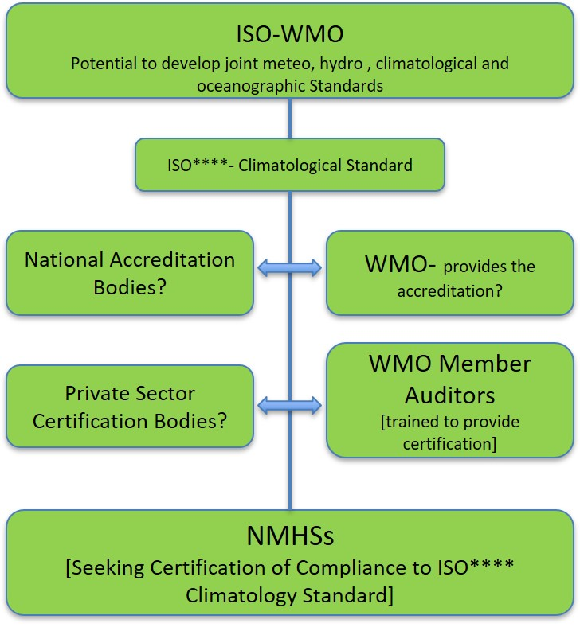
Figure 2: An ISO–WMO potential pathway to establish a joint climatological standard
- Annex SL (Note: the SL is not an acronym)
Annex SL provides a high-level structure for ISO management systems standards, and it has been created to introduce identical core text and common terms and definitions. It also ensures consistency and compatibility between the different Management System Standards. It will:
- Streamline standards;
- Encourage standardization; and
- Ease the integration of management systems.
It would be anticipated that the high-level major clauses of a joint climatological standard would reflect the current ISO 9001 Clauses but would as and where appropriate, be renamed to reflect the climatological subject matter in the following areas:
- Scope
- Normative References
- Climatological Terms and Definitions
- Context of the Organization
- Leadership
- Planning
- Support
- Operation (perhaps: Climatological Practices and Procedures)
- Performance Evaluation
- Improvement
As such, it would seem appropriate that any new Joint ISO–WMO Climatological Standard would be developed within the Annex SL format.
If this were the case, it could be anticipated that a new Joint ISO–WMO Climatological Standard if deemed certifiable could potentially take the place (for the delivery of climate products and services), of the generic ISO 9001 management standard in the future. However, in the interim (some years we suspect), it is imperative that a quality management approach is adopted within the ISO 9001 framework. Arguably the transference to the new ISO–WMO Climatological Standard would be relatively simple from those climate services already certified as ISO 9001 compliant.
- Auditing and Certification of the new Joint ISO–WMO Climatological Standard
If it is assumed WMO will desire the new Joint ISO–WMO Climatological Standard to be certifiable by an external audit body it will be challenging to identify an appropriate certification body with a specific level of technical subject expertise in climate services. As a result, part of this process should also include training appropriate personnel to be capable of performing audits against the proposed Standard. See section 4.
It is strongly recommended that the auditing capacity is not just based on climatological academic qualifications, skills, knowledge, and experience. It is an absolute imperative that staff undertaking auditing roles are trained and qualified as Lead Auditors in line with current internationally accepted standards such as those recognized by the International Auditing and Assurance Standards Board (IAASB) and the requirements of the International Register of Certificated Auditors (IRCA).
Note: All auditors conducting audits on behalf of WMO, must be qualified as Lead Auditors.
The combination of underpinning academic climatological qualifications, WMO recognized levels of competence and Lead Auditor skills, will provide NMHS with the opportunity to capitalize on the findings from a professional audit to continually improve and importantly, not undermine the very credibility of the proposed Climatological Standard. It will also provide assurance that auditors have the requisite skills and ability to perform the audit effectively.

Option 3 (WMO QMS Verification and Certification of Compliance of Climate Services)
Option 3 strongly encourages WMO Members to adopt a quality management approach to the delivery of their climatological products and services and achieve certification of compliance to ISO 9001. However, WMO is a technical standard-setting organization that monitors the implementation of the WMO technical regulatory framework and develops them further in a consistent manner by all technical bodies involved, such as the Commission for Observation, Infrastructure, and Information Systems (Infrastructure Commission – INFCOM), and the Commission for Weather, Climate, Water and Related Environmental Services and Applications (Services Commission — SERCOM). The latter contributes to the development and implementation and consistent management of globally harmonized weather, climate, water, ocean and environment-related services and applications to enable informed decision-making and realization of socioeconomic benefits by all user communities and society as a whole.
The following are envisaged as key components of a proposed “stand-alone” WMO Climatological Standard (developed independently of the International Organization for Standardization), as part of option 3:
    - A Process Approach
In this case, WMO recognized/endorsed climate processes, practices and procedures are adopted/adapted within an ISO 9001 QMS framework and are applied more specifically to climate services in the areas of data, monitoring, prediction, and service delivery. The processes for each of these areas are elaborated in the publication WMO-No. 1221 (2018).
    - Technical Standards
WMO has published Technical Regulations, which shall be implemented by NMHSs, complemented by a large set of Guides, Manuals and Guidance materials that should be taken into consideration as normative and recommended practices. These materials, collectively constitute the regulatory basis and describe good practices, procedures, and specifications that Members are encouraged to apply in their services to ensure compliance or conformity with WMO standards.
For a non-exhaustive list of the WMO climatological standards and recommended practices, refer to Annex I. The inventory of the WMO regulatory materials pertaining to climatological practices will be further completed in consultation with Expert Teams in the composition of SC-CLI to provide the best matching of the WMO publications with each of the processes indicated for data, monitoring, prediction and service delivery in WMO-No. 1221 (2018).
    - Competency-based training
WMO has adopted the Competency Framework for Climate Services, as indicated in Technical Regulations No. 49 (Vol. I), WMO-No. 1205 and WMO-No. 1209. This constitutes the basis to ensure that the designated staff in each area of climate services, namely, data, monitoring, prediction, service delivery and communications have sufficient skill in one or more areas to deliver standard products. In preparation for the implementation of the QMS in climate services, WMO has further started training nominated experts from NMHSs to serve as Lead/Internal Auditors in their respective NMHSs. See section 4.
    - Identification of the Verification of stated climate practices and procedures
The WMO Checklist for Climate Services Implementation provides the basis to verify the responses from NMHSs against the artefacts in an auditing process that leads to the preparation of ISO 9001 focused and formatted reports. These reports identify the gaps, non-compliances between the current management system and the requirements of the Climate Services Checklist and ISO 9001. Proposed remedial actions are identified to close the gaps and provide an initial classification of climate services within the Basic, Essential, Full and Advanced categories. Annex I to this Roadmap explains the methodology on the identification of the sources of evidence, their assessment, and conclusions by WMO Member Lead Auditors.
    - Identification of Certification Procedures
The Standing Committee on Climate Services (SC-CLI) of SERCOM will discuss the procedures for establishing a Technical Advisory Board under the auspices of the Capacity Development Panel (CDP) who should be authorized by the WMO Executive Council or Congress on issuing the Certification of Compliance and classification of the capacity level of the climate services of NMHSs. It has to be established and clarified whether or not conformity is going to be accepted. That is, certification of compliance is achieved via a third party (external) audit, whereas conformity is established by an internal audit. The WMO certification confirms the classification of climate services (Basic, Essential, Full or Advanced level) assigned during the verification and classification steps.
Annex I to this Roadmap expands on the verification methodology which has been implemented during the pilot phase for auditing the responses to the Checklist for Climate Services Implementation from 14 NMHSs.
Overall, the outcome of the WMO Climate Services QMS certification would entail:
- Checking the status of compliance of the WMO Members with Technical Regulations, including advice on identified barriers to compliance and ways to address them to resolve deficiencies;
- Assessing the impact and risk of new standards and technology on the systems operated by Members, including financial and human resources impact;
- Addressing the evolving user needs for information and services and alignment of the plans of the WMO technical bodies to meet those needs;
- Enhancing collaboration and coordination between the technical bodies;
- Classifying the level of climate services of the target countries based on quantitative and qualitative analysis of the Checklist, as a result of QMS auditing standards; and
- Certification of the resulting climate services capacity level.

Hierarchy of the Climate Services Checklist Response Verification
and Certification Processes
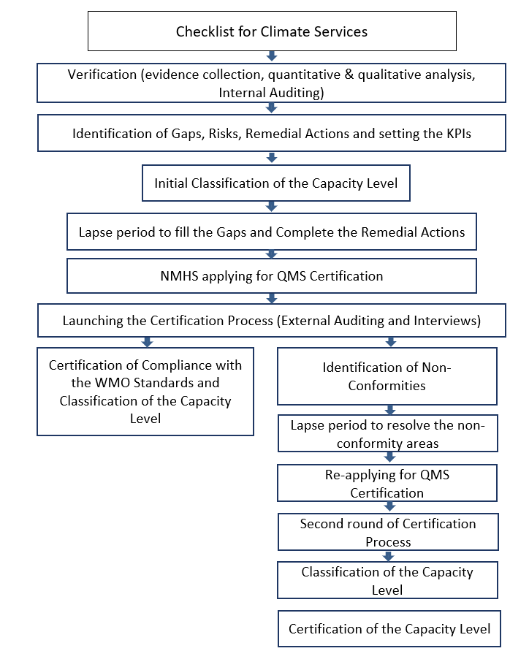

Training

Quality management training providers
- All providers of quality management and/or Management System Auditing and Lead Auditor training courses must be formally registered or certified with a national training organization;
- All auditor training should be underpinned by ISO 19011:2018 Guidelines for auditing management systems;
- All trainers should be qualified Lead Auditors with extensive auditing experience; and
- Statements of Attainment issued to participants should have international recognition.

Auditor Training Courses
- All auditor training is to be aligned with current internationally accepted standards such as those stated by organizations such as, the International Auditing and Assurance Standards Board (IAASB) and/or the requirements of the Chartered Quality Institute (CQI) and the International Register of Certificated Auditors (IRCA).
- The Management of Auditing Systems (Internal Auditor), course curriculum should provide the skills and knowledge that develop a deeper understanding of ISO 9001 and how it can be interpreted and applied in a variety of different business/industry sectors. The curriculum should cover at a minimum the following topics:
- Quality Management Systems;
- Quality concepts;
- Audit process;
- Auditing the ISO 9001 standard;
- Organizational context;
- Leadership and commitment;
- Quality planning;
- Support and resources;
- Operational planning and control;
- Quality performance evaluation;
- Quality improvement.
- The Lead Auditor course should provide comprehensive training in the theory and practice of leading a Quality Management Systems audit based on ISO 9001:2015 and ISO 19011:2018. To gain a practical understanding of the responsibilities of a lead quality auditor, and the techniques and methodologies required to effectively lead a QMS audit. The curriculum should cover at a minimum the following topics:
- ISO 9001 Overview;
- Managing an Audit Program;
- Audit planning and preparation;
- Performing the Audit – practical exercises for participants;
- Reporting Audit Outcomes;
- Quality Management Systems;
- Quality Management Concepts;
- The Audit process and auditing the ISO 9001 standard;
- Context of an organization;
- Leadership.

ANNEX I

Verification of Responses to the WMO Checklist for Climate Services Implementation and Certification of Climate Services Capacity Level

Introduction
This methodology explains the verification of responses to the WMO Checklist for Climate Services Implementation as the first step for the development and implementation of a Quality Management System (QMS) in climate services based on ISO 9001:2015. Certification of compliance to ISO 9001 and WMO regulatory materials can be achieved. For detailed information on the ISO processes, refer to WMO-No. 1100 (2017) and WMO-No. 1221 (2018).

Methodology
Figure 1 shows an overview of the verification process that consists of four steps, ranging from identification of the sources of evidence to reporting based on the assessment of the evidence.
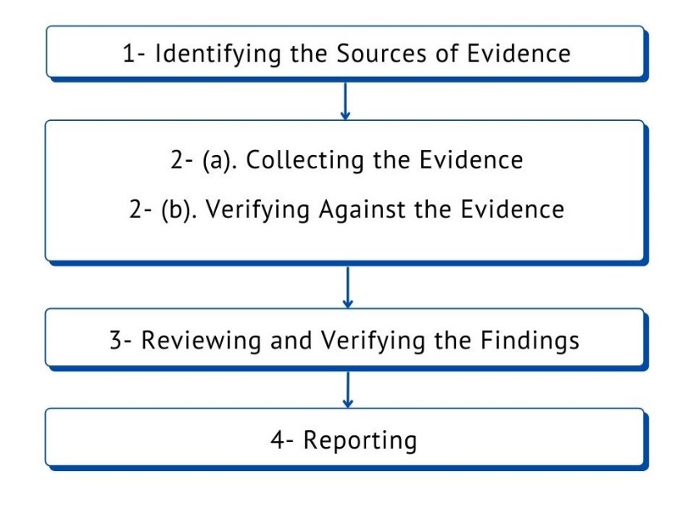
Figure 1. Main steps for identification and use of the evidence for verification

1. Identifying the Sources of Evidence:
The sources of evidence are broad. They are mainly composed of the WMO Regulatory Materials such as Technical Regulations and additional WMO publications that indicate required and recommended practices in climate services. For a non-exhaustive list, refer to Annex II. Other sources of documents include for example classified documents, web resources, etc.,

2(a) Collecting the Evidence:
Only information that can be subject to some degree of verification should be accepted as evidence. The documents shall be the official documents or shall maintain some degree of formality. The informal, outdated documents without the data and authorization of a responsible employee shall not be accepted. Figure 2 shows the steps for exploring the sources of the evidence.

2(b) Verifying Against the Evidence:
During the verification process, responses to each of the Checklist questions are to be verified against the evidence collected through various sources.
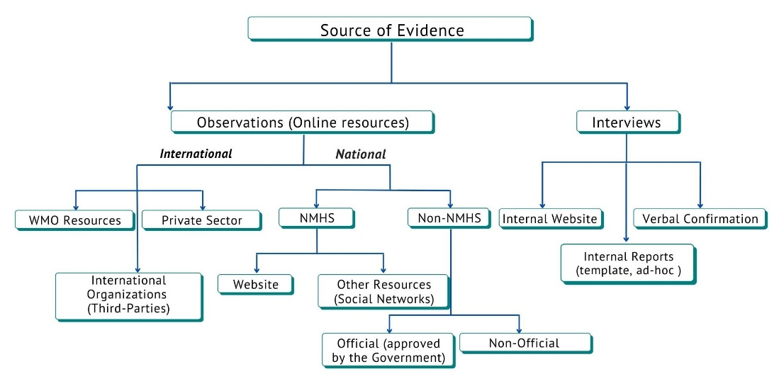
Figure 2. The flowchart for collecting sources of evidence for the checklist

3 Reviewing and Verifying the Findings:
The auditee’s relevant documented information should be reviewed to:
(a) Determine the conformity of the climate services value chain with the WMO regulatory materials, as far as documented under the verification and certification criteria.
(b) Gather information to support the verification activities. In case the evidence does not support the responses provided in the checklist, further communication with the country is sought to gather more evidence. If the additional evidence still does not confirm the checklist response, then an agreement is sought with the country on the revised checklist answer.

4 Reporting:
After completing the verification process, a time frame should be stated to follow up on any identified actions. Auditors shall provide a report to summarize the main findings and provide the verified checklist responses, and the suggested corrective action. If needed, a subsequent verification could be scheduled to verify the effectiveness and completeness of these actions.

References
- ISO 9001:2015: Quality Management Systems — Requirements, https://www.iso.org/standard/62085.html;
- ISO 19011:2018: Guidelines for auditing management systems, https://www.iso.org/standard/70017.html;
- Guide to the Implementation of Quality Management Systems for National Meteorological and Hydrological Services and Other Relevant Service Providers (WMO‑No. 1100);
- Guidelines on Quality Management in Climate Services (WMO‑No. 1221);
- Technical Regulations, Volume I: General Meteorological Standards and Recommended Practices (WMO-No. 49);
- Guide to Competency (WMO-No. 2105);
- Compendium of WMO Competency Frameworks (WMO-No. 2109).

ANNEX 2
The referenced WMO Regulatory Materials Used in the Evidence Collection
Category | Title | Summary of purpose | Edition | Remarks
Overall | WMO-No. 49  Technical Regulations, Volume I: General Meteorological Standards and Recommended Practices | a) To facilitate cooperation in meteorology and hydrology among Members.  (b) To meet, in the most effective manner, specific needs in the various fields of application of meteorology and operational hydrology in the international sphere.  (c) To ensure adequate uniformity and standardization in the practices and procedures employed in achieving (a) and (b) above. | 2021
 | WMO-No. 100  Guide to Climatological Practices | Guidance and assistance in developing national activities linked to climate information and services | 2018
 | WMO-No. 1100  Guide to the Implementation of Quality Management Systems for National Meteorological and Hydrological Services and Other Relevant Service Providers | Guidance to WMO Members on how to develop and implement a QMS | 2017
 | WMO-No. 1195  Guidelines on the Role, Operation and Management of National Meteorological and Hydrological Services | – Ensuring that the NMHS is able to meet national needs for meteorological, hydrological and related data and services;  – Responding to newly identified challenges in a rapidly changing world;  – Clarifying and articulating the mandate of the NMHS;  – Formulating and implementing effective strategic plans; | 2017
 | WMO-No. 1221  Guidelines on Quality Management in Climate Services | Provide NMHSs with guidelines and best practices for implementing a QMS in their climate services with respect to ISO 9001 | 2018
 | WMO-No. 1205  Guide to Competency | Provides competency implementation advice to Members. | 2018
 | WMO-No. 1209  Compendium of WMO Competency Frameworks | Provide Members with easy access to all the WMO competency frameworks | 2019
 | WMO-No. 1160  Manual on the WMO Integrated Global Observing System | (a) To specify the obligations of Members in the implementation and operation of WIGOS;  (b) To facilitate cooperation in observations among Members;  (c) To ensure adequate uniformity and standardization in the practices and procedures  employed in achieving (a) and (b) above. | 2021
 | WMO-No. 1133  WMO Capacity Development Strategy and Implementation Plan | Was designed to assist all Members, especially least developed  countries and small island developing States. | 2015
Climate Data | WMO-No. 488  Guide to the Global Observing System | provide practical information on the development, organization, implementation, and operation of the Global Observing System in order to enhance both the participation of individual Members in the System and the benefits they may obtain from it. | 2017
 | WMO-No. 100  Guide to Climatological Practices | Guidance and assistance in developing national activities linked to climate information and services | 2018 | Chapters 3, 4 and 5
 | WMO-No. 8  Guide to Instruments and Methods of Observation | to provide guidance on the most effective practices and procedures for, and the capabilities of, instruments and systems that are regularly used to perform meteorological, hydrological, and related environmental measurements and observations in order to meet specific requirements for different application areas. | 2018
 | WMO/TD-No. 1186  Guidelines on climate metadata and homogenization | provide information and assistance on how to organize and implement climate services, and present processes and technological solutions | 2003
 | WMO-No. 485  Manual on the Global Data-processing and Forecasting System: Annex IV to the WMO Technical Regulations | to ensure adequate uniformity and standardization of data, information and production practices, procedures and specifications employed among WMO Members in the operation of the Global Data-processing and Forecasting System (GDPFS) as it supports the mission of the Organization. | 2019
 | WMO-No. 1131  Climate Data Management System Specifications | This publication defines a set of policies and governance processes that are necessary to effectively manage climate data. These policies should be implemented as a global framework to facilitate better integration of climate data between NMHSs and ease the workload required for regional and global analysis of climate data. | 2014
 | WMO-No. 1182  Guidelines on Best Practices for Climate Data Rescue | The Guidelines cover a wide range of guidance that should provide assistance on how to organize and implement data rescue and provide generalized technological solutions for every Member | 2016
 | WMO-No. 1238  Manual on the High-quality Global Data Management Framework for Climate | Provides guidance and requirements on the development, provision, exchange and maintenance of high-quality climate datasets. | 2019
 | WMO-No. 1269  Guidelines on Surface Station Data Quality Control and Quality Assurance for Climate Applications | Provides a relatively  high‑level overview of the principles underpinning the effective quality assurance (QA) of climate data as well as considerations for the operational QA and quality control (QC) of meteorological  data from surface observing stations at various stages of the data life cycle. It then proposes in the annexes a range of QA and QC tests classified as mandatory, recommended and optional. | 2021
Climate Monitoring | WMO-No. 100  Guide to Climatological Practices | Guidance and assistance in developing national activities linked to climate information and services | 2018 | Chapter 6
 | WMO-No. 1160  Manual on the WMO Integrated Global Observing System | The Manual is designed:  (a) To specify the obligations of Members in the implementation and operation of WIGOS.  (b) To facilitate cooperation in observations among Members.  (c) To ensure adequate uniformity and standardization in the practices and procedures employed in achieving (a) and (b) above. | 2021
Climate Prediction | WMO-No. 1220  Guidance on Verification of Operational Seasonal Climate Forecasts | Describe and recommend procedures for the verification of operational probabilistic seasonal forecasts, including those from the Regional Climate Outlook Forums (RCOFs), NMHS and other forecasting centres | 2018
Service Delivery | WMO-No. 1129  The WMO Strategy for service delivery and its implementation plan | to help NMHSs raise standards of service delivery in the provision of products and services to users and customers | 2014
 | WMO-No. 1247  Capacity Development for Climate Services: Guidelines for National Meteorological and Hydrological Services | Provide NMHSs and other climate service providers with up-to-date information on available resources, strategies, procedures, and best practices available to help develop their capacities in the provision and use of climate services | 2020
 | WMO-No. 1214  Guidance on Good Practices for Climate Services User Engagement | Delivery and use of climate services | 2018
_______________

As specified by ISO 9001:2015 Quality Management Systems – Requirements, sub para 0.2.
“SL” is the sequential number of an Annex within numerous annexes as part of a document titled ISO/IEC Directives, Part 1, ‘Consolidated ISO Supplement – Procedures specific to ISO’.
Only information that can be subject to some degree of verification should be accepted as evidence. Wherever the degree of verification is low, auditors should use their professional judgement to determine the degree of reliance that can be placed on it as evidence. The outdated documents are not acceptable. The documents shall be signed by the appropriate authority.

