WEATHER CLIMATE WATER | World Meteorological Organization  COMMISSION FOR WEATHER, CLIMATE, WATER AND RELATED ENVIRONMENTAL SERVICES AND APPLICATIONS  Second Session  17 to 21 October 2022, Geneva | SERCOM-2/INF. 5.10(3b)
Submitted by:
Chairs of the SG-HEA
7.X.2022

INTEGRATED HEALTH SCIENCE AND SERVICES CONCEPTUAL FRAMEWORK
Draft for Comment September 2022

About
The Eighteenth World Meteorological Congress (Cg-18) Resolution 33 on Advancing Integrated Health Services provided a new opportunity to support partners to address climate risks, by strengthening the mandate of National Meteorological and Hydrological Services (NMHS) to collaborate with the health sector; to strengthen operational and coordination mechanisms; to enhance tailored research and data services; to develop technical norms and standards for operationalization, and to develop institutional and human resource capacity. These goals reflect a continuation of the Global Framework for Climate Services aspirations for the health sector, piloted from 2014-present.
In January 2020, WMO together with the World Health Organization (WHO) convened a joint expert team on Integrated Health Information Science and Services to advance this resolution and the implementation of the WHO-WMO Collaboration Framework Agreement on Health, Climate and Environment, vis-a-vis the Health, Environment, and Climate Science to Services Master Plan (2019-2023). This Master Plan provides a high-level alignment of existing WHO and WMO mechanisms and initiatives with the aim of strengthening cooperation and harmonization. The plan does not speak to the approach needed or “how” to scale up awareness, capacity, and strategic mechanisms that will enable broad use of climate science in the sector.
This expert team made multiple recommendations, including that the policy and technical cooperation mechanisms to be established between WHO and WMO to advance this plan, should to the extent possible, reflect and encourage integration of more comprehensive risk management and capacity building at national, regional, and global levels. They recommended the development of an integrated health framework to establish and sustain partnerships that define, clarify and enhance shared understandings for the optimal development and provision of climate services, as well as serve to educate key actors on the multiple driving forces and complex interactions of risk factors which are occurring, across timescales (e.g. heat), the intertwined technical domains involved (e.g. weather and air pollution; heatwaves, drought and fire); and the multiple sectors (e.g. water, urban planning); contextual issues (e.g. population characteristics, such as demographic, socioeconomic) and geographies (e.g. rural vs. Urban, transboundary fire, heat, or drought) which must be accommodated and addressed.
The newly established WHO-WMO Services Commission Study Group on Health picks up from the prior expert team to develop the present framework that can guide operational and strategic steps to advance the use of climate science in the health sector.
The goal of this framework is to accelerate the success of multisectoral actors to generate, provide, and apply relevant and sound climate, weather, and environmental aspects to health policy and practice decisions.

Introduction and Rationale
Climate change is the single biggest health threat facing humanity, and health professionals worldwide are already responding to the health harms caused by this unfolding crisis. To sufficiently prepare health professionals worldwide, the integration of meteorology, climatology, and related environmental sciences (hydrology, atmospheric sciences) with the fields of health and medical sciences is now indispensable to understand and address climate and weather-related health risks and opportunities, at multiple temporal and spatial scales.
“Climate services” are a vehicle through which climate and other types of information can be tailored to appropriately inform sectoral decision-makers. These services take many forms, but all have common characteristics and the common goal to produce integrated and actionable climate information, stemming from a well-grounded holistic perspective of past, present or future states of climate-related risks to society. An entire field of applied climate science and industry is developing around the provision of such intelligence.
For the health community, because a majority of health impacts are not directly linked to singular climatic conditions, the creation of climate information products, such as maps, indices, trends, or forecasts, is accomplished by blending scientifically informed understandings about the climate and weather with a range of relevant health, environmental, socioeconomic, behavioural, cultural, or other information, particularly about population vulnerabilities, exposures, and impacts. (See Figure 1). In the case of the health sector, this blending requires a range of analytical techniques to integrate spatial-temporal weather and climate information in combination with clinical, epidemiological and other health data. The goal is to understand and apply knowledge about how climate in the past, present, or future influences health outcomes, health risks, and health service delivery. Thus, by definition, the process of developing tailored climate information products requires partnerships and collaborative efforts between many actors and disciplines.
It is for this reason, climate services for health are not defined exclusively as an end-product delivered from a “provider” to a “user”, but as “the entire iterative process of collaboration between relevant multidisciplinary partners to identify, generate and build capacity to access, develop, deliver, and use relevant and reliable climate knowledge to enhance health decisions.” This type of co-production depicts the first level of “integration” we discuss here.
Furthermore, appreciating that “climate services” provide supplementary and complementary intelligence to the risk assessment, health policy, and health practice landscape, the type of collaborative partnerships and co-produced actions we recommend, actually serve the basis for a more comprehensive vision of creating “integrated climate and health information systems” that are likely a more sustainable, enabling, and fit-for-purpose way to support the health sector.
Therefore, this paper outlines a conceptual framework and set of good practices that can facilitate such a paradigm shift. The implementation of these approaches and principles can guide the creation of appropriate and sustainable integrated climate and health information systems which are more responsive to decision and capacity needs, and can result in the application of tailored intelligence with respect to climate risks and simultaneously shape the capacity and policy environment to better address risks through action and policy.
This framework aims to encourage new ways of operating which are informed by the characteristics of:
- Climate, weather, and environmentally related health risks and opportunities;
- Key operating principles and expectations (learned by experience and reflecting sectoral decision-making practices);
- Common sectoral knowledge needs (see Table 2);
- Current practices and identified pitfalls of tailoring and using applied climate science.
Table 1 Description of Integration
What do we mean by integration?
Co-production requires integration of people:  - People with diverse roles, expertise, and responsibilities (e.g. researchers, policy and operational staff)  - Actors from multiple sectors  - Community members for the co-production of community-based participatory research | Integration means inclusion of information from:  - Interdisciplinary knowledge and data  - Diverse range of data types  - Across timescales, of both climate and weather  - Across geographic scales  - Addressing both climate impacts and opportunities for adaptation and mitigation  - About capacity and readiness to product and service design  - About policy and operating environment to product and service design and evaluations  - Considerations about context, costs, and ethics  - Quantitative and qualitative data  - Co-benefits and co-harms | Integration means aligning with other integrated approaches, such as:  - All-hazard management to address simultaneous, cascading and compounding exposures and vulnerabilities  - Onehealth framework to capture non-human transmissible disease drivers (e.g. animal and environment)  - Planetary health framework to describe large scale drivers and interactions affecting health  - Health in all policies approaches  - EcoHealth to account for ecology, health sciences and sustainability

Climate and weather-related health risks and opportunities
The direct and indirect influences of meteorological and climatic conditions on health outcomes, such as disease burden or mortality are complex. Climate and weather conditions can result in acute health impacts, as well as result in cascading events, with one leading to the other, if they are causally connected. For example, heavy rain events can result in flooding of critical infrastructure in the flood plain with all the downstream implications for water and sanitation systems, and waterborne disease transmission. At one end of a spectrum, extreme weather events can seriously affect people’s mental and physical health and can compromise their access to health care, food, clean water and physical safety due to existing vulnerabilities with adverse health outcomes such as illness, injury or death. And at the opposite end, even small or gradual changes in weather and climatic conditions – such as local temperature, humidity or wind direction – can result in significant shifts in people’s exposure to harmful or beneficial conditions, from disease transmission to changing water quality. Climate risks to health are often not singular; meaning many risks may be present at the same (e.g. water borne, vector borne disease and flooding), occur in a cascading manner (e.g. droughts and heatwaves), and be compounding where impacts of one climate-related hazard give rise to other vulnerabilities. These risk characteristics define the multifactorial risk landscape in which health professionals operate. Therefore, the all-hazard risk management approach must guide the framework used for enhancing risk intelligence.
Health risks from climate and weather can be, for example: often simultaneous, compounding, multi-temporal, cascading, involve dynamic impacts driven by human behaviour, which are often high resolution such as urban scales (e.g. heat, drought, fire, air quality, water quality). Risks cannot easily be separated and cannot be managed separately in many cases. Therefore, climate information systems must also accommodate the multifaceted nature of actual risks.
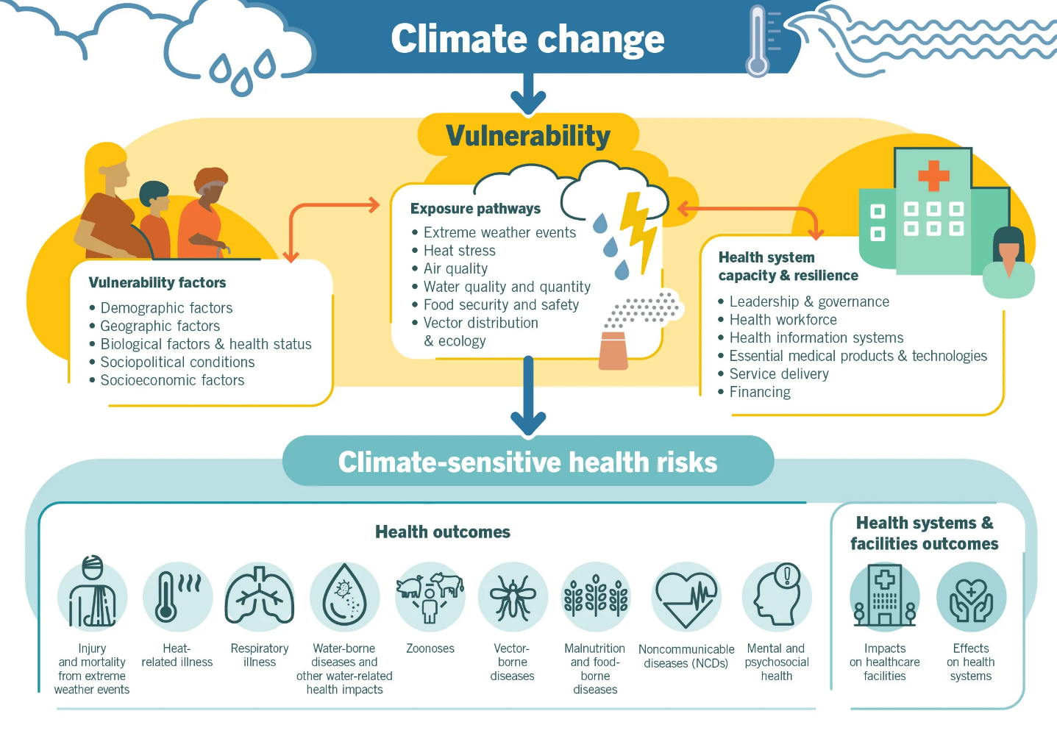
Figure 1 Pathways of Health Risks Created by climatic and environmental changes (WHO, 2020)
Climate-related public health risks will vary by region and population. Common, but not exhaustive, health risks which are affected by climate and environment often include:
- Extreme heat and cold exposure
- Extreme weather exposure (cyclones, storms, lightning strikes)
- Water borne diseases
- Vector borne diseases
- Non-communicable diseases
- Nutrition, food safety and security
- Water quantity and quality
- WASH (Water, Hygiene and Sanitation)
- Exposure to poor air quality (pollution, pollen, sand and dust, biomass/trash burning)
- Exposure to fire risk
- Mental and psychosocial health
- Injuries, fatalities, drowning
- Exposure to drought (dehydration)
- Exposure to civil conflict
- Displacement
- Health system impacts, including disruption to health services and infrastructure Climate, weather, and environmental conditions also impact health service delivery in ways that cost lives and money, such as limiting the delivery of medical supplies or ambulatory services. Moreover, climate services can be used for proactive management of public health risks such as:
- Description of climate, weather, and environmental conditions and its associated adverse health impacts
- The exposure assessment of individuals and populations to climate, weather, and environmental conditions
- The evaluation of the context, vulnerabilities and coping capacities associated with climate, weather, and environmental conditions
- Estimation of the impact of climate, weather, and environmental conditions
- Evaluation and planning of climate resilience and low-carbon operations of health systems
Climate services can be used for the systematic and iterative process of identifying far reaching risks to public health and to recognize how these risks can be managed. Climate information can be used to differentiate distinct types of climate hazards, the associated population exposures and vulnerabilities from climate change and prioritize diverse types of public health interventions. Prioritization entails ranking limited resources against current public health impacts, future risks, the effectiveness of measures, and other factors.
Climate information can help inform climate resilient health systems and build more climate resilient health infrastructure for providing safe and quality care in the context of climate change. This includes (1) the health workforce; (2) water, sanitation, hygiene, and health care waste management; (3) sustainable energy services; and (4) Infrastructure, technologies, and products.

Addressing Needs and Challenges
Providing tailored products to address the decision needs of the health sector, is only part of the puzzle. Two sets of foundational and underlying challenges must first be addressed if transformational change in practice is to occur. This starts with attention and investment to the range of barriers and challenges reported by the Meteorological Services and other climate and environmental service providers to work with the health sector and to provide basic and applied information and services. Secondly, the common bottlenecks experienced by researchers and practitioners coproducing and using this information must be analysed and addressed more systemically.

Challenges faced by NMHS and Regional Climate Centres to work effectively with health partners
Through WMO’s preliminary engagements with the WHO and health sector, a range of unmet needs have been identified spanning WMO regions, programmes, hazards, and timescales, including the need to support NMHS/RCC capacities to become more effective service providers to the underserved health sector.
These include inter-alia the need for:
- Stronger mandates to work with the health sector
- Technical advisory to NMHSs to engage in health-related research and projects
- Increased availability and access to historic and real-time observational data and information for research and risk monitoring
- Sufficient quality and skill in short-term, medium-term, and long-range weather forecasts, seasonal forecasts, and climate projections which respond to the technical requirements of the health partners
- Increased R&D investment to develop tailored products and operational services spanning multiple timescales and cascading risks
- Brokering of appropriate partnerships and identification of experts
- Analytical and translational services to synthesize regional and global products
- Establishment of standards, technical guidance, and capacity building for both service delivery and appropriate application of weather, climate, water, and environmental research, products, and services
- Improved marketing of available products and services to generate further demand
Challenges currently faced by partners in health research and practice
Recommendations have been made in the Climate Services for Health Fundamentals and in Climate Information for Public Health Action to address common operational bottlenecks including:
- Turning available data into fit-for-purpose products and services
- Securing and sustaining adequate financial and human resources
- Generating adequate demand and endorsement to mainstream climate information to decision-making
- Drawing upon and developing sufficient foundational capacities to support climate services
- Translating and communicating climate risks effectively
- Training the public health workforce in the use of these services
- Mainstream the use of climate data in health impact assessments

Information and services needed by the health sector
The potential application of climate and environmental science in the health field is vast, considering the complex climate impact pathways for health outcomes and the range of applications for health service provision and health system management. However, generically speaking, common decision needs may require a common suite of climate knowledge products to understand extreme weather, seasonal trends, and long-term projections that could be prioritized, as a minimum package, to make available to health partners.
Table 2 outlines common generic applications requested by the health sector to better understand the influence of climate and weather on health outcomes, health services, and health system management. These applications are broadly broken down by timescale, into types of products and applications requiring historical or past data which are fundamental to understanding mechanistic linkages and risks; current and real-time information to monitor risk conditions, and products which project future conditions. These products may not be mutually exclusive.
Table 2 Common generic climate information products requested by the health sector
Timescale Focus | Example Health Applications | Common Climate Inputs | Readiness Requirements
Understanding links and risks  [Timescale focus: Past] | Vulnerability & Adaptation Assessment  Climate Normals and Profiles  Scientific Literature | - Descriptive baselines of health outcomes and risks  - Descriptive analyses of local climate conditions (climatology/seasonality, ENSO influence)  - Spatial and temporal epidemiological analyses of sensitivity: mechanistic and ecological impact studies  - Analysis of population exposure and vulnerability | Climate Services to provide historical Climate Data  Sufficient historical Epidemiological Data  Analytical Capacity
Monitoring Risk  [Timescale focus: present] | Specific Disease Control Risk Analysis (Malaria or Meningitis Suitability Bulletin)  Air Quality Monitoring and public advisory  UV Indices and public advisory  Outbreak Monitors | - Indicators, Indices, Thresholds  - Risk Assessments  - Seasonal Climate Bulletins  - Risk monitoring  - Integrated surveillance systems | Consistent Climate Data Access  Systems based data collection  Decision process to feed into
Anticipating Risks  [Timescale focus: near future (months/years] | Weather and Emergency Advisories  Seasonal Disease Calendar | - Disease Modelling and Mapping  - Environmental Suitability modelling and Mapping  - Severe Weather Alerts  - Early Warning Systems  - Seasonal Forecasts and Impact Calendars  - ENSO prediction and Monitoring  - Risk-based action plan | Weather and Climate Services to provide SW Alerts, forecasts, projections, scenarios  Partnerships
Planning Future Risk  [Timescale focus: more distant future (years)] | Heat Action Plans  Water Safety Plans  Safe Hospitals  Health-National Adaptation Plans | - Climate Projections  - Climate Scenarios  - Adaptation Plans  - Hazard specific risk Management  - Awareness, Communications, and Mobilization | Sufficient evidence and understanding  Political and social will  Resources

Framework for Integrated Climate and Health Science and Services
Experience, gap analyses, expert opinion, and increasingly evaluations and research findings on the application of climate science in the health sector, all point to a convergent set of principles and approaches that can maximize practices and impact. A principal learning is that applied climate information products and services do not exist in isolation. This information joins a complex ecosystem of decision-makers, localized challenges and contexts, diverse ranges of potentially useful information and misinformation, varied capacities and social considerations, all amidst a rapidly changing and dynamic climate risk context. Therefore, we propose it is much more efficient to focus on creating information systems and an agile operating/decision-making environment that can build capacity and augment existing sectoral data, knowledge, and decision tools with reliable and relevant climate information.
This framework outlines seven good practice principles, as well as expectations and considerations, which can support health and meteorological actors to understand, adapt, and mitigate the impacts of climate change in the health sector. These approaches are iterative and reinforce one another.

Overview Good practices
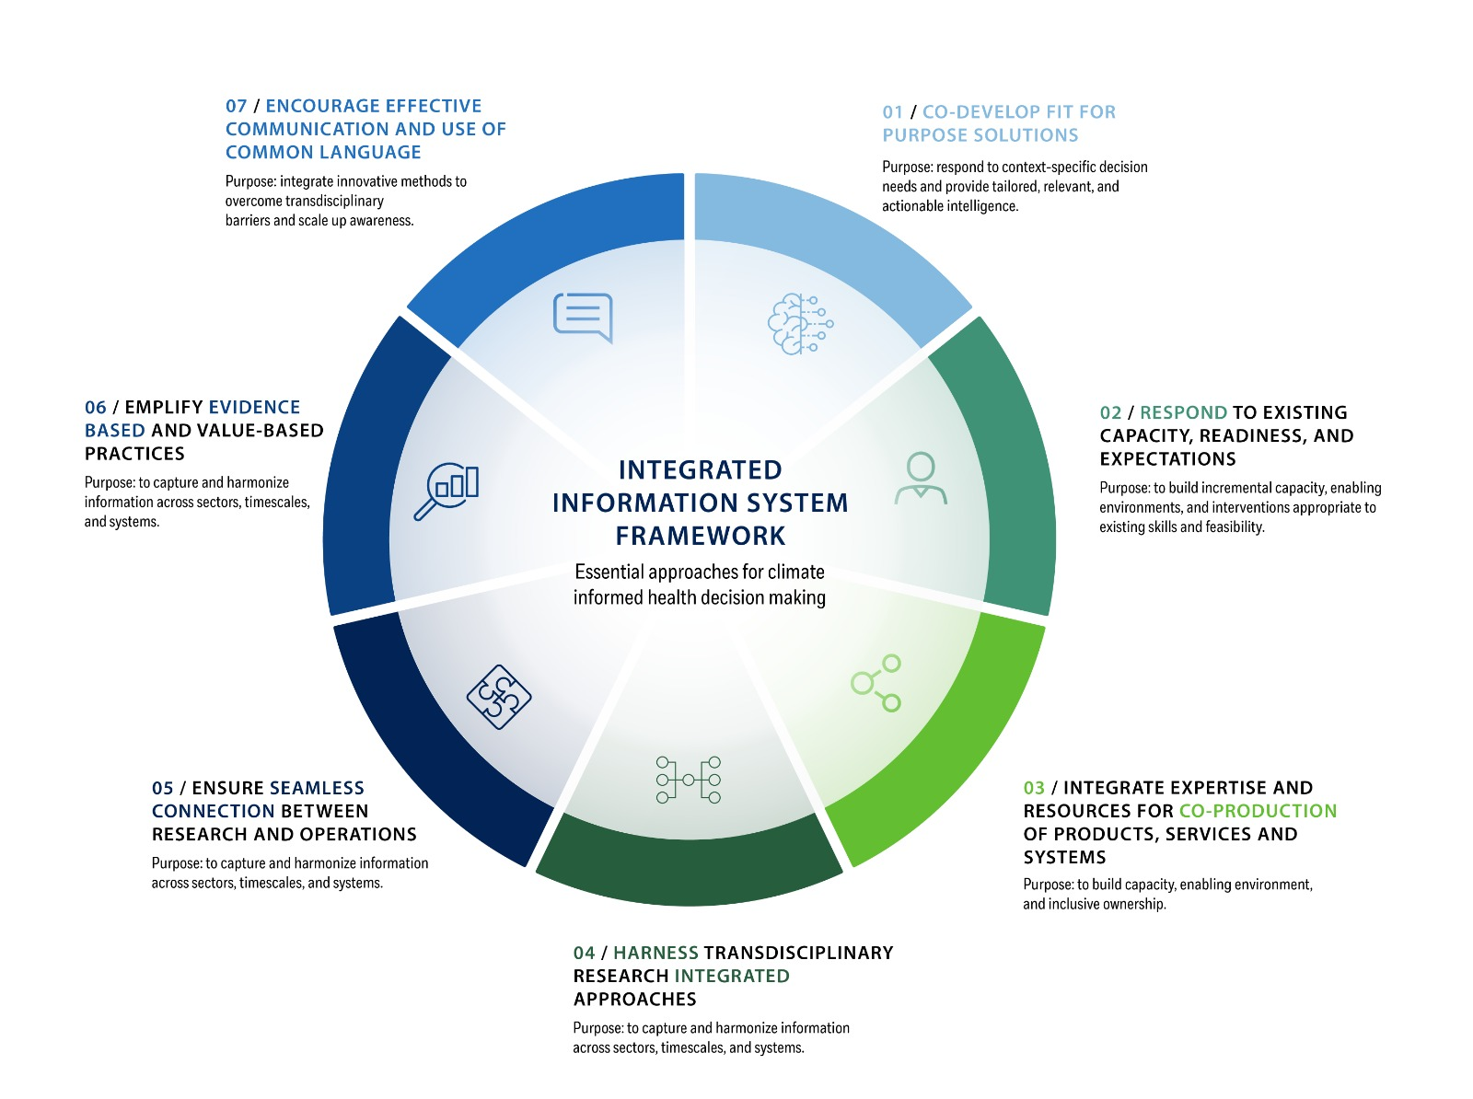
- Co-develop fit-for-purpose solutions that respond to context-specific decision needs and provide tailored, relevant, and actionable intelligence.

- Respond to existing capacity, readiness, and expectations to build incremental capacity, enabling environments, and interventions appropriate to existing skills and feasibility.

- Integrate expertise and resources for co-production of products, services, and systems to build capacity, enabling environment, and inclusive ownership.

- Harness transdisciplinary research and integrated approaches to capture and harmonize information across sectors, timescales, and systems.

- Ensure seamless connection between research and operations to strengthen operational capacity to anticipate and respond to imminent and future climate hazards.

- Exemplify evidence-based and value-based practices to build trust between actors and ensure impactful, inclusive, ethical, equitable approaches.

- Encourage effective communication and use of common language integrating innovative methods to overcome transdisciplinary barriers and scale up awareness.

Figure 2 Conceptual Framework for Integrated Climate and Health Science and Services

Good practice 1: Co-develop fit-for-purpose solutions that respond to specific context and decision needs and provide tailored, relevant, and actionable intelligence.
Decision-making in the health sector is confronted with growing challenges to simultaneously assess, understand and respond to a wide range of present and future climate-related risks to health outcomes, health service provision; and health system operations. Therefore, the development and provision of climate and weather services must first and foremost be driven by the existing decision pathways and needs and consider how to augment and fill specific knowledge gaps identified by health actors.
The demand for climate information to support health decision-making is proportionate to awareness about climate and environmental risks. Many health actors are also unaware of the scope and depth of climate, meteorological, and environmental information that may be available and potentially useful. To create a common basis of understanding, build trust necessary to support action, health and climate actors need to establish a systematic, continuous dialogue, starting with answering what questions and problems need to be solved.
Health risks are often highly localized and climate services must accommodate the resolution of information needed to understand and address these risks. This is especially true for urban areas that not only have population concentrations but also experience micro-climates that require specific localization of observations and data to develop useful climate services.

Good practice 2: Respond to existing capacity, readiness, and expectations to build incremental capacity, enabling environments, and interventions appropriate to existing skills and feasibility.
Complementing good practices which are “fit-for purpose”, systems should respond to the “readiness level of partners”. Attention to readiness, with regards to political will, technical capacity, financial resources, can help initiatives be more explicitly “tailored to reality”. Based on the process described in Figure 4, a tool was developed by WHO and WMO to assist in the evaluation of readiness and more realistically match project goals with existing capacities, institutional environments, technical feasibility, expectations, and decision timelines. The success and appropriateness of climate services must also reflect the contextual readiness, and capacity to develop, use, and sustain such services.
Expectations include that information products are high quality, accessible, reliable, credible, responsive, timely, suitable, and legitimate information. Communicating and meeting these expectations establishes trust and accountability between partners, and successful outcomes.
Figure 3 Common Quality Criteria for Climate, Environment, and Health data and services

Good practice 3: Integrate expertise and resources for co-production of products, services, and systems to build capacity, enabling environment, and inclusive ownership.
Co-production, or more clearly the collaboration and partnership required to develop and use climate science and services, underpins this framework. Integrating perspectives, expertise, and information from different sectors and actors are often necessary to understand complex health risks. Besides the core partnerships between climate and health actors as a sustained basis for co-production, other sectoral experts might need to be involved to better understand and address interconnected cross-sectoral impacts to health. Co-production is essential to build capacity, understand the expectations for products and services, develop trust and authority in the origins and use of a product, and ultimately design and sustain effective fit-for-purpose applications. Co-production allows for learning by doing and greater agility to adapting to real circumstances and decisions needs.

Good practice 4: Harness transdisciplinary research and integrated approaches to capture and harmonize information across sectors, timescales, and systems.
Health risks and impacts on health service delivery caused by population exposure to climate change, extreme weather, and environmental conditions are complex, interactive, and cascading. (See Figure 1). It is not sufficient to only consider bringing climate and health information together. Health risks often cascade from other sectors such as water, agriculture, or infrastructure, therefore demanding an interdisciplinary approach. Interdisciplinary research and multisectoral collaborations form an integral part of climate and health information systems.
Data and information from multiple sources and sectors are necessary to understand the nature and dynamics of health risks and opportunities. This implies multiple partners and sectors are likely to be relevant and involved in climate services for health. Data and perspectives will likely address multiple timescales and geographic scales. Efforts to break down disciplinary silos will assist in creating more efficient and relevant information systems. The use of integrated approaches such as OneHealth, Planetary Health, and all-hazard risk management are ways to encourage this type of integration.
Integrated and hybrid mechanisms for collecting and using available knowledge must be harnessed to leverage the combined science, intelligence and capacity of many relevant sectors and actors. Existing products and services for other sectors, such as water or agriculture, may be extremely helpful and relevant for health partners.
Integration also implies inclusiveness. The perspectives of diverse citizens (gender, ethnicity, disability, age etc.), businesses, academics, governments, non-governmental agencies can all be valuable inputs to understanding and addressing a problem.

Good practice 5: Ensure seamless connection between research and operations to strengthen operational capacity to respond to imminent and future climate hazards.
Entry points for the health community to collaborate with and benefit from climatological, meteorological, and environmental information continue to be analytical in nature, vis-a-vis strong foundations in research and integrated data and information platforms for risk monitoring.
The health sector is an evidence-based domain heavily grounded in robust processes intended to achieve reliable research and evaluation findings. Therefore, information inputs coming from outside the health sector are also subjected to similar scrutiny and data quality standards, such as those described in Figure 3.
Operational climate services must start with robust fundamental and mechanistic research. To ensure evidence-based decision-making and practice constant evaluation plays a critical role in health policy and practice. Iterative and regular evaluation and review of data sources, monitoring information, tools, and applications should be commonplace and prioritized. An integrated science to services, or research to operations approach is highly recommended. The WMO science to services approach aligns strongly with this principle.
To put this framework into action, building an enabling operating system for climate service for health is recommended to support health actors more holistically to understand and address climate risks and opportunities.
This operating system, or process, is described in detail with examples in the 2018 WHO-WMO publication, Climate Services for Health: Fundamentals and Case Studies for improving public health decision-making in a new climate.
Based on the assessment of a wide range of current practices, an effective operating system includes six essential iterative components or steps, where the good practice approaches can be implemented (See Figure 4):
- Building an enabling environment
- Capacity Development
- Research
- Product research & development
- Application
- Evaluation
This operating system complements the WMO Value Cycle and Science to Service process from a user perspective. A climate services for health readiness assessment tool has been developed by WHO and WMO to help identify decision needs, expectations, and contextual issues to guide appropriate engagement and co-development.
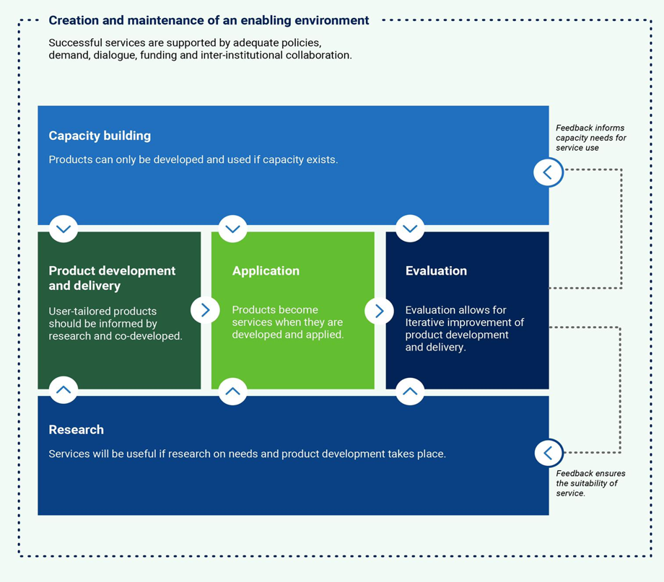
Figure 4 Climate Services for Health co-development process (WHO/WMO 2019)

Good practice 6: Exemplify evidence-based and value-based practices to build trust between actors and ensure impactful, inclusive, ethical, equitable approaches.
The health sector is not only grounded in evidence-based decision practices, but also strongly defined by ethical charters and considerations to “do no harm”, to “protect the most vulnerable”, to “prioritize action which will provide the greatest impact”, etc.
To ensure the ethical, just, and effective deployment of health care and health services evaluation plays a critical role. The augmentation of health decision tools with climate and multisectoral information, therefore, also becomes subject to these standards and practices. Assessments to monitor and demonstrate the value and impact of collaborative work, and judge and discuss whether the process and outcomes meet expected criteria (Figure 3) can offer opportunities to consider whether actions are sufficiently ethical, inclusive, and equitable. Of particular importance are considerations of the following issues: uncertainty, ethics and equity, and cost-benefit of actions.

(a) Uncertainty
Both in the discipline of climate science and epidemiology, there are states of incomplete knowledge that can result from a lack of information or from disagreement about what is known or even knowable. Uncertainty may have many types of sources, from imprecision in the data to ambiguously defined concepts or terminology, incomplete understanding of critical processes, or uncertain projections of human behaviour. Overlaying the uncertainties in climate science and epidemiology compound the uncertainties which therefore need to be represented by quantitative measures (e.g. a probability density function) or by qualitative statements (e.g. reflecting the judgment of a team of experts). Transparency of data quality and uncertainty is critical for developing effective and trustworthy services. Partnerships can be strengthened by respecting and addressing information and data requirements according to articulated criteria and measured through evaluations.
(b) Ethics, equity, and inclusivity
Professional and ethical standards, and legal and regulatory instruments applicable to the health sector, require health professionals to use rigorous approaches to collect and use the best available information for public health decision-making. This strongly applies to the use of climate services and equitable coverage of data, including adequate and appropriate climate data available for the most climate change impacted populations.
Provision of ethical climate services that promote equitable access to information is also important if investments are to benefit target and vulnerable populations. Recognition of factors affecting social vulnerability and ability to act on available information, such as gender, age, ethnicity, religion, disability, literacy, media access, local languages and ease of interpretation. Understanding and respecting the prioritization and targeting of products or services for greatest public health impact. Respect resource optimization decisions, where a climate service may not be the most useful or cost-effective way to save lives.
(c) Costs and benefits
Understanding and respecting the prioritization and targeting of products or services for greatest public health impact is important. Even when the development of a climate service may be feasible, it may not be desirable because other interventions may be more cost-effective, timely, and decision-relevant to protect and save lives. There are inherent costs to collaboration both in terms of human and technical/financial resources. The net outcome of the collaboration will have to demonstrate value relative to these costs if it is to be sustained over time. In some cases, the development of a climate service may not be the most cost-effective option for addressing a public health concern. Informal collaborations risk activity without achieving goals because the legitimacy, authority, and responsibility issues may not be as clearly worked out in a formal setting. Hence a problem focus on a clear pathway to a minimal viable product which can then be built upon, can ensure that the time and effort of the collaboration is deemed worthwhile.

Good Practice 7: Ensure effective communication and use of common language to overcome transdisciplinary language barriers and raise awareness.
Communication across sectors requires special attention because it can either facilitate or hinder successful transdisciplinary collaboration and trust building. Communication bottlenecks between the climate and health communities need to be understood and solutions identified. Sustained and regular interaction between climate and health actors is critical to establish the use of common vocabulary and terminology and ensure mutual understanding. Meteorological and climate actors need to ensure clear and appropriate communication of uncertainties, description of metadata and definitions to enhance the translation of climate science and services into health practice.
Climate and health professionals play a key role in communicating health risks to the public, as well as sharing actionable knowledge and learning amongst peers. As leading actors at the climate and health interface, their societal function and responsibility offers an impactful opportunity to scale up awareness. Communication components need to be tailored depending on communication objectives and audiences as communication needs might differ within the climate and health community, between the communities, and communication with other audiences. Vulnerable populations groups need to be included and addressed as part of communication strategies.
Communication strategies need to take a mainstreamed approach based on a clear narrative highlighting the added value of delivering climate science for health outcomes. Innovative and creative communicative solutions and tools (e.g. the WHO-WMO ClimaHealth.info Portal) need to be further explored to expand the uptake of relevant information. Science communication needs to be clear and simple using data visualization methods to navigate complex information and ensure science to services-policy translation.

CONCLUSIONS
Integrated approaches for co-developing and delivering climate and environmental information for the health sector are indispensable. The rapidly changing environment and dynamic health risk contexts are coupled with equally complex social ecosystems of decision-makers, localized challenges and contexts, varied capacities, and social dimensions. The use of these good practices can encourage stronger applied climate and health science and service integration for transformational change at the climate-environment-health nexus. Closer science-policy processes and sustained integration of climate, environment, and health science and practice can enable communities and health systems to better anticipate, prepare for, and respond to complex and cascading climate change, extreme weather, and environmental threats.
_______________

Shumake- Guillemot J, Fernandez-Montoya L, editors. Climate services for health: improving public health decision-making in a new climate. Geneva: World Health Organization and World Meteorological Organization; 2019.
WHO. 2019. WHO guidance for climate resilient and environmentally sustainable health care facilities https://www.who.int/publications/i/item/9789240012226.
(EC-70 4.3 INF) Progress of WMO to support global health. HEA-SG Regional Consultations (2022).
WHO-WMO Climate Services for Health Fundamentals. 2018. https://public.wmo.int/en/resources/library/climate-services-health-case-studies
Climate Information for Public Health Action. Thomson and Mason, 2019. https://www.routledge.com/Climate-Information-for-Public-Health-Action/Thomson-Mason/p/book/9781138069640
WHO-WMO Climate Services for Health Readiness Tool. 2019
WHO-WMO Climate Services for Health Readiness Tool. 2019
Adams, P., Hewitson, B., Vaughan, C., Wilby, R., Zebiak, S., Eitland, E., Secretariat, W., 2015. Call for an ethical framework for climate services. WMO Bulletin 64, 51–54.
Gumucio, T., Hansen, J., Huyer, S., Van Huysen, T., 2020. Gender-responsive rural climate services: a review of the literature. Climate and Development 12, 241–254.

