WEATHER CLIMATE WATER | 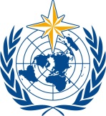  World Meteorological Organization  COMMISSION FOR WEATHER, CLIMATE, WATER AND RELATED ENVIRONMENTAL SERVICES AND APPLICATIONS  Second Session  17 to 21 October 2022, Geneva | SERCOM-2/INF. 5.10(3a)
Submitted by:
Chairs of SG-HEA
10.X.2022

SUMMARY OF THE IMPLEMENTATION PLAN FOR ADVANCING INTEGRATED CLIMATE, ENVIRONMENT AND HEALTH SCIENCE AND SERVICES 2023–2033

ABOUT
This is an Advanced Draft version of the Implementation Plan for Advancing Climate, Environment and Health Science and Services, prepared by the Study Group for Integrated Health Services. It outlines select approaches, mechanisms, and engagement opportunities for sustainable transformation in how the global health sector understands, accesses, and uses climate, weather, and environmental science and services. This INF summarizes the structure, and additional details of the anticipated activities and mechanisms for the 2023–2033 period.
The final implementation and resource plan, including proposed terms of reference for new and key mechanisms will be presented in 2023 following a peer review process.

WEATHER AND CLIMATE SERVICES: THE CURRENT STATE OF PLAY IN THE HEALTH SECTOR
Climate change is adversely affecting the mental and physical health of people globally and presents the greatest global health risk. According to the Intergovernmental Panel on Climate Change, Sixth Assessment Report, climate change and related extreme events are poised to significantly increase ill health, premature deaths, and suffering in both the near- and long-term, without substantial mitigation and adaptation.
- Population exposure to heatwaves will continue to increase with additional warming, with strong geographical differences in heat-related mortality without additional adaptation. Urban areas, which represent a majority and growing proportion of the global population are particularly affected and vulnerable.
- Poor ambient air quality is responsible for 7 million deaths annually. Wildfires, sand and dust, pollen, and pollution are exacerbated by climate change.
- In 2019, the global magnitude of climate-sensitive diseases was estimated at 39 503 684 deaths and 1 530 630 442 disability-adjusted life years. Climate-sensitive food-borne, water-borne, and vector-borne disease risks are projected to increase under all levels of warming without additional adaptation.
- Climate change is projected to exacerbate malnutrition with one million additional cases of moderate to severe stunting in children under 5 years of age, by 2030, under RCP 8.5, in 44 countries alone.
- Health care contributes to 4.4% of global net emissions of greenhouse gases, which ranks it as the fifth largest emitter on the planet, if health care were to be a country.
- Moreover, climate hazards such as extreme heat, precipitation, drought or flooding activate cascading risk pathways with a sequence of secondary, causally connected events that can disrupt critical healthcare and public health infrastructure, vital for a functional society.
These stark findings inform the prioritization of four grand challenge areas of this implementation plan. Adapting to accelerating and dynamic environmental health risks which are amplified by climate change calls for a coordinated approach across sectors to build capacity that can integrate skills, people, data, and knowledge for enhanced and agile decision-making.
The health sector currently underutilizes available climate, weather, environmental science and technology in how it does business and makes programmatic and financial decisions. Specific approaches to integrate weather, climate, and environmental services with public health practice can address this predicament. In the face of climate change, integrated climate, weather, and environmental services are an indispensable tool for health surveillance, outbreak investigations, health risk assessments, health services delivery, research, policy, long-term planning and programmatic decision-making.
Climate services, and climate-informed health decision tools, have been identified in many National Health Adaptation Plans as key to support public health prevention efforts. As part of this process, climate science is essential to inform health vulnerability and adaptation assessments to understand local risks and local opportunities. Climate services have also been used for selected forecasting tools, integrated climate-health surveillance, creation of health observatories, climate-related forecasting (floods, heat waves) and impact-based early warning systems for vector-borne diseases and heat and cold waves. However, today, these approaches remain examples, rather than mainstreamed approaches. These activities are fundamental to building the adaptive capacity of the health sector. Unfortunately, Ministries of Health report they remain the most underfunded and difficult to implement.
Harnessing weather, climate, and environmental services will advance resilience by the health sector to climate, extreme weather, and hazardous air quality. Moreover, it will open important pathways to contribute to meeting multiple targets of the SDGs, the Sendai Framework, and the Paris Agreement. Regrettably, there remains a strong silo between the health community and other sectors, and a mismatch between supply and uptake of climate, weather, and environmental services in public health. Available science and services are often developed independently from health decisionmakers and therefore tend to be underutilized, inaccessible, unaffordable, and out of context.
Financial, political, or institutional obstacles reduce the feasibility of implementing these tools. The limited organizational uptake of climate services in the health sector, is also due to technical and non-technical obstacles, such as lack of awareness of available resources and knowledge of how to interpret and use climate information. Barriers to a seamless integration of climate services by the health sector, for example, include basic discrepancies in the spatial scale of climate data, that does not match the administrative boundaries relevant to the health sector — rendering the information unusable without investments in further processing. The temporal scale of climate data might not match the needs of the health sector either, by providing data that are not actionable. The timing and accessibility of climate and environmental data is another crucial aspect that can impede timely data uptake by the health community. Discrepancies between administrative planning cycles and climate projections might not lend themselves to the integration of climate services into public health plans.
Uncertainties and lack of credibility in climate projections can also hinder the use of climate data by health authorities. These systemic impediments to the integration of climate services into the health sector call for an institutional implementation plan with far-reaching implications for public health impacts from climate change. Addressing the underlying challenges of data interoperability, climate literacy, and human resource capacity are thus fundamental goals of this plan.

THE INSTITUTIONAL CONTEXT
This plan operationalizes the objectives of the WHO-WMO Collaboration Framework on Climate, Environment and Health (2018), the eighteenth session of the World Meteorological Congress Resolution 33 (Cg-18) on Advancing Integrated Health Services, and the WHO-WMO Health, Environment and Climate Science to Services Master Plan (2019–2023).
Under the Collaboration Framework (2018), WHO and WMO agreed to work collaboratively and where appropriate, jointly, on five common goals:
- Promote the alignment of relevant policies and raise awareness of environmental and climate-related risks and solutions to protect human health;
- Promote the generation and application of scientific evidence;
- Establish appropriate technical mechanisms and partnerships to facilitate the development, delivery, access to and use of data and tailored information products on weather, climate, and environmental hazards to health;
- Develop and disseminate technical and normative guidance, scientific publications and tools, and other actions to support capacity development;
- Monitor progress on the access and use of reliable and relevant weather, climate, water and environmental information.
In the first 5 years of this agreement, targets and activities were established, and the passed Resolution 33 (Cg-18) on Advancing Integrated Health Services which set forth technical and strategic priorities for joint collaboration. However, no clear mechanisms or financial requirements for how those goals should be achieved were developed. While it is clear that existing bilateral and multilateral structures established over the last 10 years set the stage for global institutional collaboration between the health and climate sectors, these are insufficient to meet the desired targets. Consideration for new mechanisms, innovative approaches, and full engagement of the broad range of technical partners in national and subnational governments, the private sector, academia, and multilateral networks is critical for scaling the development and application of climate, weather, and environmental sciences for improved planning, preparedness, and resilience in the health sector.

VISION AND THEORY OF CHANGE FOR HARNESSING CLIMATE SERVICES FOR HEALTH PROTECTION
The joint leadership and implementation of the proposed mechanisms and actions by both the WMO and the World Health Organization are critical to achieving “better health and wellbeing for people facing existing and emerging extreme weather events, climate change, and environmental risks through the effective integration of climate, environment, and health science and services across the world”. This Implementation Plan envisions the pathway of change (see Figure 1 below) including four key transformational steps.
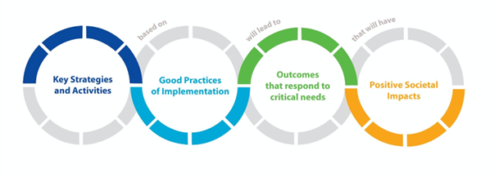
Figure 1. Theory of Change for Climate Science and Services for Health

Pathway Step 1: Implementation of key strategies and activities
Critical health risks caused by population exposure to climate change, extreme weather, and environmental conditions are complex, interactive, and cascading. Success of this Implementation Plan will require integrated and hybrid mechanisms that can leverage the combined science, intelligence and capacity of many relevant sectors and actors. The proposed key strategies and activities cover six foundational areas which support the grand challenge areas, including, inter alia:
- Develop a WHO-WMO Climate, Environment and Health Programme to support joined up policies and coordination mechanisms at all levels
- Develop transdisciplinary climate and health education and training, and strengthen institutional capacity of technical support units and Focal Points
- Improve communication skills of meteorological, climate, environment, and health actors and use of innovative tools and platforms
- Set up a systematic process to identify research gaps and priorities
- Tighten the climate and health science policy interface
- Enhance data integration and interoperability, and raise awareness of the requirements and gaps for investment
- Improve monitoring and evaluation mechanisms of the performance, effectiveness and cost-effectiveness of climate services
- Scope key needs, actions and mechanisms of the Grand Challenge areas
- Ensure dedicated resources and support functions

Pathway Step 2: Paradigm change in approaches and good practices
In order to accelerate the success of multisectoral actors to generate, provide, and apply climate-weather-environmental intelligence to health policy and practice decisions; it is critical to clarify and enhance shared understandings, principles, and approaches. Based on lessons learned and identified needs, the deployment of seven good practices are critical to change ways of working toward more optimal outcomes. These good practice principles are outlined in the Conceptual Framework for Integrated Information Systems (INF. 5.10 (3b)/Figure 2).

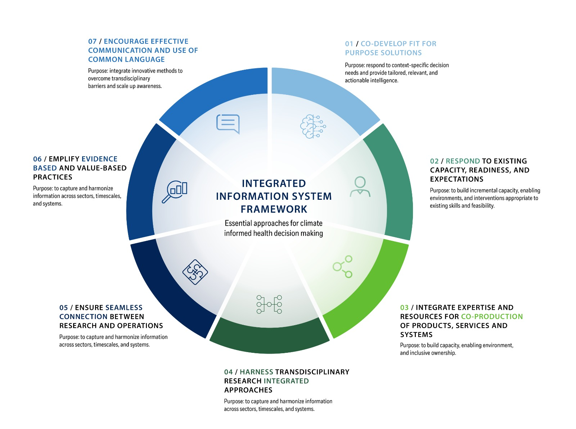
Figure 2. Integrated Climate and Health Science and
Service Framework Overview

Pathway Step 3: Outcomes represent transformation in the climate-environment-health nexus
The implementation of the activities and good practices will lead to near-term outcomes which respond to critical needs, including, inter alia:
- Increased understanding of climate risks to health
- Strengthened mandates, enabling institutional architecture at all levels
- Enhanced climate, weather, environment, and health data interoperability and ease of use
- Tested approaches and models for integrated data systems and climate service pipelines
- Enhanced transdisciplinary and intergenerational learning and knowledge exchange
- Impactful communication skills and tools for co-development, behavioural change and policy
- Systemic understanding of research, data, and knowledge needs and priorities
- Rigorous monitoring and evaluation for better analysis, accountability and learning
- More sustained partnerships between climate and health actors at all levels, and communities of practice
- Equitable access to scientific evidence
- Equitable availability, access, and use of climate data

Pathway Step 4: Long-term systemic impacts for climate vulnerable populations
Over 10 years, through the implementation of this plan, an enabling science-policy interface for climate, environment, and health science and services will be reinforced to deliver sustainable and long-term benefits, reaching beyond the climate, environment, and health interface. Including, inter alia:
- Enhanced health system capacity and resilience to climate, extreme weather and hazardous air quality episodes
- Transdisciplinary career paths and cohorts are equipped with the necessary knowledge and tools to support health adaptation and mitigation efforts
- Measurable cost-savings of evidence-based anticipatory action, justify upfront investments
- Reduced impact of climate, weather and poor air quality on health outcomes, health systems, and societies at large
- Better protection of vulnerable populations results in reduced negative health outcomes
- Universal access to climate services to protect health
- Mainstreaming climate and health services involving all relevant sectors and actors
- Significant co-benefits for health and related sectors
- Good practices in health sector approaches influence more equitable, ethical, and quality use of climate, weather, and environmental services in other sectors
- Adaptive capacity increased in health systems with integrated climate information systems

VALUE PROPOSITION
The usefulness of climate services in public health is undisputed, both economically and socially. Climate services are indispensable for emergency preparedness, early warning, and programmatic interventions, as a means to protect the health of the public. Climate services are an integral part of disaster risk reduction, intended to minimize the impact of climate hazards on public health and society at large. Early warning systems for heat waves, implemented through heat health action plans, can reduce casualties from extreme heat. Early warning systems have also been operationalized to monitor and forecast floods, droughts, forest fires, and infectious diseases. Moreover, there are tremendous benefits from the exploitation of climate services by other end users in different sectors that have co-benefits for public health. For example, climate services have been used to improve the robustness of food security and management of urban air quality.
Expanding the use of climate services for public health purposes has enormous potential. Vulnerable groups in society are often more at risk from adverse health impacts from climate hazards and would benefit greatly to have access to alerts from early warning systems. However, currently, equitable access to climate data is not assured and threatens to increase inequalities, both between countries and within. Regrettably, the most climate vulnerable groups in society often have the least appropriate coverage of climate data from ground stations to enable climate-informed decision-making. This inadequacy of climate data availability and access is a contributing factor to future vulnerability of climate risks and can exacerbate health inequality.
Climate services are an integral part of public policy, both nationally and internationally. Projecting climate change impacts in the future is essential for long-term planning and evidence-based policy making. Without scientifically grounded forecasts about possible futures, policy-making would be deprived of its foundation, and incapable of developing rational strategies.
Thus, addressing barriers to climate and meteorological data availability, access, and use by the health sector has the promise to enhance climate resilience. The intent is to make climate services widely and freely available to end users, both in low and high-income countries. Such universal access to climate services will be particularly beneficial to less well-resourced communities and will have far-reaching implications for public health. The benefits will advance prevention, emergency preparedness, and public policy with tangible health gains. Making climate services accessible to the public health community will generate tremendous cost-savings in the long-run which will justify any upfront investments.

OVERVIEW OF THE IMPLEMENTATION PLAN
This 10-year plan is organized according to three dimensions and uses a nexus approach to allow flexibility and tailoring of approaches and activities as relevant to local and regional contexts. Six foundational support areas propose actions and mechanisms to lead transformational change in climate, weather, environment and health science, services, and policy. These include: Policy and Coordination; Human Resource Development; Communications; Research; Operational Services; and Monitoring, Evaluation, and Learning.

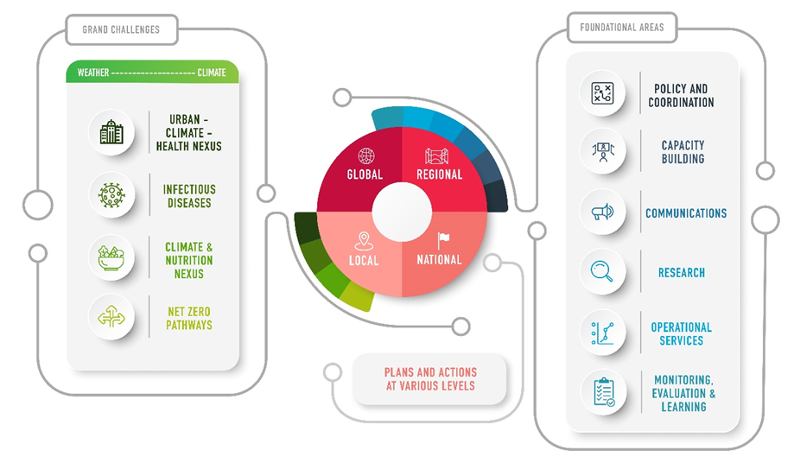
Figure 3. Three dimensions of the Implementation Plan
Focus is placed on four grand challenges in response to multiple vulnerabilities of urban populations, the sensitivity of infectious diseases to climate, risks to food security and nutrition, and climate adaptation and mitigation needs within the health sector itself. These grand challenges cover many but not all health issues affected by climate and environmental changes. This Implementation Plan envisions both top-down and bottom-up actions which take different approaches at local, national, regional, and global level. Other climate, environment, and health-related priorities may be addressed through specific place-based plans at national or regional levels. Similarly, actions related to the foundational support areas may also vary from region to region according to needs. It is intended that new and existing mechanisms will be networked to optimize resources and enhance capacity and action at all levels.
Three implementation phases of three years each will follow an inception year in 2023. This IP is further divided into phase 1 (years 2–4), phase 2 (years 5–7) and phase 3 (years 8–10). Additional activities will be developed during subsequent phases. Key to the success of the implementation plan will be monitoring, evaluation, and learning; leveraging existing and new institutional partnerships; as well as joined up extrabudgetary resource mobilization.
Note: Activities and Mechanisms described herewith are not in all cases directly aligned. More than one mechanism may be responsible for implementation, and in other cases the action may be to create the mechanism. Full details of each activity and proposed terms of reference for mechanisms will be provided in the final version.
POLICY AND COORDINATION
Goal: To support effective and sustained collaboration between the climate and health communities and other relevant stakeholders through joined up policies and coordination mechanisms
Solution Statement: Policies and coordination mechanisms are the foundation of enabling environments for effective governance able to develop and align relevant policies and approaches, promote collaboration and coordination, and generate sustained commitments to solutions that promote and protect human health. Global strategic plans, coordination and technical support mechanisms are proposed to guide and support actors to develop similar structures and strategies at national and regional levels. These joined up approaches can also help tighten the science policy interface to strengthen evidence-based decision-making.
PROPOSED ACTIONS | POSSIBLE SUPPORTING MECHANISMS
- Implementation Plan for Advancing Integrated Climate and Health Science and Services 2023–2033, 3-year workplans (Note: This plan) | Based on discussions with Members and Partners
- National and regional health strategies, units and programmes (embedded in NMHS/RCCs) with strengthened mandates, workplans and coordination mechanisms that align actions to support national priorities for addressing climate, health, emergency, environment issues. | WMO-led leveraging and strengthening implementation capacity of NMHS / RCCs, and other implementing partners
- Joint national and regional strategies for integration of health and climate science and services | National coordination mechanisms  Leveraging and strengthening existing mechanisms and capacity of NMHS/RCCs/ MOH and partners to tighten science policy interfaces and develop applied sciences
- Health and Climate Science, Technology, and Research Plan (WHO-led) | Based on discussions with Members and Partners
HUMAN AND INSTITUTIONAL RESOURCE DEVELOPMENT
Goal: To ensure that adequate human, institutional and community skills and abilities are available to enhance the development, optimal use and sustainability of climate, weather, and environmental science and services in the health sector.
Solution Statement: Scaling up climate science and services for health requires strong infrastructural, institutional, and human resource capacity at multiple levels. Developing transdisciplinary learning and career paths within the climate-environment-health professional nexus can ensure young professionals today are being trained in appropriate skills and concepts from both climate and health domains and have impactful careers ahead. Transdisciplinary and skilled professionals with defined job mandates are critical to address the complex nexus of health challenges posed by climate change. This emerging workforce will be able to speak a common language and understand impacts on both sides bridging key gaps between the climate and health communities. Job descriptions are an important instrument to craft new roles and responsibilities. Technical support, learning, and community building across this cadre of professionals (fellows, secondments, focal points) can help develop the next generation of experts who are better prepared to problem solve around environmental challenges, as well as climate adaptation and mitigation in the health sector.
PROPOSED ACTIONS | POSSIBLE SUPPORTING MECHANISMS
- Develop approach, application, validation, and review process for identified Centres, following WHO Collaborating Centre Model | WHO-WMO Technical Support Facilities/Centres of Excellence serving as technical support units and implementing partners in countries and regions;
- WMO Integrated Health Focal Points engagement and communities of practice (engagement, communication, and community of practice development) into a support and coordination mechanism | WHO-WMO Climate and Health Joint Office in consultation focal points and collaborating partners
- Climate and Health Competency Framework for strengthening transdisciplinary training and education curricula with core skills and competencies | Implementation mechanism TBD, may include Contractors/WMO Training Centres/ Consortium of Climate and Health Education
- Climate and Health (Biometeorology) Literacy Skills Programme | Climate and Health Science Training partnership/network, linking to WHO Academy, other training focused partners
- Science-Policy Fellowship Program for Health and Climate with transdisciplinary applied job placements in RCCs, NMHS, MoH or other relevant institutions, including training modules; collaborate and synergize with the WMO Fellowship partners and programme | WMO Fellowship Programme, Collaborating partners and governments
- Transdisciplinary career development support programme | NMHS/RCCs Technical Focal Points Cohort and Secondment Programme to Health agencies and partners, WMO Fellowship Programme, Collaborating partners and governments
COMMUNICATION
Goal: To support decision-making and behaviour change by members of the public, civil society partners, and Government, by more effectively communicating the health risks of climate, available science and evidence-based solutions.
Solution Statement: Raising awareness of the health impacts of climate change and adaptations available to protect people, communities and health systems is a critical requirement for preparing for a warming world. Climate and health science and services professionals (e.g., public health officials, health care system planners, community health professionals, meteorologists, climate scientists) play a leading role in local to national efforts to prepare for impacts through adaptation and are important partners in efforts to reduce GHG emissions, including by transitioning to low carbon health systems. Stakeholders within the health community are varied and play multiple functions as a target audience for partnership and communication. These health actors however provide a core climate change communications function for many audiences, for example, to the public through weather alerts and warnings, to community stakeholders to raise awareness of the need to protect vulnerable populations from growing risks, and to Government decision makers about projected health impacts to help plan future responses. By creating a global task team of experts, a climate science and health communication plan, a corresponding communication toolkit and partnerships, and guide the online platform www.climahealth.info and other dissemination channels, barriers in communication can be reduced to improve capacity and impact.
PROPOSED ACTIONS | POSSIBLE SUPPORTING MECHANISMS
- Develop a Strategic Communications Engagement, and Uptake Plan including 1) a NMHS Health Focal Point (and Health sector Climate Focal Point) Engagement Plans; 2) a climate and health science communication toolkit to address communication bottlenecks; 3) Monitor and communicate opportunities to leverage relevant outreach through events and partners; and 4) Scope and develop repository of climate change and health communications guidance and case studies | Establish and sustain Climate and Health Editorial/Communications with Experts, based on discussions with Members and Partners
- Climate and health science communication toolkit to address communication bottlenecks | Based on discussions with Members and Partners
- ClimaHealth.info Portal to promote and disseminate available technical, learning, and engagement resources
RESEARCH
Goal: To strengthen climate, environment and health research activities by facilitating data availability, access, and use by the research community; and addressing structural barriers to technical problems that hamper the use of climate services and research outputs.
Solution Statement: A systematic mapping exercise of the global research effort on health impacts from climate change revealed a predominance of evidence from high-income and upper middle-income countries and an underrepresentation of evidence from central Asia, north and central Africa, and South America. Moreover, there is an underrepresentation of evidence on the social determinants of climate impacts on health and on intervention options to attenuate health impacts. There is also a need to build the evidence base for climate change adaptation and mitigation strategies in order for governments to devise policy strategies to minimize effects of climate change on public health. These discrepancies in empirical evidence are a direct consequence of the differential availability of research support, climate data by region and socially vulnerable groups. A new mechanism to identify and monitor the needs of the research community, devise strategies to address existing limitations and impediments in applied climate and health research, and advocate on their behalf for financial and technical resources is needed.
PROPOSED ACTIONS | POSSIBLE SUPPORTING MECHANISMS
- Set up systematic process for a State of Climate and Health Research and Science monitoring including regular synthesis every 3 years, in relation to the Monitoring Evaluation and Learning Mechanisms and the grand challenge areas | Research and Data Expert Team, in coordination with the WHO-led STAG and GAPHTAG, other research mechanisms, contractors, and collaborating partners
- Climate, Environment and Health Global Research Conference to identify research priorities and link with global policy needs; synergize with development of WHO Climate and Health Research Agenda
OPERATIONAL-TECHNICAL SERVICES
Goal: Develop and deliver responsive integrated climate, weather, environmental and health services and systems through increased collaboration and good practices between health, climate and other relevant communities.
Solution Statement: Sustained partnerships between climate and health actors can effectively translate and implement climate science and service systems for health. However, climate services cannot be developed without first integrating core data, knowledge, and information from both the health and meteorological communities in a seamless and streamlined manner. Dedicated technical units, working groups, and institutes at national, regional, and global levels need to be strengthened with capacity, resources, and coordination. A co-creation and co-development process can lead technical partners to understand needs and create climate information products with sufficient quality, reliability, usability, suitability, and responsiveness to support actions such as risk assessment, integrated surveillance, early warning, sectoral policy, communication, and other community and health system actions.
PROPOSED ACTIONS | POSSIBLE SUPPORTING MECHANISMS
- TOR/specific tasks of the Data Expert Team TBD | Based on discussions with Members and Partners
- Raise awareness of the requirements and gaps for investment/advocate for an Intermediary Funding Body and Climate Data Support Facility/Provider that makes climate services from ground stations and satellites available to researchers | Based on discussions with Members and Partners
- Data and Climate Service Pipelines Demonstration Projects | Based on discussions with Members and Partners
- Climate and Health Data Integration Toolkit | Based on discussions with Members and Partners
- Integrated Systems R&D for Nexus area applications (e.g. Heat Health EWS, air quality services, drought and health monitors, infectious disease forecasts, climate and air quality projections) | NMHS/RCCs, Centres of Excellence, Collaborating partners
MONITORING AND EVALUATION
Goal: Provide evidence on the performance, effectiveness, and cost-effectiveness of climate services to save lives and reduce climate-related health risks.
Solution Statement: Current data collection mechanisms on the access and use of reliable and relevant weather, climate, water and environmental information significantly lacking in precision, rigour, and scope. New mechanisms are needed to assess progress being made and needs being met. Global monitoring of changing climate vulnerability and risks is left largely to the research community and provides often limited evidence to policy makers. More extensive evaluation methods and practice are needed to learn and inform how to more efficiently use climate information for behaviour change, risk management, and population preparedness. A rigorous Monitoring, Evaluation, and Learning Framework will help guide this work to better track, learn, and iteratively improve the approaches being deployed to support the health community address climate and environmental risks.
PROPOSED ACTIONS | POSSIBLE SUPPORTING MECHANISMS
Develop a Monitoring, Evaluation, and Learning Framework to support the analysis and learning to Advance Integrated Climate Science and Services for Health | Appropriate technical bodies, WHO-WMO Climate and Health Joint Programme, collaborating partners and entities
Strengthen accountability and monitoring systems, monitor and report on an agreed cadence (2 or 3 years) the availability and use of climate information products and services for the health sector | Mechanisms TBD, collaborating Members and partners, ClimaHealth.info data dashboard and portal
Monitor health risks and the impacts of climate on health outcomes and systems (e.g., improved metrics, monitoring systems, advocacy)
Support more rigorous evaluation of climate services for health, including early warning systems, climate-informed surveillance systems, and vulnerability and adaptation assessments, starting with methods and pilots in multiple regions
Develop systematic documentation of associated health and socioeconomic benefits of the use of climate science and services in the health sector

GRAND CHALLENGE AREAS OF CLIMATE, ENVIRONMENT, AND HEALTH
The Grand Challenges in climate, environment, and health respond to some of the most pressing climate and environmental risks to health: Extreme heat, poor air quality, water scarcity, infectious diseases, food security, and disrupted and dysfunctional health services. Initial examples and ideas have been outlined for the thematic areas but full workplans will be further developed with the appropriate partner and expert communities during the inception year of this plan.
Health and Urban Nexus
(Extreme weather events, Heat, Fire, Air Quality, UV, Water stress)
Capacity development and scale up of interventions to understand, forecast and address cascading risks of extreme heat; including interconnections of fire, air quality, water, and UV related health risks into heat early warning systems and action plans, promotion of evidence-based actions, and risk and impact monitoring of heat-related impacts
Global Heat Health Information Network for learning, building capacity, and sharing information on extreme heat, health, and urban services
Develop appropriate activities with the WHO-led GAPH-TAG, and WMO-led GAW on Air Quality and Health
Integrated data platforms for urban settings in order to improve urban data access and use, urban modelling capabilities and resolution challenges. Institutionalize collaborations between health services and appropriate science and advisory bodies, to enhance adaptation, mitigation, and risk management action plans
Infectious diseases
Task team on Infectious Diseases to define the approach and mechanisms required
Training programme for a cadre of epidemiologists and health practitioners equipped to integrate met/climate services and health services
Assess the use of climate services for health as part of the health capacities including for the implementation of the International Health Regulations (IHR) 2005 and OneHealth approaches
Enhancing anticipatory action on infectious diseases with longer lead times, through actions such as creating data pipelines to be used by infectious disease epidemiologists and climate scientists for monitoring and modelling disease risk, use of machine learning technologies
Phase 2 – Health, Nutrition and Droughts (livelihoods, food system nexus)
Collaborate with the Integrated Drought Management Programme to scope needs, guidance, opportunities, and critical impact points for improved health and nutritional outcomes in the climate, drought, food systems, health and livelihoods nexus. (Establish a TT with IDMP on Health)
Phase 2 – Climate resilient and net-zero health systems
Collaborate with the WHO-led Alliance for Transformative Action on Climate and Health (ATACH) to define climate science and service support to enable net-zero transitions in the health sector, including energy dependent public health goods and services such as health facilities, water and sanitation infrastructure, cooling and refrigeration, housing, and transport. (Establish a TT on Health with Energy SG)
_______________

Intergovernmental Panel on Climate Change. Climate Change 2022: Impacts, Adaptation and Vulnerability. The Working Group II contribution to the IPCC Sixth Assessment Report. https://www.ipcc.ch/report/ar6/wg2/
GBD 2019 Diseases and Injuries Collaborators. Global burden of 369 diseases and injuries in 204 countries and territories, 1990–2019: a systematic analysis for the Global Burden of Disease Study 2019. Lancet. 2020 Oct 17; 396(10258):1204–1222. doi: 10.1016/S0140–6736(20)30925–9.
Lloyd, 2018: A Global-Level Model of the Potential Impacts of Climate Change on Child Stunting via Income and Food Price in 2030. Environmental Health Perspectives, 126(9), 097007, doi:10.1289/ehp2916.
Health Care Without Harm Climate-smart health care series. Green Paper Number One (2019). https://noharm-global.org/documents/health-care-climate-footprint-report
WHO, 2021 Climate and Health Country Survey
WHO/WMO Joint Workplan and Integrated health Services. https://community.wmo.int/meetings/whowmo-joint-workplan-and-integrated-health-services
Eighteenth World Meteorological Congress (Cg-18). https://public.wmo.int/en/eighteenth-world-meteorological-congress-cg-18
Berrang-Ford L, Sietsma AJ, Callaghan M, Minx JC, Scheelbeek PF, Haddaway NR, Haines A, Dangour AD. Systematic mapping of global research on climate and health: a machine learning review. The Lancet Planetary Health. 2021 Aug 1; 5(8):e514–25.

