WEATHER CLIMATE WATER | 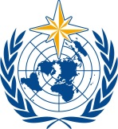  World Meteorological Organization  COMMISSION FOR WEATHER, CLIMATE, WATER AND RELATED ENVIRONMENTAL SERVICES AND APPLICATIONS  Second Session  17 to 21 October 2022, Geneva | SERCOM-2/INF. 5.10(1b)
Submitted by:
Chairs of the SG-HEA
4.X.2022

OPERATIONAL GUIDANCE
GLOBAL HEAT HEALTH INFORMATION NETWORK

(Update 2022)

Section 1: Background
Climate change is rapidly increasing human exposure to extreme temperature and heat conditions in all world regions. Heat stress is the leading cause of weather-related death and can exacerbate underlying illnesses including cardiovascular disease, diabetes, mental health, asthma, increase the risk of accidents and infectious disease, and impact maternal and child health. Accelerated action to mitigate climate change, coupled with comprehensive and evidence-based extreme heat prevention, preparedness and risk management is required worldwide to save lives now and in the future.
In 2015, international experts from public health agencies and meteorological services from around the world called for the development of international heat health coordination capability to facilitate the sharing of scientific and operational information, methods and tools for more effective management and evaluation of heat’s health effects; to support the convening of a Global Forum; to coordinate international heat health efforts; and to become a global resource for the dissemination of evidence and good practices.
In response, the Global Heat Health Information Network (GHHIN), here forth referred to as “the Network”, was founded in 2016 by representatives from multiple National Meteorological Agencies, Public Health Agencies, and Academic and Civil Society partners, with the following description:
The Global Heat Health Information Network is an independent, voluntary, and member-driven forum of scientists, practitioners, and policy makers focused on improving capacity to protect populations from the avoidable health risks of extreme heat in our changing climate.
The Network was publicly launched in 2018 as a joint initiative of the World Meteorological Organization (WMO), WHO, and the National Oceanic Administrative Administration (NOAA), to respond to gaps in coordination and technical advisory identified by the global meteorological and public health communities. The Network’s operational and governance structures were updated in 2021 to enable growth of the Network and to respond to emerging needs of key constituents at the national and local scales.
The Network’s purpose is to convene a community of practice and broker the knowledge of both institutions and individuals from the broad range of disciplines addressing the human health risks posed by extreme heat across timescales. Key audiences and partners include national meteorological and hydrological services, government authorities for public health and disaster management, academia, media, and civil society partners from a broad range of disciplines. These entities have called for improved heat health early warning systems, heat action plans, responsive policy frameworks; enhanced use of science and technology; good practices in risk communications; agenda setting for hazard and impact related research; and translation of research outcomes via robust decision tools and integrated climate, human health, and urban services.
The Network strives to achieve five common goals, as defined in the 2018 Global Heat Health Forum Call to Action:
- To urgently improve awareness of the disaster that increasing extreme heat poses to human health, wellbeing, and productivity worldwide;
- To catalyse and sustain interdisciplinary partnerships and co-learning between research and practitioners across relevant government, academic, private sector and civil society actors;
- To synthesize and advance science and technology available for decision-making and risk reduction across sectors and time scales;
- To improve access to expert resources and opportunities for learning, exchange, and engagement;
- To identify and accelerate action to address critical gaps in research, knowledge and practice.
Implementation to meet these goals is organized according to a five-pillar integrated heat health management framework (Figure 1/Annex 2) with corresponding workstreams that enable engagement with and sharing between a wide number of stakeholders for the advancement of technical activities.
As a community of practice, the Network aims to bring together and leverage the work and progress of contributing and co-sponsoring partners, as well as individual participating members to create a holistic picture of the needs, science and strengths to address extreme heat risks to society.
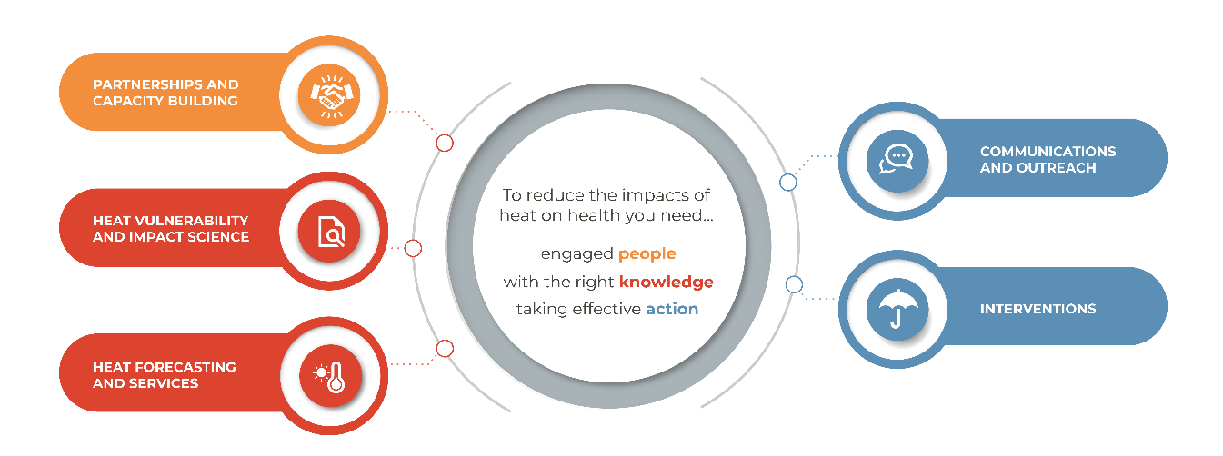
Figure 1: Integrated Heat Health Management Framework and Workstreams

Section 2: Operational Structures
The key operational entities of the Network consist of (1) a Technical Support Unit, (2) Co-sponsoring Organizations, (3) Contributing Partners and Individual Members, (4) Financial Partners. Regional Network Nodes will be established during 2022–2027. The partners who lead these nodes will be considered contributing partners to the global network.
The Network’s governance structure is comprised of an Advisory Group and a Management Committee. Interaction between operations and governance are described in Figure 2.
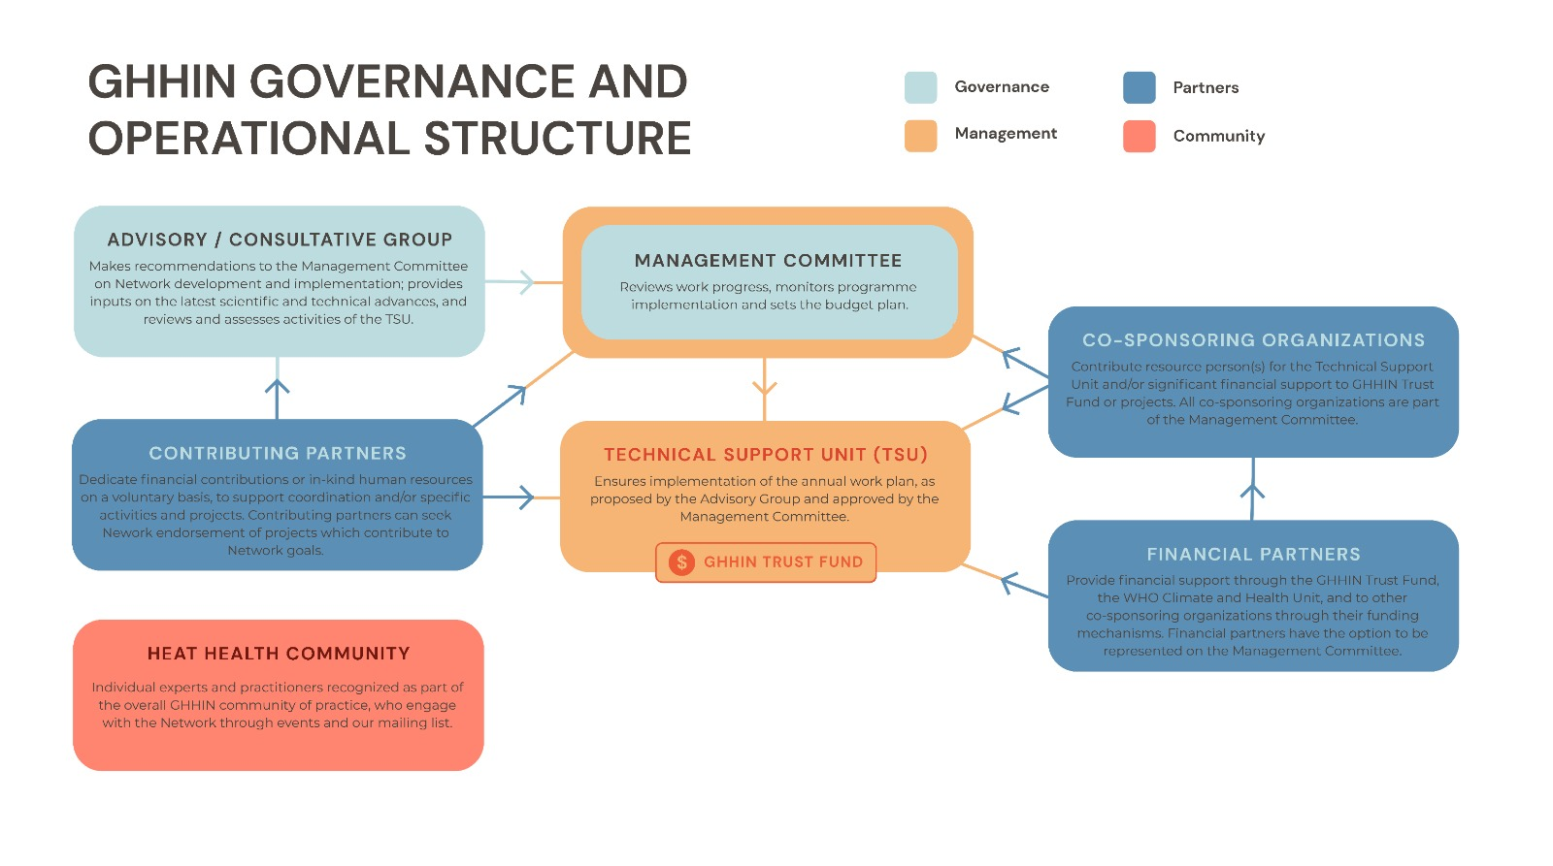
Figure 2 Governance and Operational Structures of the Network
The roles and responsibilities of the operational entities are described below.
- Technical Support Unit (TSU)
The TSU is physically based in the WHO-WMO Joint Office located in the WMO Services Department, but may include virtual team members in other locations from co-sponsoring institutions. The TSU is composed of hired and seconded professional staff from co-sponsoring organizations (e.g., WMO, WHO, NOAA, others), as agreed by the Management Committee. The Lead of the WHO-WMO Joint Office is the head of the TSU. Overall responsibility for the operation of the Network and financial management of its Trust Fund is assigned at the level of the Director of the WMO Services Department.
Specifically, the TSU has the following functions:
- Ensures implementation of the annual work plan, as proposed by the Advisory Group and approved by the Management Committee, and formulates its yearly work plan timetable to meet the expected results;
- Serves as the point of contact for incoming requests to the Network and its HelpDesk functions;
- Routes incoming requests to the Network Co-sponsoring Organizations and Contributing Partners and coordinates follow up;
- Provides strategic advice concerning heat management policy, strategy and institutional arrangements in response to requests;
- Provides technical support and project management for the implementation of projects developed under the Network;
- Maintains, updates and upgrades the Network website and related information and develops new components (especially heat management guidelines/tools) as required;
- Develops and maintains, as a basis for the continuous improvement of Network activities, a registry of received requests and follow-up actions taken;
- Strengthens the Network partnerships and maintains linkages and regular communication with Contributing Partners (see below) and Financial Partners (see below), amongst others, by keeping track of available competencies and areas of interest;
- Develops and implements a Network information/outreach strategy;
- Develops a Network community of practice tailored to different User Groups as and when recommended by the Advisory Group and Management Committees;
- Advocates for Integrated Heat Health Management (IHHM) concepts in appropriate international and national initiatives;
- Provides coordination and secretarial support for the activities under the Network, as well as to the Advisory Group and Management Committee;
- Provides logistical and technical support for capacity-building activities as part of the Network; and
- Liaises regularly with relevant WHO and WMO technical bodies and divisions to harmonize activities between the two related programmes and exchange knowledge and know-how.
- Co-Sponsoring Organizations
Any organization with a stated scope and substantive activities on extreme heat management issues are invited to become a co-sponsoring organization. Co-sponsoring organizations should have a compatible mandate which reflects the needs and values of the Network; does not possess conflicts of interest with the mandate and goals of the Network, and is prepared to contribute at least one of the following minimum financial commitments:
• Seconded staff, or in-kind resource person(s) to support the TSU;
• Financial support to the GHHIN Trust Fund (greater than 75 000 Swiss francs per year) or through direct financial contributions to Network projects (also greater than 75 000 Swiss francs per year).
Co-sponsoring organizations agree to directly liaise with each other on international heat-related initiatives, and to share information on regional, national and local initiatives of relevance to the Network.
The level and extent of in-kind contributions from co-sponsoring (and contributing) Partners is determined in the Letter of Engagement signed by each of them and will be reported on an annual basis to the Management Committee. Direct contributions for the operations of the Network made by contributors or co-sponsors will be retained in a dedicated budget line within an allocated Trust Fund and managed according to WMO financial rules.
It is recommended that organizations considering becoming a co-sponsoring institution do so for not less than a two-year period adhering to the above commitments. It is recognized that co-sponsoring (and collaborating) organizations retain the right to engage in their own regional, national or local projects solely or in coordination with other Network partners.
All co-sponsoring organizations have the right to representation on the Network’s Management Committee. If co-sponsoring organizations would like to withdraw from the Network, a 6-month notice is required. A 6-month notice of termination of status would also be given should such an organization cease to make their in-kind or financial contributions or not fulfil the spirit of being part of the Network, such as failing to share information on regional, national or local heat management initiatives.
- Contributing Partners
The Network aims to bring together and leverage the learning and activities of multi-disciplinary organizations working on heat risk management and adaptation issues from different perspectives around the world. Institutions contributing to the Network, known as Contributing Partners, indicate their readiness to dedicate a minimum of 10 000 US dollars in cash OR in-kind human resources capacity annually on a voluntary basis for implementation of coordination and/or specific activities and projects.
Institutions interested in contributing their expertise and independently funded and implemented activities to the Network can become a contributing partner. Partnership with the Network is open to all institutions whose mission is aligned with the basic concepts and aims of the Integrated Heat Health Action Framework, who have no declared conflicts of interest with the mission of the Network, accept the principles of good practice and partnership (Annex 3), and are willing to work together to fulfil the objectives of the Network.
A written letter of agreement to become a contributing partner will describe the partner agency, including scope and mission, type of organization, areas of expertise. This letter will indicate the contributing partner’s readiness to dedicate activities or a pre-set amount of in-kind human resources capacity (on a voluntary basis) to contribute to activities in accordance with the specialized capacity of the respective contributing partner. Principal areas of activity where contributing partners may engage in support of integrated heat health action include:
- Piloting and implementation of extreme heat and health-related science, public services and interventions, and/or leading research activities endorsed and contributing to the Network;
- Advice and high-level advocacy for heat management policy and strategy formulation;
- Development, input and review of technical documents, heat management tools, guidelines, and communications;
- Development and facilitation of workshops, training, skill building, and e-learning options for human capacity development;
- Advice and formulation of high-level objectives/scoping/implementation approaches for interventions and project proposals across the Network;
- Facilitation of science policy partnerships and communications between relevant government, academic, private sector and civil society actors, including the media.
Each Party shall be responsible for its own costs for its activities under this Agreement.
The letter should designate an organizational focal point, who will be invited to participate in the Advisory Group, and represent the contributing partner (see below).
Contributions by organizations will be acknowledged on the Network website and in the activities to which they contribute. Contributing partners may seek Network endorsement by the Management Committee of projects which contribute to GHHIN goals through an online form.
- Financial Partners (Donors)
Institutions providing financial support to the Network are known as Financial Partners. They contribute to WMO through the Network Trust Fund, and to other co-sponsoring organizations through their respective funding mechanisms. Voluntary financial contributions to the Network shall meet existing rules for the receipt and use of United Nations extrabudgetary funding. As in the case of co-sponsoring organizations, Financial Partners automatically have the option to be represented on the Management Committee, if they so choose.
- Individual Experts and Participating Members
As a knowledge network, individual experts and practitioners are recognized as participant members in the Network, which is independent of affiliation with their home institutions. Individual members may range from active experts who may serve on any level of Network governance and projects to more “silent” members such as attendees at events and subscribers to mailing lists will be recognized as part of the overall Network community of practice.
See Annex 1: Partnership and Membership Model

Section 3: Governance
A two-tier governance structure is comprised of the Advisory Group and Management Committee.
- Advisory Group
The Advisory Group (AG) is a global and open consultative group that will serve as a resource and feedback mechanism to identify emerging issues and guide the development and implementation of Network activities. The AG is expected to share learning and identified needs, findings from projects, evaluations, and policy, scientific and technical advances in extreme heat health-related issues. With the support of the TSU as Secretariat, the AG will consist of the following:
- The Chairperson: Nominated jointly by Co-sponsoring Organizations;
- Two representatives from each co-sponsored organization;
- One representative from the WMO Service Commission Health Study Group, Standing Committee on Disaster Risk Reduction (DRR), Standing Committee on Climate;
- One representative from the WHO thematic platform for Health Emergency and Disaster Risk Management, or relevant programmes;
- One representative from each of the Contributing Partners;
- Two representatives from Regional Network Nodes;
- One representative from each of the Financial Partners;
- Observers.
The Terms of Reference of the AG are as follows:
- Guides the implementation of the Network, making proposals for the annual work plan to be considered by the Management Committee;
- Ensures, by advising the TSU, that the Network develops and maintains an adequate service spectrum, an effective and efficient working arrangement vis-à-vis beneficiaries, Contributing Partners and Financial Partners;
- Ensures synergies and multi-disciplinary inputs into the activities of the Network and suggests approaches to implement IHHM Framework concepts in the field;
- Proposes priorities and opportunities for the network’s activities, impacts, and influence.
- Management Committee
The Management Committee will review the progress of work, monitor implementation of the programme and decide on the budget plan. The Management Committee has approximately 18-20 members, meeting agreed criteria of technical, institutional, regional, and age diversity.
With the support of the TSU as Secretariat, the Management Committee consists of (as minimum):
- The Chairperson: To be nominated jointly by the co-sponsoring international organizations, who is also the Chairperson of the AG;
- Two representatives from each co-sponsoring organization;
- One representative from each of the Financial Partners (if desired);
- One representative from each of the Regional Network Nodes;
- Five members from the Contributing Partners;
- Two early career representatives.
In cooperation with the Chairperson, the TSU has the right to invite additional participants or observers on an ad-hoc basis.
The Terms of Reference of the Management Committee are as follows:
- Promotes the values, mission, and goals of the Network;
- Provides oversight to the Network and its TSU, monitoring the progress of implementation of activities and the AG recommendations;
- Advises the level of financial support required for the Network including the TSU, as well as the corresponding resource mobilization strategy;
- Approves the Network annual work plan and budget;
- Adopts modifications to the governance framework of the Network;
- Sets and reviews criteria of eligibility for Contributing Partners as well as the threshold to qualify as a substantive financial contributor;
- Establishes its own modus operandi and procedural rules, as well as those of the AG.
The AG and the Management Committee will meet at least once a year and shall meet, as far as possible, in conjunction.

Section 4: Contributions and Resources
The Network common activities are carried out using resources consisting of in-kind and financial contributions from the co-sponsoring organizations, voluntary in-kind contributions from Contributing Partners/Members and financial contributions by the Financial Partners to the Network Trust Fund.
Based on the current arrangement, the Network has in practice already been co-sponsored by WHO, WMO, and NOAA since 2017, and would therefore be transitioned to this new model through an exchange of letters. Based on the current situation including assessed available resources, the proposed transition includes:
WMO would continue supporting the Network via in-kind and financial contributions, including:
- The provision of professional and general service staff supports from the WMO Service Department to the TSU;
- The provision of logistics in the form of office space and utilities for the Network TSU;
- Provision of technical inputs from the WMO Service Department and Science and Innovation Department;
- Facilitate interaction and linkages to the WMO Service Commission technical bodies;
- Facilitate the update of technical guidance, evidence and good practices on heat and health by WMO members and partners.
WHO would continue supporting the Network through combined support from the Climate and Health Programme, Health Emergency Preparedness, and Regional Offices.
The in-kind and financial contributions from WHO include:
- The provision of seconded staff supports to the TSU;
- Web hosting for relevant parts of the Network;
- Provision of technical inputs via projects and secretariat staff;
- Facilitation of interaction and linkages to regional organizations and collaborating centres, and relevant networks such as the Thematic platform for Health Emergency and Disaster Risk Management (Health-EDRM);
- Facilitate the updating of technical guidance, evidence and good practices on heat and health by WHO members and partners.
NOAA would continue supporting the Network through:
- The provision of seconded or in-kind staff supports to the TSU;
- Provision of technical inputs from the National Heat Health Information System and other NOAA research and operational programmes;
- The provision of resources for selected activities or meetings;
- Facilitate engagement and linkages with other relevant research, technical, and policy partners;
- Facilitate the update of evidence and good practices on heat and health by other federal agencies and partners.

Section 5: Liability
Neither the co-sponsoring organizations, contributing partners, nor Financial Partners and their staff shall be held liable for any damage caused or sustained by any party, including any damage caused to third parties as a consequence of the advice, guidance and professional opinions generated by the Network. A clear disclaimer to this effect is provided on the public website https://ghhin.org/legal/.

Section 6: Intellectual Property
The Network aims to have an open data and information sharing policy. Collaborating partners and contributors to the Network shall retain ownership of, and all rights, title and interest in and to, their respective pre-existing intellectual property, which may be shared with or presented to the Network.
Upon mutual written agreement, collaborating partners may grant the Network an unlimited, royalty-free, perpetual, non-exclusive, revocable, non-transferable license to use pre-existing intellectual property from contributors, as specified by such contributors. All Network printed and published materials will credit the source and original contributors of materials. Permission to use institutional logos, personal information or contacts will be sought in writing for all published materials.
Full information can be referenced at https://ghhin.org/legal/

Annex 1: GHHIN Partnership/Membership model
Member Type | Role | Privileges | Current example | Supported by
GHHIN Partners (Institutions)
Financial Partners | Financial donors. Not involved in technical implementation. | Decision-making: Financial Partners will have the opportunity to be involved in network governance, strategic priority setting, and implementation, as desired.  Opportunity to contribute to high-level awareness raising, leverage multi-disciplinary partners, invest in capacity development, and technical guidelines and recommendations with global impact.  Visibility: Institutional logos featured as appropriate and in accordance with donor requirements. | Welcome Trust  Public Health England | Funding agreement
Co-Sponsoring Institutional Partners | Institutional partners provide a minimum annual financial support (in cash or in-kind) of 75 00 US dollars  Responsibilities: Co-sponsors take a lead role in coordination and implementation of activities | Decision-making: Co-sponsors will have the opportunity to be involved in network governance, strategic priority setting, and implementation.  Visibility: Institutional logos featured as appropriate | NOAA  WHO  WMO | - Engagement letter  - Designated staff and ToR for supporting TSU
Contributing Partners | Institutional partners provide a minimum bi-annual financial support (in cash or in-kind) of 10 000 US dollars for implementation, coordination and/or contribution to specific activities and projects per annum.  Regional Network Nodes are considered contributing partners, with additional TORs | Decision-making: Supporting members will have the opportunity to be involved in network governance, strategic priority setting, and implementation via AG, report progress.  Visibility: Institutional logos featured as appropriate,  GHHIN Endorsed projects | Examples:  PAHO  IITM  Univ. Copenhagen | - Engagement letter and expected contributions  - Designated Focal Point  - Letter of Agreement with Co-Sponsors for funding (when applicable)  (Alt.)  - Project Endorsement approved by MC
GHHIN PARTICIPATING MEMBERS (Individual experts in the community of practice)
Member Type | Role | Privileges | Current example | Supported by
Participating Members | Individual members may have different levels of activity:  Some members may provide in-kind time and expertise to support activities such as organizing webinars, trainings, workshops, writing and revision of technical documents.  Includes Management Committee members who contribute substantial time (5-10 days per year).  Some may attend activities and share lessons and research at Network events. (E.g. participate or present in Network events) | Visibility: Individual Members have the option to be featured in the “Expert Network”, and work considered for the library.  Opportunity to shape and contribute to high-level guidelines and recommendations that are used globally.  Gives flexibility to involve home institutions or not.  Representation: Participating members will be invited to annual AG meetings and have the opportunity to submit interest/ candidacy for governance bodies to represent contributing members, as well as join and participate in activities and other technical working groups. | Certain members of the Management Committee:  May and may not bring institutional affiliation but participate as experts | Recognized through participation records  Submission of Expressions of Interest and contribution  (Managed as an online form/register with 2-year time limit)
 |  |  | Forum or webinar presenters | Recognized through participation records
 | Some may be less active members who observe Network events, subscribe to the digest and social media | Silent “members” who have access to all information and opportunities to participate and learn | Mailing list subscribers | Recognized through subscription base

Annex 2: Integrated Heat Health Management Framework
In 2018, the Network adopted an integrated systems approach to facilitate the co-design and co-production of information and tools across applications in varied disciplines.
The integrated heat management approach is comprised of five co-dependent workstreams:
- Partnerships and capacity building;
- Data, science, and research for understanding health risks of heat;
- Climate and weather information for decision-making and action;
- Effective interventions to prevent heat exposure and negative health outcomes;
- Communications and outreach.
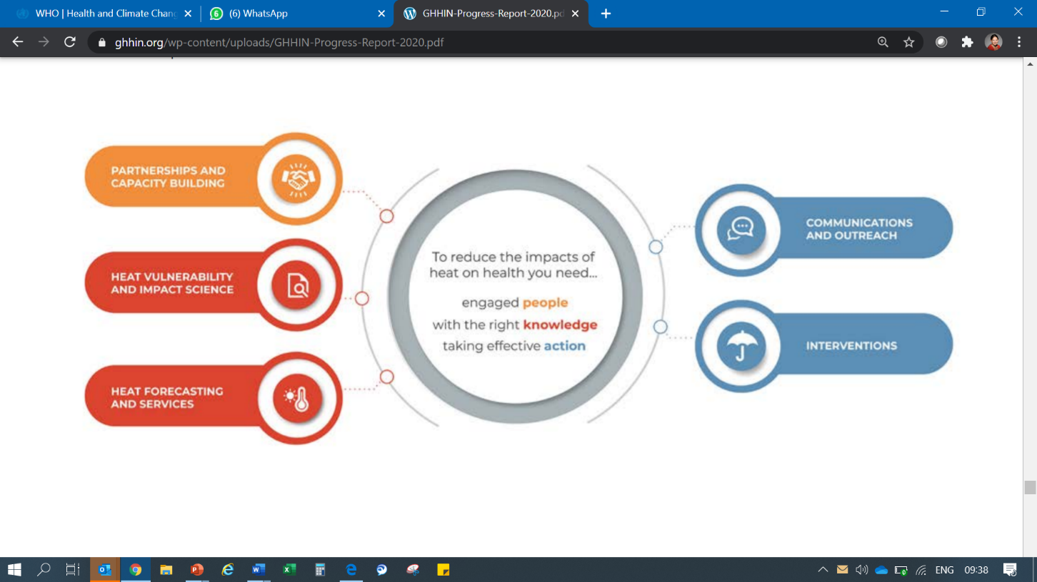

ANNEX 3: PRINCIPLES OF PARTNERSHIP AND GOOD PRACTICE
As part of GHHIN’s commitment to quality science and services, the Principles of Partnership and Good Practice serve to not only guide the work of the Network, but serve to motivate members to improve the quality and effectiveness of their own work by employing these principles.
The Network expects its Partners and Members to voluntarily share these principles, and to guide their interactions within the network:
- Strategic and results oriented partners have a shared vision for heat health action, be guided by evidence-based frameworks for the priorities and directions of interventions and employ results-based approaches to long-term aims and measurable plans for achieving objectives.
- Harmonized and aligned partners work is consistent with local and national plans and complements the activities of other development partners. Seek to complement and integrate with existing international partnerships, frameworks, and mechanisms.
- Open access and transparent partners promote open access to data and information for all partners on an equal basis.
- Responsible and evidence-based partners conduct activities with integrity, pursue evidence-based approaches and cultivate trust in their interactions with stakeholders.
- Effective and sustainable partners operate in ways that deliver high-quality projects that meet targets and seek to achieve long-term results.
- Respectful and reciprocal partners respect the autonomy of local authorities and decision-makers, and listen to one another and plan, implement and learn together. Recognize vulnerability to extreme heat is complex and locally determined, with differential effects.
- Diverse, equitable, and inclusive partners make efforts to include a broad range of partners, stakeholders and perspectives appropriately representing ethnicities, races, ages, religions, disabilities and genders in the implementation of their work, to better address inequities of all vulnerable populations.
- Accountable partners have clear and transparent decision-making processes and see out commitments to the network.
- Flexible, resourceful, and innovative partners proactively adapt and respond to altered circumstances and embrace change.
- Committed to joint learning partners monitor, evaluate and reflect on their activities and results, articulate lessons learned and share knowledge with others.
- Promoting GHHIN partners agree to co-brand their contributing heat efforts with the GHHIN logo and to fairly and accurately represent and cite the work of other partners. In turn, information and relationships presented as part of GHHIN will clearly indicate partner country contributions and give proper credit.
_______________

Workshop on the development of climate information systems for heat health early warning: assessing knowledge, needs, and the path forward. Chicago, 2015 convened by NOAA, CDC, DWD, WMO, GFCS
Founding Partners: U.S. National Oceanic and Atmospheric Administration (NOAA), Germany's Deutscher Wetterdienst (DWD), the World Meteorological Organization (WMO), the Global Framework for Climate Services (GFCS), UK Met Office, UK Public Health England, Columbia University, University of Washington, Imperial College London, Indian Meteorological Department (IMD), Hong Kong Observatory (HKO), Boston University, Durham University, National Resources Defence Council (NRDC), University of Hong Kong.

