|  |  |  |
| --- | --- | --- |
| WEATHER CLIMATE WATER | **World Meteorological Organization**  **REGIONAL ASSOCIATION VI (EUROPE)**  **Nineteenth Session (Phase I)** 15 to 16 October 2024, Virtual Session | **RA VI-19(I)/INF. 3.3.4(1)** |
| Submitted by: RA VI President  9.IX.2024 |

## PROGRESS REPORT RELATED TO THE ESTABLISHMENT OF THE REGIONAL AGROMETEOROLOGICAL CENTRE FOR RA VI, INCLUDING ITS FACILITIES AND OPERATION

### Background

With the increasing effects of global climate change, the lack of operative communication among agrometeorological researchers may lead to the impossibility of making the best and most sustainable decisions at international level. In this context, on 8 June 2019, on the eighteenth session of the World Meteorological Congress (Cg-18) in Geneva, Switzerland, the initiative on the establishment, in Romania, of a Regional Agrometeorological Centre for Region VI (Europe), the first one within WMO, was presented at a side-event and endorsed by the participants.

### Main functions of the Regional Agrometeorological Centre

The Centre will aim to strengthen cooperation between the National Meteorological and Hydrological Services within Region VI, to improve the skills/professional training of agrometeorology experts and facilitate the conclusion of beneficial partnerships at European and international level, to ensure the successful implementation of research programmes and projects to reduce the effects of global warming and climate change.

The Centre will be able to carry out assessments of the impact of weather and climate-related phenomena on current and future agricultural systems and identify the measures to be taken to ensure development of sustainable agricultural systems in the Regional Association VI (Europe), as the effects of variability and climate change are becoming increasingly apparent worldwide.

Within the Centre, the entire range of activities in the field of agrometeorology will be carried out, starting from observations and monitoring, continuing with the processing and exchange of data and up to the provision of services/products.

Among the activities to be performed within the Centre, an important place is taken by the continuous training and professional capacity development of the specialists in agrometeorology and related sciences, as well as of the young researchers. Exchanges of experience and examples of good practice as well as training sessions/stages will be encouraged both at the National Meteorological Services’ and at the WMO Regional Centres’ level.

### Source of funding

INFRAMETEO Project: “Modernization of the infrastructure for monitoring and warning of severe hydro-meteorological phenomena in order to ensure the protection of life and material assets”

1. Cohesion Fund through the Large Infrastructure Operational Programme (POIM) 2014–2020, Priority Axis 5 “Promoting adaptation to climate change, risk prevention and management”, Specific Objective 5.1 “Reducing the effects and damages on the population caused by the associated natural phenomena the main risks accentuated by climate change, mainly by floods and coastal erosion”;
2. Cohesion Fund through the Sustainable Development Programme (FEDR) 2021–2027, Specific Objective OS 2.4 Promoting climate change adaptation and disaster risk prevention and resilience based on ecosystem approaches.

### Objective 7 “Establishment of the Regional Agrometeorological Centre for Regional Association VI-Europe of WMO”:

Objective 7a “Services for the design and execution of works for the Regional Agrometeorological Centre for the VI-Europe Region of the WMO”

The Contract started on 12 December 2022, and it will be finished in September 2024. The value of the investment is € 4 665.622 (excluding VAT).

Objective 7b “Establishment of the Regional Agrometeorological Centre for Regional Association VI-Europe Region of WMO; Supplying equipment – IT Data Centre, videoconference system, software licences; Software development services – 3 dedicated software applications”

The Contract started on 4 June 2024 and it will be finished in June 2025. The value of the investment is € 2 219.497 (excluding VAT).

### Investment stage

The investment includes:

1. A two floor building

Having a built area of about 780 m2 and a developed area of about 2 660 m2, which will accommodate: two conference rooms, offices, laboratories, bedrooms, kitchen, a library, and a state-of-the-art videoconference system. The building is in the final phase of execution, and preparation for reception, currently being executed interior finishes and presentation of samples for equipment and furniture.

This will be a *“smart & green”* building, a high-performance, energy and resource-efficient, clean, flexible, and adaptable one, smoothly combining innovation and technology with high-performance management, to maximize return of investment and the benefit/cost ratio, in accordance with the design theme and legislation in force. The building will have many green areas with resilient vegetation, specific to the area. The roof of the construction itself will be a green terrace-type with a drip irrigation system, also meant to reduce noise in the outer area, both around the building and at the level of the terraces. The building will be energy efficient, to limit the heat loss and reduce energy consumption.It will usean alternative power supply system with photovoltaic panels mounted on its roof.

The building is in the final phase of execution, and preparation for reception, currently being executed interior finishes and presentation of samples for equipment and furniture.

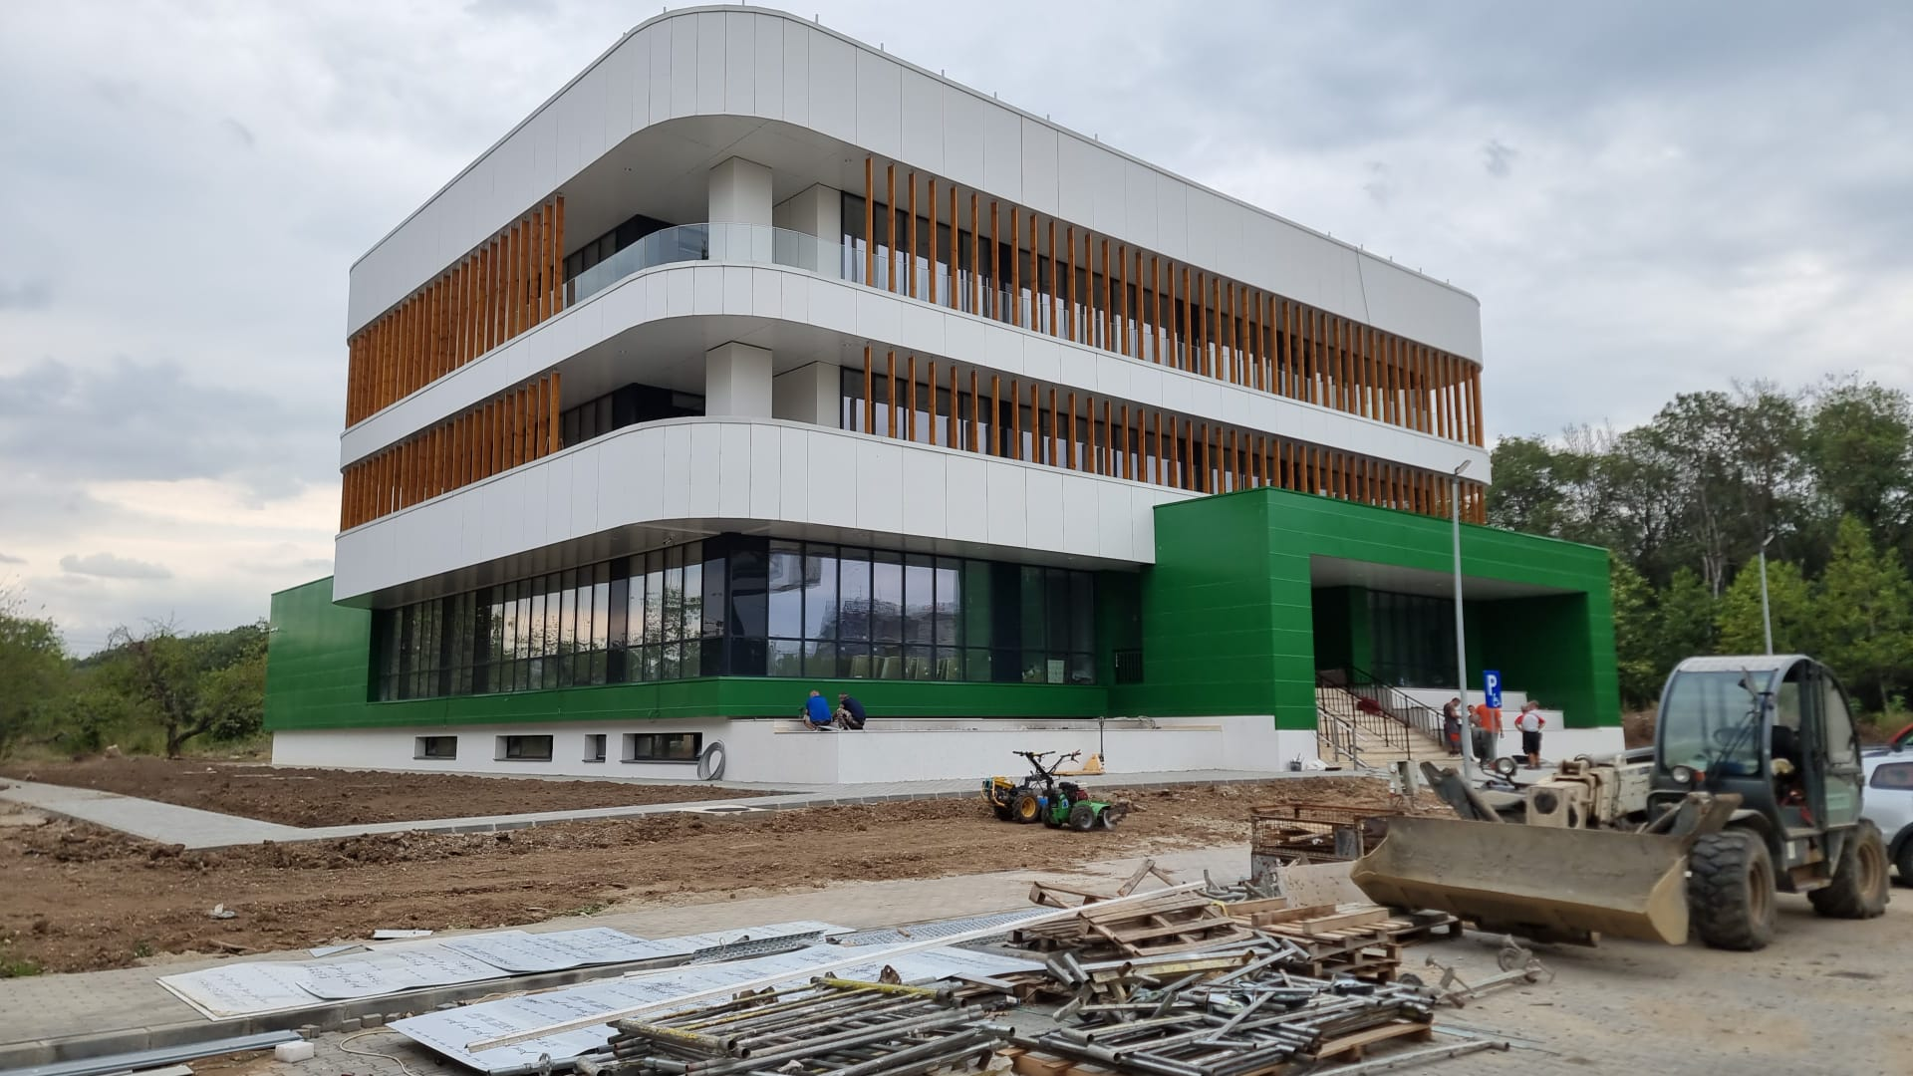

*Source*: National Meteorological Administration of Romania

1. An IT Data Centre

This facility will provide the intercommunication with other national agrometeorological centres in the European Union and access for partner countries to real-time agrometeorological products and services, the international data exchange with all meteorological services in Europe that carry out agrometeorological activities, the access to real-time agrometeorological products, the real-time dissemination of agrometeorological information to the main beneficiaries and the storage and archiving of agrometeorological data.

The IT Data Centre will be equipped with modern computer systems and IT equipment, that will provide a high-performance Mission-Critical infrastructure and implement reliability facilities, high availability, and maintenance capacity (*Reliability – Availability – Service Ability (RAS)*) at all levels that can impact the availability of the hardware system and allow the expansion of RAS facilities to software applications.

The IT Data Centre is currently in the stage of mounting equipment, to be settled and tested later.

1. A videoconference system

It will include specific equipment for conference management and Voice over Internet Protocol (VOIP) communications (*Call Manager*) as well as specific video conference equipment (two “video wall” systems and seven video terminals), with the aim ofdisseminating the information and providing communication with the National Agrometeorological Services in Europe and with the Standing Committee on Services for Agriculture within WMO.

It will allow National Medicines Agency (NMA) Romania to coordinate activities with relevant European authorities and structures and facilitate the real-time communication and exchange between specialists, leading to the improvement of agrometeorological products that are to be made available to farmers and decision makers.

The videoconference system is in the execution phase.

1. Dedicated software applications: application development and implementation services

The IT Data Centre infrastructure implementation is required to develop, install, and operate dedicated software applications that enable data collection and management from all data sources, both existing within NMA and for those that will be purchased and implemented through the *three dedicated software applications* project:

1. “Application 1” - for aggregation and visualization of geospatial data to be made available in real-time, to partner countries and decision makers;
2. “Application 2” - for the management and dissemination of phenological questionnaires, with the aim of analysing the impact of weather and climate on existing and future agricultural systems, as well as defining the necessary actions to ensure the long-term sustainability of agricultural systems within RA VI;
3. “Application 3”- for the processing of meteorological data in agrometeorological indicators and carrying out studies and research meant to understand the effects of climate change and variation on food security, including effects due to extreme weather events on the atmosphere-ground-plant system.

The agrometeorological products obtained through Applications 2 and 3 will contribute to the development of operational or field data retrieval and processing capabilities, which will cover the needs of complex agrometeorological products, diagnosis or forecast for commercial companies or state institutions, to streamline and harmonize crop production or to guarantee the necessary support in the face of extreme weather phenomena.

It will also enable information to be shared with other specialized European agencies by expanding the capacity to define targeted and complex products, allowing the National Meteorological Administration to forecast crop developments based on trends of the same crop types in regions adjacent to Romania or determine the best locations for new crops based on crop prosperity of the same type in other European geographical areas.

The software applications are in the implementation phase.

______________