|  |  |  |
| --- | --- | --- |
| WEATHER CLIMATE WATER | **World Meteorological Organization**  **REGIONAL ASSOCIATION VI (EUROPE)**  **Nineteenth Session (First Part)** 15 to 16 October 2024, Virtual Session | **RA VI-19(I)/INF. 3.3.1** |
| Submitted by:  President of RA VI  12.IX.2024 |

## REGIONAL WIGOS CENTRE (RWC) CONCEPT AND IMPLEMENTATION PLAN FOR REGIONAL ASSOCIATION VI

### Introduction

This concept document is intended to describe the basic principles and approach for establishment and operation of Regional WMO Integrated Global Observing System Branch (WIGOS) Centres (RWCs) in RA VI including their functions, possible architecture, and affiliated Members to various RWC nodes, operational principles, impacts and benefits for the Members.

This concept document will be subject to updates based on application experiences, possible changes in the conditions and performed functions, intentions from Members (current and future candidates) for hosting RWCs as well as the guidance and/or requests from relevant entities of RA VI, input from the RA VI Members, from the RA VI Working Group for Observation, Infrastructure and Information Systems (WG-INF), and guidance and assistance from WMO Secretariat.

This document will provide guidance on establishment of RA VI RWCs in pilot mode, how to conduct their functions and on how Members should respond in efficient and cooperative way within RA VI regarding RWC related activities.

### Background and Rationale

The former Task Team on WIGOS (2015–2017) developed a demonstration project for testing the RWC functions as a “RWC in a nutshell”, involving Germany, Türkiye, Bosnia and Herzegovina and Lebanon, which worked on:

1. Improving metadata of RA VI stations from few countries in OSCAR/Surface
2. Improving of WIGOS Data Quality by using WIGOS Data Quality Monitoring System (WDQMS) and with support of EUMETNET monitoring tool (EUMETNET Composite Observing System (EUCOS) portal).

At the Seventeenth Session of RA VI, held from 7 to 9 February 2018, the Regional Association made some decisions for the establishment of RWCs in RA VI and requested the Management Group to support the establishment of RWCs.

It was also decided to approve the EUCOS Observing Monitoring Facility (currently located at Deutscher Wetterdienst in Offenbach am Main[1]), operated under the EUMETNET Observations Programme Management, as a Regional WIGOS Centre (RWC) for Region VI, with the responsibility for operating an automated web-based Quality Monitoring Portal to display data quality monitoring statistics for EUMETNET Members, accessible to all RA VI Members.

### Functions

The RWCs in RA VI will perform functions for regional coordination, guidance, oversight and support to WIGOS implementation and operational activities at the regional and national levels, as daily activities.

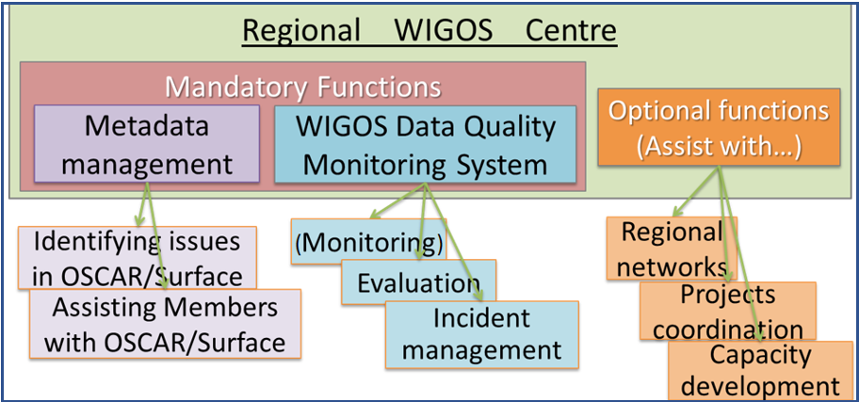There are mandatory and optional functions for RWCs as specified in the [*Guide to WMO Integrated Global Observing System*](https://library.wmo.int/records/item/55696-guide-to-the-wmo-integrated-global-observing-system) (WMO-No. 1165).[2]

**Figure 1. RWC Mandatory & Optional Functions**

It was agreed by the candidate Members to host an RWC that the multifunctional approach for the establishment and operation of the RWCs will be adopted. Each RWC in RA VI will take on the responsibility for both mandatory functions.

* 1. Mandatory Functions

Two mandatory functions are specified to be performed by the RWCs in support of the Members as described in the [*Guide to WIGOS*](https://library.wmo.int/records/item/55696-guide-to-the-wmo-integrated-global-observing-system)(WMO-No. 1165):

1. (Regional) WIGOS Metadata management (to work with data providers to facilitate collecting, updating, and improving the quality of WIGOS metadata in OSCAR/Surface)
2. (Regional) WIGOS performance monitoring, evaluation, and incident management (WDQMS) and follow-up with data providers in case of data availability or data quality issues.

Functions of monitoring and evaluation shall be performed by the RWC by using WIGOS tools, that is OSCAR/Surface, WDQMS, or other tools available. Function of Incident management should be performed exclusively with Incident Management Tool (IMS) for RWC.

If other tools for monitoring and evaluation are available, RWCs can also use them as complementary tools for their operations.

* + 1. WIGOS Metadata Management

OSCAR/Surface is the official repository for WIGOS metadata. Members should register their stations/platforms with required metadata in OSCAR/Surface in accordance with the [*WIGOS Metadata Standard*](https://library.wmo.int/records/item/55626-wigos-metadata-standard?offset=5)(WMO-No. 1192).

WIGOS metadata management is under the responsibility of each Member with the assistance of the RWCs to assess and correct their metadata records and keep them up to date in OSCAR/Surface.

The metadata in OSCAR/Surface should be maintained by the OSCAR/Surface National Focal Points (NFPs), metadata editors, or station contacts, with assistance from RWCs as needed. Although all stations are expected to be registered in OSCAR/Surface, those stations that exchange data internationally must be registered in OSCAR/Surface.

RWCs will provide guidance and support to the Members on how to:

1. Collect the metadata for their stations
2. Register their stations in OSCAR/Surface, e.g. new stations
3. Check and correct their metadata
4. Use it as their national metadata database
5. Solve any other issues related to metadata management.

This process will be closely linked to the quality monitoring process via WDQMS webtool for checking and updating relevant metadata, since many data availability and quality issues are caused by incorrect/incomplete metadata in OSCAR/Surface, e.g. station coordinates, international data exchange flag and reporting schedule, WIGOS Station Identifiers (WSIs).

* + 1. WDQMS

As shown in Figure 2, there are three basic components of the WIGOS data quality monitoring process:

1. Monitoring function
2. Evaluation function
3. Incident management function.

These three components defining the scope of WDQMS are explained in detail in the [*Technical Guidelines for Regional WIGOS Centres on the WIGOS Data Quality Monitoring System*](https://library.wmo.int/records/item/56347-technical-guidelines-for-regional-wigos-centres-on-the-wigos-data-quality-monitoring-system?language_id=&offset=2) for land surface stations (WMO-No. 1224).

1. Monitoring Function:

Monitoring function will be performed by designated Numerical Weather Prediction (NWP) centres, called as WIGOS Quality Monitoring Centres (WQMC)[3].

The WQMCs provide 6-hourly quality monitoring (QM) reports (CSV files in a commonly agreed format containing information for each observing station based on data assimilation results) which are collected and stored by WDQMS webtool.

The QM reports are prepared in near real-time based on the data available from the WMO Information System (WIS) as the basis of the monitoring function and input to the evaluation function.

The “NWP module” of the WDQMS webtool monitors in near real-time the observations from the Global Observing System (GOS) land-based surface and upper-air stations which will be used by RWCs for performing their functions.

1. Evaluation Function:

The results from the WQMCs will be evaluated by RWCs according to the metadata information in OSCAR/Surface and data distribution on WIS.

The metadata registered in OSCAR/Surface are used as baseline within this process. Therefore, it will be critical that NFPs on OSCAR/Surface insert and maintain the correct metadata in OSCAR/Surface.

The main roles of RWCs for this component will be to review and analyse the monitoring results available in the WDQMS webtool, to determine the issues for further steps of the process, including checking the metadata in OSCAR/Surface and identifying any issues.

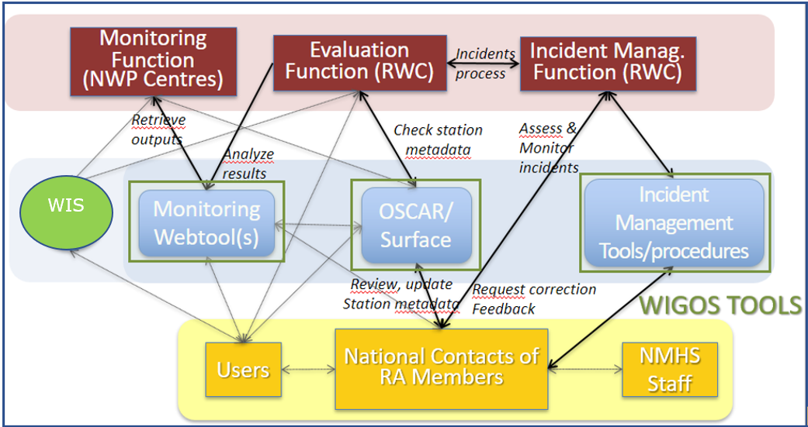

**Figure 2. The WDQMS Process**

1. Incident Management Function:

Based on the results from the evaluation of the issues, incident management will be applied for solving the issues. If the issues considered by the evaluation function merit being raised as incidents following the relevant technical guidance, then the incident management function will undertake this. As shown in Figure 3, there are different stages of this process with important roles and responsibilities for RWCs and Members at each stage.

The main role of RWCs in this component are to initiate the incident process, issuing the ticket for the identified incident, communicate with the Members via relevant staff (NFPs for WDQMS), follow the process for solving the issues by the Members, update the ticket status and close the ticket (if issue is solved) or escalate the ticket, if needed.

Due to the critical role of Members to engage in the incident management process, establishing and maintaining close collaboration between the RWCs and affiliated Members will be essential to perform the incident management function successfully towards improving the stations performances in particular for availability and quality of internationally exchanged data.

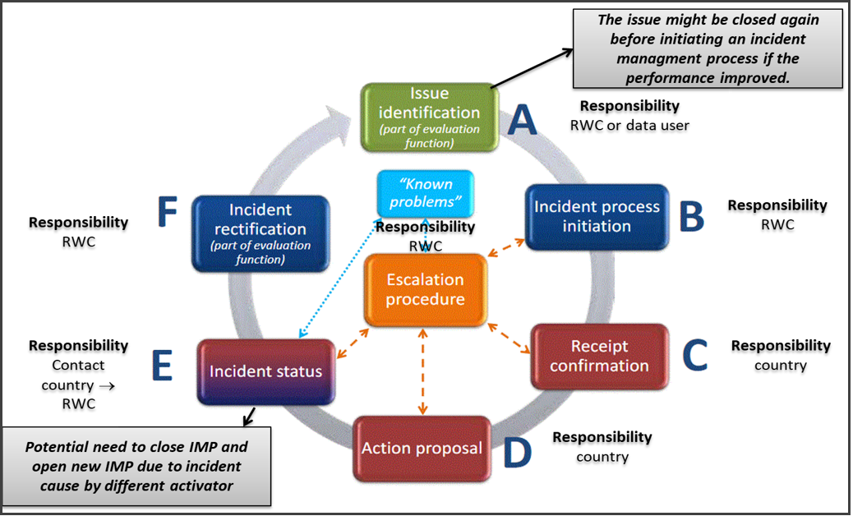

**Figure 3. WIGOS Incident Management Process**

* 1. Optional Functions

It is envisaged that RWCs can provide regional coordination, guidance, oversight and support for WIGOS implementation in the RA VI.

Depending on available resources and regional needs, one or more optional functions as defined below, and other relevant optional functions can be adopted and performed by the RWCs:

1. Assistance with the coordination of regional/subregional and national WIGOS projects
2. Assistance with regional and national observing network management
3. Support for regional capacity development activities.

### Architecture and Operational Principles

It was agreed that RWCs candidates in RA VI will perform both mandatory functions for their affiliated Members. A draft structure for functions and affiliated Members by RWC proposed nodes is submitted in the Annex I by considering the following criteria:

1. Balanced distribution of number of affiliated Members to each RWC
2. Geographic proximity of Members to RWCs
3. Existing cooperation agreements between RWCs and Members
4. Language and cultural familiarity between RWCs and Members.

The roles of RWCs, Members and WMO Secretariat in the establishment and operations of RWC network in RA VI are listed further below in this section of this document.

The establishment of RWCs in RA VI in pilot mode will follow the proposed approach to submit this concept to the RA VI WG-INF, via the Task Team on WIGOS in coordination with the WMO Secretariat, for their feedback and subsequent submission to the RA VI Management Group. Following endorsement by the MG each candidate Members will apply in accordance with the final version of the concept.

In the current stage, EUMETNET has been performing certain monitoring evaluation and incident management functions for the EUMETNET Members in RA VI. EUMETNET has been operating the EUCOS Quality Monitoring Portal (QMP) under the EUMETNET Observations Capability Area Management Programme (OBS CA MP) with the responsibility for operating an automated web-based QMP to display data quality monitoring statistics for EUMETNET Members, accessible to all RA VI Members. However, EUMETNET does not cover the metadata management function for their members.

The structure and operating principles are prepared considering existing RWC (EUMETNET), and candidate Members for hosting RWCs in RA VI as follows:

* 1. RWC EUMETNET

EUMETNET operates an automatic monitoring tool (QMP) for EUMETNET Members as well as for the remaining Members of RA VI for radiosonde and automatic weather stations. It also issues a quarterly monitoring report for EUMETNET Members for all the EUCOS networks (i.e., also marine networks and remote sensing ground-based networks).

EUMETNET uses the QMP to perform the monitoring and evaluation functions, alongside of the WDQMS when required.

The metadata management function is not currently performed by EUMETNET for their Members. EUMETNET only provides support if required particularly to resolve non-compliance issues raised by users. From 2024, EUMETNET will start to progressively perform this function for its members.

* 1. RWC Bosnia and Herzegovina

Bosnia and Herzegovina will perform both mandatory functions for the affiliated Members. Affiliated Members will be defined based on agreement with other RWCs in RA VI as well as considering the concurrence of Members for the affiliation. A preliminary list of Members to be supported by Bosnia and Herzegovina is submitted in Annex I.

* 1. Joint RWC Kazakhstan, Russian Federation and Belarus

Kazakhstan, Russian Federation and Belarus will perform both mandatory functions for the affiliated Members. Affiliated Members will be defined based on agreement with other RWCs in RA VI as well as considering the concurrence of Members for the affiliation. A preliminary list of Members to be supported by Kazakhstan, Russian Federation and Belarus including the Members from RA II and RA VI will be determined considering available Centres in RA II and RA VI and the fact that Kazakhstan, Russian Federation and Belarus are planning to perform as an interregional RWC for both Regions.

* 1. RWC Romania

Romania will perform both mandatory functions for the affiliated Members. Affiliated Members will be defined based on agreement with other RWCs in RA VI as well as considering the concurrence of Members for the affiliation. A preliminary list of Members to be supported by Romania is submitted in Annex I.

* 1. RWC Türkiye

Türkiye will perform both mandatory functions for the affiliated Members. Affiliated Members will be defined based on agreement with other RWCs in RA VI as well as considering the concurrence of Members for the affiliation. A preliminary list of Members to be supported by Türkiye is submitted in Annex I.

* 1. Members

Members will play a critical role in the operation of RWCs with close cooperation and communication with the RWCs they are affiliated to, and with other Members as well.

Considering Members have primary role in performing both mandatory functions of RWCs, Members are expected to actively involve in and contribute to RWC operations by developing the following main activities:

1. Designate/update their NFPs on OSCAR/Surface, WDQMS and WIGOS
2. Respond and update to the ticket(s) assigned to them in time in the Incident Management System (IMS)
3. Regular check to ensure the availability of correct metadata in OSCAR/Surface
4. Promote activities to improve data and metadata quality from their stations
5. Participate in the capacity development activities organized by the WMO Secretariat, by RWCs, and by other regional entities
6. Actively make use of further training material provided by the WMO in the [WIGOS Learning Portal](https://etrp.wmo.int/course/view.php?id=146) to improve the skills of staff for better usage of WIGOS tools.
   1. WMO Secretariat

The WMO Secretariat will contribute to this process by developing the following main activities:

1. Provide updated technical guidelines and to assist with the implementation of RWCs’ functions in consultation with the Infrastructure Commission
2. Organize training workshops and webinars on WIGOS tools and RWC operations
3. Support the coordination of RWCs activities, within the RA VI
4. Support the establishment and implementation process of RWCs
5. Facilitate experience sharing among RWCs, and Members
6. Facilitate the cooperation among RWCs in different Regions
7. Provide best practice examples for improvement of RWCs operations
8. Coordinate the audit process for RWCs in pilot mode in consultation with RWCs and following the guidance from INFCOM.

### Resourcing requirements for RWCs

The responsibility for resourcing the establishment and operations of RWCs rests with the Member(s) hosting the RWC, which should secure suitable infrastructure, technical, human and other resources for establishment and sustained operations of the Centre.

The resourcing strategy covering technical, human and financial resources will be developed by each RWC considering entire process of establishment and operation of RWCs for start-up phase, pilot and operational modes as well as audit process for transition from pilot mode to operational mode, and surveillance and recertification audits. Such resourcing strategy will be a living document which should be updated for required resources based on the results of audit process, and experience gained by the RWC in performing their functions and considering knowledge shared by other RWCs within and outside the region.

Considering the functions and number of affiliated Members, each RWC will allocate the required resources of funds, staff, and technical infrastructure to perform the functions for affiliated Members, accordingly.

* 1. Basic infrastructure

Each host country will make available to the RWC adequate, secure, fully equipped and easily accessible premises on a permanent basis. These premises will be supplied with water and electricity and will be equipped with a reliable telecommunications system. If employees, in addition to their primary duties, combine work according to RWC, then they can use their own existing work offices.

* 1. Technical infrastructure

Each RWC will have adequate information technology facilities and infrastructure (workstations, high speed internet access, data processing and storage capabilities) needed for RWC functions.

The minimum technical resources for RWCs should be a workstation with broad-band and stable internet access for performing the required tasks.

RWCs will have technical infrastructure, including hardware and software, which will enable the RWC staff:

1. To access to the OSCAR/Surface (<https://oscar.wmo.int/surface>) for metadata management
2. To access to WDQMS web tool (<https://wdqms.wmo.int>) for performing QM and evaluation functions
3. To access to web-based IMS (<https://jira.ecmwf.int/projects/RWC/>) for performing incident management function
4. To access to EUCOS Portal of EUMETNET (<https://eucos.dwd.de/ravi/#SurfaceStationsSelectionPlace:%7B%7D>)
5. To access, monitor and analyse the relevant data, metadata, and reports
6. To communicate with other RWCs and Members, other WMO Regional Centres and the WMO Secretariat.
   1. Human Resources

The necessary human resources (managers and scientific, technical and administrative personnel) with required competencies and number of staff will be allocated by the host country to RWC establishment and operations. These staff can be assigned with full or partial dedication for RWCs operations, in the organization of the Members hosting RWC depending on the local operational conditions of the Members hosting RWC.

The host countries will follow a sustainable approach to allocating staff to RWCs.

RWC staff responsible for performing RWC functions should have at least:

1. Mature knowledge of observing stations, measurements, and QC/QA as well as data collection and transmission
2. Knowledge and experience on using WIGOS tools
3. Familiarity with WIGOS and WIS systems and operations
4. Skills on using IT equipment.

The allocated staff for RWCs operations should be familiar with the process that each RWC would have to undergo as part of an audit programme including auditing the RWCs towards becoming RWCs in operational mode as well as surveillance audits and recertification audits.

It is expected that the RWC staff will perform their RWC related tasks during normal working hours on official weekdays, in principle. The extension of the working days and hours will be under consideration and decision of each RWC depending on their resources and operating strategy.

* 1. Financial Resources

It is agreed that the responsibility for funding RWC operations rests with the Members hosting RWCs. Considering it may be needed to get support for allocating resources, it is recommended that any RWC in need of additional support will identify partners and develop effective resource mobilization strategies with a view to deriving maximum benefit from the various multilateral funding mechanisms and regional development institutions. The WMO Secretariat is prepared to support all stages of such resource mobilization efforts.

### References

1. [*Manual on the WMO Integrated Global Observing System*](https://library.wmo.int/records/item/55063-manual-on-the-wmo-integrated-global-observing-system) (WMO-No. 1160)
2. [*Guide to the WMO Integrated Global Observing System*](https://library.wmo.int/index.php?lvl=notice_display&id=20026#.XYTBcC2B0W8%20target=) (WMO-No. 1165),  
   Establishing RWCs in Pilot Mode (Chapter 8)
3. [*Technical Guidelines for Regional WIGOS Centres on the WIGOS Data Quality Monitoring System*](https://library.wmo.int/records/item/56347-technical-guidelines-for-regional-wigos-centres-on-the-wigos-data-quality-monitoring-system?language_id=&offset=2) (WMO-No. 1224)
4. [*WIGOS Metadata Standard*](https://library.wmo.int/records/item/55626-wigos-metadata-standard?language_id=&offset=1) (WMO-No.1192)
5. [*Regional Association VI (Europe) – Seventeenth session*](https://library.wmo.int/records/item/55852-regional-association-vi-europe-seventeenth-session?language_id=&offset=2)(WMO-No. 1210)
6. WIGOS website: <https://community.wmo.int/activity-areas/WIGOS>
7. WMO RWCs website: <https://community.wmo.int/rwc>
8. [WIGOS Learning Portal](https://etrp.wmo.int/course/view.php?id=146)
9. EUCOS Portal: <https://eucos.dwd.de/ravi/#SurfaceStationsSelectionPlace:%7B%7D>

## Annex I

### Distribution of functions and Members affiliations (May 2024, updated July 2024)

|  |  |  |  |  |  |
| --- | --- | --- | --- | --- | --- |
| **RWC** | **Bosnia and Herzegovina** | **Kazakhstan, Russian Federation and Belarus** | **Romania** | **Türkiye** | **EUMETNET** |
| **Functions** | Metadata&WDQMS | Metadata&WDQMS | Metadata&WDQMS | Metadata&WDQMS | Metadata&WDQMS |
| **Proposed Affiliated Members** | 1. **Albania**  2. **Bulgaria**  3. **Türkiye** | 1. **Armenia**  2. **Belarus**  3. **Russian** **Federation**  4. **Kazakhstan\***  5. Kyrgyzstan*  6. Turkmenistan*  7. Tajikistan*  8. Uzbekistan* | 1. **Republic of Moldova**  2. **Ukraine**  3. **Monaco**  4. **Andorra**  5. **Syrian Arab Republic**  6. **Israel** | 1.**Azerbaijan**  2. **Georgia**  3. **Jordan**  4. **Lebanon**  5. **Bosnia** **and** **Herzegovina** | **EUMETNET** **Members** |

* Currently covered by RA II RWCs

## IMPLEMENTATION PLAN for RWCs in RA VI

### INTRODUCTION

Considering the high importance and critical roles of the Regional WIGOS Centres (RWCs) for implementation of WIGOS in the region and in the Member countries, the Seventeenth Session of the RA VI held in 2018 decided to establish RWCs in the region.

Furthermore, the operational deployment of RWCs is defined as one of the six main priority areas of activities for the WIGOS Initial Operational Plan for 2020–2023.

The RWCs play a critical role in advancing the implementation of WIGOS at national as well as at regional level, providing regional or subregional coordination and technical support to Members.

The mandatory functions of the RWCs are defined as metadata management in OSCAR/Surface and data quality monitoring with WIGOS Data Quality Monitoring System (WDQMS). RWCs will perform evaluation and incident management functions within data quality function by using WDQMS webtool and Incident Management System (IMS), or other complementary tools. The RWC can assume additional optional functions, such as capacity development activities, regional/subregional projects coordination support and others related to WIGOS.

A hybrid workshop for RWCs in RA VI was organized by the WMO Secretariat in Geneva, Switzerland, on 14 and 15 March 2023 to review, discuss and further development of a concept document and an implementation plan as a start-up phase activity for establishment and operations of RWCs in RA VI with the representatives of Members willing to host RWCs, that is candidate RWCs.

WIGOS tools, RWC functions and required resources were introduced in the workshop to the participants from the candidate RWCs. A draft RWC concept for establishment and operations of RWCs in RA VI was prepared in line with the [*Guide to the WMO Integrated Global Observing System*](https://library.wmo.int/records/item/55696-guide-to-the-wmo-integrated-global-observing-system?language_id=&offset=2) (Guide to WIGOS) (WMO-No. 1165) by the candidate RWCs. The draft RWC concept document describes the structure of a RWCs network in RA VI for performing distributed metadata management and quality monitoring functions as the mandatory functions to cover all RA VI Members.

The capabilities and requirements for the RWCs have been identified in general, in the concept document, considering technical infrastructure, human and financial, resources of the Members establishing RWCs: Bosnia and Herzegovina, Kazakhstan, Russian Federation, Belarus, Romania and Türkiye. EUMETNET will also act as an RWC for EUMETNET Members as defined in the concept document.

The concept document and implementation plan will be submitted to the RA VI Working Group for Observation, Infrastructure and Information Systems (WG-INF) for their review and endorsement. Then, WG-INF will submit the concept document and implementation plan to the Management Group (MG) of RA VI for approval. After approval of the concept document and implementation plan by RA VI MG, the application and designation process for RWCs will be implemented as defined in the below sections.

### ENGAGEMENT OF ALL RA VI MEMBERS

Engagement of all RA VI Members will be crucial for the RWCs’ operations. Therefore, the following actions will be carried out towards this engagement:

1. All RA VI Members shall nominate or update their NFPs for WIGOS, OSCAR/Surface and WDQMS.
2. RWCs and NFPs for WDQMS from all Members will be registered in IMS by the WMO Secretariat.
3. The procedures and workflow for RWC operations including roles and responsibilities of RWCs and all Members will be developed and agreed by the candidate RWCs, if needed, with support from WMO Secretariat.
4. Specific trainings and regional workshops will be organized by the WMO Secretariat to improve the awareness and knowledge of the RA VI Members particularly NFPs for OSCAR/Surface and WDQMS on RWC operations and WIGOS tools (OSCAR/Surface, WDQMS webtool and Incident Management System) to ensure they will have sufficient awareness, knowledge, and expertise on their roles for identifying and solving the issues in cooperation with RWCs within this process.
5. Other capacity development activities will be planned and organized by RA VI, for newly appointed NFPs, in cooperation with the RWCs and WMO Secretariat including the Regional Office for the Europe (ROE), and other WMO relevant Centres, e.g. Regional Training Centres (RTCs), Regional Instrument Centres (RICs), Global Information System Centres (GISCs), as needed.
6. Arrangements for geographical and linguistic distribution of RA VI Members for all RWC functions must be agreed. All RA VI Members must have access to RWC functions through the RA VI RWCs or through another non-RA VI RWC process.

### READINESS FOR HOSTING RWC

The Members establishing the RWCs will work towards their readiness, with required capabilities and resources, for initially operating the RWCs in pilot mode.

The further details of this implementation plan for the establishment of the RWCs will be developed by representatives of the candidate Members for establishing an RWC and EUMETNET in accordance with the concept document which is prepared in consultation with the candidate RWCs by following the Guide to WIGOS.

Considering both mandatory functions will be performed by each RWC for affiliated Members, each candidate RWC should allocate the required resources of basic infrastructure, technical infrastructure, human and financial resources as defined in detail in the concept document.

The RWCs will develop procedures and workflows describing their tasks and activities for RWC functions as well as the roles of affiliated Members. The procedures and workflows will be annexes of RWC concept document.

### IMPLEMENTATION STEPS

Establishment and operation of the RWCs in RA VI will be realized by following the action steps defined below.

The MG of the RA VI, in close collaboration with the WG-INF of the association, and the WMO Secretariat, will consider the implementation plan proposed by the Members hosting RWCs.

The RWC host Members will follow the recommendations and guidance by relevant RA VI entities and the WMO Secretariat for further elaboration of the proposal for the implementation, if any.

* 1. Approval of the concept document and implementation plan

After finalizing the concept document and implementation plan, these documents will be submitted to the WG-INF for their review and endorsement. Any suggestions and comments by the WG-INF will be considered for update of the documents.

When the documents are endorsed by the WG-INF, they will submit them to the RA VI MG for their review and approval. After approval of RA VI MG, the candidate RWCs will be informed by the President of RA VI to make official application to be a RWC in RA VI.

* 1. Application to be a RWC

Each candidate RWC will express its intention to be designated as an RWC in pilot mode by sending an application to the President of RA VI with a copy to the President of INFCOM and to the Secretary-General of WMO. Should any required information be missing from the application, the WMO Secretariat will communicate the shortcoming (s) to the candidate RWC, which must ensure that the missing information is provided before assessment of the application proceeds.

As defined in the Guide to the WIGOS, the application should comprise a letter of intent that clearly states the candidate’s willingness and ability to provide RWC functionalities and an annex (Annex I) containing the following information (this applies also to individual members of a virtual RWC which will collectively fulfil the RWC functions):

* 1. Name of the country, WMO Regional Association, name of the organization and full address
  2. Affiliation (sponsors, stakeholders, partnering agencies, etc.) at the global, regional and national levels
  3. Mandate of the Centre relevant to WIGOS activities (mandatory and optional functions)
  4. Liaison with relevant existing WMO centres, particularly regional centres
  5. Website of the Centre describing WIGOS related activities
  6. Current operational activities relevant to the candidate’s application (following the mandatory and optional RWC functions)
  7. Staff deployment/human resources relevant to RWC activities (managerial, scientific, technical, and administrative categories)
  8. Description of current facilities, the necessary basics, physical infrastructure, and communication systems relevant to RWC mandatory and optional functions
  9. Funding strategy to ensure the long-term sustainability of the RWC
  10. Geographical/economic/linguistic region for which the RWC functionalities are offered
  11. Type of RWC (a single multifunctional RWC or a virtual/distributed RWC (RWC network) provided by a group/consortium of Members)
  12. Proposed RWC Manager (name, position, contacts, and curriculum vitae)
  13. Stakeholders engaged in the current and planned RWC operations
  14. Relevant National Focal Point(s)
  15. RWC proposal:
      1. Prepared by (name, position)
      2. Approved by (name, position)
      3. RWC Executive (name, position)
      4. RWC Terms of Reference
      5. Implementation period
      6. RWC budget
      7. Funding sources
      8. List of activities, deliverables, outcomes, milestones, resources required and associated risks
      9. Additional documentation demonstrating the experience and the capacity of the candidate organization to fulfil the described functions.
  16. Additional information as appropriate.

The information available in the Annex I should be reviewed and updated by each RWC, if needed.

The up-to-date contact information of key persons of RWCs and affiliated Members should be available on a platform with easy access, e.g. the web page of host Members or RWC page of WIGOS community platform.

* 1. Evaluation of applications

When a candidate RWC submitted application, this application will be evaluated by an evaluation team approved by the president of INFCOM, in consultation with the president of the RA VI within a process coordinated by the WMO Secretariat as defined in the Guide to the WIGOS.

The results of the evaluation process, together with a recommendation for acceptance/rejection of the application, will be submitted to the president of INFCOM for endorsement on behalf of INFCOM, and will then be conveyed to the Secretary-General of WMO. The Secretary-General will inform the president of the RA VI and the Permanent Representative (PR) of the country with WMO (candidate RWC) of the INFCOM recommendation.

* 1. Designation of RWCs in pilot mode

If application is found successful after the technical evaluation of RWC applications and assessment of RWCs by the Commission for Observation, Infrastructure and Information Systems (INFCOM) as defined in the Guide to the WIGOS, the RA VI RA will be invited to designate the new RWC in a pilot mode by following the action steps as defined in the Guide to the WIGOS.

Prior to the designation, RA VI MG and relevant RWC will agree on an initial date of the pilot phase considering the proposed timeline in implementation plan which will be communicated to all stakeholders.

### OPERATING RWCs IN PILOT MODE

After designation by the RA VI, the RWCs and Members will start to perform required functions according to their agreed timeline.

RWCs and affiliated Members will perform their functions as defined in the relevant regulatory and guidance material, the concept document, procedures and workflow showing the operational steps for each RWC and affiliated Members.

If needed, WMO Secretariat will provide additional support and guidance to RWCs for their operations.

### ACTIVITIES TOWARDS ESTABLISHING RWC IN PILOT MODE (2022–2025)

Annex II to this document provides a table with the planned activities towards the pilot mode operations of the RWCs in RA VI with a tentative timeline. The proposed timeline should be considered as a dynamic timeline which can be updated depending on the implementation progress and conditions.

| **IMPLEMENTATION PLAN FOR REGIONAL WIGOS CENTRES IN RA VI – Annex I** | | | | | |
| --- | --- | --- | --- | --- | --- |
| **Items** | **Bosnia and Herzegovina** | **Kazakhstan, Russian Federation and Belarus** | **Romania** | **Türkiye** | **EUMETNET** |
| 1. Name of the country, name of the organization and full address |  |  |  |  |  |
| 2. Affiliation (sponsors, stakeholders, partnering agencies, etc.) at the global, regional, and national levels |  |  |  |  |  |
| 3. Mandate of the Centre relevant to WIGOS activities (mandatory and optional functions) |  |  |  |  |  |
| 4. Liaison with relevant existing WMO centres, particularly regional centres |  |  |  |  |  |
| 5. Website of the Centre describing WIGOS related activities |  |  |  |  |  |
| 6. Current operational activities relevant to the candidate’s application (following the mandatory and optional RWC functions) |  |  |  |  |  |
| 7. Staff deployment/human resources relevant to RWC activities (managerial, scientific, technical and administrative categories) |  |  |  |  |  |
| 8. Description of current facilities, the necessary basics, physical infrastructure, and communication systems relevant to RWC mandatory and optional functions |  |  |  |  |  |
| 9. Funding strategy to ensure the long-term sustainability of the RWC |  |  |  |  |  |
| 10.Geographical/economic/linguistic region for which the RWC functionalities are offered |  |  |  |  |  |
| 11. Type of RWC (a single multifunctional RWC or a virtual/distributed RWC (RWC network) provided by a group/consortium of Members) |  |  |  |  |  |
| 12. Proposed RWC Manager (name, position, contacts, and curriculum vitae) |  |  |  |  |  |
| 13. Stakeholders engaged in the current and planned RWC operations |  |  |  |  |  |
| 14. Relevant National Focal Point(s) |  |  |  |  |  |
| 15. RWC proposal:  •Prepared by (name, position);  •Approved by (name, position);  •RWC Executive (name, position);  •RWC Terms of Reference;  •Implementation period;  •RWC budget;  •Funding sources;  •List of activities, deliverables, outcomes, milestones, resources required and associated risks;  •Additional documentation demonstrating the experience and the capacity of the candidate organization to fulfil the described functions |  |  |  |  |  |
| 16. Additional information as appropriate |  |  |  |  |  |
| 17.Contact information of key persons in RWC |  |  |  |  |  |

| **IMPLEMENTATION PLAN FOR REGIONAL WIGOS CENTRES IN RA VI – Annex II**  **Activities towards establishing RWC in pilot mode (2022–2025)** | | | | |
| --- | --- | --- | --- | --- |
| **Phase/Activity** | **Tasks** | **Responsible** | **Timeline** | **Remarks** |
| 1. Start-up Phase/ Preparatory actions | 1.1. Introductory meeting for RWCs in RA VI | * WMO Secretariat (WIGOS branch with support from ROE) | 29 September 2022 | **Done** with the participation of representatives from EUMETNET, candidate Members for hosting RWCs (candidate RWCs), TT-WIGOS |
| 1.2. Development of a draft concept for RWCs in RA VI | * WMO Secretariat (WIGOS branch with support from ROE) | Q4,2022 | **Drafted** by the WMO Secretariat based on initial feedback from candidate RWCs and EUMETNET and Task Team on WIGOS (TT-WIGOS) |
| 1.3. Organize a RA VI RWC Workshop | * WMO Secretariat (ROE with support from WIGOS branch) | 14 and 15 March 2023 | Draft RWC Concept and implementation plan discussed and further developed by the representatives from candidate RWCs, EUMETNET, WG-INF, TT-WIGOS to submit RA VI MG via WG-INF |
| 1.4. Finalize RWC concept and implementation plan | * Candidate RWCs | End of March 2023 | with support from WMO Secretariat, and feedback from EUMETNET |
| 1.5. Review and endorsement of RWC concept and implementation plan | * WG-INF | Q2,2023 | Under coordination of WMO Secretariat (ROE) |
| 1.6. Approval of RWC concept and implementation plan | * RA VI MG | Q2/Q3,2023 | Submission by WG-INF, Under coordination of WMO Secretariat (ROE) |
| 1.7. Official application by candidate RWCs | * Members establishing RWCs | Q2/Q3, 2023 | Under coordination of WMO Secretariat (ROE) |
| 1.8. Evaluation of applications | * INFCOM President and RA VI President | Q3, 2023 | Under coordination of WMO Secretariat |
| 1.9. Designation of RWCs | * RA VI MG | Q4, 2023 |  |
| 2. Start-up Phase/Readiness activities | 2.1. Allocate human resources | * Members establishing RWCs | Q2/Q3 2023 | Guidance from the Secretariat, if needed |
| 2.2. Allocate technical resources |
| 2.3. Allocate financial resources |
| 2.4. Nominate/update of WIGOS related NFPs | * RA VI Members with support from the WMO Secretariat | Ongoing | Monitored by WMO Secretariat |
| 2.5 Registration of WDQMS-NFPs in IMS | * WMO Secretariat | Q2/Q3 2023 | Nominations needed by the Members; it will be an ongoing process to keep the WDQMS-NFPs up to date |
| 3. Training phase | 3.1 Training on WDQMS and IMS for RWCs staff and WDQMS-NFPs | * WMO Secretariat (WIGOS branch with support from ROE) | Q3/Q4 2023 | Training workshop (hybrid) |
| 3.2 Other capacity development activities | * TBD | TBD | Based on the requirements of the Members |
| 4. Operation in pilot mode/Kick-off of Pilot RWCs operations | 4.1. Seek “green light” for kick-off and inform all RA VI Members | * WG-INF (or TT-WIGOS) informs the MG of successful implementation of the plan and seek confirmation for kick-off | Q4, 2023/Q1, 2024 | After successful technical evaluation and designation process, operation in pilot mode will start; Under coordination of WMO Secretariat (ROE) |
| 4.2. Actual kick-off of RWCs operations in pilot mode | * Members hosting the RA VI RWCs | Q4, 2023/Q1, 2024 | In collaboration with the WMO Secretariat |
| 5. Operation in pilot mode/Develop plan to transition to fully operational RWC | 5.1 Coordination meetings among RWCs | * Members hosting the RA VI RWCs with support from Secretariat | 2024 | Under coordination of WMO Secretariat (ROE) |
| 5.2. Develop regular reports | * RWCs | 2024 | To RA VI MG and WMO Secretariat |
| 5.3. Development of transition plan including auditing | * RWCs | Q1/Q2 2025 | In collaboration with WMO Secretariat |

1. EUCOS Programme is currently operated by UK Met Office as of March 2023.
2. The previous version of the Guide to WIGOS is available in the link for now. The updated version approved by EC-76 which is used as reference for this concept document will be available in this link soon.
3. In the current stage there are four global NWP centres providing quality monitoring results as WQMCs:

   * The European Centre for Medium-Range Weather Forecasts (ECMWF)
   * The German Weather Service (Deutscher Wetterdienst) (DWD)
   * The Japan Meteorological Agency (JMA)
   * The US National Centres for Environmental Prediction (NCEP).

  