WEATHER CLIMATE WATER | 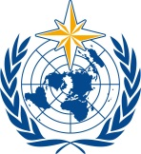  World Meteorological Organization  REGIONAL ASSOCIATION VI (EUROPE)  Nineteenth Session (Phase I)  15 to 16 October 2024, Virtual Session | RA VI-19(I)/INF. 2.1(1)
Submitted by:
President of the Regional Association VI
4.IX.2024

PROGRESS REPORT FROM THE RA VI PRESIDENT (INCLUDING RA VI BODIES AND REGIONAL OFFICE FOR EUROPE)

The report covers the intersession period from November 2020 to October 2024
Between November 2020 and October 2024, the Regional Association VI (RA VI) (Europe) of the World Meteorological Organization (WMO) faced a series of significant challenges and transformative changes. These included leadership transitions, the COVID-19 pandemic, regional conflicts, the reform initiatives, and integration of new digital tools.

RA VI sessions and leadership transitions:
The eighteenth session of the RA VI (RA VI-18) (First Phase) was held, in November 2020, virtually due to the COVID-19 pandemic, under the leadership of Dr Michael Staudinger. The pandemic, which began in late 2019 and was declared a global pandemic in March 2020, severely disrupted traditional operations. The need to switch to a virtual format for the session was a significant challenge, as it required adapting to new methods of communication and collaboration while ensuring that critical activities and decisions were not delayed.
The Second Phase, held in November 2021, saw a leadership transition, with Dr Kornélia Radics (Hungary) taking over as RA VI President and Dr Roar Skålin (Norway) as RA VI Vice-president. This transition occurred amidst ongoing pandemic-related challenges, adding another layer of complexity to the Association’s work. The new leadership had to navigate the difficulties of continuing operations in a predominantly virtual environment while ensuring a smooth handover of responsibilities.
During an extraordinary session of RA VI, held in May 2023, back-to-back to the nineteenth World Meteorological Congress (Cg-19), the RA VI elected Dr Elena Mateescu (Romania) as RA VI president and Mr Mark Rieder (Czech Republic) as RA VI vice-president. Their terms run until the conclusion of the 19 session of RA VI, as per WMO General Regulation 10.
The extraordinary session of RA VI held alongside the Cg-19, facilitated substantial in-person participation while accommodating remote attendees, demonstrating RA VI’s resilience and adaptability.
The period has been marked by both significant challenges and strategic advancements.

Challenges and impacts:
- Pandemic and Regional Conflicts: the COVID-19 pandemic and ongoing regional conflicts created a complex operational environment, affecting Member engagement and regional stability.
- Leadership Transitions and New Session Format: the period included significant leadership transitions and a new two-phase session format, increasing the frequency of meetings, and necessitating enhanced mobilization and strategic organization.
- Regional Reform and Digital Transformation: the regional reform and digital transformation have both presented opportunities and challenges.
Initiatives such as the review and optimization of regional mechanisms, integration of digital tools (e.g. the Community Platform, Members and Experts databases), and the extension of partnerships have aimed to improve efficiency.
Emphasizing the Earth system approach and implementing a Unified Data Policy have been critical in guiding these reforms.
Developing a framework for Public-Private engagement has been crucial for leveraging diverse expertise and resources. Efforts to enhance collaboration within the United Nations system, including engagement with United Nations Resident Coordinators and United Nations Country Offices, have been pivotal in strengthening regional cooperation.
- Demands on Members and Regional Mechanism: the increased frequency of sessions and the hybrid meeting format placed considerable demands on both Members (who had to adapt to new formats and increased engagement requirements) and the Regional Office for Europe. As the smallest regional Office within the WMO Secretariat, the Office faced substantial resource constraints in managing a larger, more complex meeting schedule and supporting the needs of the second largest WMO RA.

Strategic advancements
The ongoing regional reforms, coupled with strengthened collaboration, public-private partnerships, and the integration of digital tools, are continuously positioning RA VI-supported by the Management Group and the expertise of RA VI Working Mechanism- to effectively tackle future challenges and advance its mission across Europe.

RA VI Management Group membership
The RA VI Management Group consists of key figures including the RA VI President, Vice-President, and Hydrological Adviser.
While core membership is represented by a few Permanent Representatives with WMO; associated Members include the Chairs of the Informal Conference of Southeast European Directors (ICSEED), Informal Conference of Central Europe Directors (ICCED), Informal Conference of Western Europe Directors, and the Interstate Council on Hydrometeorology of the Commonwealth of Independent States (ICH CIS), and the Second Vice-President of WMO. This diverse group ensures comprehensive oversight and guidance for the RA VI's initiatives and operations.

RA VI regional priorities to 2027
During the period from 2020 to 2024, a crucial strategic step for RA VI was aligning its priorities with global WMO objectives and optimizing its working mechanisms for enhanced inclusivity and impact. Regional goals were integrated into the global WMO plan, ensuring consistency with Sustainable Development Goals (SDGs), and reinforcing coherence across different levels.
In preparation for the WMO Strategic Plan for 2024–2027, endorsed by the Cg-19, the Management Group has extended the regional priorities from 2023 to 2027. This extension introduces two additional priorities, resulting in a total of five key areas to be addressed:
- Unified Data Policy: enhancing data availability and cross-border exchange to support regional cooperation and informed decision-making.
- Improvement of Services: advancing weather, water, climate, and environmental services to ensure they are reliable, accessible, and responsive to regional needs.
- Research and Development: driving innovation to support better adaptation and mitigation strategies in the face of climate change.
- Capacity Development and Technology: leveraging artificial intelligence and new technologies to advance weather, water, and climate services, improving their accuracy and effectiveness.
- HydroSOS Implementation: enhancing water resource management and resilience through the Hydrological Status and Outlook System (HydroSOS), focusing on sustainable water management.
These priorities reflect RA VI's commitment to both regional and global initiatives. The Management Group will oversee their implementation, ensuring effective coordination and leadership. With these extended priorities and robust support from specialized centres, working groups, task teams, and regional forums, RA VI is well positioned to continue making significant contributions to global advancements and demonstrate its dedication to community welfare and environmental sustainability.

Regional working mechanisms
The RA VI Management Group, supported by the Regional Office for Europe and in coordination with the RA VI Working Group chairs, has recently implemented key changes to optimize its working mechanisms. The RA VI Management Group has streamlined its operations by discontinuing certain teams and integrating their functions into the Management Group and other forums. Focus areas were revised, such as shifting the Global Multi-hazard Alert System (GMAS) Framework Team to the Early Warnings for All (EW4All) initiative and restructuring working groups by consolidating tasks and dissolving inactive teams. In the Working Group (WG) on Services and Applications, sector-specific rapporteurs were merged into a Multisector Services Task Team, and a new Coordination Team on Forecasting was established including existing subregional teams or partners representatives to support the capacity development activities. Gender and disaster risk reduction considerations were integrated into broader activities.
These strategic adjustments are designed to streamline discussions, foster inclusivity, prioritize impactful actions, and leverage collaborative opportunities for greater efficiency and effectiveness.

Picture: RA VI working mechanism, 2024 (below)
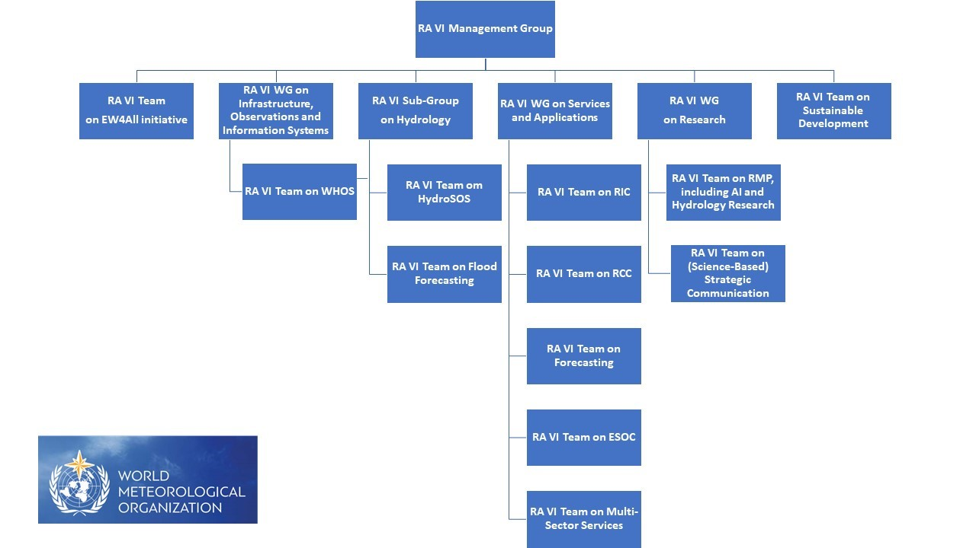

Key flagship initiatives of the Region
The Regional Forum on Sustainable Development for the Economic Commission for Europe (UNECE) region, convened annually in the spring by UNECE, serves as a vital regional platform for policy debates, exchanging best practices, and peer learning on the implementation of the SDGs. This forum provides an opportunity for countries to share experiences, discuss challenges, and explore innovative solutions to advance the 2030 Agenda for Sustainable Development.
The following Peer Learning Round Table Sessions were held as part of the forum:
2022: Sessions on Enhancing Ocean literacy and the sustainable development of regional seas, related to SDG 14-Life below water and on “Navigating the data boom: finding, understanding and using SDG data” contributing to SDG 17 - Partnerships for the goals
2023: Session on SDG 6: Water and Sanitation for All
2023: Session on SDG 17: Partnerships for inclusive and sustainable digital development
2024: Peer learning round table on SDG 13 – Solving the Rubik’s cube of the planetary crisis: lining up policy solutions for climate risks and biodiversity loss and Session on Food Systems Transformation as an Accelerator for the SDGs Implementation and Climate Action related to SDG 1: Zero Hunger
The Regional Conference on the Future Role of National Meteorological and Hydrological Services (NMHSs) Leadership and Management was held in November 2022. The event featured a high-level session coinciding with the launch of the State of the Climate in Europe report and was conducted back-to-back with the inaugural Regional Forum on Public-Private Engagement (PPE). This conference played a crucial role in supporting all regional priorities, including the implementation of the Unified Data Policy. It also emphasized the development of infrastructures and services in collaboration with multiple sector partners, such as Microsoft, to enhance regional capabilities and resilience.
The Annual Launch of the European State of the Climate report (2021, 2022, 2023), which has become a joint publication between the WMO and the European Commission's Copernicus Climate Change Service. This report provides an in-depth overview of the state of the climate within WMO RA VI.
The Regional Scientific Forum, held in October 2023 in Bucharest, Romania, was designed to strengthen the region's research component and facilitate the transfer of research into operational practices. Serving as a vital platform, it brought together researchers and scientists specializing in weather, water, climate, and related environmental issues to foster collaboration and drive innovation. The forum also featured a social science communication session, complemented by an art and science exhibition, enhancing the interdisciplinary exchange and public engagement.
The implementation of the EW4All initiative in RA VI has been supported by activities and series of significant events, including:

Activities:
- Establishment of Regional WMO Integrated Global Observing System Branch (WIGOS) Centres in pilot mode in 2024
- Implementation of WMO Hydrological Observing System (WHOS) prototype for Sava River basin
- Further development and maintaining the south-east European Early Warning Advisory System hosted by the ECMWF.

Events:
- 2022: UNECE Regional Forum on Sustainable Development Side Event on “Partnerships to Address Climate Change, Extreme Events, and Disaster Risk Reduction towards SDGs” (Geneva, Switzerland/Hybrid)
- 2023: UNECE Regional Forum Side event on EW4All implementation (Geneva/Hybrid)
- 2023: Coordination Meeting on the EW4All Plan of Action for RA VI (Geneva, Switzerland)
- 2023: ICSEED Side Event on “Early Warning for All” (Brdo, Slovenia)
- 2023: Artificial Intelligence Event to Support EW4All, held alongside the Cg-19
- 2023: South Caucasus EW4All Event (Geneva, Switzerland)
- 2023–2024: Rapid Assessments of Hazard Monitoring and Forecasting Capacity
- 2024: South-East European Early Warning for All Event (Athens, Greece).
In performing its duties, the president was assisted by the WMO Regional Office for Europe.
The WMO Regional Office for Europe carries out its mission through five core functions: representation, advocacy, coordination, administrative and logistical support, and internal management.

Representation
The Office represents the WMO Secretariat in WMO RA VI by advising Members on WMO strategic goals and following up on key global and regional events. It also represents the region to the WMO Secretariat, providing updates on weather, water, and climate activities and facilitating the region’s contributions to WMO strategic plans.

Advocacy
The Office works to increase WMO visibility and influence in WMO RA VI by liaising with regional partners and United Nations agencies, strengthening regional networks, and advocating for investment in meteorological systems and services. It engages stakeholders in initiatives aligned with strategic priorities.

Coordination
This involves disseminating information on weather, water, and climate developments to Members, analysing regional needs and gaps, and supporting regional centres. The Office also assists the RA and its leadership in their activities and projects.

Administrative and logistical support
The Office assists with planning and organizing regional sessions, meetings, and events. It supports the development of operating plans, collects information for planning and advocacy, and maintains up-to-date country profiles.

Internal management
The Office is composed of a Director, a Programme Officer, a Coordinator, and a Chief position that is to be discontinued in October 2024.

Key achievements
It includes multiplied advocacy platforms and mechanisms, enhanced communication, strengthened visibility of WMO activities and the role of NMHS in sustainable development, fostered more inclusive collaboration with extended partnerships, strengthened involvement of specialized centres in key processes, such as capacity development as well as transfer of research into operations, thereby enhancing the region's capabilities.
For more details you can access the following web pages:
Regional Office for Europe | World Meteorological Organization (wmo.int)
Interviews | World Meteorological Organization (wmo.int)

Planned activities
Future efforts focus on implementing the regional plan, supporting the development of national strategies, enhancing regional partnerships, and participating in regional collaboration mechanisms. The Office also plans to develop communication materials and operational dashboards, while continuing to follow up on ongoing projects.

