|  |  |  |
| --- | --- | --- |
| WEATHER CLIMATE WATER | **World Meteorological Organization**  **COMMISSION FOR OBSERVATION, INFRASTRUCTURE AND INFORMATION SYSTEMS**  **Second Session** 24 to 28 October 2022, Geneva | **INFCOM-2/INF. 6.1(3)** |
| Submitted by: Chair of SC-ON  27.IX.2022 |

## REQUIREMENTS FOR OBSERVATIONAL DATA IN THE FRAMEWORK OF THE WMO EARTH SYSTEM APPROACH:

**THE ROLLING REVIEW OF REQUIREMENTS**

Contents

1. Introduction 3

2. Overview of the Rolling Review of Requirements (RRR) process 3

3. Users of observations: Application Areas 5

4. Points of Contact (POC) and Earth System Application Category Coordinators 7

5. Requirements for observations 7

6. Capabilities of WIGOS observing systems 9

7. The Critical Review 10

8. Statements of Guidance (SoG) 11

9. High-Level Guidance for the Evolution of Global Observing Systems 12

10. Other RRR outputs and uses 12

11. Involvement of stakeholders 13

Annex I. List of Application Areas in each Earth System Application Category 14

Annex II. Regional aspects of the RRR process 19

Annex III. OSCAR/Requirements 22

Annex IV. OSCAR/Space and OSCAR/surface 27

Annex V. Cost-benefit considerations 29

Annex VI. Observations impact studies 30

Annex VII. The Vision for the WIGOS 31

Annex VIII. WIGOS total system design 32

ANNEX IX. OSCAR UPDATING/MAINTENANCE PROCEDURE 34

Annex X. Procedure for update, validation and approval of Statements of Guidance (SOG) within the WMO Rolling Review of Requirements (rrr) process 41

Annex XI. Prioritization concept in the RRR Process 43

Annex XII. Acronyms 47

ATTACHMENT 1: Statement of Guidance (SOG) template 48

Attachment 2: Example for Statement of Guidance gap analysis (Global NWP) 55

ATTACHMENT 3: Reference Guide for Points of Contact (PoC) for Application Areas, and Coordinators for Earth System Application Categories, within the WMO Rolling Review of Requirements (RRR) Process. 57

Annex 1 to Attachment 3. Role of the Points of Contact (PoC) for Application Areas, and Coordinators for Earth System Application Categories 63

Annex 2 to Attachment 3. PoC and Coordinator roles: Work planning 65

[Annex 3 to Attachment 3. PoC and Coordinator roles:   
Communicating with your Application Area “owner” 67](#_Toc113633980)

Annex 4 to Attachment 3. PoC and Coordinator roles: Coordination amongst PoCs 68

Annex 5 to Attachment 3. PoC and Coordinator roles: Consulting with Stakeholders 70

Annex 6 to Attachment 3. PoC and Coordinator roles: Assessing observation impact studies 72

Annex 7 to Attachment 3. PoC and Coordinator roles: Compiling and Updating Requirements 73

[Annex 8 to Attachment 3. PoC and Coordinator roles:  
 Completing the Statement of Guidance (SoG) 74](#_Toc113633985)

Annex 9 to Attachment 3. PoC and Coordinator roles: Further notes 75

# Introduction

WMO Members require international observations to fulfil their mandates, which include monitoring and the provision of services. They endeavour to collect and share observations which address their requirements, by each cooperatively agreeing to comply with prescribed arrangements for the operation of WMO observing systems, in the framework of the WMO Integrated Global Observing System (WIGOS). This is an element of the cooperation described in [Resolution 1 (Cg-Ext(2021))](https://library.wmo.int/doc_num.php?explnum_id=11113#page=9), WMO Policy for the International Exchange of Earth System Data. The requirements for observations are documented for each of a series of Application Areas in which the observations are directly used.

It is a challenging exercise to develop a consensus view on the design and implementation of WMO integrated observing systems, in particular where the need and implementation occur on global or regional scales. The WMO former Commission for Basic Systems (CBS) has encouraged the development of a process to accomplish this, as objectively as possible. The process is known as the Rolling Review of Requirements (RRR) and has evolved under the WMO Commission for Observation, Infrastructure and Information Systems (INFCOM) to take into account WMO’s Earth System approach.

This revised description of the RRR process includes recognition of Earth System Application Categories: Space; Atmosphere, Oceans; Hydrosphere and Terrestrial; and Cryosphere; together with the overall Integrated Earth System. Interfaces are recognized as important areas for activities which have significant requirements for observations. New arrangements are included for collaboration between all the Application Areas within each category – to identify gaps in observing system capabilities and to provide guidance on the most important and achievable priorities for addressing the gaps in that Earth System Application Category.

# Overview of the Rolling Review of Requirements (RRR) process

In brief, the RRR process compiles information about requirements for observations, about observing system capabilities, and draws on experts and impact studies to provide guidance on the most important priorities for addressing the gaps between requirements and capabilities. The main elements of the RRR process are illustrated in **Figure 1**. Ongoing management of the RRR process is undertaken by the WMO Commission for Observation, Infrastructure and Information Systems (INFCOM) through its Joint Expert Team on Earth Observing System Design and Evolution (JET-EOSDE), supported by the WMO Secretariat in the Observing Networks and Measurement Division of the Infrastructure Department.

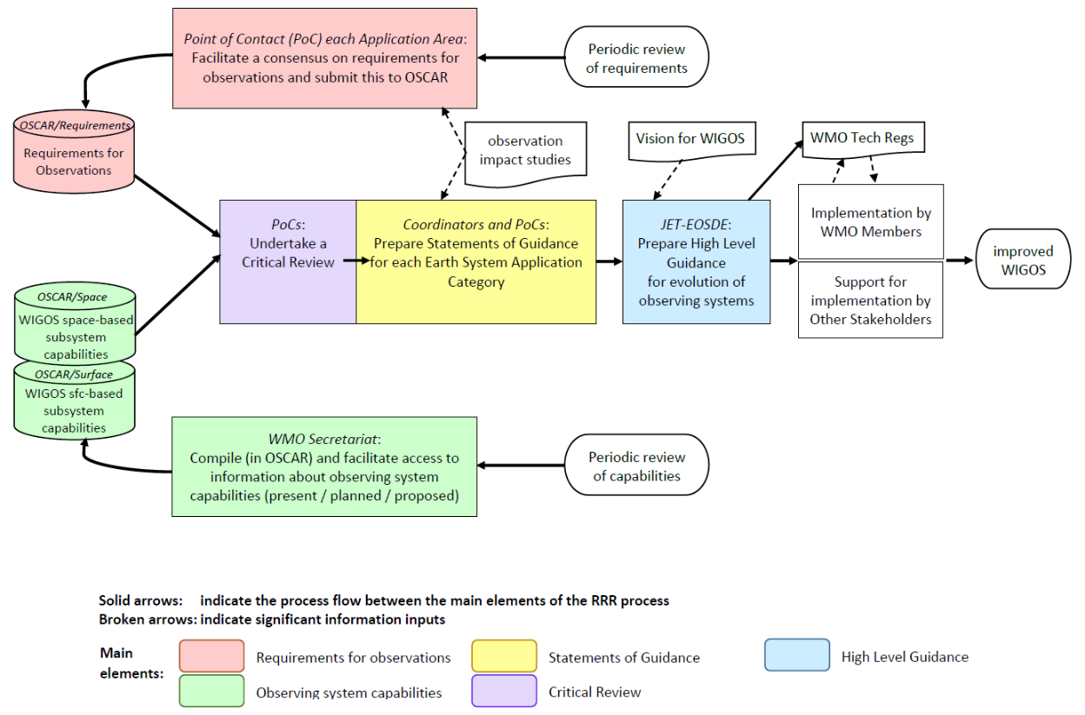

**Figure 1**. Elements of the RRR process.

The RRR process consists of the following elements:

1. a review of Members' technology-free[1] requirements for observations, as compiled by the Point of Contact within each Application Area;
2. a review of the observing capabilities of existing, planned and proposed observing systems, both surface- and space-based;
3. a Critical Review of the extent to which the capabilities (b) meet the requirements (a);
4. a Statement of Guidance for each Earth System Application Category based on synthesis of (c) for all Application Areas considered within the category. It is authored jointly by the relevant Points of Contact working together under a Coordinator; and
5. the High-Level Guidance on the Evolution of Global Observing Systems in Response to the WIGOS Vision (HLG) which compiles key guidance for the next 4 to 5 years taken from all the SoGs in response to the WIGOS Vision.

The aim of the Statement of Guidance is:

1. to inform WMO Members on the extent to which their requirements are met by present systems, will be met by planned systems, or would be met by proposed systems. The Statement of Guidance is essentially a gap analysis with recommendations on how to address the gaps based on expert judgement and Observations Impact Studies. It also provides the means whereby Members, through the Technical Commissions, can check that their requirements have been correctly interpreted.
2. to provide resource materials useful to WMO Members for dialogue with the agents responsible of implementing observing systems as well as the industry regarding whether existing systems should be continued or modified or discontinued, whether new systems should be planned and implemented, and whether research and development is needed to meet unfulfilled aspects of the user requirements.

The RRR process also feeds information into two key documents. Based on knowledge of:

1. Strategic direction of WMO and priorities;
2. Current and planned observing systems;
3. The gaps identified by the Statements of Guidance;
4. Which future observing systems are likely to be feasible and affordable,

guidance is provided on the component observing systems to which the WMO community should aspire in:

1. the “Vision for the WIGOS“ for the coming decade(s).
2. the High-Level Guidance on the Evolution of Global Observing Systems in Response to the WIGOS Vision in the next 4 to 5 years.

These two documents are periodically revised and submitted to the Infrastructure Commission and the Executive Council for approval. Indeed, the whole RRR process is a rolling activity through which all data and documents are periodically reviewed and updated – more details are included in the following sections, but as a general rule all elements of the process need to be completed at least once in each 4-yearly planning cycle of the WMO.

# Users of observations: Application Areas

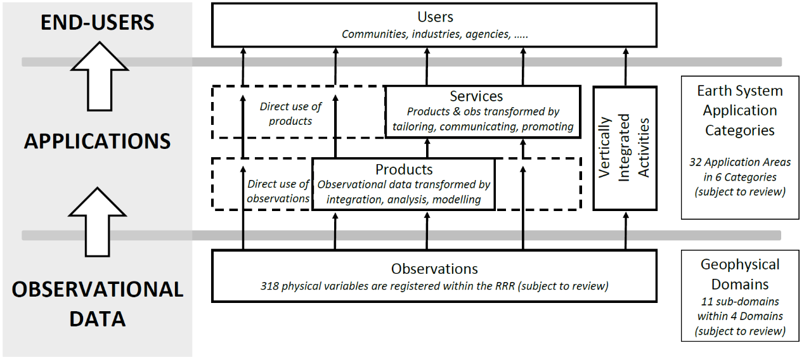

**Figure 2**. schematic diagram of applications in the value-chain which transform observations into the products and services seen by end-users. Some applications are primarily concerned with generating products; some applications are primarily concerned with the usefulness of services to end-users; some applications integrate all of these concerns in their activities.

As illustrated schematically in **Figure 2**, end-users of weather, climate and water services benefit from observations but often have little awareness of the role observations play in supporting the products and services they use. To understand user requirements and priorities for observations it is more informative to seek advice from those involved in activities which directly use observations, rather than the end-users.

An Application Area is an activity involving primary use of Earth System observations which allows National Meteorological and Hydrological Services or other organizations to render services related to weather, climate and water, and other environmental events[2], contributing to public safety, socio-economic well-being and development in their respective countries. The concept of a WMO Application Area is used in the framework of the WMO RRR and describes a homogeneous activity for which it is possible to compile a consistent set of observational user requirements agreed by community experts working in this area.

Each Application Area is owned by an identified body which has the authority to (a) designate a Point of Contact, and (b) concur with the observational user requirements in Observing Systems Capability Analysis and Review (OSCAR)/Requirements, and with the gap analysis of the application area provided within a Statement of Guidance. Annex I provides a list of Application Areas and their ownership. This list is kept up-to-date online at <https://community.wmo.int/rolling-review-requirements-process>

Annex I also shows the groupings of Application Areas in six Earth System Application Categories, and the attributes of each Application Area indicating whether it uses observations for forecasting activities, for monitoring activities, and/or for integrated products and direct use of observations for services.

There are many ways that a list of applications could be constructed. A long list could differentiate in fine detail between numerous applications. The list used in the RRR process represents a balance between granularity/detail and keeping it short enough for the practical feasibility of maintaining the RRR process. Application Areas may be proposed for addition to or deletion from the list as required. Note however that a single Application Area can achieve substantial granularity in expressing its requirements by: (i) stating different requirements in different vertical and horizontal locations, for example across different Regions or local areas; and (ii) using the Comments field in the OSCAR/Requirements database (see Section 5 below) to indicate when a requirement is specific to a particular subset of activities within the overall Application.

Regional aspects of the RRR process are discussed further in Annex II where it is noted that a WMO Region in total is not regarded as an application area because it includes a diversity of activities associated with a range of application areas. Regional experts liaise with the Point of Contact for each relevant application area to collaborate in documenting Region-specific requirements, gaps, and priorities for the evolution of observing system capabilities.

Requirements defining which geophysical observations are needed for a certain application, and their associated attributes, are meant to provide information from experts (as compiled by the Points of Contact (PoCs) in each Application Area) to provide guidance to observing systems designers and networks architects to optimize their designs and networks. However, these requirements are currently not prioritized. To provide such information, the concept of prioritization in the RRR process has been developed which can be found in Annex XI.

Note also that, as illustrated in **Figure 2**, Application Areas have many relationships and data flows with each other. Requirements for observations are only to be expressed where there is direct use of the observation in the application activity, otherwise it is left to the upstream activity to express the requirement for the observation.

# Points of Contact (POC) and Earth System Application Category Coordinators

The RRR process depends on input from each Application Area regarding its requirements and priorities for observations. To obtain this input, an expert in each Application Area is identified to be the PoC. That expert has a very important role as the conduit to the RRR for input and feedback from the entire stakeholder community for that Application Area, through that Application Area owner. Hence it is important for the PoC to provide information on input and feedback processes to their stakeholder community, including Members, Regional Associations, and Technical Commissions and their expert teams. As well as documenting requirements for observations, PoCs are also co-authors of the Statement of Guidance (SoG) for the Earth System Application Category in which their Application Area is active.

The authority for selecting each PoC is with the owner of the relevant Application Area (see Annex I). A list of PoCs is maintained online at <https://community.wmo.int/rolling-review-requirements-process>

See Attachment 3 for further details on the role of the Points of Contact.

Additionally, in the framework of the WMO Earth System approach, just one SoG is prepared for each Earth System Application Category. The PoCs within each Earth System Application Category must work together as a team of experts to prepare the SoG, under the guidance of an Earth System Application Category Coordinator. The role of an Earth System Application Category Coordinator is to coordinate with the PoCs of the relevant Application Areas to develop the SoG (gap analysis with recommendations on how to address the gaps) of an Earth System Application Category. They are the lead author of the SoG.

A Coordinator is selected from within the team of PoCs in each Earth System Application Category.

See Attachment 3 for further details on the role of the Coordinators.

# Requirements for observations

One of the main elements of the RRR process, as shown in **Figure 1**, is the compilation of requirements for observations in the Requirements component of the OSCAR tool, known as OSCAR/Requirements. Each PoC consults widely with the community of experts in their Application Area, considers any relevant guidance from Observations Impact Studies, and applies their own expert assessment, in order to establish a consensus view of the requirements for observations, in particular with the body which has been identified as the owner of the Application Area. The PoC then enters into the OSCAR/Requirements database their proposed updates to existing requirements and/or additions of new requirements.

The user requirements are not system-dependent; they are intended to be technology-free. No consideration is given to what type of measurement characteristics, observing platforms or data processing systems are necessary (or even possible) to meet them. The requirements are aimed at the WIGOS Vision time frame.

The basic structure used to record each individual requirement is shown in **Figure 3**. There are three basic elements needed to express a requirement:

1. the first element is to specify who wants the observation, this is one of the Application Areas together with a comment which may elaborate further, for example to identify a specific activity within the overall Application;
2. the second element is to specify what the observation is, importantly this combines a geophysical variable with the place/s where it is to be observed within[3] a defined list of 31 vertical layers and 8 types of horizontal coverage;
3. then the third element is to specify the performance level required for this observation for this user.

Further illustration of the detailed structure of requirements, as they are expressed in the OSCAR/Requirements database, is provided together with some examples in Annex III.

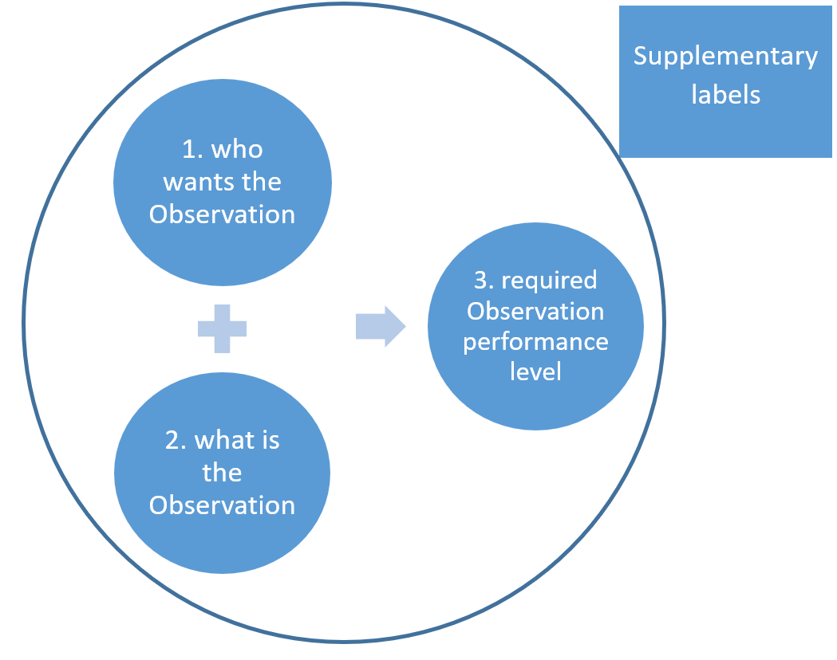

**Figure 3**. Schematic diagram of the basic structure used to express an observation requirement in the OSCAR/Requirements database.

The required performance levels are stated quantitatively in terms of six criteria, which are :

1. Horizontal resolution;
2. Vertical resolution;
3. Frequency (observation cycle);
4. Timeliness (delay in availability);
5. Uncertainty[4] (acceptable RMS error and any limitations on bias), and
6. Stability (the maximum permissible cumulative effect of systematic changes of the measurement system, to allow long-term climate records compiled from assorted measurement systems – percentage change per decade).

A further two criteria are to be included in the future:

1. Layer/s quality (how well the specified vertical layer/s is/are delivered),
2. Coverage quality (how well the specified horizontal coverage is delivered).

For each Application, there is usually no abrupt transition in the utility of an observation as its quality changes; improved observations (in terms of resolution, frequency, accuracy, etc.) are usually more useful while degraded observations, although less useful, are usually not useless. Moreover, the range of utility varies from one application to another. Therefore, for each of these criteria, the requirement includes three values determined by experts: the “goal“, the “threshold“, and the “breakthrough“.

The “goal” or “maximum requirement“ is the value above which further improvement of the observation would not cause any significant improvement in performance for the application in question. The cost of improving the observations beyond the goal would not be matched by a corresponding benefit. The goals are likely to evolve as applications progress and develop a capacity to make use of better observations.

The “threshold” or “minimum requirement“ is the value that has to be met to ensure that data are useful. Below this minimum, the benefit derived does not compensate for the additional cost involved in using the observation. Threshold requirements for any given observing system cannot be stated in an absolute sense; assumptions have to be made concerning which other observing systems are likely to be available.

Within the range between threshold and goal requirements, the observations become progressively more useful. The “breakthrough” is an intermediate level between “threshold” and “goal“ which, if achieved, would result in a significant improvement for the targeted application. Note also that the concept of a "breakthrough" level is different to the concept of the optimum cost-benefit level (see Annex V) since it refers to a significant increase in the value or benefit of an observation without reference to the costs involved.

# Capabilities of WIGOS observing systems

Another one of the main elements of the RRR process, as shown in **Figure 1**, is the compilation of information about WIGOS observing system capabilities. The ideal situation would be to integrate the capabilities of all component systems in a single database using the same technology-free structure as the requirements database – that is to document which observations are being made by WIGOS (which variables at what vertical locations and horizontal coverage) with what performance level (eight criteria: horizontal resolution, vertical resolution, frequency, timeliness, uncertainty[5], stability, layer/s quality, coverage quality). It is a very complex challenge to derive such information from available information about the various observing technologies being used at many different stations and platforms and facilities, and how they are deployed and operated in many different networks and systems and missions and constellations and fleets. The ideal situation remains an aspiration for the future; for now the relevant information is found in several sources and with data structures reflecting the specific technologies, platforms and/or networks.

The Infrastructure Department of the WMO Secretariat coordinates the compilation of observing capabilities data in the two databases shown in **Figure 1**: capabilities of the WIGOS space-based subsystem are stored in OSCAR/Space and capabilities of the WIGOS surface-based subsystem are stored in OSCAR/Surface, keeping track as much as practicable with the addition of Earth System components and interface observations as WMO’s Earth System approach is applied. Additional information about WIGOS observing capabilities may also be obtained from other sources.

For the capabilities of space-based observing systems, each of the contributing space agencies has provided a summary of the potential performances of their instruments, expressed in the same terms as the user requirements, together with sufficiently detailed descriptions of the instruments and missions to support evaluation of the performances. Assessment of service continuity is based on the programmatic information supplied. Particular care has been taken to establish a common language, in the form of agreed definitions for the geophysical variables for which observations are required / provided and agreed terminology to characterize requirements and performances.

For the capabilities of surface-based observing systems, observing system operators provide station-by-station metadata in accordance with the WIGOS metadata standard and reporting obligations. The OSCAR/Surface database also obtains some station information indirectly from other databases such as the WMO Radar Database and the Global Atmosphere Watch Station Information System.

A complementary approach for assessing the WIGOS observing capabilities is provided by the monitoring and evaluation components of the WIGOS Data Quality Monitoring System (WDQMS). This provides an in-practice confirmation of the observations that are actually made available to the global NWP centres providing monitoring information for WDQMS (known in this context as WIGOS Monitoring Centres), however careful interpretation is needed since it also reflects the performance of the data communications pathways.

Annex IV provides further information about OSCAR/Space, OSCAR/Surface and the WDQMS.

# The Critical Review

A further element of the RRR process, as shown in **Figure 1**, is the Critical Review. This represents the first step in comparing WIGOS observing capabilities to the requirements in an objective fashion to identify gaps. If observing capabilities were documented in the ideal manner described earlier, this step could be undertaken as a simple and direct comparison between the databases. In practice, some effort is needed to investigate and understand the observing capabilities in an integrated view and to assess how well they address the requirements.

Some tools are available which provide a more limited but still helpful scope of comparisons. OSCAR/Space is supplemented with a gap analysis tool which assesses the capabilities of various satellite instruments against requirements. The monitoring and evaluation components of the WDQMS provide ongoing assessments of how well actual surface observations meet the planned performance levels.

Currently, each PoC undertakes this Critical Review effort in some form as an initial step in analysing the gaps and priorities for action relevant to their Application Area before drafting their input to the SoG.

# Statements of Guidance (SoG)

A key element of the RRR process, as shown in **Figure 1**, is the SoG. Each of the six Earth System Application Categories prepares an SoG under the leadership of its Coordinator as the lead author. All the PoCs for Application Areas within each Earth System Application Category contribute as co-authors.

The role of a SoG is to provide a synthesis and interpretation of the outputs of the critical reviews as gap analyses for the relevant application areas, to draw conclusions, and to identify priorities for action. The process of preparing such a statement is necessarily more subjective than that of the critical review. Moreover, whilst a review attempts to provide a comprehensive summary, a SoG is more selective, drawing out key issues. It is at this stage that judgements are required concerning, for example, the relative importance of observations of different variables. These judgements can be enhanced by taking into account the results of observation impact studies (see Annex VI) and considering cost-benefit aspects (see Annex V). The SoG template provides informative guidance on what is required to be included in the document. The template is available online at: [editorial note: hyperlink to be provided once approved and available online; it is available in Attachment 1 for the time being]

The following terminology has been adopted in the SoGs:

1. "Marginal" indicates minimum user requirements are being met,
2. "Acceptable" indicates greater than minimum but less than maximum requirements (in the useful range) are being met, and
3. "Good" means close to maximum requirements are being met.

Since the preliminary SoG were published in 1998, several updates and additions have been completed in order to extend the process to new application areas, to take into account the evolving nature of requirements, and to include the capabilities of surface-based sensors. Also, during 2022, the RRR process has evolved to take into account the WMO’s Earth System approach. The latest SoG can be found on the WMO website at: <https://community.wmo.int/rolling-review-requirements-process>

When reviewing the existing versions, keep in mind that the new Earth System Application Category approach is significantly different from the previous approach in which each Application Area drafted its own SoG.

# High-Level Guidance for the Evolution of Global Observing Systems

The High-Level Guidance for the Evolution of Global Observing Systems in Response to the WIGOS Vision (HLG), which responds to the Vision for WIGOS (see Annex VII), is a key document providing Members with clear and focused guidelines and recommended actions, in order to stimulate cost-effective evolution of the observing systems and to address the requirements of WMO programmes and co-sponsored programmes in an integrated way.

The HLG is produced by the Infrastructure Commission following wide expert review through the RRR process, looking at SoG for all Earth System Application Categories and their component Applications Areas, taking overall cost-effectiveness into account, as well as WMO priorities.

Progress against actions in the HLG is regularly reviewed and, when necessary, recommended actions are revised or added.

The current version of the HLG is available from the WMO website at: [editorial note: hyperlink to be provided once approved and available online; for the time being it is available as INFCOM-2 INF 6.1(1)]

# Other RRR outputs and uses

The key outputs resulting from the RRR process are the Statements of Guidance, the High-Level Guidance that builds on them, and less directly the Vision for WIGOS which takes into account the SoGs. These outputs aim to influence the actions of observing system owners, operators, planners and sponsors in all Member countries and other supportive entities as they evolve their observing systems for greater capabilities. Once a new capability is widely implemented – once a strong majority of Member countries have the capability and agree – then it may be added to the Technical Regulations, elevating the capability to a standard practice which all Members are required to adopt or, if the capability and agreement is less widespread, then it may be added as a recommended practice which all Members are urged (but not required) to adopt.

Other products of the RRR – the OSCAR/Requirements, OSCAR/Space, and OSCAR/Surface databases – are also directly useful. For example, the OSCAR/Requirements database provides a direct source of information to surface observing system planners, designers and operators regarding their contributions to the Global and Regional Basic Observing Networks (GBON and RBONs). For RBON, the following standard practices form part of the WIGOS Technical Regulations in the [*Manual on the WMO Integrated Global Observing System*](https://library.wmo.int/index.php?lvl=notice_display&id=19223#.YxtA5XZBw2w) (WMO-No. 1160), 2019 edition as updated in 2021:

*3.2.3.3 Members shall nominate an observing station/platform for inclusion in RBON only if it meets one or more requirements of one or more WMO application areas.*

*3.2.3.6 Members shall design RBONs in response to user observational requirements as compiled in the OSCAR/Requirements database, in consideration of regional needs.*

*3.2.3.7 Members shall each nominate a set of stations/platforms to enable RBONs to meet, at threshold levels or better, the observational requirements of all WMO application areas.*

OSCAR/Requirements is freely available to all for read-only access and there are several tables with filtering, sorting and export options to enhance the useability of the data. Access is available at: <https://space.oscar.wmo.int/observingrequirements>.

# Involvement of stakeholders

Success of the RRR process is extremely dependent on the productive involvement of stakeholders. It critically depends on the willingness of Member countries to contribute information about their observing system capabilities and to nominate volunteer experts to fulfil roles, particularly the role of PoC for an Application Area or the role of Coordinator for an Earth System Application Category. It also depends on the willingness of Member countries to consider and act on the published HLG and SoGs, and to report on their actions taken.

The PoC for each Application Area can only carry out the role effectively if the community of experts (applications experts and observing technology experts, including with WMO programmes and co-sponsored programmes) for that application contribute to the compilation of their requirements for observations as well as providing input to the drafting of the SoG. This includes the active involvement of relevant experts from each of the WMO Regional Associations, as is urged in Annex II.

The Infrastructure Commission encourages feedback to the Coordinators from Members, Regions, other Technical Commissions and other stakeholders.

The RRR process is intended to be comprehensive, covering all observation-using activities of WMO programmes and co-sponsored programmes across all WMO Regions and the Antarctic. It should broadly cover all applications, whether global, regional or national, which require international observations. It is important that any deficiencies in this respect are reported back to the Infrastructure Commission so that they can be considered and corrected. More generally, all stakeholders are invited to share feedback regarding any aspect of the RRR process. The following email address may be used for this purpose:

[obs-rrr@wmo.int](mailto:obs-rrr@wmo.int) [editorial note: this email address is not functional yet; it will be implemented in due course]

Members and Regions are also encouraged to adopt the concepts of the RRR process when considering observing system developments specific to their own country or region.

Finally, it may be noted that the design, implementation and evolution of WIGOS as a total integrated system depends on the combined efforts of all observing system owners, operators, planners and sponsors. It will not be achieved by relying on the RRR process alone, as discussed further in Annex VIII.

# Annex I. List of Application Areas in each Earth System Application Category

The concept of an Application Area was explained in Section 3 as follows: an Application Area is an activity involving primary use of Earth System observations which allows National Meteorological and Hydrological Services or other organizations to render services related to weather, climate and water, and other environmental events, contributing to public safety, socio-economic well-being and development in their respective countries. The concept of a WMO Application Area is used in the framework of the WMO RRR and describes a homogeneous activity for which it is possible to compile a consistent set of observational user requirements agreed by community experts working in this area.

The list of Application Areas below represents a balance between granularity/detail and the practical feasibility of maintaining the RRR process. However, it is important to note that Application Areas may be proposed by their owners for addition to or deletion from the list as required.

This table lists all the Application Areas which currently form part of the RRR process, against the Earth System Application Categories in which they are grouped. This list is kept up-to-date online at <https://community.wmo.int/rolling-review-requirements-process>.

| ***Earth System Application Category*** | ***Application Area1,2*** | ***Observations are primarily used for …..*** | | | ***Ownership*** |
| --- | --- | --- | --- | --- | --- |
| ***Forecasting*** | ***Monitoring*** | ***Other uses7*** |
| 1. Space Weather Applications | 1.1 Space Weather | ☒ | ☒ | ☐ | INFCOM/ET-SWx |
| 1.2 Energetic Particle Forecasting & Monitoring | ☒ | ☒ | ☐ | INFCOM/ET-SWx |
| 2. Atmospheric Applications | 2.1 Global NWP & Real-time Monitoring | ☒ | ☒ | ☐ | INFCOM/SC-ESMP |
| 2.2 High-Resolution NWP | ☒ | ☐ | ☐ | INFCOM/SC-ESMP |
| 2.3 Nowcasting / Very Short Range Forecasting (VSRF) | ☒ | ☐ | ☒ | INFCOM/SC-ESMP |
| 2.4 Sub-Seasonal to Longer Predictions (SSLP) | ☒ | ☐ | ☐ | INFCOM/SC-ESMP |
| 2.5 Atmospheric Climate Monitoring and Forecasting | ☒ | ☒ | ☐ | GCOS/AOPC |
| 2.6 Atmospheric Composition Forecasting & Monitoring*3* | ☒ | ☒ | ☐ | RB/EPAC SSC |
| 2.7 Atmospheric Composition information services in urban and populated areas*3* | ☐ | ☐ | ☒ | SERCOM/SG-URB |
| 2.8 Aviation Meteorology | ☐ | ☐ | ☒ | SERCOM/SC-AVI |
| 2.9 Agricultural Meteorology*3* | ☐ | ☐ | ☒ | SERCOM/SC-AGR |
| 2.10 Atmospheric Disaster Risk Reduction | ☐ | ☐ | ☒ | SERCOM/SC-DRR |
| 3. Oceanic Applications | 3.1 Ocean Mesoscale Forecasting & Real-Time Monitoring | ☒ | ☒ | ☐ | GOOS/ETOOFS |
| 3.2 Wave Forecasting | ☒ | ☐ | ☐ | SERCOM/SC-MMO/ET-MOR |
| 3.3 Oceanic Climate Monitoring | ☐ | ☒ | ☐ | GCOS/OOPC |
| 3.4 Tsunami Monitoring & Detection | ☐ | ☒ | ☒ | SERCOM/SC-MMO/ET-MOR |
| 3.5 Oceanic Disaster Risk Reduction | ☒ | ☐ | ☒ | SERCOM/SC-DRR |
| 4. Hydrological & Terrestrial Applications | 4.1 Hydrology Forecasting & Real-Time Monitoring | ☒ | ☒ | ☐ | INFCOM/JET-HYDMON |
| 4.2 Hydrological and Terrestrial Climate Monitoring | ☐ | ☒ | ☐ | GCOS/TOPC, alternative GTN-H |
| 4.3 Hydrological and Terrestrial Disaster Risk Reduction | ☐ | ☐ | ☒ | SERCOM/SC-DRR |
| 5. Cryospheric Applications | 5.1 Terrestrial Cryosphere Forecasting and Monitoring*4* | ☒ | ☒ | ☒ | INFCOM/GCW-AG |
| 5.2 Sea-Ice Forecasting and Monitoring5 | ☒ | ☒ | ☒ | INFCOM/GCW-AG |
| 5.3 Cryospheric Climate Monitoring | ☐ | ☒ | ☐ | GCOS/TOPC and OOPC |
| 5.4 Cryospheric Disaster Risk Reduction | ☐ | ☐ | ☒ | SERCOM/SC-DRR |
| 6. Integrated Earth System Applications | 6.1 Earth System Forecasting & Monitoring*6* | ☒ | ☒ | ☐ | INFCOM/SC-ESMP |
| 6.2 Understanding Earth System processes*1* | ☒ | ☒ | ☐ | RB/WWRP |

Footnotes:

1 Each Application Area considers its requirements for observations, not only for operational activities but also for the research that will enable its future activities and evolving usage of observations. Application Area “6.2 Understanding Earth System processes” considers the requirements for observations of all WMO research activities not covered in any other Application Area;

2 The list of Application Areas is intended to include all WMO uses of observations where it is practicable to collect observational user requirements with a community of experts behind; it needs to be checked periodically and updated accordingly;

3 The Atmospheric Composition and Agricultural Meteorology application areas, numbered 2.6, 2.7 and 2.9, have some activities which may have an affinity with other Categories. Each application area may consider whether to split into components to belong in different Categories, in the way that Disaster Risk Reduction and Climate Monitoring are split into different Categories;

4 Application area 5.1 “Terrestrial Cryosphere Forecasting and Monitoring” includes snow, glaciers and permafrost, ice caps, glaciers;

5 Application area 5.2 includes glaciers;

6 Application area 6.1 deals with the Integrated Earth System, including all domain interfaces between components of the Integrated Earth System;

7 The column “Other uses” applies to for example Integrated products, direct use of observations for services, post-processing for verification or validation.

Explanatory notes:

1. Earth System Application Categories are intended to provide groupings of Application Areas of similar types which have related disciplines and professional communities. The concept is not directly based on having common geographical domains; it is intended to provide a pragmatic and workable approach that will enable groups of applications with similar needs for observations to collaborate in preparing their joint SoG on priorities for evolving the capabilities of WIGOS observing systems;
2. The Integrated Earth System, in accordance with the WMO Strategic Plan 2020-2023, is considered as an integrated system of atmosphere, ocean, cryosphere, hydrosphere, biosphere and geosphere;
3. An Application Area can belong to only one Category. If an application has two or more components that are so different from each other that they are best located in different Categories, and cannot be considered collectively as an Integrated Earth System Application, then they must have distinct names. Examples of this are provided by the components of Disaster Risk Reduction and Climate Monitoring;
4. In any case, the relevant applications community should lead the management of their Application Area/s (creation, naming, deletion);
5. Each Application Area is shown with attributes indicating whether it uses observations for:
6. Forecasting: that is numerical prediction or other means of projection forwards in time;
7. Monitoring: that is description of conditions at the time of observation by numerical analysis, modelling or other means of integration and interpretation of the available data;
8. Integrated products and direct use of observations for services: that is direct use of observational data alone or as an integrated dataset;
9. The “Ownership” of each Application Area is important because the owner has authority and responsibility to create, name, delete and nominate their PoC, for the specification of observation requirements, and for contributions to SoG.

Abbreviations used in this table (those not explained above or in Annex XI):

ET-SWx Expert Team on Space Weather;

SC-ESMP Standing Committee on Data Processing for Applied Earth System Modelling and Prediction & Projection;

AOPC Atmospheric Observation Panel for Climate;

RB / EPAC SSC Research Board / Environmental Pollution and Atmospheric Chemistry Scientific Steering Committee;

SERCOM Commission for Weather, Climate, Water and Related Environmental Services and Applications;

SG-URB Study Group on Integrated Urban Services;

SC-AVI Standing Committee on Services for Aviation;

SC-AGR Standing Committee on Services for Agriculture;

SC-DRR Standing Committee on Services for Disaster Risk Reduction and Public Services;

GOOS / ETOOFS Global Ocean Observing System / Expert Team on Operational Ocean Forecast Systems;

SC-MMO / ET-MOR Standing Committee on Marine Meteorological and Oceanographic Services / Expert Team on MetOcean Requirements;

OOPC Ocean Observations Physics and Climate Panel;

JET-HYDMON Joint Expert Team on Hydrological Monitoring;

TOPC Terrestrial Observation Panel for Climate;

GTN-H Global Terrestrial Network for Hydrology;

GCW-AG Global Cryosphere Watch Advisory Group;

WWRP World Weather Research Scientific Steering Committee.

# Annex II. Regional aspects of the RRR process

A WMO Region, and similarly the Antarctic, in total is not regarded as an application area in the RRR process because it includes a diversity of activities associated with a range of application areas. A key mechanism to promote Regional involvement in the RRR process is for regional experts to liaise with the PoC for each relevant application area. This will achieve collaboration in documenting Region-specific requirements for observations, gaps, and priorities for the evolution of observing system capabilities.

**Regional requirements for observations**

The requirements for observations that are recorded in the OSCAR/Requirements database have, until now, generally not indicated any differences between WMO Regions. However, within each Application Area there may be some differences in how activities are conducted or prioritized from Region to Region, hence there may be some differences in the requirements for observations.

Relevant experts in the Working Group on Infrastructure and related Task Teams of each of the six Regional Associations and, for the Antarctic, experts in the Infrastructure Commission Advisory Group on the Global Cryosphere Watch, are encouraged to liaise with the PoC for each relevant application area. This liaison should enable Regional differences in requirements to be recognized and documented in the OSCAR/Requirements database.

Within the data structure used to express a requirement, there are several ways that a PoC can achieve granularity and show different requirements in different Regions. A key mechanism that has so far been under-utilized is to specify the “Horizontal Coverage” parameter to be “Regional” and then in the “Comments” parameter to state which of the WMO Regions this requirement applies to. In this way the PoC could express a different required performance level (frequency, horizontal resolution, uncertainty, …) in different WMO Regions for any given observed variable. Another mechanism is to state, within the “Comments” parameter, the limited applicability of this requirement within the overall Application Area. Two examples which are currently in the database: “This air-quality requirement applies on urban areas”; and “near steep topography or jet-streams”. The “Comments” parameter could equally be used to state “this requirement applies in Region II (Asia)”.

**Building WIGOS to meet the requirements**

At the Regional level, a key activity is implementation of the Regional Basic Observing Network (RBON) which is an important part of the WIGOS surface-based subsystem effort to satisfy requirements for observations. The WIGOS Technical Regulations in the [*Manual on the WMO Integrated Global Observing System*](https://library.wmo.int/index.php?lvl=notice_display&id=19223#.YxtA5XZBw2w) (WMO-No. 1160) 2019 edition updated in 2021, provide the basic concept and background:

*3.2.3.1 Members shall establish and manage the RBON in their Region and the Antarctic.*

*Notes:*

*1. The former Regional Basic Synoptic Network (RBSN) and Regional Basic Climatological Network (RBCN) in each Region were the predecessors of RBON. The previous focus on the requirements of synoptic meteorology and climate monitoring is now expanded to include all WMO application areas. Similarly, the network of synoptic and climatological stations is now expanded with the inclusion of other stations/platforms, for example, aircraft stations.*

*2. The former Antarctic Observing Network (AntON) was the predecessor of RBON in the Antarctic; this will be managed by Members that contribute observations in the Antarctic to WIGOS.*

The WIGOS Technical Regulations also include the following provisions which Members, by agreement, have an obligation to undertake:

*3.2.3.3 Members shall nominate an observing station/platform for inclusion in RBON only if it meets one or more requirements of one or more WMO application areas.*

*Notes:*

*1. WMO application areas have a range of requirements, as explained further in Attachment 3.1. The greater the number of requirements met by a station/platform, the greater its value in general for inclusion in RBON;*

*2. Attention must be given to a multi-station or regional level assessment of “horizontal resolution”, since this component of the requirements is met by the network, not by any individual station/platform.*

*3.2.3.6* *Members shall design RBONs in response to user observational requirements as compiled in the OSCAR/Requirements database, in consideration of regional needs.*

*3.2.3.7* *Members shall each nominate a set of stations/platforms to enable RBONs to meet, at threshold levels or better, the observational requirements of all WMO application areas.*

*Notes:*

*1. The terms threshold, breakthrough and goal in the context of observational data requirements are defined in OSCAR and described further in Attachment 3.1.*

These regulations highlight two things: firstly, the importance of ensuring that the OSCAR/Requirements database adequately documents all significant Regional differences in requirements for observations, and secondly, the need for each RBON to address all requirements documented in OSCAR/Requirements, not only the requirements expressed Regionally.

The Infrastructure Commission has developed a systematic process to implement the RBONs as “Process and principles for the design of the RBON”, ready to be applied and implemented by the Regional Associations in 2023. In this process, Regional Associations will be asked to decide on a small number of key regional weather, climate, water and other environmental challenges to be addressed with RBON observations. The application area/s involved in addressing each challenge are identified in order to derive the quantitative requirements for observations from the OSCAR/Requirements database and thereby allow the gap analysis to be performed for RBON. In the short-term this leads to an updated composition and selection of RBON stations addressing the key gaps. It also leads to a plan for the evolution of RBON to address remaining gaps over the longer term.

There is a critical need for Regional experts to collaborate with the PoCs of all relevant Application Areas as they conduct the above RBON design process. Such collaboration will address:

1. the documentation of requirements for observations in OSCAR/Requirements;
2. the consideration of impact studies and their results at the regional level;
3. the gap analyses conducted by the Application Area/s and by the Regional Association;
4. the plans and guidance for evolution of observing systems developed by the Application Area/s and by the Regional Association;
5. This collaboration will aim to achieve compatible and complementary analyses and plans, and avoid conveying conflicting advice or competing priorities to WMO Members.

# Annex III. OSCAR/Requirements

The OSCAR tool provides three separate databases: OSCAR/Requirements, OSCAR/Space and OSCAR/Surface. This Annex provides further information about OSCAR/Requirements.

As was illustrated in **Figure 3**, three basic elements are needed to express a requirement in the OSCAR/Requirements database: who wants the observation, what is the observation (the combination of a geophysical variable and the place/s where it is to be observed), and the performance level required for this observation for this user. Further details of the main parameters used are provided in **Figure III.1**. Some elaboration on some parameters is provided here – further details may be found on the OSCAR website at: <https://space.oscar.wmo.int/>

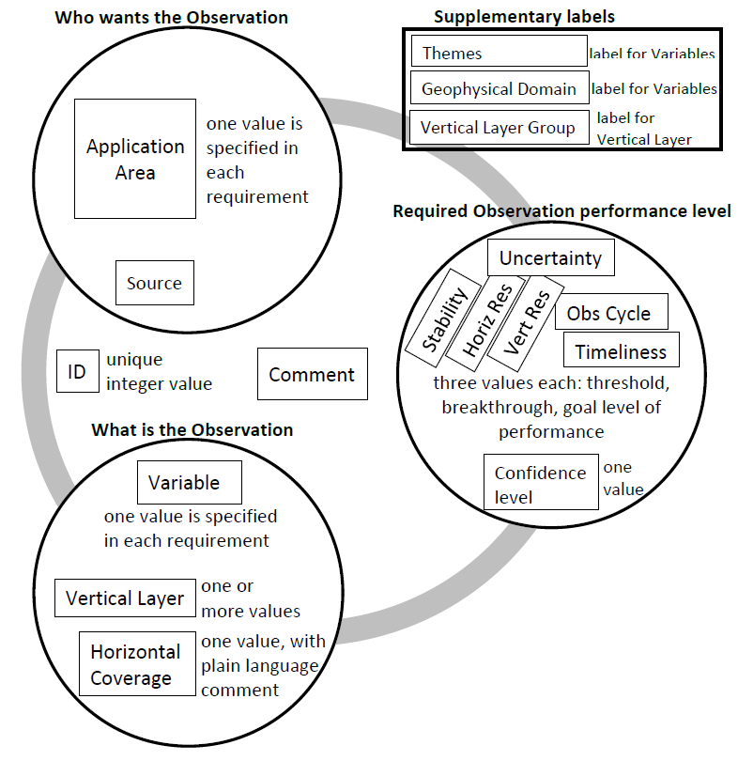

**Figure III.1**: Schematic diagram of the basic structure and main parameters used to express a requirement for an observation in the OSCAR/Requirements database.

**Who wants the observation**

This is one of the Application Areas and may be elaborated further with a comment, for example to identify a specific activity within the overall Application.

**What is the observation**

This combines a geophysical variable, selected from OSCAR’s defined list containing 318 variables (subject to review), with the place/s where it is to be observed within a defined list of 31 vertical layers and 8 types of horizontal coverage. One or more “vertical layers“ may be included in a single requirement. The “horizontal coverage“ parameter locates where the variable is to be observed in the horizontal dimension. From a list of 8 options, exactly one entry must be specified. The options are: Global; Global Land; Global Ocean; Coastal areas; Regional (the applicable WMO Region/s to be specified in Comments); Sub-regional (area of magnitude 1000x1000 km to be specified in Comments); Local (area of magnitude 100x100 km to be specified in Comments); and Point (specific locations to be specified in Comments).

**Required observation performance level**

The required performance level is stated quantitatively in terms of six, in the future there will be eight, criteria: Horizontal resolution, Vertical resolution, Frequency (observation cycle), Timeliness (delay in availability), Uncertainty (acceptable RMS error and any limitations on bias), Stability (the maximum permissible cumulative effect of systematic changes of the measurement system to allow long-term climate records compiled from assorted measurement systems – percentage change per decade), Layer/s quality (how well the specified vertical layer/s is/are delivered), Coverage quality (how well the specified horizontal coverage is delivered).

**Figure III.2** shows additional parameters proposed for inclusion in OSCAR/Requirements in the future. It shows the comment field split into several separate Comments, making it easier to locate and interpret the various Comments in each Requirement. It also shows several “priority“ parameters, giving the user the opportunity to ascribe different levels of priority for the requirement overall, and for each of the six performance criteria within a given requirement.

The structure of a requirement may be further illustrated by exploring the content of Requirement #335 from the OSCAR/Requirements database (as of January 2022, please visit the database for up-to-date requirements):

Application Area: High Res NWP;

Physical variable: Air pressure (near-surface);

Place/s: vertical layer = Near-Surface; Horizontal Coverage = Global;

Observations performance level:

|  |  |  |  |  |
| --- | --- | --- | --- | --- |
|  | Goal | Breakthrough | Threshold | |
| Uncertainty | 0.5 hPa | 0.6 hPa | 1 hPa |
| Stability/decade | -- | -- | -- |
| Horizontal Resolution | 2 km | 10 km | 40 km |
| Vertical Resolution | -- | -- | -- |
| Observing cycle | 30 min | 60 min | 3 h |
| Timeliness | 15 min | 30 min | 2 h |

While High Res NWP is not the only application area which requires observations of “Air pressure (near-surface)” over a global domain, it is the only one with a requirement for these performance levels. In general, where multiple application areas require observations of the same physical variable in the same place/s, they usually have different performance requirements.

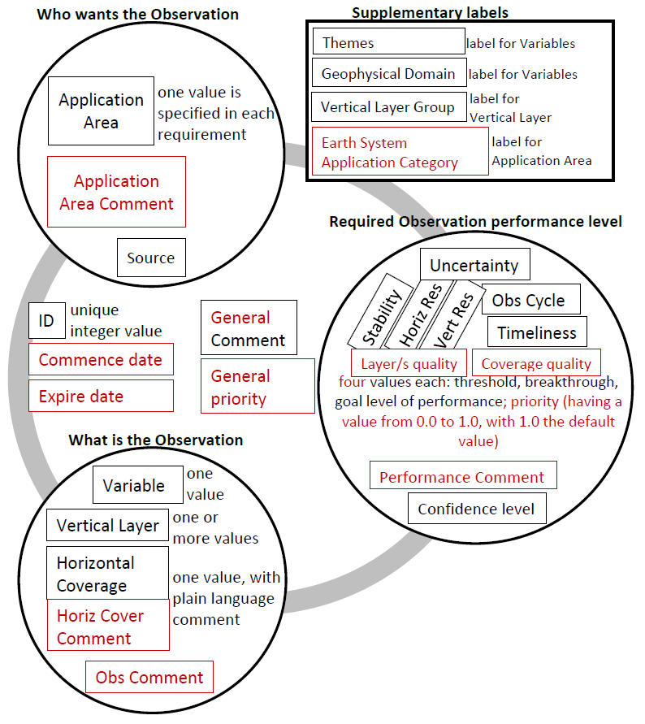

**Figure III.2**: Schematic diagram of the basic structure and main parameters used to express a requirement for an observation in the OSCAR/Requirements database, with proposed changes shown in red.

All of the requirements registered in the OSCAR/Requirements database may be freely and easily viewed through read-only access online at: <https://space.oscar.wmo.int/observingrequirements>. The website provides several tables with filtering, sorting and export options to enhance the useability of the data. For example, **Figure III.3** shows a table of requirements that was filtered to show only the requirements of the Global NWP Application Area, and sorted in alphabetical order of the variable name.

Access to OSCAR/Requirements for proposing new requirements or updating existing requirements is restricted. It is the role of the PoC for each Application Area to undertake this activity (see Attachment 3). Similarly, access to OSCAR/Requirements for proposing new variables or updating the definitions of existing variables is restricted.

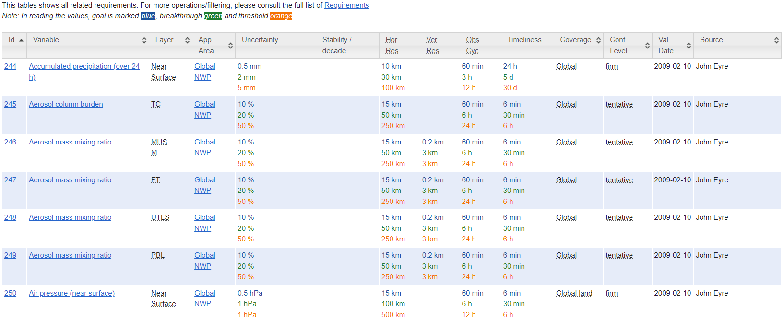

**Figure III.3** shows part of the screen display of the observational user requirements of the Global NWP Application Area, sorted alphabetically on the variable name (as of May 2022).

# Annex IV. OSCAR/Space and OSCAR/surface

The OSCAR tool provides three separate databases: OSCAR/Requirements, OSCAR/Space and OSCAR/Surface. This Annex provides further information about OSCAR/Space and OSCAR/Surface which contain information about the observing capabilities of the WIGOS space-based subsystem and capabilities of the WIGOS surface-based subsystem respectively.

OSCAR is freely accessible online at: <https://space.oscar.wmo.int/>, with links to:

1. OSCAR/Space: <https://space.oscar.wmo.int/spacecapabilities>,
2. OSCAR/Space (and OSCAR/Requirements) User manual: <https://wmoomm.sharepoint.com/:b:/s/wmocpdb/EZupID26Dn1Hr1sDnmRMvvsBbAv-RTuxsF6UnhBNSLhyVQ?download=1>,
3. OSCAR/Surface: <https://space.oscar.wmo.int/surfacecapabilities>,
4. OSCAR/Surface User manual: <https://library.wmo.int/index.php?lvl=notice_display&id=20824#.XaRg0a6Wapq>.

The OSCAR webpage also provides a link to an Analysis page: <https://space.oscar.wmo.int/analysis> which is not yet implemented. As noted earlier under “Critical Review“, in the absence of a direct and comprehensive comparison of capabilities to requirements there are tools which provide a more limited but still helpful scope of comparisons.

OSCAR/Space allows observing capabilities data to be viewed as a list of satellite programmes (also known as missions), a list of satellites, a list of instruments, or a list of all space agencies who operate satellite programmes. In addition, under the heading Satellite Status, OSCAR/Space shows how those satellites are structured to deliver the space-based subsystem of WIGOS in the following categories:

1. Backbone Satellites Contributing to WIGOS:
2. Geostationary Core Constellation: Current, Future;
3. Sun-synchronous Core Constellation: Current, Future;
4. Additional Satellites Contributing to WIGOS:
5. Geostationary and Molniya Orbit: Current, Future;
6. Low Earth Orbit: Current, Future;
7. Specific Orbits (for Space Weather): Current, Future.

OSCAR/Space is supplemented with a gap analysis tool which assesses the capabilities of various satellite instruments to satisfy some aspects of the observing requirements. Further information is provided in the User manual and on the website at: <https://space.oscar.wmo.int/gapanalyses>.

OSCAR/Surface allows observing capabilities to be viewed as lists of selected subsets of the complete database of stations/platforms, including all fixed and mobile stations on land, sea, ice, lakes/rivers, in the air or under the water, performing in-situ or remote sensing observations. A station list can be selected by country, by station type, station class or observed variable. Also, a station name or WIGOS station identifier (WIGOS ID) can be specified to retrieve/view detailed information about a station. No direct comparison of these surface observing capabilities data against requirements is currently available. However, the WDQMS does provide some relevant information. The monitoring and evaluation components of WDQMS provide ongoing assessments of how well actual surface observations meet the planned and/or required performance levels. Further information is provided on the website at: <https://wdqms.wmo.int/about>.

# Annex V. Cost-benefit considerations

User requirements are expressed in a technology-free manner, and therefore cost-free also. However, decisions on design and implementation of observing systems must take account of cost. The relationship between user requirements, as defined by the RRR process, and decisions on design and implementation of observing systems based on cost-benefit considerations is therefore important. The cost-benefit curve for a single observing system, in the context of a single application, is illustrated schematically in **Figure V.1** below. It is assumed that "benefit" can be estimated quantitatively and also that it can be expressed in financial terms. The cost-benefit curve has the following generic characteristics:

1. A significant cost must be incurred before any significant benefit is derived. Beyond this point (B), additional cost then results in increasing benefit. However, a point (A) is reached beyond which additional cost does not bring any significant benefit;
2. The "maximum" and "minimum" requirements of the CBS method map on to points A and B respectively;
3. The cost-benefit curve will (normally) first cross the line of equal cost-benefit at the "break even" point. It represents the point above which we can make a (business) case for implementing the system;
4. The optimal point, representing the highest ratio of benefit to cost, is also shown.

**Figure V.1**. Generic cost-benefit curve for an observing system.

Note that the point of optimal cost-benefit represents a benefit (and cost) that is, in general, lower than the point of "maximum requirement". This is important; it is often assumed that we should be striving to meet the maximum requirement. Whereas this analysis shows that a system meeting "maximum" requirements is likely to deliver a level of benefit in a region of diminishing returns. Also a system’s performance must exceed the "minimum" requirement before it is likely to be cost-effective.

# Annex VI. Observations impact studies

The WMO Commission for Observation, Infrastructure and Information Systems (INFCOM) Joint Expert Team on Earth Observing System Design and Evolution (JET-EOSDE) encourages observation impact studies to be carried out and conducts a series of technical workshops on this topic. Impact studies are conducted using quantitative assessment such as Observing System Experiments (OSEs) and Observing System Simulation Experiments (OSSEs) and other assessment tools such as Forecast Sensitivity to Observation Impacts (FSOI). Each workshop provides an update on the latest understanding about the impact that various observing systems have on numerical forecasts and other products generated by numerical prediction systems.

Such information may contribute to the assessment of the optimum observation requirements that a Point of Contact makes for their Application Area, as well as the PoC‘s judgement about the most important gaps to give priority to addressing.

JET-EOSDE makes plans for future workshops from time to time. The most recent workshop was:

[*Scoping Workshop on Future Activities to Assess Impact of Various Observing Systems on Earth System Prediction*](https://wmoomm.sharepoint.com/:b:/s/wmocpdb/EeofnfGRvRhBh82z98XD-bMBZ6vmDP14UvTd76EWa8Pe-A?e=IVcyaj)*, Geneva, 9-11 December 2019*

1. The series of WMO Workshop on the Impact of Various Observing Systems on Numerical Weather Prediction is also of interest:
2. [Seventh Workshop, Geneva, 30 November – 3 December 2020](https://wmoomm.sharepoint.com/sites/wmocpdb/eve_activityarea/Forms/AllItems.aspx?id=%2Fsites%2Fwmocpdb%2Feve%5Factivityarea%2FWMO%20Integrated%20Global%20Observing%20System%20%28WIGOS%29%5F99452102%2D7575%2De911%2Da98e%2D000d3a44bd9c%2FNWP%2D7%2DPresentations%2FNWP%2D7%5FFinal%2DReport%2Epdf&parent=%2Fsites%2Fwmocpdb%2Feve%5Factivityarea%2FWMO%20Integrated%20Global%20Observing%20System%20%28WIGOS%29%5F99452102%2D7575%2De911%2Da98e%2D000d3a44bd9c%2FNWP%2D7%2DPresentations&p=true&ga=1);
3. [Sixth Workshop, Shanghai, China, 10 – 13 May 2016](https://wmoomm.sharepoint.com/sites/wmocpdb/eve_activityarea/Forms/AllItems.aspx?id=%2Fsites%2Fwmocpdb%2Feve%5Factivityarea%2FWMO%20Integrated%20Global%20Observing%20System%20%28WIGOS%29%5F99452102%2D7575%2De911%2Da98e%2D000d3a44bd9c%2FWMO%2DNWP%2D6%5F2016%5FShanghai%5FFinal%2DReport%2Epdf&parent=%2Fsites%2Fwmocpdb%2Feve%5Factivityarea%2FWMO%20Integrated%20Global%20Observing%20System%20%28WIGOS%29%5F99452102%2D7575%2De911%2Da98e%2D000d3a44bd9c&p=true&ga=1);
4. [Fifth Workshop, Sedona, Arizona (USA), 22-25 May 2012](https://old.wmo.int/extranet/pages/prog/www/OSY/Reports/NWP-5_Sedona2012.html);
5. [Fourth Workshop, Geneva, 19-21 May 2008](https://old.wmo.int/extranet/pages/prog/www/OSY/Reports/NWP-4_Geneva2008_index.html);
6. [Third Workshop, Alpbach, Austria, 9-12 March 2004](https://old.wmo.int/extranet/pages/prog/www/GOS/Alpbach2004/Agenda-index.html).

As part of the early planning for future workshops, there may be an opportunity to propose scientific questions that could, for example, assist an Application Area to enhance its understanding and description of its requirements for observations.

# Annex VII. The Vision for the WIGOS

The “Vision for the WIGOS“ provides high-level goals to guide the evolution of observing systems in the coming decades. These goals are intended to be challenging but achievable. Despite its name, the Vision attempts to address the needs of all the Application Areas with WMO programmes and co-sponsored programmes to which WIGOS responds. The Vision considers that future observing systems will build upon existing sub-systems, both surface- and space-based, and capitalize on existing, new and emerging observing technologies not presently incorporated or fully exploited. Incremental additions to observing systems will be reflected in better data, products and services from the National Meteorological and Hydrological Services (NMHSs), including for developing countries, Least Developed Countries (LDCs) and Small Island Developing States (SIDS).

The Vision is proposed by the Infrastructure Commission following wide consultation with experts in the user and observational communities, taking into account the SoG and foreseen technological developments, both in terms of future application areas’ requirements and observational technology evolution, both surface- and space-based.

The Vision for the WIGOS is available from the WMO website at: <https://community.wmo.int/vision2040>

# Annex VIII. WIGOS total system design

The RRR process provides a mechanism for coordination amongst all WMO-relevant observing activities, that is all WIGOS components. It results in integrated guidance on priorities for future developments applicable to all component observing systems. However, further activities beyond the RRR process are needed to achieve a WIGOS total system design process and in this regard two features of the RRR are noted below.

Firstly, WIGOS is not a single monolithic observing system, rather it is a framework which provides a common vision and set of principles and standards enabling the integrated operation of a diversity of component observing systems. While guidance arising from the RRR describes the priorities for improving WIGOS observing capabilities, it is left to the planners of each observing system to identify the guidance relevant to them and to act on it in association with the standards specified in the WMO Technical Regulations. In that way, a coherent and efficient WIGOS in total depends on the separate planning done to develop a multitude of individual implementation plans at all levels:

Ranging from the global level:

1. Global Cryosphere Watch (GCW) Implementation Plan;
2. WMO Global Atmosphere Watch (GAW) Implementation Plan: 2016-2023;
3. The Global Observing System for Climate: Implementation Needs;
4. Implementation Plan of the Global Framework for Climate Services (GFCS);
5. WMO Hydrological Observing System (WHOS) Phase II – Initial Implementation Plan;
6. Various plans for elements of the Global Observing System (GOS) such as the WMO global Aircraft Meteorological DAta Relay (AMDAR) observing system, and, most recently;
7. The Global Basic Observing Network (GBON),

To the WMO Regional level, for example the seven RBONs,

To the regional/local level involving multilateral or bilateral implementation plans,

And to the national level where Member countries generally have not only a national observing system but also many component observing systems each with Implementation Plans.

Secondly, the RRR process and resulting guidance is weighted towards an incremental approach to the evolution of WIGOS, being focused on addressing the most important gaps where existing observing system capabilities fall short of requirements rather than redesigning entire observing systems from the ground-up. There are situations where it is necessary for the planning and design or re-design of a WIGOS component observing system to take a ground-up (or zero-based) approach, for example when a new or replacement system is to be funded and implemented.

**Figure VIII.1** represents this difference in a simplistic schematic way, showing the ground-up system design process as being distinct from the RRR process. In reality, observing system design or re-design and implementation activities are likely to involve various combinations of the incremental view of gaps to be addressed and the ground-up total system view.

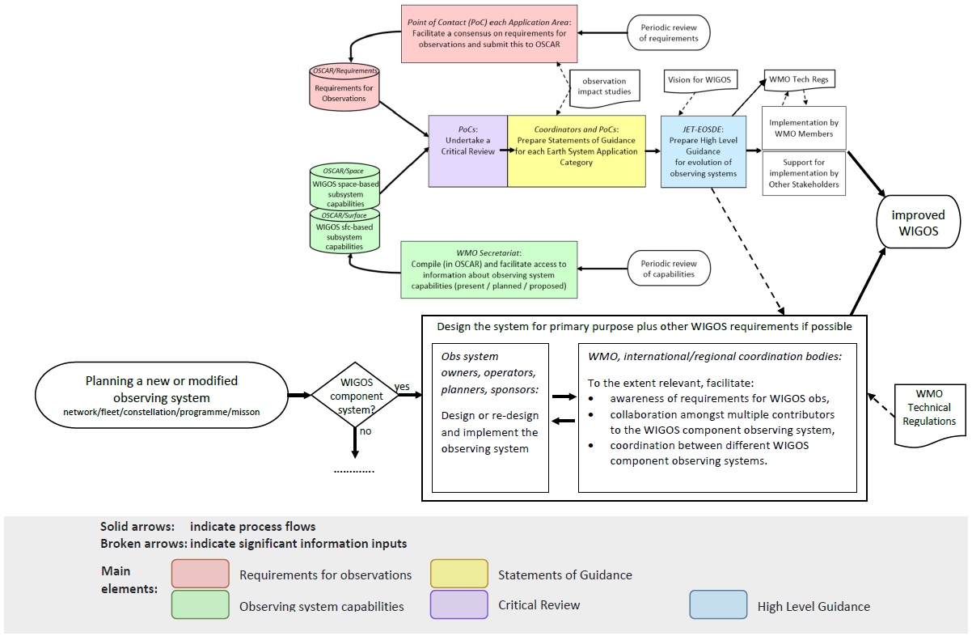

**Figure VIII.1** adapted version of the RRR process diagram showing a complementary process for ground-up observing system design, alongside the incremental approach of the RRR guidance based on a gap analysis.

# ANNEX IX. OSCAR UPDATING/MAINTENANCE PROCEDURE

OSCAR Updating/Maintenance Procedure[6]

Proposed update to the OSCAR Updating/Maintenance Procedure[7]

WIGOS Information Resource

OSCAR/Space updating/maintenance procedure

V 2.0

Document change record

| **Date and Version** | **Description** | **Authorized by** |
| --- | --- | --- |
| 10.04.2013 / v0.1 | Initial draft |  |
| 29.04.2013 / v0.2 | Edits by J. Lafeuille |  |
| 29.04.2013 / v0.3 | Editorial changes, paragraph on content versioning, paragraph on user feedback |  |
| 1.10.2013 / v1.0 | Implementation | J. Lafeuille C/SBOS |
| 21.2.2014 / v1.1 | Insertion of Section 3 OSCAR/Requirements updating process |  |
| 3.4.2014 | Section 3 approved by IPET-OSDE-1 | IPET-OSDE1 |
| 29.2.2016 / v1.2 (Draft) | - Section 4.2 and Step 2.1 for OSCAR/Space V. 2  - Section 8: IPET-SUP |  |
| 14.4.2016 / v1.3 | Reviewed by IPET-OSDE-2 (no change) | IPET-OSDE-2 |
| 3.11.2017 / v1.4 | Rationalization of management of variables in WIGOS context. Making it mandatory to record source of the requirements. |  |
| 1.2.2018 / v.1.5 | Point of Contacts for Application Areas are responsible for making sure that the Application Area “owner”, i.e. the relevant Commission or Expert Group, is agreeing with the proposed requirements in OSCAR/Requirements | IPET-OSDE-3 |
| 17.7.2018 / v1.6 | Reflected the role of O/SST and O/SSAT.  Reflected the role of CGMSSEC and its support in ensuring the factual content of OSCAR/space and the link to the annual CGMS Risk Assessment | CGMS-46 |
| 12.11.2019 / v1.7 | Procedure for OSCAR/Requirements updated, so that the PoC for AAs should check whether there is any possible conflict with the WIGOS Metadata Standard; if not, the Chair of IPET-OSDE has authority to approve a new variable. | IPET-OSDE action |
| 08.06.2022 / v2.0 | Procedure updated to reflect the new RRR process | JET-EOSDE |

OSCAR/Requirements updating/maintenance procedure

1. INTRODUCTION

1.1 Purpose and scope

This procedure defines the roles, responsibilities and steps to be followed to update content, functionality and interface of the OSCAR/Requirements module with the aim to ensure that the database content is up-to-date, correct, quality-controlled, accessible and fit for purpose.

1.2 Document plan

The document contains seven sections:

Section 1: Introduction

Section 2: Roles

Section 3: OSCAR/Requirements updating process

1.3 Background documents

* ISO/IEC 14764:2006 Software Maintenance
* [*Guide to Instruments and Methods of Observation*](https://library.wmo.int/index.php?lvl=notice_display&id=12407#.YxtGdnZByUm) (WMO-No. 8)
* [Rolling Review of Requirements (RRR) process](https://community.wmo.int/rolling-review-requirements-process)

1.4 Definitions

|  |  |
| --- | --- |
| **Acronym** | **Definition** |
| AA | Application Area |
| JET-EOSDE | Joint Expert Team on Earth Observing System Design and Evolution |
| OSCAR | [Observing System Capability Analysis and Review Tool](https://space.oscar.wmo.int/requirements) |
| TT-WIGOSMD | Task Team on WIGOS Metadata |
| WIGOS | [WMO Integrated Global Observing system](https://community.wmo.int/activity-areas/WIGOS) |
| WMDR | [WIGOS Metadata Repository](http://codes.wmo.int/wmdr) |

2. Roles

The updating and maintenance processes involve the following roles. In practice, one person can take multiple roles.

|  |  |
| --- | --- |
| **Role name** | **Description** |
| PoC | Point of Contact in charge of reviewing and updating the requirements for a given Application Area identified in the RRR process |
| JET-EOSDE | Joint Expert Team on Earth Observing System Design and Evolution, responsible for providing oversight on the RRR |
| TT-WIGOSMD | Task Team on WIGOS Metadata Standard, responsible for maintaining the WIGOS Metadata Standard and associated terminology |
| WIGOS Tools Project Manager | Person responsible for coordinating the overall WIGOS Tools developments including OSCAR developments |
| OSCAR Developer | Person(s) responsible for the technical developments of the OSCAR tool |
| OSCAR Technical Administrator | Person(s) responsible for the maintenance and operation of the OSCAR tool *[Note: possibly different persons for OSCAR/Requirements, OSCAR/Space, OSCAR Surface]* |

**Requirements owner**: In addition, observational user requirements in OSCAR/Requirements shall be owned by an identified body or expert group representing the relevant community (e.g. Technical Commission). The PoC for Application Areas are responsible for making sure that the Application Area “owner” is agreeing with the proposed requirements in OSCAR/Requirements.

3. OSCAR/REQUIREMENTS UPDATING PROCESS

3.1 Explanations

This section applies to the updating of the contents of OSCAR/Requirements. For changes to the functionality of OSCAR, please refer to Section 5.

The variables registered in OSCAR are generally shared by several application areas. Each variable has the following attributes, which can only be updated by the administrator.

TABLE IX.1: Attributes of a variable in OSCAR

|  |  |
| --- | --- |
| **Attribute** | **Example** |
| Name | *Sea-surface temperature* |
| Applicable cross-cutting tags | *Cryosphere, Tropical Meteorology* |
| Domain or sub-domain | *Ocean* |
| Definition | *Temperature of the sea water at surface. The “bulk” temperature refers to the depth of typically 2 m, the “skin” refers to within the upper 1 mm* |
| Comment | *Detailed SST definitions are available from GHRSST: https://www.ghrsst.org/ghrsst-science/sst-definitions/* |
| Measuring unit | *K* |
| Uncertainty unit | *K* |
| Stability unit per decade | *K* |
| Unit for horizontal resolution | *km* |
| Unit for vertical resolution |  |
| Applicable layers | *Sea-surface, Bulk* |

3.2 New variables or changes to the attributes of a variable

The following steps shall be followed when entering a new variable or updating any attribute of an existing variable:

|  |  |  |  |
| --- | --- | --- | --- |
| **Step** | **Description** | **Responsibility** | **Frequency** |
| 1 | When identifying the need to either register a new variable or amending the attributes of an existing variable, the Point of Contact or a relevant expert submits the proposed attributes (as listed in Table IX.1) to the administrator with a brief justification | PoC or other expert | When needed |
| 2 | The administrator checks the formal consistency of the recommended change, seeking clarification from the initiator if necessary.  Check whether there is any possible conflict with the WIGOS Metadata Standard.  If the change is minor (e.g. adding a layer, or editorial correction on the definition, etc.) the administrator jumps to step 6 | Administrator | When contacted by a PoC or other expert |
| 3 | If the recommended change is substantial and/or has a potential impact on the requirements of several applications, the administrator should consult WMDR first and then seek confirmation from the JET-EOSDE Chair | Administrator | When appropriate |
| 4 | The JET-EOSDE Chair reviews the proposed change, may contact the expert for further discussion, or submits the proposal to discussion by JET-EOSDE, and then submits proposal to the Chair of the TT-WIGOSMD for decision | JET-EOSDE Chair | When appropriate |
| 5 | The TT-WIGOSMD Chair either confirms the proposed change or consults with TT-WMD and/or other experts for clarification or alternate proposal | TT-WIGOSMD Chair | When appropriate |
| 6 | Upon confirmation by the TT-WIGOSMD Chair, or if the recommended change is minor, the OSCAR/Requirements administrator implements the change | Administrator | When a proposed change is confirmed |

3.3 Requirements applicable to an existing variable

The provisions below are applicable when a requirement is updated, or a new requirement is entered, for a variable which is recorded in OSCAR, without changing the definition, unit, or applicable layers of this variable.

|  |  |  |  |
| --- | --- | --- | --- |
| **Step** | **Description** | **Responsibility** | **Frequency** |
| 1 | The PoC reviews the requirements of his/her application area in consistency with the SoG, taking into account the evolution occurred in the application area. | PoC | Yearly |
| 2 | If updates are necessary, the PoC consults with the group which is the owner of the application area, and then obtains concurrence about the proposed changes. | PoC, AA Owner | Yearly |
| 3 | If updates are necessary, and concurrence of the AA owner is obtained, the PoC logs in as Editor, and updates the requirements or enters new requirements as appropriate. If necessary he/she contacts the administrator for assistance. Information about the source of the requirement ought to be added in the database in the corresponding field. | PoC | Yearly |
| 4 | When the update is ready, the PoC informs the OSCAR/Requirements administrator that requirements are in draft status. | PoC | When update is ready for validation |
| 5 | The administrator checks the formal consistency of the new or updated requirement. If the updates are purely editorial or a factual correction, the administrator jumps to step 7. | Administrator | When requested |
| 6 | If the updates are substantial, the administrator seeks confirmation from the JET-EOSDE Chair. | Administrator | When relevant |
| 7 | The JET-EOSDE Chair either confirms the updated requirement, or contacts the PoC for further discussion, or submits the proposed update to TT-WIGOSMD for discussion. | JET-EOSDE Chair | When relevant |
| 8 | Upon confirmation by the TT-WIGOSMD Chair, or endorsement by JET-EOSDE, or if the draft update is minor, the OSCAR/Requirements administrator validates the update. | Administrator | When confirmed |

___________

# Annex X. Procedure for update, validation and approval of Statements of Guidance (SOG) within the WMO Rolling Review of Requirements (rrr) process

1. The Coordinator for the Earth System Application Category in consultation with the PoCs of the Application Areas within that category, reviews the latest version of the SoG and proposes amendments, in the form of a Microsoft Word document using the “track changes” option. (If there is no pre-existing version, then the Coordinator together with the team of PoCs draft the first version of the SoG). In performing this update, the Coordinator is expected to refer to some or all of the following: (i) the latest version of the user requirements for the Application Areas; (ii) the latest version of the database Observing System Capabilities as well as other sources deemed relevant to assess the available or projected observing systems capabilities; (iii) his / her and the PoCs own expertise on the Earth System Application Category and its Application Areas; (iv) advice from other international experts including, where relevant, WMO constituent bodies, and WMO programmes and co-sponsored programmes;
2. The Coordinator refers the new draft version of the SoG to the Chair of the Joint Expert Team on Earth Observing System Design and Evolution (JET-EOSDE), with copy to the WMO Secretariat staff responsible for this Expert Team;
3. The Chair of the JET-EOSDE decides the appropriate review process with the JET-EOSDE for the new draft. If a meeting of the Expert Team is imminent, the new draft becomes a document for this meeting and is reviewed by the Meeting. If a meeting is not imminent, the new draft may be referred to the JET-EOSDE for comment(s) by correspondence;
4. The Chair of the JET-EOSDE refers the comments of the JET-EOSDE to the Coordinator, either by reference to the report of a JET-EOSDE meeting or otherwise, as appropriate;
5. The Coordinator, in consultation with the PoCs updates the draft to take account of comments received. Contentious issues are discussed with the Chair of JET-EOSDE, as necessary. Microsoft Word “track changes” option continues to be used at this stage;
6. The Coordinator refers the revised draft version of the SoG to the Chair of JET-EOSDE, with copy to WMO Secretariat staff responsible for the JET-EOSDE;
7. The Chair of the JET-EOSDE considers the revised draft and concurs with it, or refers it back to the Coordinator with comments for further revision (by steps 5 and 6 mentioned above);
8. The Chair of the JET-EOSDE requests the Chair of the Standing Committee on Earth Observing Systems and Monitoring Networks (SC-ON) to have the SoG submitted to the INFCOM president for her/his review and approval in consultation with the INFCOM management group, with 1-month deadline;
9. The INFCOM president informs the WMO Secretariat staff responsible for the JET-EOSDE if and when the revised version has been approved; in case the SoG is not approved or changes are proposed, she/he refers it back to the JET-EOSDE with comments for further revision by the Coordinator (by steps 5 and 6 mentioned above);
10. The WMO Secretariat staff responsible for the JET-EOSDE updates the WMO documentation (website, etc.) with the new version of the SoG, with due attention to version control procedures; and
11. At each JET-EOSDE meeting, the WMO Secretariat staff responsible for the JET-EOSDE reports to the ET on changes since the last meeting, in relation to the SoG version and its review and adoption status.

___________

# Annex XI. Prioritization concept in the RRR Process

1. Background

The WMO’s RRR process captures the observational requirements ranges for a variety of application areas. These requirements are currently expressed in terms of 6 criteria (or attributes): uncertainty, horizontal resolution, vertical resolution, observing cycle, timeliness, and stability (where appropriate). For each of these criteria, the requirements are captured in a table containing three values determined by experts: these are (1) "threshold" the minimum requirement to be met to ensure that data are useful, (2) "goal" is an ideal requirement above which further improvements are not necessary, (3) "breakthrough" is an intermediate level between "threshold" and "goal" which, if achieved, would result in a significant improvement for the targeted application.

These requirements defining which geophysical observations are needed for a certain application, and their associated attributes, are meant to provide information from experts (as compiled by the Points of Contact, PoCs, in each Application Area) to provide guidance to observing systems designers and networks architects to optimize their designs and networks. However, these requirements are currently not prioritized. In the absence of prioritization of requirements, the relative importance of the requirements and their attributes is not known to sensors’ designers and network planners, leaving an important gap in the guidance to those architects and designers to really know how to optimize their concepts and networks.

2. Suggesting a Mechanism to Prioritize the Requirements

We propose including the notion of prioritization in the RRR process as this could be useful to those designing and deploying observing systems (both space and surface-based). For example, in situations where budget constraints are such that not everything is affordable at the breakthrough level, it is informative to know whether one observation should be prioritized over another in terms of meeting users’ requirements at the breakthrough or threshold or goal levels. Or, for a specific observation required, it is also useful to know the relative importance of the particular attributes. In case of technology constraints (in terms of mass, volume, power and cost), during the design of a specific sensor, engineers would appreciate knowing whether spatial resolution for example (requiring bigger antennas) is more or less important than the precision of the measurement (usually driving designs with additional spectral channels). It is important to note that implicitly, if no priority is given, all requirements (and their attributes like resolution, temporal refresh, etc.) are considered to be of equal importance.

It should be highlighted that the priorities proposed in this document are against observations requirements and their attributes. They should be archived in the OSCAR database along with the requirements and are specific to individual application areas. The priorities are defined for:

1. The Requirement in total e.g., does an application value more the near-surface temp. than moisture for instance?
2. The attributes of the Requirement e.g., for a given Requirement, does the application area value one attribute more than another, e.g. does it value more the spatial resolution than vertical resolution or/and than the uncertainty?

These priorities are called the Application-dependent Technical Priorities (ATP) and should be defined to convey, for a given application area, the relative importance between the requirements and, for a given requirement, the relative importance between the attributes. These priorities (or weights) should be a numerical value between 0 and 1, that can be used for optimizing network design purposes. They should be defined with a minimum level of granularity i.e., enough to be useful but not too complex to assign. The table below contains the suggested definition of the different priorities.

**Table XI. 1 Definition of priorities**

|  |  |
| --- | --- |
| **Priority Value (weight)** | **Description** |
| 1.0 | **Core (1):** The requirement (or criteria) is **absolutely critical** for the application, so meeting at least the breakthrough requirements where technical solutions exist, must be the highest priority. Where breakthrough requirements are not already being met by existing capability, research and development plans should be actively seeking to address the gap as a high priority |
| 0.8 | **Recommended (0.8):** The requirement (or criteria) is **essential** for the application so should meet at least the breakthrough requirements where technical solutions exist.  Where breakthrough requirements are not already being met by existing capability, research and development plans should be actively seeking to address the gap, but with a lower priority than those requirement identified as Core |
| 0.6 | **Useful (0.6):** The requirement (or criteria) is **useful** for the application, but not absolutely essential. Meeting the breakthrough requirements where technical solutions exist, should be a medium priority, but meeting the threshold requirement should be a high priority. Where threshold requirements are not already being met by existing capability, research and development plans should be actively seeking to address the gap, but with a lower priority than requirements identified as Recommended or Core |
| 0.4 | **Marginally useful (0.4):** The requirement (or criteria) is **not essential** for the application. Meeting the threshold requirements where technical solutions exist, should be a low priority. Where threshold requirements are not already being met by existing capability, research and development plans should not be actively seeking to address the gap, but opportunities arising should be considered |
| 0.2 | **Not currently useful (0.2):** There is no current identified use of the requirement (or criteria), but some use may be identified in the future. |
| 0.0 | **Not useful (0):** There is no current or future identified use of this requirement (or criteria). |

**Note:** priorities for requirements and their attributes are sometimes scientifically inter-connected. In other words, the specific requirement (and associated priority) for the attributes (of vertical resolution, uncertainty, horizontal resolution, timeliness, observing cycle, etc.) sometimes vary depending on the ranges of the other attributes. It is important to note that this inter dependency applies to both priorities and requirements ranges. Despite this caveat, it is believed however that the requirements’ ranges (and priorities) are very important and informative to the observing systems and networks owners. They should be considered as *first degree assessment* of ranges of requirements and their priorities, with the caveat that there are nuances related to the fact that there are spatial, temporal and situational variations of the requirements and priorities.

3. Two Additional attributes:

Currently, in OSCAR, a Requirement defines the sought-after observational data stream in terms of the variable and the domain (vertical layer/s and horizontal coverage) to be sampled. However, an observing system (network/fleet/constellation/programme/mission) designer may seek to optimize the trade-off between the sampling of the specified domain and the quality characteristics of the measurements, and the User (Application Area) may wish to convey the extent to which this is acceptable. To enable this, two additional attributes are proposed and these are (1) vertical Layer(s) extent and (2) Horizontal Coverage extent.

## 4. How to Implement the Prioritization into the RRR Process and OSCAR system

The priorities, for each Application area, should be handled in a fashion similar to how the requirements are currently collected, vetted, and maintained. The entity/person(s) responsible for gathering the priorities should be the same PoC in charge of collecting the requirements. Similarly, the same entity/person(s) responsible for coordinating the requirements within an application area category should also be coordinating the priorities within the same category.

In OSCAR, it is recommended that (1) a priority value be associated with each recorded requirement (to be interpreted vertically, i.e. between requirements), and (2) a priority value be associated with each of the attributes of each requirement (to be interpreted horizontally, i.e. between the attributes). By default, a priority value of 1.0 will be assigned to each requirement and associated attributes. The person(s) in charge of updating/maintaining the requirements ranges should therefore be able to update the priorities and modify the default values.

It is recommended that all documentation related to the (1) RRR, (2) SoG, (3) WIGOS manuals, (4) PoC guide, etc. be updated to reflect the notion of the Prioritization described in this document.

For illustration purposes of this prioritization concept, the Figure 1 is introduced in the appendix, showing the proposed two additional attributes, and illustrating how the priorities (for the requirements and the attributes) should be handled. The particular cases of application areas related to the global NWP, Space weather and aeronautical meteorology were used for illustration.

|  |  |  |  |  |  |  |  |  |  |  |  |  |
| --- | --- | --- | --- | --- | --- | --- | --- | --- | --- | --- | --- | --- |
| ***ID*** | ***Requirement definition*** | | | | ***Requirement attributes*** | | | | | | | |
| ***User*** | ***Observational data stream*** | | | ***Priority=red. Performance level: blue=goal; green=breakthrough; orange=threshold*** | | | | | | | |
| ***No.***  ***Pr.*** | ***Appli-cation Area*** | ***Va-riable*** | ***Vertical Layer/s*** | ***Horizontal Coverage*** | ***Vertical Layer(s) Extent*** | ***Hori-zontal Coverage Extent*** | ***Uncer-tainty*** | ***Sta-bility*** | ***Hori-zon-tal Reso-lution*** | ***Ver-tical Reso-lution*** | ***Obs. Cycle*** | ***Time-li-ness*** |
| 255  1.0 | GNWP | T | FT | Global | 100%  70%  30%  1.0 | 100%  80%  40%  1.0 | 0.5 K 1 K 3 K  1.0 |  | 15 km 100 km 500 km  1.0 | 0.3 km 0.5 km 1 km  1.0 | 60 min 6 h 24 h  1.0 | 6 min 30 min 6 h  1.0 |
| 256  1.0 | GNWP | T | UTLS | Global | 100%  70%  30%  1.0 | 100%  80%  50%  1.0 | 0.5 K 1 K 3 K  1.0 |  | 15 km 100 km 500 km  1.0 | 0.3 km 1 km 3 km  1.0 | 60 min 6 h 24 h  1.0 | 6 min 30 min 6 h  1.0 |
| 257  1.0 | GNWP | T | PBL | Global | 100%  70%  30%  1.0 | 100%  70%  30%  1.0 | 0.5 K 1 K 3 K  1.0 |  | 15 km 100 km 500 km  1.0 | 0.3 km 1 km 3 km  1.0 | 60 min 6 h 24 h  1.0 | 6 min 30 min 6 h  1.0 |
| … |  |  |  |  |  |  |  |  |  |  |  |  |
| 739  1.0 | Space Weather | Electron differential directional flux | Geo,  Leo,  Meo | Global | 100%  1.0 | 100%  1.0 | 5 % 10 % 25 %  1.0 |  | 45 degrees 90 deg 180 deg  1.0 |  | 60 sec 5 min 10 min  1.0 | 60 sec 10 min 100 min  1.0 |
| 740  1.0 | Space Weather | Electron differential directional flux | L1 | Global | At L1  Not at L1  1.0 | 100%  1.0 | 5 % 10 % 25 %  1.0 |  | 360 deg 360 deg 360 deg  1.0 |  | 60 sec 5 min 10 min  1.0 | 60 sec 10 min 100 min  1.0 |
| … |  |  |  |  |  |  |  |  |  |  |  |  |
| 731  1.0 | Aeronautical Meteorology | Precipitation intensity at surface (solid) | Near-Surface | Point (Comment: At the aerodrome) | Full compl-iance with siting / exposure standards  1.0 | Full compl-iance with siting / exposure standards  Representative of aerodrome  1.0 | 0.1 mm/h  0.2 mm/h  1 mm/h  1.0 |  |  |  | 30 min 60 min 2 h  1.0 | 5 min 10 min 30 min  1.0 |

**FIGURE XI.1**: This table shows in red the addition of relative priority ratings. All priorities are set to 1.0 by default, which is the maximum of the possible values, until changed by the User. The values convey the relative priorities between the attributes within one Requirement (one row of blue cells) or, in the case of the general priority overall for the Requirement, as a rating of relative priorities between the different Requirements of this particular User / Application Area. Note the two additional columns proposed to represent the extent of the vertical coverage and the extend of the horizontal coverage. This allows the user to specific a threshold, goal and breakthrough levels for specifying how well the specified vertical layers and the horizontal coverage should be met.

# Annex XiI. Acronyms

AMDAR Aircraft Meteorological DAta Relay

CBS Commission for Basic Systems (WMO)

FSOI Forecast Sensitivity to Observation Impacts

GAW Global Atmosphere Watch

GBON Global Basic Observing Network

GCOS Global Climate Observing System (WMO, IOC, UNEP, ICSU)

GCW Global Cryosphere Watch

GFCS Global Framework for Climate Services

GOS Global Observing System (WMO)

HLG High-Level Guidance on the Evolution of Global Observing Systems in Response to WIGOS Vision

ICSU International Council for Science

IOC Intergovernmental Oceanographic Commission of UNESCO

INFCOM WMO Commission for Observation, Infrastructure and Information Systems

JET-EOSDE Joint Expert Team on Earth Observing System Design and Evolution

LDC Least Developed Countries

NMHS National Meteorological and Hydrological Service

NWP Numerical Weather Prediction

OSCAR Observing Systems Capability Analysis and Review tool

OSE Observing System Experiment

OSSE Observing System Simulation Experiment

PoC Point of Contact of an Application Area

RBON Regional Basic Observing Network

RMS Root Mean Square

RRR Rolling Review of Requirements

SC-ON Standing Committee on Earth Observing Systems and Monitoring Networks

SIDS Small Island Developing States

SoG Statement of Guidance

SSLP Sub-Seasonal to Longer Range Prediction

UN United Nations

UNEP UN Environment Programme

UNESCO UN Educational, Scientific and Cultural Organization

WDQMS WIGOS Data Quality Monitoring System

WHOS WMO Hydrological Observing System

WIGOS WMO Integrated Global Observing System

WMO World Meteorological Organization_______________

# ATTACHMENT 1: Statement of Guidance (SOG) template

Template for

Statements of Guidance (SoGs)

(for evolved RRR process per WMO’s Earth System Approach)

Draft version 1.2, 20220106

The SoG for applications of a WMO Earth System Application Category is a gap analysis with recommendations on how to address the gaps; it provides an assessment of the adequacy of observations to fulfil the observational user requirements and suggests priority areas of progress towards improved use of space-based and surface-based observing systems. Only the most significant variables in the given Application Category are analysed in the SoGs. Each Earth System Application Category is owned by an identified body which has the authority to endorse the SoG.

Each Application Area within an Earth System Application Category is owned by an identified body which has the authority to (i) designate a PoC, and (ii) concur with the observational user requirements in OSCAR/Requirements, and with the gap analysis of the application area provided within a SoG.

The aims of the SoG are:

1. to inform WMO Members on the extent to which their requirements are met by present systems, will be met by planned systems, or would be met by proposed systems. The SoG is essentially a gap analysis with recommendations on how to address the gaps. It also provides the means whereby Members, through the Technical Commissions, can check that their requirements have been correctly interpreted.
2. to provide resource materials useful to WMO Members for dialogue with observing system agencies regarding whether existing systems should be continued or modified or discontinued, whether new systems should be planned and implemented, and whether research and development is needed to meet unfulfilled aspects of the user requirements.

Following WMO’s Earth System approach, SoG are provided for the following Application Categories:

1. Space Weather Applications;
2. Atmospheric Applications (incl. weather, climate and atmospheric composition);
3. Oceanic Applications;
4. Hydrological & Terrestrial Applications;
5. Cryospheric Applications;
6. Integrated Earth System Applications (this Category is for applications which span the Integrated Earth System).

The SoG for applications of a WMO Earth System Application Category is one element of the RRR process. It is used by the Infrastructure Commission (INFCOM) to complete the RRR process and contribute to the “Vision for WIGOS in 2040”[8], and hence to having WMO Technical Regulations updated and High-Level Guidance to be provided to Members for assuring the required evolution of global observing systems.

The drafting of the SoG is done by the team of authors consisting of the designated Coordinator for the considered Earth System Application Category (lead author) and the designated PoC of the Application Areas[9] within that Application Category (contributing authors). The role of the team is to compile and summarize information provided by the PoCs that are relevant to this Application Category. The PoCs are responsible for coordinating the development of specific parts of the SoG with their respective communities, particularly the gap analysis for an Application Area. The PoCs are also invited to consult with the Regional Associations working groups on infrastructure or relevant Task Teams (e.g. on WIGOS) to collect and consider regional requirements associated with the relevant key regional weather, climate, water and other environment challenges considered by them for the design of the RBON; however, duplication of regional requirements with the global requirements should be avoided, and regional requirements considered only if they differ substantially from the global ones. The Coordinator will submit the SoG and future updates to the Chair of the INFCOM Joint Expert Team on Earth Observing System Design and Evolution (JET-EOSDE) for his/her review and submission to the JET-EOSDE for discussion. SoGs are recommended by the Chair of JET-EOSDE and/or the JET-EOSDE meetings to the INFCOM president, who in consultation with the management group will approve them.

The SoG will be structured as follows. The inclusion of additional annexes is discouraged.

______________

Statement of Guidance for

[Name of Earth System Application Category] Applications

(Contributors: name of Coordinator and PoCs who contributed to the SoG)

(Version number, approval status, and date)

TABLE OF CONTENTS:

1. Introduction
2. Application Areas
   1. The considered application areas and their prioritization
   2. Summary of key variables to be observed and identified key gaps for the considered Earth System Application Category
3. Recommendations on how to address the gaps

Annex 1 to Attachment 1. Gap analysis for [Earth System Application Category] application areas

Annex 2 to Attachment 1. References

1. Introduction

[1/2 to 1 page]

This section shall briefly describe the Earth System Application Category and its Application Areas. It provides some information on the purpose and end-users of those applications.

It also provides some general information on how the Application Areas depend on observations.

1. Application areas

2.1 The considered application areas and their prioritization

[1/2 page]

Provide a general description of the considered application areas (not necessarily the whole list), and their prioritization in the WMO framework[10]. A detailed gap analysis for each Application is provided in Annex 1 to Attachment 1.

2.2 Summary of key variables to be observed and identified key gaps for the considered Earth System Application Category

[1/2 page]

This section provides a summary of key variables, key gaps and impacts or limitations resulting from these gaps to be addressed for the considered Application Areas within the Earth System Application Category; taking into account the priorities expressed in the WIGOS Vision and the WMO Strategic Plan.

1. Recommendations on how to address the gaps

[1 page]

This section shall summarize the recommendations on how to address the gaps described in Section 2 above according to the prioritization of applications expressed in the WIGOS Vision and through the WMO Strategic Plan. It may include a first section with some generic recommendations, followed by a second section listing the critical variables that are not adequately measured by current or planned systems and the nature/extent of the limitation are (in order of priority).

______________

Annex 1 to Attachment 1. Gap analysis for [Earth System Application Category] application areas

This annex provides for gap analysis of specific application areas within the considered Earth System Application Category. Each application area has a PoC responsible for providing input into this annex.

As observational user requirements are not necessarily independent between Application Areas, duplication shall be avoided when one Application Area depends on the requirements of another Application Area. For each Application Area, there should be explanations on how the requirements of other Application Areas could be relevant to this Application Area.

The tables below provide the results of the critical review and gap analysis for the most impactful variables to highlight the main gaps. The critical review involves comparing the capabilities of the surface- and space-based observing systems with the quantitative observational user requirements from the OSCAR/Requirements[11] database.

The process of preparing the gap analysis is necessarily more subjective than that of the critical review. Moreover, whilst a review attempts to provide a comprehensive summary, a SoG is more selective, drawing out key issues. It is at this stage that judgements are required concerning, for example, the relative importance of different observations. If impact studies have been conducted, the results of such studies should also be considered for the gap analysis.

The following terminology has been adopted in the gap analysis:

1. **"Marginal"** indicates minimum user requirements are being met;
2. **"Acceptable"** indicates greater than minimum but less than maximum requirements (in the useful range) are being met; and
3. **"Good"** means close to maximum requirements are being met.

Note: Each Application Area will also include a consideration of the observations required to enable research into its future activities and evolving usage of observations.

List below as many tables as there are relevant application areas to be considered for the Earth System Application Category. Each table shall be organized by observed variable, and for each variable, provide a description where there are gaps and how they might be addressed in order to have substantial impact on the Application Area.

|  |  |  |  |  |  |
| --- | --- | --- | --- | --- | --- |
|  | | | | | |
| **Type of Application Area (tick one or more boxes)** | | Forecasting | | | ☐ |
| Monitoring | | | ☐ |
| Integrated product | | | ☐ |
| Direct use of observations for services | | | ☐ |
| **Point of Contact (Name, Country)** | |  | | | |
| **Application owned by (group/body)** | |  | | | |
| **Status of observational user requirements in OSCAR/Requirements** | |  | | | |
| **Date of gap analysis** | |  | | | |
|  | | | | | |
| This box shall briefly describe the application area and its observational user requirements. | | | | | |
|  | | | | | |
| **No.** | **Required Variable (and vert./horiz. domain/s)** | **Type of gap[12]** | **Gap description, impact and how it could be addressed** | **Comments, clarifications, phenomenon observed** | |
| 1 |  |  |  |  | |
| 2 |  |  |  |  | |
| 3 |  |  |  |  | |
| 4 |  |  |  |  | |
| 5 |  |  |  |  | |
|  |  |  | |  |  |

Annex 2 to Attachment 1. References

This section may include sources of additional relevant information concerning the Earth System Application Category Application Area and their requirements.

______________

# Attachment 2: Example for Statement of Guidance gap analysis (Global NWP)

|  |  |  |  |  |  |
| --- | --- | --- | --- | --- | --- |
|  | | | | | |
| **Type of Application Area (tick one or more boxes)** | | Forecasting | | | ☐ |
| Monitoring | | | ☐ |
| Integrated product | | | ☐ |
| Direct use of observations for services | | | ☐ |
| **Point of Contact (Name, Country)** | | Kazumori Masahiro, Japan | | | |
| **Application owned by (group/body)** | | INFCOM | | | |
| **Status of observational user requirements in OSCAR/Requirements** | |  | | | |
| **Date of gap analysis** | | April 2020 | | | |
|  | | | | | |
| Global Numerical Weather Prediction(NWP) models are used to produce short-and medium-range weather forecasts (out to 10-15 days) of the state of the atmosphere, with a horizontal resolution of typically 10-25 km and a vertical resolution of 10-30 m near the surface increasing to 500-1000 min the stratosphere. Ensembles of up to 50 members of such forecasts provide estimates of uncertainty. Forecasters use NWP model outputs as guidance to issue forecasts of important weather variables for their area of interest. Ensemble model output is used to predict the risk for extreme or severe and damaging weather events in terms of probabilities. Such ensembles require good knowledge of the uncertainty in the NWP model and all input data including the observations. Global NWP models are also used to provide boundary conditions for high-resolution models, regional NWP, air-quality, atmospheric composition and operational oceanography. | | | | | |
|  | | | | | |
| **No.** | **Required Variable (and vert./horiz. domain/s)** | **Type of gap** | **Gap description, impact and how it could be addressed** | **Comments, clarifications, phenomenon observed** | |
| 1 | 3D Wind field | Coverage is marginal or poor over ocean and sparsely inhabited land  Very few in-situ wind observations from the Polar Regions. In the lower stratosphere, only radiosondes provide wind information | Extension of AMDAR technology (principally for ascent/descent profiles but also for flight level information) offers an opportunity for increasing observations of wind, and meeting spatial criteria for detection of inversions and related profiled structures. It is noted that large areas of the world would still remain uncovered. From satellites, Doppler wind lidar technology is being developed to provide 3D winds of acceptable coverage and vertical resolution, to identify cell structures within thunderstorms and cyclones, but thick cloud will provide limitations. Satellite Doppler wind lidar has with the launch of Aeolus satellite in August 2018 provided significant forecast impact in the southern hemisphere extra-tropical and the tropical regions, with very significant forecast impact for wind, temperature and geopotential height retained up to day 10. This has been confirmed by several NWP centres. The very small footprint of the high-frequency lidar has been proven to give wind measurements in scattered cloud conditions. |  | |
| 2 |  |  |  |  | |
| 3 |  |  |  |  | |
| 4 |  |  |  |  | |
| 5 |  |  |  |  | |
|  |  |  | |  |  |

# ATTACHMENT 3: Reference Guide for Points of Contact (PoC) for Application Areas, and Coordinators for Earth System Application Categories, within the WMO Rolling Review of Requirements (RRR) Process.

TABLE OF CONTENTS:

1. Introduction
2. The WMO RRR Process and the PoC and Coordinator roles
3. Commitment of time
4. Representing an Application Area
5. Fulfilling the PoC and Coordinator roles

Annex 1 to Attachment 3. Role of the Points of Contact (PoC) for Application Areas, and Coordinators for Earth System Application Categories

Annex 2 to Attachment 3. PoC and Coordinator roles: Work planning

Annex 3 to Attachment 3. PoC and Coordinator roles: Communicating with your Application Area “owner”

Annex 4 to Attachment 3. PoC and Coordinator roles: Coordination amongst PoCs

Annex 5 to Attachment 3. PoC and Coordinator roles: Consulting with Stakeholders

Annex 6 to Attachment 3. PoC and Coordinator roles: Assessing observation impact studies

Annex 7 to Attachment 3. PoC and Coordinator roles: Compiling and Updating Requirements

Annex 8 to Attachment 3. PoC and Coordinator roles: Completing the SoG

Annex 9 to Attachment 3. PoC and Coordinator roles: Further notes

Drafting versions:

|  |  |  |  |
| --- | --- | --- | --- |
| version | date | name | Changes made (please use tracking of changes) |
| 0.1 | 10 Jan 2022 | Russell Stringer | First draft, some questions and incomplete sections |
| 0.2 | 14 Jan 2022 | Russell Stringer | Revised based on comments from Sid and Rosemary |
| 0.3 | 20 Apr 2022 | Russell Stringer | Final draft responding to feedback and other updates in other related documents |
| 0.4 | 24 May 2022 | Secretariat | Editorial changes for submission to JET-EOSDE |
|  |  |  |  |

This document is maintained by: WMO Secretariat, Observing Networks and Measurement Division of the Infrastructure Department.

1. Introduction

The World Meteorological Organization (WMO) Integrated GOS (WIGOS) consists of multiple components which observe many different geophysical variables across the many parts of the Earth System. By working together to collect and share their observations in the WIGOS framework, WMO Member countries gain access to the international observations needed in the activities undertaken to fulfil their mandates in monitoring the Earth System and delivering services. To maintain a consensus view on the design and implementation priorities for WIGOS, WMO conducts the ongoing RRR process.

PoC and Coordinators play vital roles in the RRR process. The roles are defined as part of the RRR, as described in [Requirements for Observational Data in the Framework of the WMO Earth System Approach: The Rolling Review of Requirements](https://community.wmo.int/rolling-review-requirements-process). This Reference Guide is a supplement to that document and is intended to (a) further highlight the responsibilities and importance of the PoC and Coordinator roles, and (b) support PoCs and Coordinators at a more practical level by providing further role descriptions, suggestions and links for activities and reference material that may be helpful.

1. The WMO RRR process and the PoC and Coordinator roles

In summary, the RRR process compiles information about requirements for observations, about observing system capabilities, and draws on experts and impact studies to provide guidance on the most important and achievable priorities for addressing the gaps between the identified requirements and capabilities. The main elements of the RRR process are illustrated in Figure 1 of Attachment 3. The prominent and pivotal role of a PoC in documenting requirements for observations and in contributing to the authorship of a SoG is evident, as is the role of a Coordinator in leading a team of PoCs in the authorship of a SoG.

The RRR process depends on input from each recognized Application Area regarding its requirements and priorities for observations. The PoC for each Application Area has the very important role of compiling input and feedback from the entire stakeholder community for that Application Area, developing a consensus view of their requirements for observations and documenting this in the OSCAR/Requirements database.

In the framework of the WMO Earth System approach, several Application Areas are grouped together in each of six Earth System Application Categories. The RRR process calls for the PoCs in each of these groupings to work together as a team of experts to prepare a SoG, under the leadership of a Coordinator. The SoG is essentially a gap analysis for that Earth System Application Category, with recommendations on how to address the gaps. The Coordinator is selected from amongst the group of PoCs and is the lead author of their SoG.

See Annex 1 to Attachment 3 for further details on the role of the PoCs and the Coordinators.

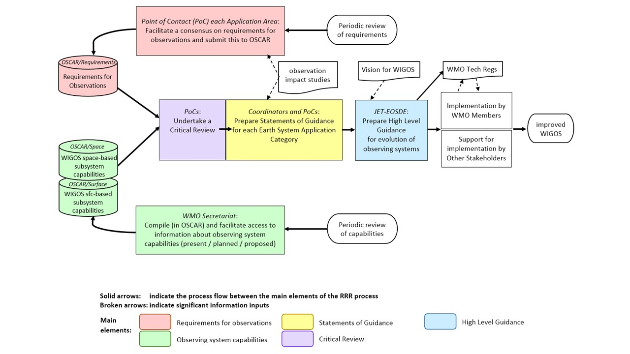

**Figure 1 of Attachment 3**. Main elements of the WMO RRR process (source: Requirements for observational data in the framework of the WMO Earth System Approach: the Rolling Review of Requirements).

1. Commitment of time

WMO relies on Member countries to nominate volunteer experts to carry out the work of constituent bodies such as Technical Commissions and their various expert teams and working groups. For such a nomination to be made depends on the expert’s employer supporting them to commit the required amount of time to carry out the relevant role. The role of PoC requires a commitment of the equivalent of around 10 days each year. For those who take on the additional role of Coordinator the time commitment might roughly double.

It is also anticipated that the experts who are nominated are actively working in the relevant field, hence they will have the opportunity to gather information and develop their thoughts about the WMO tasks during the normal course of their regular work.

1. Representing an Application Area

For each Application Area there is a body which has ownership responsibility and authority. A list of Application Areas and their owners is shown in Annex I, however this list is undergoing changes and the online version should be consulted for up-to-date information, at: <https://community.wmo.int/rolling-review-requirements-process>

A PoC is a representative in the RRR process for the owner of their Application Area. After initially tasking you to perform the role of PoC for this Application Area they will also need to be satisfied with the consultation you have achieved across the relevant stakeholder community, to concur with all updates you propose for observations requirements in the OSCAR/Requirements database, and to concur with the material you include in the SoG for your Earth System domain. You should establish a clear mutual understanding with the owning body on how and when these interactions will occur.

1. Fulfilling the PoC and Coordinator roles

This section expands on practical details of the PoC and Coordinator roles. Extended notes for the topics presented here are made in Annexes 2 to 9 to Attachment 3, including many spaces for each PoC and Coordinator to add your own notes about the specific contact details, information sources and activities relevant to you. In that way the Guide becomes specific to you, however there will also be value in sharing your notes with other PoCs/Coordinators and in particular your successor when in the future you eventually hand over the role. Similarly, a helpful source of practical advice for you is your predecessor in the role and other current and former PoCs/Coordinators across all Application Areas and Earth System Application Categories.

5.1 Work planning

The ongoing activities which constitute the RRR process are coordinated by the WMO Commission for Observation, Infrastructure and Information Systems (INFCOM) through its Joint Expert Team on Earth Observing System Design and Evolution (JET-EOSDE). Your activities will contribute as a component of the larger work plan of the JET-EOSDE.

The most important person to keep in touch with regarding your contribution to the RRR is the Chair of JET-EOSDE. Communication with the Chair, and understanding of the work of JET-EOSDE, can be facilitated by people in the WMO Secretariat who support the JET-EOSDE. A formal starting point is with the Head of the Observing Networks and Measurement Division of the Infrastructure Department.

It is useful to familiarize yourself with the work and meeting plans, as well as reports from previous meetings, of JET-EOSDE as they help to explain where your work fits in with other RRR activities and timelines.

Annex 2 to Attachment 3 provides further notes and spaces for you to add your own notes.

5.2 Communicating with your Application Area “owner”

As well as having good lines of communication with JET-EOSDE, it is important to maintain good communication with the body which has ownership responsibility for your Application Area. The details may differ between different bodies, but in general it is good to have contact with: the most senior expert heading the body, for example President or Chair of the relevant panel/ team/ committee; and the most relevant secretariat support person.

Annex 3 to Attachment 3 provides further notes and spaces for you to add your own notes.

5.3 Coordination amongst PoCs

Each Application Area is grouped with the other Application Areas in their Earth System Application Category, as explained in the RRR description in Section 2 above. The primary task that is undertaken by PoCs working as a team is preparation and submission of the SoG. One PoC in the team – identified as the Coordinator for that Earth System Application Category – is selected to coordinate this activity and to take responsibility as lead author, while others contribute as co-authors.

Whether you are the Coordinator or a co-author, you will need to collaborate actively with the other PoCs in your Earth System Application Category. Annex 4 to Attachment 3 provides further notes and spaces for you to add your own notes.

5.4 Consulting with Stakeholders

The RRR process depends on input from each Application Area regarding its requirements and priorities for observations. As the PoC for your Application Area, you have a very important role as the conduit to the RRR for input and feedback from your entire stakeholder community. Hence it is important to provide information to your stakeholder community on input and feedback processes, and to promote and maintain active and effective communication mechanisms.

The characteristics of each Application Area are different, however in broad terms you could consider mechanisms for consultation across your community of experts, with the body that owns this Application Area, and with relevant experts across WMO Technical Commissions and Regional Associations as well as the WMO Executive Council in relation to the Antarctic. Annex 5 to Attachment 3 provides further notes and spaces for you to add your own notes.

5.5 Assessing observation impact studies

JET-EOSDE encourages observation impact studies to be carried out and conducts a series of technical workshops on this topic. Each workshop provides an update on the latest understanding about the impact that various observing systems have on forecasts and other products generated by numerical prediction systems. Such information may contribute to your assessment of the optimum observations requirements for your Application Area, as well as the most important gaps to give priority to addressing.

Once you are familiar with the content and goals of these workshops, you might wish to propose scientific questions to be investigated that could assist your Application Area to enhance its understanding and description of its requirements for observations. Annex 6 to Attachment 3 provides further notes and spaces for you to add your own notes.

5.6 Compiling and Updating Requirements

A key result of your activities as PoC is the maintenance of an up-to-date record in the OSCAR/Requirements database of your Application Area’s requirements for observations. Based on input from across the stakeholder community in your Application Area, any relevant guidance from Observations Impact Studies, and your own expert assessment, you will need to review the current requirements expressed in the OSCAR/Requirements database for your Application Area and enter your proposed updates to existing requirements and/or additions of new requirements.

This pre-supposes that you have a good familiarity with the details of existing requirements expressed by your Application Area and a good ability to navigate the Observing Systems Capability Analysis and Review Tool (OSCAR) database to investigate and update the contents of relevance to you. Further notes on this are provided in Annex 7 to Attachment 3. Also, some further explanation and general perspective on update procedures may be found in Annex IX (OSCAR UPDATING/MAINTENANCE PROCEDURE).

At a very practical level, instructions for entering proposed updates to Application Area requirements are provided for PoCs (referred to in the document as Focal Points) in a Focal Point Manual: <https://www.wmo-sat.info/oscar/files/OSCAR_Focal_Point_Manual.pdf>

5.7 Completing the Statement of Guidance (SoG)

The other key result of your activities is the SoG for your Earth System Application Category, which is essentially a gap analysis (identifying requirements for observations which are not being met) with recommendations on priorities for addressing the gaps. A Statement of Guidance template provides informative guidance on what is required to be included in the document.

The SoG for your Earth System Application Category is drafted by a team consisting of the PoCs of each Application Area within that category, under the leadership of a Coordinator and is the lead author of the SoG. The Coordinator is either nominated by the Earth System Application Category Owner, or by default selected from, amongst the group of PoCs. In the past, each Application Area prepared its own SoG. The current approach is significantly different. There may be a settling-in period for all stakeholders to feel completely comfortable and confident with the new approach. Annex 8 to Attachment 3 provides further notes.

5.8 Further notes

As stated earlier, each PoC and Coordinator is encouraged to add your own notes about the specific contact details, information sources and activities that you have discovered that are useful to you in fulfilling this role. Annex 9 to Attachment 3 provides the space to encourage to record your notes for future reference.

# Annex 1 to Attachment 3. Role of the Points of Contact (PoC) for Application Areas, and Coordinators for Earth System Application Categories

The PoC of an Application Area is tasked to:

1. Collect, record and maintain observational user requirements of the Application Area in the OSCAR/Requirements database;
2. Conduct a critical review and gap analysis for the Application Area by comparing observing capabilities with the observational user requirements of the Application Area, as well as by considering the results from impact studies and applying their own expert judgement;
3. As a representative of the Application Area owner, promote and maintain active and effective communication mechanisms to obtain input and feedback from across the Application Area stakeholder community including in particular Member countries and Regional Associations;
4. Liaise in her/his work with the body, which is the RRR owner of the Application Area, and seek concurrence of that community with the observational user requirements in OSCAR/Requirements and the result from the critical review and gap analysis;
5. Provide input to the Coordinator of the Earth System Application Category to which the Application Area belongs, and contribute to the development of that Earth System Application Category SoG, including the critical review;
6. Respond to requests for information from the JET-EOSDE as needed.

The PoCs are designated by the bodies identified as the owners of the Application Areas.

The Coordinator for an Earth System Application Category is tasked to:

1. Coordinate with and guide the PoCs of the relevant Application Areas, to obtain their expert contributions to the development of the SoG (gap analysis with recommendations on how to address the gaps) of the Earth System Domain;
2. As lead author, complete the drafting and submission of the SoG of the Earth System Application Category;
3. Consult with relevant bodies and respond to requests for information from the JET-EOSDE as needed;
4. Submit the SoG and future updates to the Chair of the INFCOM Joint Expert Team on Earth Observing System Design and Evolution (JET-EOSDE) for his/her review and submission to the JET-EOSDE for discussion; SoGs are eventually recommended by the Chair of JET-EOSDE and/or the JET-EOSDE meetings to the president of INFCOM, who in consultation with the management group will approve it.

The Coordinator is selected from amongst the PoCs of the Application Areas in the relevant Earth System Application Category, proposed by them through JET-EOSDE and SC-ON, and then appointed by the Infrastructure Commission President in consultation with the management group.

The timelines and deadlines for the activities of PoCs and Coordinators will be determined to support the work plans of the INFCOM JET-EOSDE. However, as a general rule, once in each 4-yearly planning cycle of the WMO:

1. the complete set of observational requirements of the Application Area is to be reviewed and, where relevant, updated; and
2. a complete review and re-submission of the SoG is to be undertaken.

# Annex 2 to Attachment 3. PoC and Coordinator roles: Work planning

As outlined in Section 5.1, the most important person to keep in touch with regarding your contribution to the RRR is the Chair of JET-EOSDE.

Contact details (each PoC may enter and maintain these details for their own reference):

Name: ………………………….

Email: ………………………….

Phone: ………………………….

Communication with the Chair, and understanding of the work of JET-EOSDE, can be facilitated by people in the WMO Secretariat who support the JET-EOSDE. A formal starting point is with the Head of the Observing Networks and Measurement Division of the Infrastructure Department:

Contact details (each PoC may enter and maintain these details for their own reference):

Name: ………………………….

Email: ………………………….

Phone: ………………………….

It is useful to familiarize with the work and meeting plans, as well as reports from previous meetings, of JET-EOSDE as they help to explain where your work fits in with other RRR activities and timelines.

A general entry point to relevant information is the GOS page at:

<https://community.wmo.int/activity-areas/global-observing-system-gos>

Note however that the WMO web pages have been going through a transition from the old site:

<https://old.wmo.int/extranet/pages/index_en.html>

to the new site:

<https://public.wmo.int/en>

As a result, some relevant material might not currently be easy to find or access.

New entry points to relevant information include the Commission for Observation, Infrastructure and Information Systems (INFCOM) page at:

<https://community.wmo.int/governance/commission-membership/commission-observation-infrastructure-and-information-systems-infcom>

Specific pages of relevance under that page include the Standing Committee on Earth Observing Systems and Monitoring Networks (SC-ON) page:

<https://community.wmo.int/governance/commission-membership/commission-observation-infrastructure-and-information-systems-infcom/commission-infrastructure-officers/infcom-management-group/standing-committee-earth-observing-systems-and-monitoring-networks-sc>

And the JET-EOSDE page at:

<https://community.wmo.int/governance/commission-membership/commission-observation-infrastructure-and-information-systems-infcom/commission-infrastructure-officers/infcom-management-group/standing-committee-earth-observing-systems-and-monitoring-networks-sc/joint-expert-team-earth>

Past meeting reports can be found online at:

[to be clarified ………………..]

Or they can be otherwise obtained from:

………………………………………..

The work plans of JET-EOSDE can be found online at:

[to be clarified ………………..]

Or they can be otherwise obtained from:

………………………………………..

Future meeting plans can be found online at:

[to be clarified ………………..]

Or they can be otherwise obtained from:

………………………………………..

# Annex 3 to Attachment 3. PoC and Coordinator roles: Communicating with your Application Area “owner”

As outlined in Section 5.2, as well as having good lines of communication with JET-EOSDE, it is important to maintain good communication with the body which has ownership responsibility for your Application Area. The details may differ between different bodies, but in general it is good to have contact with:

1. The most senior expert heading the body, for example President or Chair of the relevant panel/ team/ committee:

Contact details (each PoC may enter and maintain these details for their own reference):

Name: ………………………….

Email: ………………………….

Phone: ………………………….

Other experts with delegated authority to liaise with you on behalf of the owning body:

………………………………………..

………………………………………..

Meeting and/or reporting arrangements requiring your input:

………………………………………..

………………………………………..

1. The most relevant secretariat support person:

Contact details (each PoC may enter and maintain these details for their own reference):

Name: ………………………….

Email: ………………………….

Phone: ………………………….

# Annex 4 to Attachment 3. PoC and Coordinator roles: Coordination amongst PoCs

As outlined in Section 5.3, each Application Area is grouped with the other Application Areas that are active in the same Earth System Application Category. The primary task that is undertaken as a team with the other PoCs is preparation and submission of the SoG. One PoC in the team – identified as the Coordinator for that Earth System Application Category – is selected to coordinate this activity and to take responsibility as lead author, while others contribute as co-authors.

Whether you are the Coordinator or a co-author, you will need to collaborate actively with the other PoCs in your Earth System Application Category as listed in this table (each PoC may enter and maintain these details for their own reference):

|  |  |
| --- | --- |
| Application Area: ………………………….  *PoC Contact details:*  Name: ………………………….  Email: ………………………….  Phone: …………………………. | Application Area: ………………………….  *PoC Contact details:*  Name: ………………………….  Email: ………………………….  Phone: …………………………. |
| Application Area: ………………………….  *PoC Contact details:*  Name: ………………………….  Email: ………………………….  Phone: …………………………. | Application Area: ………………………….  *PoC Contact details:*  Name: ………………………….  Email: ………………………….  Phone: …………………………. |
| Application Area: ………………………….  *PoC Contact details:*  Name: ………………………….  Email: ………………………….  Phone: …………………………. | Application Area: ………………………….  *PoC Contact details:*  Name: ………………………….  Email: ………………………….  Phone: …………………………. |
| Application Area: ………………………….  *PoC Contact details:*  Name: ………………………….  Email: ………………………….  Phone: …………………………. | Application Area: ………………………….  *PoC Contact details:*  Name: ………………………….  Email: ………………………….  Phone: …………………………. |

The most critical collaboration is with the Coordinator for your Earth System Application Category grouping:

Contact details (each PoC may enter and maintain these details for their own reference):

Name: ………………………….

Email: ………………………….

Phone: ………………………….

Each grouping is different in size and characteristics so is likely to have different working arrangements:

Working arrangements for my Earth System Application Category:

………………………………………..

………………………………………..

…..…………………………………..

………………………………………..

# Annex 5 to Attachment 3. PoC and Coordinator roles: Consulting with Stakeholders

As outlined in Section 5.4, the RRR process depends on input from each Application Area regarding its requirements and priorities for observations. As the PoC for your Application Area, you have a very important role as the conduit to the RRR for input and feedback from your entire stakeholder community. The characteristics of each Application Area are different, however in broad terms you could consider:

1. Mechanisms for consultation across your application community of expertise, such as meetings, conferences and personal contacts:

………………………….

………………………….

1. Mechanisms for consultation within the body that owns this Application Area, such as working groups / expert teams, meetings, conferences and personal contacts associated with that body:

………………………….

………………………….

1. Mechanisms for consultation within the WMO, further to the above, with relevant experts across Technical Commissions and Regional Associations as well as the WMO Executive Council in relation to the Antarctic, through working groups / expert teams, meetings, conferences and personal contacts:

………………………….

………………………….

Working structures and other information such as meeting reports, work plans, and future meeting plans can be found online for:

WMO Technical Commissions and their subsidiary bodies:

<https://community.wmo.int/governance/commission-membership>

WMO Regional Associations, online here:

<https://community.wmo.int/governance/regional-association>

That page provides links to each of the six Regional Associations:

1. WMO
2. Regional Association III (South America);
3. WMO Regional Association I (Africa);
4. WMO Regional Association II (Asia);
5. WMO Regional Association IV (North America, Central America and the Caribbean);
6. WMO Regional Association V (South-West Pacific); and
7. WMO Regional Association VI (Europe).

You should also consider the WMO Executive Council in relation to the Antarctic.

# Annex 6 to Attachment 3. PoC and Coordinator roles: Assessing observation impact studies

As outlined in Section 5.5, JET-EOSDE encourages observation impact studies to be carried out and conducts a series of technical workshops on this topic. Each workshop provides an update on the latest understanding about the impact that various observing systems have on numerical models. Such information may contribute to your assessment of the optimum observations requirements for your Application Area, as well as the most important gaps to give priority to addressing.

You will see plans for future conferences within meeting reports and plans of the JET-EOSDE. The most recent workshop was:

[*Scoping Workshop on Future Activities to Assess Impact of Various Observing Systems on Earth System Prediction*](https://wmoomm.sharepoint.com/:b:/s/wmocpdb/EeofnfGRvRhBh82z98XD-bMBZ6vmDP14UvTd76EWa8Pe-A?e=IVcyaj)*, Geneva, 9-11 December 2019*

The series of WMO Workshop on the Impact of Various Observing Systems on Numerical Weather Prediction is also of interest:

1. [Seventh Workshop, Geneva, 30 November – 3 December 2020](https://wmoomm.sharepoint.com/sites/wmocpdb/eve_activityarea/Forms/AllItems.aspx?id=%2Fsites%2Fwmocpdb%2Feve%5Factivityarea%2FWMO%20Integrated%20Global%20Observing%20System%20%28WIGOS%29%5F99452102%2D7575%2De911%2Da98e%2D000d3a44bd9c%2FNWP%2D7%2DPresentations%2FNWP%2D7%5FFinal%2DReport%2Epdf&parent=%2Fsites%2Fwmocpdb%2Feve%5Factivityarea%2FWMO%20Integrated%20Global%20Observing%20System%20%28WIGOS%29%5F99452102%2D7575%2De911%2Da98e%2D000d3a44bd9c%2FNWP%2D7%2DPresentations&p=true&ga=1);
2. [Sixth Workshop, Shanghai, China, 10 – 13 May 2016](https://wmoomm.sharepoint.com/sites/wmocpdb/eve_activityarea/Forms/AllItems.aspx?id=%2Fsites%2Fwmocpdb%2Feve%5Factivityarea%2FWMO%20Integrated%20Global%20Observing%20System%20%28WIGOS%29%5F99452102%2D7575%2De911%2Da98e%2D000d3a44bd9c%2FWMO%2DNWP%2D6%5F2016%5FShanghai%5FFinal%2DReport%2Epdf&parent=%2Fsites%2Fwmocpdb%2Feve%5Factivityarea%2FWMO%20Integrated%20Global%20Observing%20System%20%28WIGOS%29%5F99452102%2D7575%2De911%2Da98e%2D000d3a44bd9c&p=true&ga=1);
3. [Fifth Workshop, Sedona, Arizona (USA), 22-25 May 2012](https://old.wmo.int/extranet/pages/prog/www/OSY/Reports/NWP-5_Sedona2012.html);
4. [Fourth Workshop, Geneva, 19-21 May 2008](https://old.wmo.int/extranet/pages/prog/www/OSY/Reports/NWP-4_Geneva2008_index.html);
5. [Third Workshop, Alpbach, Austria, 9-12 March 2004](https://old.wmo.int/extranet/pages/prog/www/GOS/Alpbach2004/Agenda-index.html).

Once you are familiar with the content and goals of these workshops, you might wish to propose scientific questions that could assist your Application Area to enhance its understanding and description of its requirements for observations.

Further notes about these workshops in general or specific studies of relevance to the use of observations in your Application Area:

………………………….

………………………….

………………………….

………………………….

# Annex 7 to Attachment 3. PoC and Coordinator roles: Compiling and Updating Requirements

As outlined in Section 5.6, a key result of your activities as PoC is the maintenance of an up-to-date record in the OSCAR/Requirements database of your Application Area’s requirements for observations. In addition to building on your consultation, analysis and expertise to develop your proposed updates to the requirements, you will also need a good ability to navigate the Observing Systems Capability Analysis and Review Tool (OSCAR) database to investigate and update the contents of relevance to you.

The OSCAR database home page is at: <https://space.oscar.wmo.int/>

The home page provides the summary Figure shown below, an overview description of OSCAR and a link to further explanation in the OSCAR User Manual at: [OSCAR User Manual](https://wmoomm.sharepoint.com/:b:/s/wmocpdb/EZupID26Dn1Hr1sDnmRMvvsBbAv-RTuxsF6UnhBNSLhyVQ?download=1)

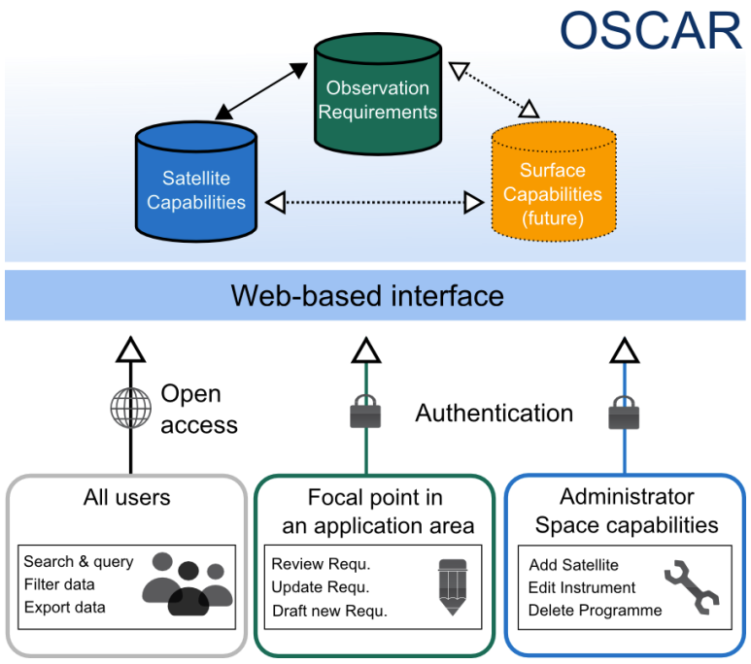

**Figure 2 of Attachment 3**. Basic Structure of OSCAR and examples of access

The User Manual concentrates on the open access aspects of OSCAR, however it also provides a link to a further document containing information specifically relevant to you as PoC (referred to in the document as Focal Point): <https://www.wmo-sat.info/oscar/files/OSCAR_Focal_Point_Manual.pdf>

The Focal Point Manual explains how to edit existing requirements and how the enter new requirements. It is also possible to request the addition of new variables to the database – you will need to define various attributes of the variable as part of your request.

# Annex 8 to Attachment 3. PoC and Coordinator roles: Completing the Statement of Guidance (SoG)

As outlined in Section 5.7, the other key result of your activities is the SoG for your Earth System Application Category, which is essentially a gap analysis (identifying requirements for observations which are not being met) with recommendations on priorities for addressing the gaps.

A Statement of Guidance template provides informative guidance on what is required to be included in the document. The template is available online at: [hyperlink to be provided once approved and available online; for the time being, it is available in Attachment 1 of this document]

Existing versions of SoGs are available online on the RRR web page; scroll down to find the SoG table:

<https://community.wmo.int/rolling-review-requirements-process>

When reviewing the existing versions, keep in mind that the new Earth System Application Category approach is significantly different from the previous approach.

# Annex 9 to Attachment 3. PoC and Coordinator roles: Further notes

In your role as PoC and, if applicable, Coordinator, you are encouraged to document for future reference your own additional notes about the specific contact details, information sources and activities that you have discovered that are useful to you in fulfilling this role.

………………………………………..

………………………………………..

………………………………………..

…….….……………………………..

________________

1. Technology-free means that the requirements do not take into account the available technology for making the observations, whether it is surface-based and/or space-based; they are independent of observing system capabilities as far as is possible.
2. In the context of WMO Strategic Plan 2020-2023, the term “weather” refers to short-term variations in the state of the atmosphere and their phenomena or effects, including wind, cloud, rain, snow, fog, cold spells, heat waves, drought, sand and dust storms and atmospheric composition, as well as tropical and extratropical cyclones, storms, gales, the state of the sea (e.g. wind-generated waves), sea ice, coastal storm surges etc. “Climate” refers to longer-term aspects of the atmosphere-ocean-land surface systems. “Water” includes freshwater above and below the land surfaces of the Earth, their occurrence, circulation and distribution, both in time and space. Related “environmental” issues refer to surrounding conditions affecting human beings and living resources, for example the quality of air, soil and water, as well as “space weather” - the physical and phenomenological state of the natural space environment, including the Sun and the interplanetary and planetary environments.
3. We only expect requirements to be expressed where it makes sense to do so.
4. Within the context of WMO Guide No. 8 Guide to Instruments and Methods of Observation and other INFCOM documentation the term uncertainty is aligned to the JCGM_200_2012_VIM: International vocabulary of metrology and JCGM_100_2008_e_GUM: Guide to the Estimation of Uncertainty. These definite of Expanded Uncertainty as a quantity defining an interval about the result of a measurement that may be expected to encompass a large fraction of the distribution of values that could reasonably be attributed to the measurand, at a typical 95% confidence level. Within INFCOM this is the definition used when referring generally to uncertainty, rather than the RMS (69% confidence level) quoted here. It is important to take this difference of meaning into account when comparing similar information between OSCAR and INFCOM. It is also noted that most reputable manufactures of instruments, also comply with the GUM, however this needs to be checked on a case-by-case basis.
5. Within the context of WMO Guide No. 8 Guide to Instruments and Methods of Observation and other INFCOM documentation the term uncertainty is aligned to the JCGM_200_2012_VIM: International vocabulary of metrology and JCGM_100_2008_e_GUM: Guide to the Estimation of Uncertainty. These definite of Expanded Uncertainty as a quantity defining an interval about the result of a measurement that may be expected to encompass a large fraction of the distribution of values that could reasonably be attributed to the measurand, at a typical 95% confidence level. Within INFCOM this is the definition used when referring generally to uncertainty, rather than the RMS (69% confidence level) quoted here. It is important to take this difference of meaning into account when comparing similar information between OSCAR and INFCOM. It is also noted that most reputable manufactures of instruments, also comply with the GUM, however this needs to be checked on a case-by-case basis.
6. Note: the OSCAR/Requirements parts added to the ET-SAT approved document are highlighted in green. IPER-OSDE concurred with the Space part, and approved the Requirements part.
7. Note: the OSCAR/Requirements parts added to the ET-SAT approved document are highlighted in green. IPER-OSDE concurred with the Space part, and approved the Requirements part.
8. <https://community.wmo.int/vision2040>
9. New definition of an application area
10. Advice regarding such prioritizations is to be obtained from the WMO Secretariat.
11. https://space.oscar.wmo.int/observingrequirements
12. Geographical, Vertical structure, Temporal/Seasonal, Latency, Data quality