The WMO Strategy for Service Delivery

V6 – 12 September 2022

Contents
Foreword – to be added 2
1. Context 3
2. The WMO Strategic Plan and Linkages to the WMO Strategy for Service Delivery 4
3. Services: Types, Benefits, and Access 6
4. Significant Trends of Relevance to the WMO Strategy for Service Delivery 12
5. Services – Government Agencies, Sectors, and Stakeholders 15
5.1 Services to Cross-Sectoral Government Functions 16
5.1.1 Disaster Risk Management 16
5.1.2 Planning 17
5.1.3 Social Services 18
5.2 Services to Economic Sectors 18
5.3 The Services Value Cycle, its Stakeholders, and Roles 20
6. A Strategic Roadmap for the Improvement of Services at the National Level 23
6.1 Member Government’s Assignment of Responsibility for Services Provision 25
6.2 NMHS Services Strategic plan and organizational structure 27
6.3 Services Assessment and Evaluation 28
6.4. National Frameworks for Climate Services and Other Platforms 30
6.5. Users, Stakeholders, and Partners 32
6.5.1. Government and Public Institutions 32
6.5.2. Private Sector 34
6.5.3 Not-for-Profit Organizations 36
6.5.4. The General Public 38
6.6. NMHS’s Operations and Systems 38
6.6.1 Communications and user experience 39
6.6.2. Competencies, Skills, Human Resources, Management Systems 40
6.6.3 National, Regional, and International Cooperation 41
6.6.4 Special Studies for Horizon Scanning 42
6.6.5 Quality Management Systems (Including Monitoring and Evaluation) 43
6.6.6. Financial Sustainability 44
6.7. Services Delivery Improvement Plan 45
7. WMO and Service Delivery 52

Foreword – to be added

1. Context

The WMO Strategy for Service Delivery was approved in 2011, and its Implementation Plan was subsequently prepared and approved in 2013 (WMO-No. 1129). Since then, there have been tremendous advances in research, science and technology, including those related to observations, analysis, forecasting, and service delivery. At the same time, the understanding of the socio-economic benefits of services has increased significantly. The last decade has seen a significant improvement in understanding the severity and impacts of climate change and corresponding extreme weather and climate events. The COVID-19 pandemic that started in 2020 had major implications on a global scale including the general population, the private sector, the government, and other societal stakeholders who had reconsider and restructure their service delivery approaches. Furthermore, the growing number of projects and activities that WMO and its Members were and are undertaking on service improvement calls for a more coordinated, modern and fit for purpose approach that leverages the existing strengths and complementarities, and also identifies gaps that need to be addressed. For all these reasons, WMO decided to update and renew the 2011 WMO Strategy for Service Delivery. There are several aspects of this document that continue to be relevant today and which are incorporated into the updated WMO Strategy for Service Delivery, as presented in Annex 1. This new Strategy both updates and replaces WMO-No.1129 ‘WMO Strategy for Service Delivery and its Implementation Plan’ (2014).

The updated WMO Strategy for Service Delivery (also referred to in the document as the “Strategy for Service Delivery” as a shorthand) is organized in the following seven sections:
- Section 1 provides the context of the Strategy for Service Delivery.
- Section 2 presents the linkages between the new 2024-2027 WMO Strategic Plan and the Strategy for Service Delivery.
- Section 3 describes the wide range of societal benefits – economic, social, and environmental - of services.
- Section 4 briefly presents some significant trends – both technological and societal – that influence provision of services.
- Section 5 illustrates the significance of services to a broad range of economic sectors, cross-sectoral government functions, vulnerable communities, and the general population. It also presents the multi-stakeholder perspective taken by the Strategy for Service Delivery and the multiple channels of identification, design, production, development, and improvement of services.
- Section 6 is the core of the Strategy for Service Delivery with a detailed description of a roadmap for the Member States and Territories (henceforth referred to as “Members”), and their NMHSs to improve the standard and specialized services.
- Section 7 concludes with a brief description of the WMO’s support systems that help Members and their NMHSs in their service improvement journey.

2. The WMO Strategic Plan and Linkages to the WMO Strategy for Service Delivery

The WMO Strategic Plan 2020-2023 (WMO No. 1125) , adopted by Congress through Resolution 1 (Cg-18) in June 2019, sets the directions and priorities to guide the activities of the Organization during 2020–2023 and up to 2030 to enable all Members to improve their information, products, and services.
The WMO Strategic Plan was developed to help the organization achieve its vision: “By 2030, we see a world where all nations, especially the most vulnerable, are more resilient to the socio-economic consequences of extreme weather, climate, hydrological, and other environmental events; and underpin their sustainable development through the best possible services, whether over land, at sea or in the air.” This vision is the foundation of this Strategy for Service Delivery.
The WMO Strategic Plan sets three overarching priorities:
- Enhancing preparedness for reducing loss of life, critical infrastructure, and livelihoods from hydrometeorological and climatic extremes;
- Supporting climate-smart decision making to build or enhance adaptive capacity or resilience to climate risk; and
- Enhancing the socio-economic value of weather, climate, hydrological, and related environmental services.
These three priorities are at the core of this Strategy for Service Delivery. Improving weather, climate, hydrological, and related environmental services is indispensable to achieving the three overarching priorities listed above.
At the next level, the WMO Strategic Plan sets out five long-term goals for the 2030 horizon and strategic objectives, focused on addressing the most pressing developments and needs during the four-year planning cycles of the Organization.
The five long-term goals (LTGs) highlighted for the 2020-2023 planning cycle are:
1. Better serve societal needs: Delivering authoritative, accessible, user-oriented, and fit-for-purpose information and services.
2. Enhance Earth system observations and predictions: Strengthening the technical foundation for the future.
3. Advance targeted research: Leveraging leadership in science to improve understanding of the Earth system for enhanced services.
4. Close the capacity gap on weather, climate, hydrological, and related environmental services: Enhancing service delivery capacity of developing countries to ensure availability of essential information and services needed by governments, economic sectors, and citizens.
5. Strategic realignment of WMO structure and programmes for effective policy- and decision-making and implementation.
LTGs (1) and (4) are more directly related to this Strategy for Service Delivery. The enhancement of Earth system observations and predictions and the advancement of targeted research (LTG 2 and 3) are also critical foundations for the continuous improvement of services. The effective policy and decision-making, and implementation capabilities of WMO will directly impact the support the organization provides to its Members and their NMHSs as they improve their services.
While there may be changes to the LTGs in the coming four-year planning cycle 2024-2027, the Strategy for Service Delivery is designed around the overarching objectives of WMO that are not expected to change over this decade.
Table 2.1 presents the long-term outcomes of LTGs 1 and 4 of the WMO Strategic Plan, given their close relation to the Strategy for Service Delivery.

Table 2.1 – LTGs 1 and 4 and their Long-term Outcomes
LTGs | Long-term Outcome
1 - Better serve societal needs: Delivering authoritative, accessible, user-oriented, and fit-for-purpose information and services. | Enhanced capability of Members to develop, access, and utilize accurate, reliable, and fit-for-purpose weather, climate, hydrological, and related environmental impact-based services to best support the policymaking and actions that implement sustainable development and mitigate weather, climate, and water-related risks.
4 - Close the capacity gap on weather, climate, hydrological, and related environmental services: Enhancing service delivery capacity of developing countries to ensure availability of essential information and services needed by governments, economic sectors, and citizens. | Improved access to regional and global monitoring and prediction systems and utilization of weather, climate, and hydrological information and services bringing tangible benefits to developing Members, in particular Least Developed Countries, Small Island Developing States and Member Island territories. This will be achieved through strategic investments, technology transfer, knowledge and experience sharing, and by taking due account of social inclusion and gender factors.

3. Services: Types, Benefits, and Access

The services considered in the Strategy for Service are broad and include weather, meteorological, climate, hydrological, marine, cryosphere and related environmental services. The Strategy uses the term “services” to encompass all of them, unless specifically defines a subset of services.

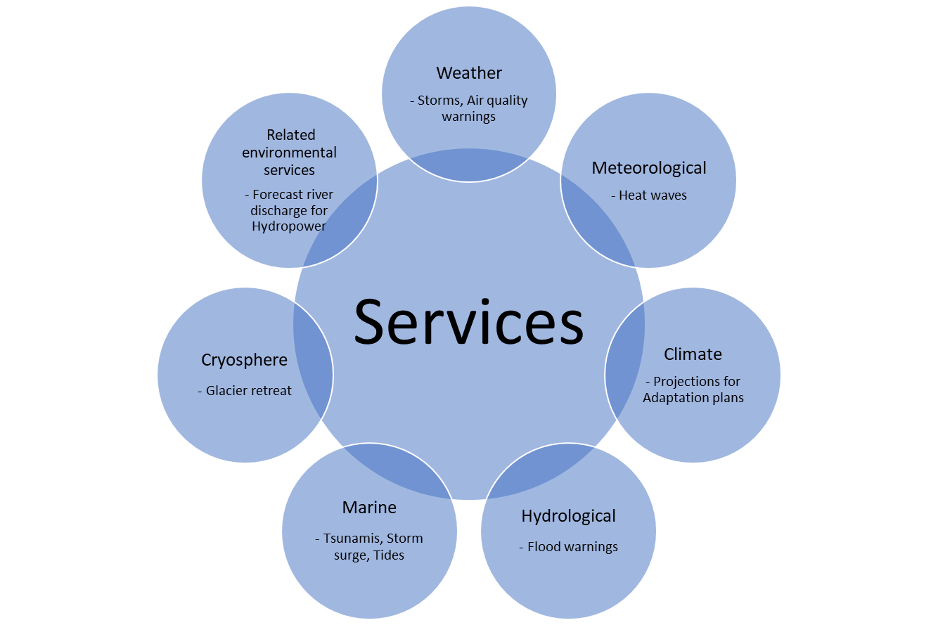
Figure 3.1 – Types of services with only one example per area of research and development.

The socio-economic benefits of improved data and information, forecasts, long-term projections, and derived services touch all corners of the economy and stakeholders in society, and the safety of lives. Stakeholders who can understand and leverage these services will be able to harness economic, social, and environmental benefits far superior to those unaware of or unable to use the services. These benefits can be classified into four categories: (i) reduction of adverse impacts from hazardous hydrometeorological and climatic events; (ii) sustainable development and economic growth, including efficiency, productivity, and competitiveness of economic sectors, as well as reduced wastage and environmental sustainability; (iii) adaptation to climate change through implementing mitigation tools; and (iv) inclusive economic growth, poverty reduction, services to vulnerable and hard-to-reach communities.

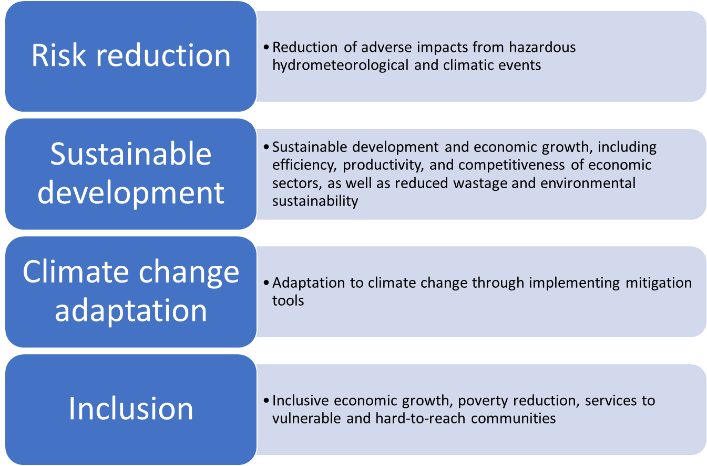
Figure 3.2 – Socio-economic Benefits of Services

Reduction of adverse impacts from hazardous hydrometeorological and climatic events: The ability to prepare for hazardous hydrometeorological events and to respond more effectively and efficiently to deal with the aftermath of unavoidable damages have major social and economic benefits to societies. Some of these benefits include but are not limited to
- Reduction of loss of life, injuries, and illness caused by hydrometeorological and climatic extreme events, or industrial disasters and volcanic eruptions with dangerous releases to the atmosphere or ocean.
- Reduction of climate-related illnesses, such as those caused by heatwaves or poor air quality events.
- Reduction in long-term human capital impacts, such as stunting or loss of educational attainment due to floods or droughts.
- Reduction in crop losses from frost, hail, floods, or drought.
- Reduction in loss of personal property, commercial assets, and infrastructure caused by hydrometeorological and climatic extreme events (e.g., tropical cyclones, tornadoes, thunderstorms, etc.).
- More cost-effective transport, energy, or housing infrastructure designs to withstand hydrometeorological and climatic extreme events.
- More cost-effective responses to humanitarian crises caused (or compounded) by hydrometeorological and climatic extreme events, or other natural disasters.
Sustainable development and economic growth: In addition to the socio-economic benefits of data and information on hydrometeorological and climatic extreme events, the efficiency, productivity, and competitiveness of most sectors of the economy can be enhanced with timely and targeted information on weather, climate, hydrology, and related environmental parameters. Furthermore, the sustainability of the economic sectors also depends on their planning choices and operational decisions, which, in turn, rely on hydrometeorological and climate information. These linkages are vital for achieving most of the Sustainable Development Goals (SDGs) efficiently and effectively.
A non-exhaustive list of socio-economic benefits in this area includes the enhanced efficiency, productivity, and competitiveness of the following sectors:
- Agriculture through planting decisions, irrigation schedules, machinery use, fertilizer and pesticide applications, rainfed and irrigation development, or herd movements.
- Water supply through informed management and planning.
- Transport (air, land, and sea) through routing and timing decisions, logistical and equipment optimization, among other factors.
- Energy, particularly renewable energy, including hydro, wind, and solar, through optimized operational and maintenance scheduling, peak load management, and regional power pools’ operations.
- Urban economies, through building energy and cooling efficiency, green space water needs optimization, hospitality business planning, and urban infrastructure design.
- Natural resources – such as forestry, fisheries, and landscape management – through advanced forest fire management, fishing optimization, sustainable extraction, recreation and tourism, and water resources management decisions.
- Environmental sustainability and biodiversity protection, through enhanced design and implementation of protection measures.
- Insurance and financing with risk distribution schemes
The publication Climate Indicators and Sustainable Development (WMO-No. 1271) describes in greater detail the interconnections between the WMO climate indicators and the SDGs.
Climate change adaptation and mitigation: as the intensity and frequency of hydrometeorological and climatic extreme events increase and the climate patterns vary due to the increasing impacts of anthropogenic climate change, the role of weather and climate data, information, research, and services becomes more critical. The design, implementation, and improvement of adaptation measures in economic sectors depend on the quality of sub-seasonal, seasonal and decadal predictions and long-term projections of climate trends. This information brings benefits in a variety of sectors, such as:
- Agriculture, through the gradual change of crop patterns, plant varieties and cultivation methods, medium-term water resources management strategies for sustainable irrigation, and better preparedness for climate shocks, including floods, droughts, and heatwaves for crops, herds, and aquatic food.
- Coastal economies, through the planning of green and gray infrastructure for coastal flood reduction, zoning decisions to respond to sea-level rise, distant swell waves and storm surges, building codes for increasing intensity of storms and cyclones/hurricanes, and tourism infrastructure planning, among others.
- Energy and transport (including air, land, and sea), through new equipment and infrastructure design standards under uncertainty, update of maintenance and emergency procedures, and assets retrofit to changing climate conditions.
- Finance and insurance, through better risk modeling, risk financing, and a better understanding of climate risks in financial institutions’ portfolios.
- Health through better planning for increased illnesses and deteriorating health indicators due to climate shocks and better health infrastructure plan, operations, and maintenance to withstand climate shocks.
- Humanitarian actors through better preparedness for responses before climate shocks, development of innovative tools for preparedness, and shock absorbing measures to reduce impacts on health, education, and well-being of displaced populations and refugees.
- Integrated water resources management, including water supply, irrigation, hydropower, and others.
- Disaster risk reduction, impact-based forecasting, and early warning systems.
Climate research, information, and services continue to evolve rapidly, alongside the practice of design and preparedness under deep uncertainty at small spatial scales and medium- to long-temporal scales. This is an active area of development and innovation with an expectation for rapidly growing socio-economic benefits in the years to come.
The NMHS data and services can also provide the basis for action on climate change mitigation by informing countries on trends, renewable energy potential, water resources availability, and many others. Furthermore, greenhouse gas emissions monitoring is indispensable for the design and monitoring of climate mitigation action.
Inclusive economic growth, poverty reduction, services to vulnerable and hard-to-reach communities: In addition to the socio-economic benefits described in this section, services have an essential role to play in the protection of the most vulnerable members of society, including excluded groups, as well as in the reduction of poverty. Still, the emphasis of this category is on direct benefits to the poor and excluded communities. These benefits are achieved through:
- Reduction of loss of assets, housing, and lives due to hydrometeorological and climatic extreme events that disproportionately affect the poor and the excluded and require specific actions to protect these vulnerable populations.
- Improved agricultural productivity and sustainability for marginal farmers, as well as women and young farmers.
- Reduction in health expenses caused by hydrometeorological shocks and climate change impacts.
- Reduction of dependency from external oil and gas supply through the assessment and sustainable exploitation of domestic renewable energy resources.
- Better design of resilient infrastructure services – such as water supply, urban drainage, sanitation, roads, and electricity – that leads to more effective government, household, and humanitarian efforts to reduce and eliminate poverty.
- Empowerment of women and excluded groups through better access to information that may lead – with adequate agency and capacity – to improved choices, household asset allocation and management, savings, and human capital (education and health) growth for current and future generations.
The publication ‘Valuing Weather and Climate: Economic Assessment of Meteorological and Hydrological Services’ (WMO-No. 1153) provides a rigorous and comprehensive methodology for evaluating the benefits of hydrometeorological and related services and the required enabling infrastructure. NMHSs, central governments, and development agencies need to understand the full value of the socio-economic benefits provided by hydrometeorological services, as well as the financial realities of maintaining modern operations and service delivery so that adequate financing can be mobilized and invested to achieve these benefits. The case studies included in WMO-No. 1153 show that NMHSs improvements in services to reduce disaster losses in developing countries can have socio-economic benefits of US$4 to US$36 for every dollar invested.
A summary of the categories of socio-economic benefits of services by industry/ sector is shown on Table 3.2 where the Risk reduction of adverse impacts and Inclusion categories are cross-sectoral to all industries.

Table 3.1 Socioeconomic benefits of weather, climate, water and environmental services by industry.
 | Socioeconomic benefits
Industry/Sector | Risk reduction-adverse impacts | Sustainable development | Climate change adaptation | Inclusion (for the most vulnerable members of society, excluded communities)
Water supply, Transport (Air, land, water), Renewable energy, Urban economies, Education, Research, Media and Defence | Reduction of:  Loss of life, injuries, illness (including volcanic eruptions, dangerous releases to atmosphere, ocean and water, heat waves, poor air quality, sand and dust storms).  Loss of property, assets, infrastructure (Severe weather, i.e., tropical cyclones, tornadoes thunderstorms)  Long term human capital impact, stunting, educational attainment.  Crop losses from frost, hail, floods, droughts, environmental conditions that increase rapid propagation of pests and diseases  Increase of:  Cost-effective transport, energy, housing infrastructure design  Cost effective responses to humanitarian crises  Disaster risk reduction, impact-based forecasting, early warning systems | Design, construction, operation & maintenance | New equipment, infrastructure, design standards, updated maintenance and emergency procedures, assets retrofit.  Integrated Water Resource Management (water supply, irrigation, hydropower) | Reduction of:  Loss of assets, housing, lives.  Dependency on foreign oil and gas by implementing domestic renewable energy  Better design of:  Resilient infrastructure services | Increased access to information, better decision making for asset allocation, management, human capital growth for current and future generations by empowering women and excluded groups
Agriculture |  | Rainfed & Irrigation development, Planting decisions, Irrigation scheduling, Machinery use, Fertilizer & pesticide application, Herd movements | Strategies for sustainable irrigation, preparedness for climate shocks, i.e., floods, droughts, heatwaves. | Improved agricultural productivity and sustainability for women and young farmers
Natural resources |  | Forest fire management, fishing optimization, sustainable extraction, recreation & tourism, water resource management | Strategies for natural resource protection and conservation
Environmental sustainability and biodiversity |  | Design and implementation of protection/ conservation measures | Strategies to develop environmental services sustainable business models
Coastal economies |  |  | Strategies for coastal flood reduction, i.e., design, construction, operation and maintenance of green/ gray infrastructure, updated building codes
Finance and Insurance |  |  | Improved risk modelling, management and financing on organization’s portfolios.
Health |  |  | Improved health infrastructure design, construction, operation and maintenance to respond to climate shocks, | Reduction of health expenses  Effective government and humanitarian efforts to reduce poverty through better infrastructure
Humanitarian Aid |  |  | Better preparedness for responses before climate shocks. Tools for preparedness and shock absorbing measures to reduce impacts on health, education and wellbeing of displaced populations and refugees | Effective government and humanitarian efforts to reduce poverty through better infrastructure

4. Significant Trends of Relevance to the WMO Strategy for Service Delivery

There are three categories of significant trends relevant to the Strategy for Service Delivery and the services at the national level that NMHSs and other agencies provide (See Table 4.1).
- First, the rapid development of new emerging technologies, systems, and approaches profoundly impacts the delivery of services.
- Second, the rapid development in the generation and processing of data and delivery of services. It also affects how these services are consumed by users and repurposed for other societal activities. Many of these technologies relate to specialized services that leverage the data, information, and services provided by NMHSs for targeted audiences or enterprises.
- Third, the rapid changes in the environment, society, and the economy require commensurate changes in NMHSs services. Of relevance is the growing demand for climate change information in support of adaptation and mitigation actions and the increasing understanding by stakeholders of the benefits derived from the use of hydrometeorological data and advice. At the same time, NMHSs need to recognize these trends and anticipate the next-generation challenges and opportunities associated with the tendencies.

Table 4.1 – Significant Trends Impacting NMHSs Services – Indicative List
New emerging technologies, systems and approaches | New service delivery | Society and Economy
Evolution of satellite programs  High temporal and spatial resolution Earth system monitoring  Internet of Things (IoT)  High-performance and Quantum computing  High-resolution Numerical Weather Prediction (NWP) models  Earth system modelling  Reanalysis  Artificial intelligence (AI)  Machine learning (ML)  Big data analytics  Stochastic downscaling and calibration  Climate monitoring and assessments  Advances in climate forecasts (sub-seasonal to seasonal and annual to decadal)  Climate change projections | High-resolution geospatial data sets  Precision farming  Smart energy grid  Blockchain  5G telecommunications and connectivity  Smart cities  Impact assessment models and decision support tools  AI/ML  Social media platforms  Social and behavioral change science  Autonomous vehicles/Maritime Autonomous Surface Ship  Digital twins  Circular economy 2.0  Open data approaches  Advances in risk management and reduction  Climate change mitigation tools | Digital transformation  Urbanization  Globalization and economic interconnectedness  Net-zero climate commitments  Climate change impacts  Global prosperity and inequality  Demographic change  Food system transformation  Ecosystems degradation  Changes in consumer preferences (food, mobility, location)  Data security and privacy and cybersecurity threats  Sustainable development approaches

New emerging technologies transforming the quality of observations, the skill of forecasting, and the speed of processing include, inter alia, the new generation of satellite programes, the coordinated modeling and analysis approaches leading to a higher temporal and spatial resolution in earth system monitoring and prediction, etc. The immense opportunities that the Internet of Things and the massive expansion of environmental sensors will transform our understanding of the Earth system and its components. The rapid development of high-performance computing and storage, and the innovations of quantum computing are opening new avenues for much higher-resolution Numerical Weather Prediction (NWP) models as well as downscaling and calibration. The doors that artificial intelligence, machine learning and big data analytics are opening bring new opportunities that are yet to be fully developed.
The opportunity to combine the information emerging from enhanced observations, analyses, and forecasting with emerging technologies in economic sectors can leverage the socio-economic benefits of NMHSs services. For example, in agriculture, NMHSs’ services together with precision farming, new platforms to reduce food loss and waste, blockchain approaches to product tracing, logistical advances, integrated water-energy-food nexus approaches, and distributed farm-to-table platforms will multiply the benefits to the economy and society. These benefits will be possible thanks to the combination of ancillary data and information with advances in services.
In urban areas, the rapid improvements expected in NMHSs services will be connected with advances in smart cities, crowdsourcing, social media platforms that change the relationship between cities and citizens, digital twins for planning and modeling, and next-generation developments in circular economy approaches to transform the quality of life and economic progress of urban populations in the next decade.
The third trend relates to socio-economic relations and their impact on services development by NMHSs. The world continues a fast trend of urbanization, globalization, and economic interconnectedness. Climate change impacts, pandemics, and geopolitical risks continue to cast a shadow on socio-economic development. The contrasting trends of global prosperity and inequality, combined with demographic changes – from rapid population growth in some countries to aging populations in others – will influence the modalities and channels of NMHSs services. Finally, the Sustainable Development Goals and their 2030 targets maychange the landscape of vulnerable communities globally.
New trends may emerge, and some will be replaced by new technologies or tendencies. A key message of the Strategy for Service Delivery is that WMO Members and their NMHSs need to recognize these trends and the implications on service delivery. They need to continuously scan the horizon to understand new technologies and their impacts, scientific developments, and societal trends. Advanced NMHSs and WMO have mechanisms in place to support members and their NMHSs in their journey to findnew ways of providing services through emerging technologies. The opportunities are immense.

5. Services – Government Agencies, Sectors, and Stakeholders

One of the most essential premises of the 2011 WMO Strategy for Service Delivery was that the user must be at the center of effective delivery of services. Public-Private Engagment and Partnerships continue to be at the core of the Strategy for Service Delivery. This section illustrates the wide range of users, particularly government agencies and economic sectors and stakeholders, that the NMHSs should progressively consider in their services improvement journey.

As the 2011 WMO Strategy for Service Delivery highlights, a key role of the NMHSs is to identify and engage the potential users to understand their needs and determine how the organization can meet those needs by itself or in partnership with other institutions or private enterprises.
This section is organized in three parts. First, a discussion on services to cross-sectoral government functions; second, an overview of the wide range of economic sectors that can benefit from NMHSs services; and third, a description of the variety of stakeholders and the multiple interactions and service delivery pathways that may need to be considered by the NMHSs in the analysis of the services landscape in the country. The first section does not cover government agencies working in a specific sector, such as agriculture or transport. Rather, it focuses on key cross-sectoral or multi-agency functions that are critical for the benefit of society and economic growth.

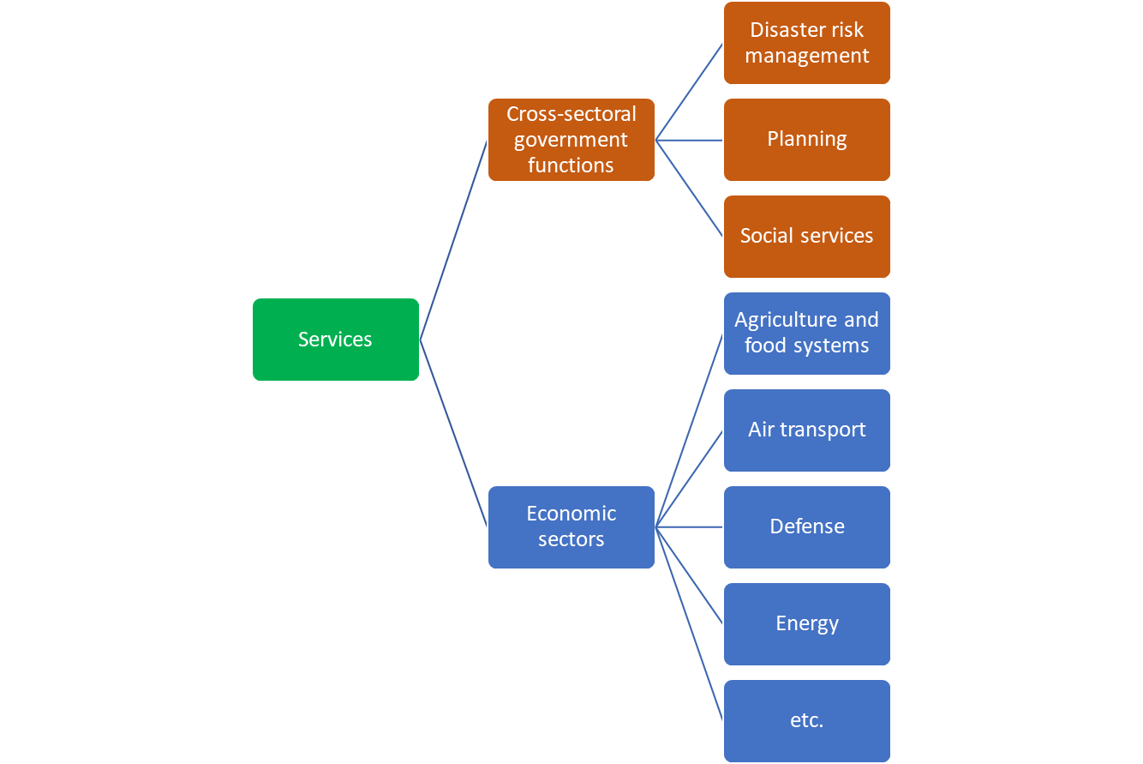
Figure 5.1 – Services to Cross-Sectoral Government Functions and Economic Sectors

5.1 Services to Cross-Sectoral Government Functions

There are at least three important cross-sectoral government functions that can better achieve their objectives and mandate with high-quality services: disaster risk management, planning, and social services. This list is not intended to be comprehensive. Rather, it illustrates the importance for NMHSs to explore government functions beyond the more traditional sectoral agencies. These government functions are fundamental for the achievement of socio-economic benefits from services like those listed in Section 3 of this document.

5.1.1 Disaster Risk Management

Government agencies such as civil defense or emergency authorities are responsible for the guidance, coordination, and mobilization of national and sub-national agencies to prepare for and recover from disasters, many of them caused by hydrometeorological and climatic extreme events. Anthropogenic climate change is increasing the intensity and frequency of these disasters in many regions. Hence, adaptation and resilience planning are increasingly incorporated in disaster risk management activities.

The planning, preparedness, response, and recovery functions led by these cross-sectoral agencies require the coordination with a wide range of sectoral agencies – including infrastructure, agriculture, and water, among many others. They also coordinate their work with the private sector, non-governmental organizations, and communities to discharge their responsibilities.

Services are critical for preparedness for, responding to or recovering from a wide range of disasters that may occur due to storms, floods, droughts, forest fires, heatwaves, volcanic eruptions, accidental industrial releases, among others. The urgency of providing timely, reliable, authoritative data and information in fast-changing conditions is critical. The specific needs of these agencies require close coordination with the NMHSs, as discussed in the WMO Guidelines on Multi-hazard Impact-based Forecast and Warning Services. The NMHSs need to keep abreast of technological advances – in scientific development modeling and communications – to provide the best possible services. The support of WMO is strategic in this area.

5.1.2 Planning

Government agencies at the national and sub-national level have the responsibility for planning functions – including zoning, land use planning, spatial policies, regional development strategies and policies, to name a few.

These planning functions are particularly important in special geographical settings, such as coastal areas, small islands, or high mountain areas, that face important environmental challenges compounded by climate change impacts (including land and forest degradation, sea level rise, storm surges and glacier melting). The planning functions are also important for the positioning, design, and resilience of critical national infrastructure.

The planning functions require coordination, trade-offs, and multi-sectoral engagements with other sectoral agencies for effective policy making. Services are indispensable inputs to this process. A balanced socio-economic development, particularly of geographical areas with special climate change challenges, requires solid planning policies. The NMHSs through their dedicated services should make special efforts to provide the knowledge, intelligence and support needed for effective policy making, management decisions and, rules and regulations as it is illustrated in Figure 5.2.

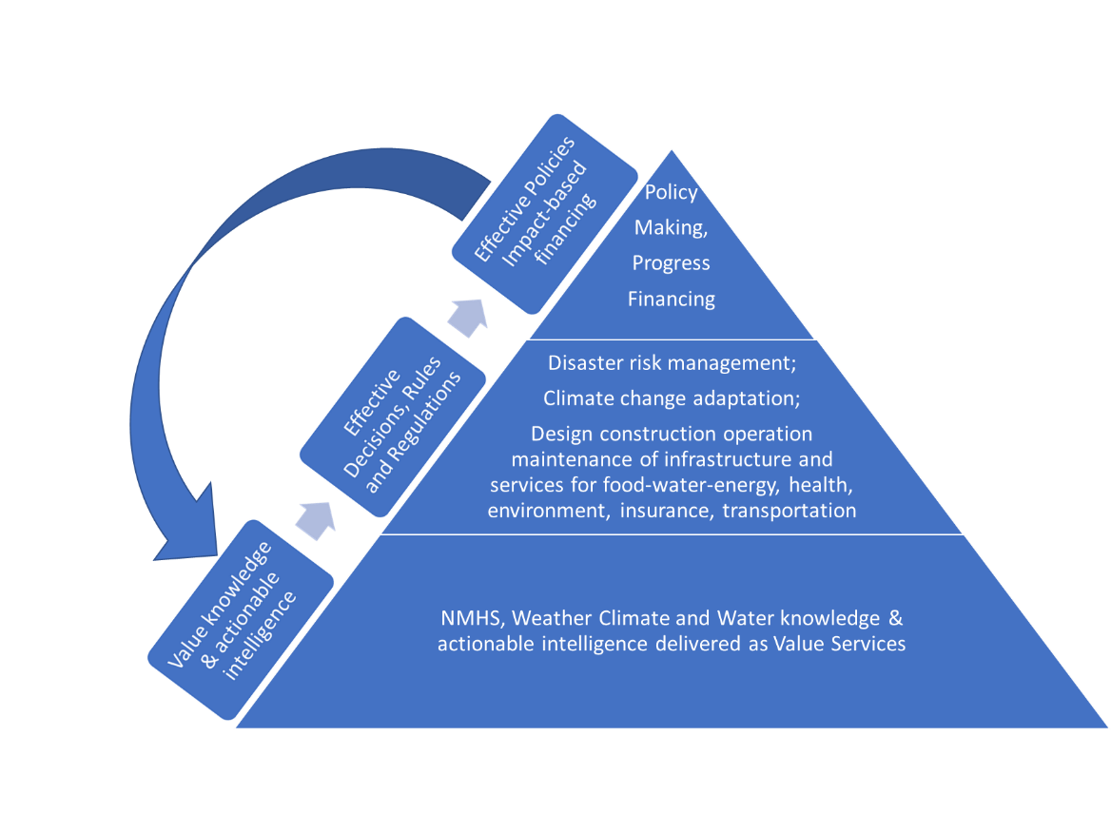
Figure 5.2 Planing Socio-economic development with dedicated weather, climate, water and environmental services.

5.1.3 Social Services

The achievement of the fourth category of socio-economic benefits associated with services presented in Section 3 (inclusive economic growth, poverty reduction, services to vulnerable and hard-to-reach communities) is dependent on effective social services agencies and NGOs, given their mandate and work with vulnerable and excluded communities.

The special impact of hydrometeorological extreme events on excludedcommunities requires targeted action that uses specific data, information and services designed to cater the needs and means of communication trusted by these groups. Building the partnership with social services agencies and adapting the services by NMHSs to make them more inclusive can help in a wide range of areas, from heatwaves impacting poor communities without access to cooling options, to droughts and related humanitarian crises leading to displacement of poor rural households and communities.

5.2 Services to Economic Sectors

The socio-economic benefits of the services described in Section 3 of this document touch, essentially, every sector of the economy and most stakeholders in society.

Keeping that broad perspective of possibilities in mind when undertaking strategic and planning processes to continuously improve services would be beneficial for NMHSs. Box 5.1 presents an indicative list of economic and social sectors that are related – to some degree – to possible services by NMHSs, either to prepare and recover from hazardous hydrometeorological and climatic events, to improve the economic performance and efficiency, to enhance the sustainability of operations and/or to incorporate projected climate change trends in medium- and long-term planning.

Some of these sectors have a decades-long relation with NMHSs and the WMO, such as aviation. Others are becoming increasingly interested in deepening the relation, such as health, given the growing health impacts of hydrometeorological extreme events and climate change – from heatwaves to air pollution due to forest fires, malnutrition caused by droughts, and changing impact areas for malaria and other vector diseases. Renewable energy systems – solar, inland/coastal wind, off-shore wind, hydro – depend for their planning, construction, operation, and maintenance on effective and reliable services.

Box 5.1 – Indicative List of Economic and Social Sectors Influenced by Weather, Climate, Hydrology, Water Resources, and the Environment
Agriculture and food systems
Air transport
Defense
Energy
Finance, insurance, and social protection financial instruments
Health
Humanitarian response/UN
Land transport and logistics
Manufacturing and construction
Maritime and inland waterways transport
Media
Natural resources (forestry, fisheries, landscapes) and ecosystem conservation
Recreational activities
Education
Research
Tourism
Urban
Water supply and water resources management

For each of these sectors, the range of possible services can be quite large, as illustrated in Box 5.2 for the aviation sector. This box shows that even for sectors with a long history of engagement with services, the continuously upgrading and renewal of those services is core to an effective and efficient operation of the sector.

Today, very few NMHSs globally cover all the services needed by all the economic and social sectors presented in Box 5.1. Prioritization and gradual expansion of sectors (and services within sectors), commensurate with mobilization of financial resources, are key for a successful NMHSs’ services improvement process.

Box 5.2 – An example of services evolution: WMO long-term planning for aeronautical meteorological hazards
In response to the continuous modernization process of air transport, WMO and its Members have developed a long-term planning approach for aeronautical meteorology that can be applied across several following thematic areas. For example, in aeronautical meteorological hazards science, the work ahead includes:
- Promotion, coordination and advocacy of scientific and technological research and innovation to improve the monitoring and forecasting of aviation hazards in support of improved impact-based decision-support services, through advances in:
  - Verification, validation and calibration tools and techniques;
  - Utilization of ground-based and aircraft-based observations;
  - Satellite and other remote sensing applications;
  - Numerical weather prediction modelling and nowcasting, machine-learning and artificial intelligence applications; and
  - Probabilistic and other forecasting techniques.
- Analysis of the climatological variation of the atmosphere (seasonal and interannual characteristics) resulting in changes in the location and/or intensity of jet streams, aviation hazards such as icing, turbulence and convection, and extreme weather events downscaled to the local level where required;
- Analysis of the impact of climatological variation of the atmosphere on:
  - airport operations and airspace management/optimization; and
  - airframe design.

5.3 The Services Value Cycle, its Stakeholders, and Roles

As NMHSs embark on a service delivery improvement process, it is important to consider the numerous stakeholders that may be involved. Many actors and relations are part of the process from weather, climate, hydrological, and related environmental data, and information, all the way to value generation activities. Figure 5.3 shows a simplified version of the service value cycle.
In the services value cycle, there are many stakeholders that conceive, create, co-create, develop, upgrade, leverage, disseminate, receive, interpret, and use those services. Figure 5.3 also emphasizes the important role of public-private engagement and partnerships in the communication, perception, agency, and capacity to interpret and make informed decisions, behaviors, biases, and, in the end, decisions and actions taken by stakeholders. Through this cycle, the services are transformed into outcomes and ultimately the many socio-economic benefits described in Section 3 of this document. Feedback from users, and evaluation of the users’ actions, outcomes, and benefits need to be brought back to the beginning of the cycle to influence the modification, upgrade, re-design, or retirement of services in a process of continuous improvement. The prioritization step should be guided by the strategic value of the service, i.e., the socio-economic benefits, the availability of resources and, when multiple service improvement opportunities are evaluated, an asymmetrical benefit/cost ratio.

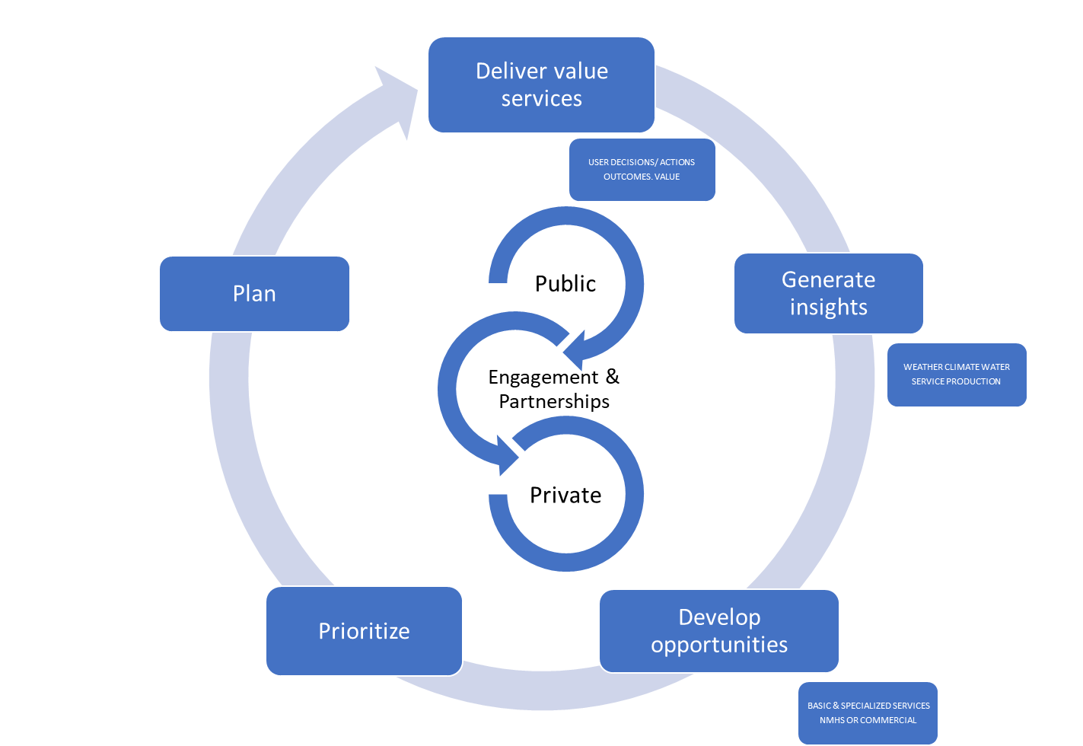
Figure 5.3 – Simplified Schematic of the Services Value Cycle

To aid in the services improvement journey of NMHSs, it is useful to classify the specific roles of the different stakeholders participating in public-private engament (PPE)and partnerships. Figure 5.4 shows four categories of stakeholders:
- Decision makers (individual and institutional);
- Producers and co-creators of NMHS’s services, and developers of specialized services that build and expand the NMHS’s services;
- Funders; and
- Regulators.

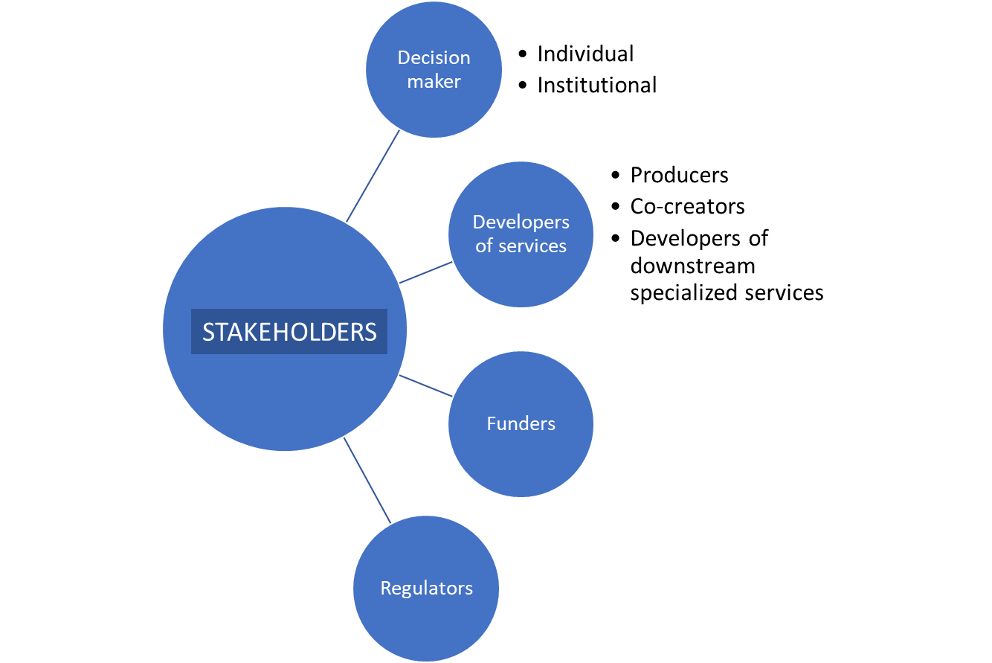
Figure 5.4 – Stakeholders in Services Value Cycle
The decision makers or end users – individuals, households, communities, private businesses, social entrepreneurs, civil society organizations, media, development partners or government agencies – must be at the core of any efforts to improve service delivery. PPE and partnerships are central to the services value cycle. Furthermore, to achieve the fourth category of socio-economic benefits presented in Section 3 – Inclusive economic growth, poverty reduction, services to vulnerable and hard-to-reach communities – the services should be designed with specific needs and channels preferred by vulnerable and excludedcommunities.
The decision makers or end users are not always passive recipients of NMHS’s services. Effective services need the users’ feedback to continuously improve their functionalities. Ideally, and where possible, users can be invited to be co-creators of upgraded or new services.
The private sector can play at least three roles in the services value cycle: (i) user of NMHS’s services; (ii) contracted developer or co-creator of NMHS’s services; (iii) developer of specialized services that build on NMHS’s data, information, or services, either as contractor to another party (for example, another government agency) or as part of an enterprise that sells these services to clients. The not-for-profit sector (social entrepreneurs, civil society organizations, or non-government organizations) can also play these three roles operating within their missions.
The Member government can play at least five key roles in the services value cycle:
(i) End-users of NMHS’s services: sectoral agencies at the national level, such as Ministries of Agriculture, Transport, Energy, Urban Development, Environment, Tourism, and other sectors, need accurate and reliable data, information, and services from NMHSs to fulfill their functions and design their policies. Sub-national entities, such as provinces, cities, or State-Owned Enterprises, are also beneficiaries of these high value services.
(ii) Intermediaries between the NMHSs and the final users: for example, Civil Defense or Disaster Risk Management agencies are responsible, in some countries, for the issuance of early warning alerts to the general population, based on the services provided by the NMHSs.
(iii) Co-creators or developers of specialized services that build on the NMHS’s services: sectoral agencies like the Ministry of Agriculture may develop (or commission the private sector to develop) sector-specific applications that combine data and information they own with the NMHS’s services for agency’s beneficiaries (farmers, herders, or agribusiness, for example).
(iv) Funders of NMHSs for the provision of services: the Ministry of Finance or Treasury (or the parent Ministry when the NMHS is a department) is a key stakeholder in the development of services. In the assignment of fiscal resources, the funding agency needs to understand the wide range of socio-economic benefits of the NMHS’s services.
(v) Regulator of NMHS’s services and other related services: the regulatory authority (which may be different from country to country) defines the assignment of the scope and responsibilities of different agencies in the delivery services, as well as related services. This assignment can lead, at times, to overlaps and sub-optimal production and delivery of services.
The NMHSs, in their services improvement journeys, need to map out, understand and interact with the various stakeholders and the different roles they may play in the services value cycle. This is a complex landscape that requires continuous analysis and building and sustaining of relationships. Section 6 provides a strategic roadmap that NMHSs and Members can consider for the improvement of service delivery.

6. A Strategic Roadmap for the Improvement of Services at the National Level

This section brings together the range of socio-economic benefits of services described in Section 3, the services to government agencies and economic sectors presented in Sections 5.1 and 5.2, and the users and stakeholders of the service delivery cycle discussed in Section 5.3 and proposes a Strategic Roadmap for the Members and their NMHSs (the “Strategic Roadmap”) for their journey to improve services at the national level.

The Strategic Roadmap should be seen only as a framework to be adapted to the specific institutional and regulatory conditions in each country, as well as the state of development of the NMHSs. The NMHSs that are beginning their journey in the development and improvement of services can start with a few elements and actions of the Strategic Roadmap. Advanced NMHSs may already have most of the Strategic Roadmap elements in place, and they will only have a few items to focus on. The Strategic Roadmap is comprehensive in its presentation to cover a variety of circumstances. Therefore, its use must be adapted to the specific national situation and priorities.

The Strategic Roadmap does not cover the important NMHS’s functions of observations, analysis, modeling, processing and data management, research and development, monitoring, and forecasting. Rather, it focuses on the services delivery cycle shown in Figure 5.3.
The 2011 WMO Strategy for Service Delivery had six strategic elements to guide NMHSs towards a service-oriented culture, as shown in Box 6.1 These strategic elements are relevant for the diverse services, and for ensuring equitable access to them.

Box 6.1: Strategic Elements to Move Towards a Service-Oriented Culture^{i}
- Evaluate user needs and decisions
- Link service development and delivery to user needs
- Evaluate and monitor service performance and outcomes
- Sustain improved service delivery
- Develop skills needed to sustain service delivery
- Share best practices and knowledge

The Strategy for Service Delivery builds upon the six strategic elements above and incorporates relevant trends, lessons learned, inputs from Members, and guidelines issued by WMO over the last decade. The strategic roadmap expands on the six elements in the following four ways:
- a deeper set of actions related to several key users categories and their common roles;
- a review of important Member State actions to consider in order to support services improvement, such as regulatory clarity, finance, and others;
- consideration of systems and platforms that have proven necessary for successful service improvement, including broader applications of the National Frameworks for Climate Services into the weather and water domains, management systems, quality management systems, and communications, among others; and
- additional considerations linked to the services cycle discussed in Section 5.3.

The Strategic Roadmap, and the organization of this section, is divided into seven main areas of work:

- Member Government’s Assignment of Responsibility for Services Provision
- NMHS Services strategic plan and organizational structure
- Services Assessment and Evaluation
- National Frameworks for Climate Services and Other Platforms
- Users, stakeholders, and partners
- NMHS operations and systems
- Services Delivery Improvement Plans
The structure of each area of work in the Strategic Roadmap for Services includes a description of the areas’ goal(s), its long-term outcome(s), and specific objectives. The structure of the Strategic Roadmap follows the structure of the WMO Strategic Plan and is connected to its three overarching priorities, and its long-term goals (1) and (4), as discussed in Section 2 of this document.

6.1 Member Government’s Assignment of Responsibility for Services Provision
The development and improvement of services, as well as specialized services, can have a wide range of stakeholders involved with different roles. In many countries, the lack of integrated approaches and clarity in the delineation of responsibilities among government agencies can hamper progress. In other situations, the unclear role of the private sector in the provision of services can lead to inefficiencies and sub-optimal solutions for all parties involved. Member Governments can therefore support the efficient delivery and improvement of services through the necessary regulatory clarity. Box 6.1 presents excerpts from the Geneva Declaration – 2019: Building Community for Weather, Climate, and Water Action that specifically provide guidance on this topic.
The regulatory clarity for service provision responsibilities should ensure the quality and integrity of the services, and protect public safety. Governments need to put in place legislative mandates to ensure regulatory mechanisms, authenticity, and accountability.
Box 6.2 – Excerpts from the Geneva Declaration – 2019: Building Community for Weather, Climate, and Water
We, the delegates from 160 Member States and Territories of the World Meteorological Organization (WMO), meeting in Geneva from 3 to 14 June 2019 at the Eighteenth World Meteorological Congress, having considered:
- that the global societal risks related to extreme weather, climate, water and other environmental events should be addressed through interdisciplinary and multi-sectoral partnerships, and
– that the expanding opportunities to use meteorological, climatological, hydrological and related environmental information and services to inform critical decisions can foster increased societal and structural resilience, and sustainable economic development;
declare as follows:
[…]
We CALL ON all Governments to give due consideration to the statements expressed in this
Declaration to:
- Foster structured dialogue between public, private and academic sectors at both national and international level;
- Safeguard and strengthen the authoritative voice of NMHSs for the issuance of warnings and relevant information to support critical decisions related to natural hazards and disaster risks, in collaboration with national disaster management authorities;
- Endeavour to put in place appropriate legislative and/or institutional arrangements to enable effective cross-sector partnerships and remove barriers to mutually beneficial cooperation and collaboration;
- Ensure the fulfilment of international commitments, including those stemming from the WMO Convention, for sustainable operation of the international infrastructure and exchange of required data;
- Promote uptake of and compliance with WMO standards and guidance by all stakeholders to enhance interoperability and the quality of data and products;
- Engage with civil society to extend the outreach to communities and citizens in particular to enhance public understanding and response to warnings of natural hazards;
- Encourage stakeholders from all sectors to facilitate international data sharing and make their data available as needed for essential public purposes, such as disaster risk reduction;

Action
Goal 1: Clear assignment of roles and responsibilities at the national and sub-national level for services, as well as clear intra and inter-institutional arrangements for specialized services. This assignment includes clear mechanisms for public-private engagements in different areas of service development and provision.
Long-term Outcome 1.1: A wide range of high-quality services are provided to all society stakeholders, thanks to the clarity in institutional responsibilities.
Long-term Outcome 1.2: Cross-sectoral services – including impact-based forecasting – are seamlessly produced and shared through efficient and collaborative inter-agency arrangements and public-private engagements, as applicable. In addition, clear mandated roles of agencies for providing as well as using services, in dealing with weather, climate, water and related environmental hazards are in place.
To achieve the proposed goal and long-term outcomes, the following four steps are proposed for consideration by the Member Government:
1) To make services more efficient and effective, the Member Government may consider mapping the existing services provided in the country; and identify overlaps, gaps, and unclear areas of responsibility.
2) The Member Government may review options for synergies and clear delineation of responsibilities for services provision by different agencies.
3) Member Government may consider formalizing or clarifying the initial assignment of services delivery responsibility among agencies.
4) As part of the periodic review, refinement, and improvement of assignment of responsibilities, the Member Government may consider:
- using the National Framework for Climate Services, strategic planning for NMHSs, or similar platforms (as described in Section 6.4);
- periodically evaluating opportunities for engagement of the private and not-for-profit sector in certain services, extensions, and enhancement (which may require updating of the regulatory frameworks); and
- linking those decisions to the corresponding budget allocations to ensure the assigned agencies can achieve the services responsibilities assigned.

6.2 NMHS Services Strategic plan and organizational structure
The transformation of the NMHS into a service-oriented user-focused organization requires a clear strategic plan that management and staff can use to drive change, make operational choices, define priorities, and allocate resources. The preparation of a Services strategic plan (or the modification of the NMHSs strategic planto put services at its core) demands senior management buy in and leadership. More importantly, the translation of the strategic plan into management and operational systems and decisions may require an organizational structure reform and a cultural change driven by the top of the organization, potentially touching every corner of the institution
Goal 2: The NMHS has a strategic plan and organizational structure that embeds and puts user-focused, user-driven services at its core
Long-term Outcome 2.1: The NMHS strategic plan , with services at its core, is continuously applied in its multi-year and annual work programmes, budget and staffing decisions, results framework, quality management system, and management decisions. The organizational structure empowers an effective and efficient execution of the strategic plan.
Only three objectives are proposed in this work area. However, they may be difficult to implement and will require senior NMHS management buy in and leadership to drive the process.
1) Prepare, review, or – as needed – update the services strategic plan and organizational structure.
2) Set up processes to ensure that the strategic plan and organizational structure drive the multi-year and annual work programmes, budget and staffing decisions, and results frameworks.
3) Reform organizational structure to empower the execution of the strategic plan

6.3 Services Assessment and Evaluation
It is advisable to begin the NMHS’s services improvement journey with an assessment and evaluation. However, this process should not be done just once but become part of the improvement cycle for the organization. The breadth and depth of the initial assessment can vary. For NMHSs beginning this journey with a small set of services, this may involve only a small number of user categories engaged, and/or limited institutional relations with other government agencies, and the exercise can be brief and focused. For advanced NMHSs, this process may already exist and the proposed objectives to achieve the goal and long-term outcome may help identify additional areas in the following assessment and evaluation cycle. For advanced NMHSs, the services assessment and evaluation could be performed in an integrated manner across: (i) institutional, infrastructure and service delivery aspects; and (ii) all the dimensions of services provided across weather, hydrology, climate, marine, cryosphere, and related environmental areas.
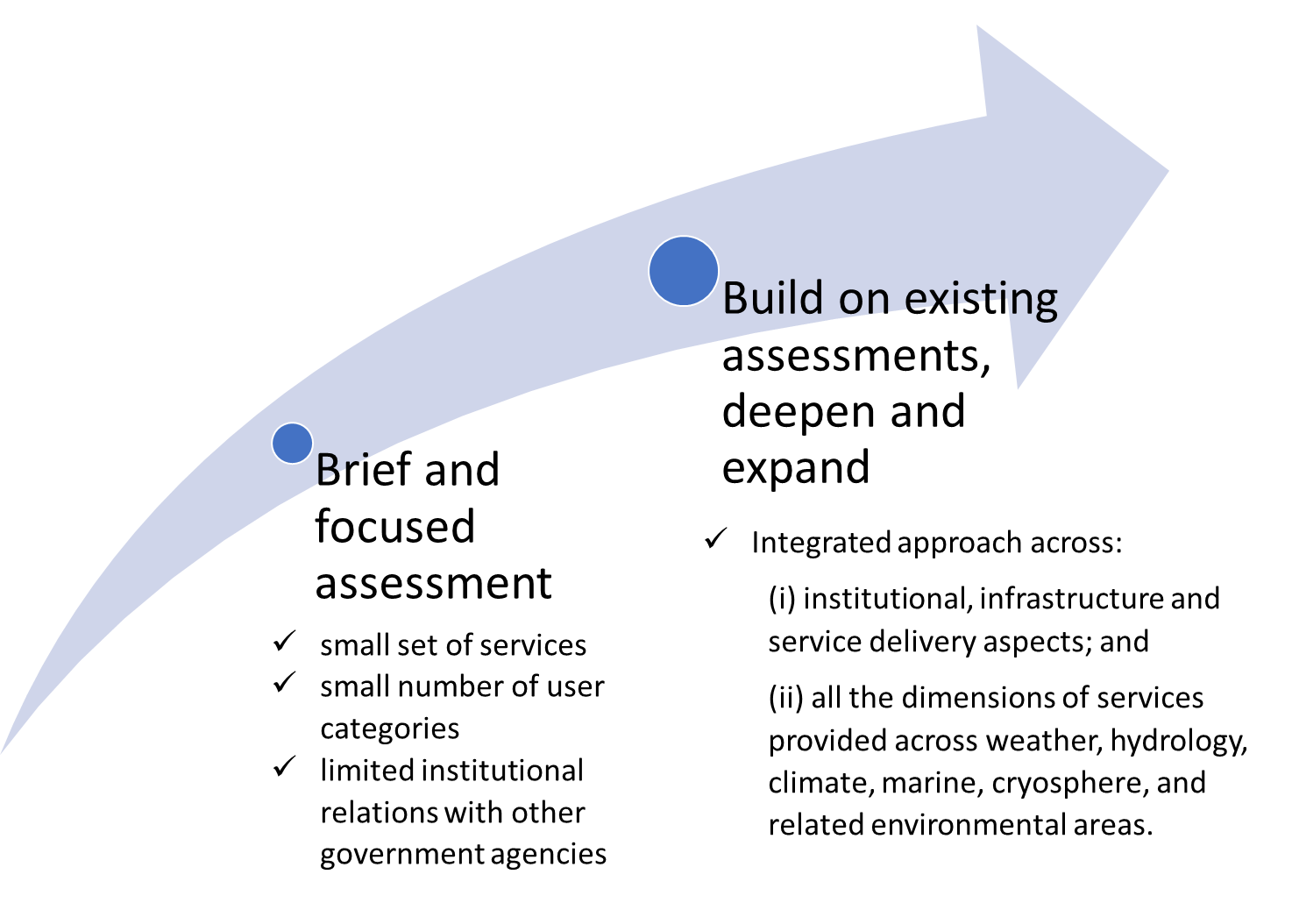
Figure 6.1 – Targeted Services Assessment and Evaluation Commensurate with NMHS Capacity
Goal 3: The NMHS has a periodic process to assess and evaluate its services, its relations with users and partners, and its systems. This periodic Services Assessment and Evaluation process allows the organization to identify gaps, priorities, and opportunities
Long-term Outcome 3.1: The periodic Services Assessment and Evaluation and the Services Delivery Improvement Program (presented in Section 6.7) lead to a continuous expansion and betterment of services that reach all users – broadly defined - who, in turn, can access, understand, and make informed choices based on the NMHS and related services.
The objectives of the proposed steps for this area of work are organized into those for the first iteration, and those for subsequent cycles:
1) For the first iteration of the Services Assessment and Evaluation, undertake an initial review of:
- NMHS’s services;
- users of these services;
- partners (for delivery, outreach, co-creation, and upgrade/research/development including through contracting);
- multi-stakeholder platforms for services; and
- a SWOT analysis of NMHS’s services and systems (specifically including a review of NMHS’s capacity and capability).
2) In subsequent iterations, evaluate progress, achievements, and areas for improvement of the Services Delivery Implementation Program’s activities, deliverables, and targets to set the basis for a new cycle of assessments and actions plans to be prepared in platforms, clients, and systems (see Sections 6.4-6).

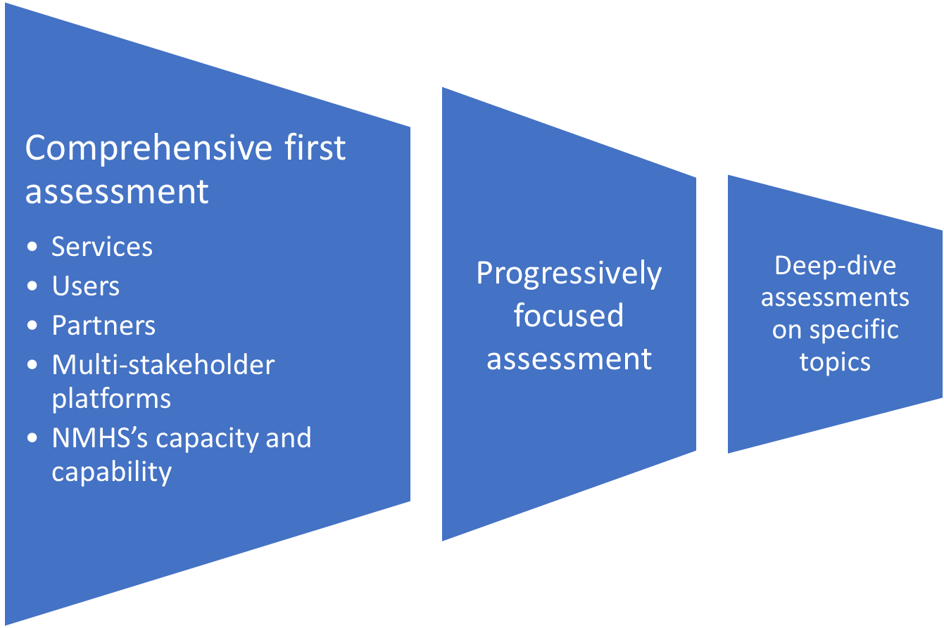
Figure 6.2 – Focus Areas of Services Assessment and Evaluation Iterations

6.4. National Frameworks for Climate Services and Other Platforms
The Global Framework for Climate Services (GFCS) has been established by a High-Level Declaration at the World Climate Conference-3 in 2009 to strengthen the production, availability, delivery, and application of science-based climate prediction and services. The initial focus of the GFCS has been on the five priority areas of water, health, agriculture and food security, disaster risk reduction (DRR) and energy.
The success of GFCS implementation depends on the establishment of similar frameworks at the regional and national levels to enable the coordination and collaboration mechanisms needed to identify gaps, needs and priorities in the various GFCS components, and to support the development and application of climate services. The publication ‘Step-by-step Guidelines for Establishing a National Framework for Climate Services’ (WMO-No. 1206) is a centerpiece for this work area.
At its 75th session, the WMO Executive Council reaffirmed the relevance of the GFCS Implementation Plan as a reference for guiding the implementation of the pillars and priority areas and also adopted a strategy and measures to Enhance the Visibility, Effectiveness and Implementation of GFCS. The strategy articulates two principal areas of strategic focus. The first of these aims at improved articulation of end-use demand for climate services, including through co-identification and co-development of tailored products and services with user stakeholders, with more rigorous and systematic documentation of associated socioeconomic benefits. The second aims to strengthen operational weather, water, climate and environmental systems and services on sub-regional scales, to increase Member access, and capacity to add value, to global and regional climate-relevant data and products. The areas of strategic realignment complement the focus which predominated during the phase of GFCS implementation which is now ending — namely, what should be implemented — with an increased focus on how GFCS should be implemented. This realignment can be realized through a set of interconnected processes, or building blocks, all of which are already established and on-going, climate priorities identification, climate services gaps and needs assessment, implementation support, quality management systems, climate policy and finance support.
Full details to be found in the published document, as per Executive Council request.
In addition to a National Framework for Climate Services (NFCS), a country may have other platforms of relevance to the delivery and improvement of NMHS’s services. For example, a sectoral ministry – such as agriculture or tourism – may have coordination platforms for planning and policies of the sector. These coordination platforms sometimes include development partners in emerging economies and developing countries and play an important role for the financing of the sector. The engagement of the NMHSs in these platforms can be an effective means to promote the use of services in the sector agency programmes and policies.
Furthermore, a country may be engaged or may wish to participate in regional platforms and mechanisms that provide services, for example multi-country river basin commissions that work on flood forecasting and early warning systems.
Goal 4: Well-functioning coordination platform(s) – such as the NFCS – are established to identify user needs, bring the providers and users of services together, develop capacity for generating and using services, and build services targeted to support all types of decision-makers in using such services for enhanced socio-economic and environmental benefits.
Long-term Outcome 4.1: Enhanced quality and effectiveness -through reduced institutional overlap and increased stakeholder coordination - of NMHSs and related services that benefit all users and lead to significant socio-economic and environmental benefits.
Long-term Outcome 4.2: Enhanced and broad recognition of the value provided by the NMHSs to society through its data, information, and services.
The publication WMO-No. 1206 presents a detailed step-by-step roadmap for the development and functioning of the NFCS. The reader is referred to that publication for greater details. A summary of the most salient recommendations follows:
1) Assess the baseline on climate services in the country, by answering the following questions:
- What are the capacities of the relevant institutions in a country regarding the five GFCS pillars?
- What is the country’s state of readiness to implement an NFCS?
- Which actors make up the national cycle for climate services, that is, who are the key stakeholders in the cycle linking climate knowledge with action on the ground (users/ providers/co-producers/communicators/boundary organizations/enablers/partners)?
- What climate services are currently being provided? What are the needs? And what gaps exist in climate service delivery?
2) Organize a national stakeholder consultation workshop on climate services to bring together all identified key stakeholders. The consultation workshop should be designed to identify the gaps and key elements for development of a national strategic plan and an action plan for the NFCS in the following step.
3) Develop, endorse, and launch a national strategic plan and action plan for the NFCS. The national strategic plan should have an annexed action plan detailing costs and timelines for delivering the NFCS and improving climate services delivery nationwide.
The WMO-No. 1206 recommends including the risks that may influence efforts to improve climate services in the national strategic plan, as well as a monitoring, evaluation, and reporting process. Finally, it is recommended to convene a high-level meeting with all national stakeholders to endorse the national strategic plan and action plan to be implemented across scales including at lower levels.

6.5. Users, Stakeholders, and Partners
This section is organized in four parts by grouping the goals, long-term outcomes, and steps for each category of user, stakeholder, and partner. The four categories are: (i) government and public institutions; (ii) the private sector; (iii) Not-for-profit organizations, including non-governmental organizations, civil society organizations, and social entrepreneurs, with special emphasis on organizations working with women, youth, and vulnerable and excluded communities; and (iv) the general public.
This section of the Strategic Roadmap has a different set of goals, long-term outcomes, and steps for each category of stakeholder to reflect the diverse roles they can take in the service delivery cycle (as discussed in Section 5). This detailed presentation is also a reflection of the importance and centrality of users for the NMHSs services.

6.5.1. Government and Public Institutions
Government agencies and other public institutions (State-owned enterprises, research centers, and independent bodies, among others) are key stakeholders – both as users, intermediaries, and distributors of NMHS’s services, and co-creators or developers of specialized services based on NMHS’s services. These different roles require diverse approaches and partnerships.
It is very important for Member Governments to provide the clarity and delineation of roles and responsibilities between agencies working on sectors closely related to services (for example, agencies in charge of irrigation and water resources management, or responsible for the environment at large). While this process may take time as structures, roles, and responsibilities adjust, it is nevertheless critical for more effective services and timely decision support. The delineation of roles and responsibilities of individual agencies does not preclude but facilitate collaboration. The parameters for such collaboration are part of the clarification and delineation process, as the Geneva Declaration-2019 clearly calls for.
The two goals in this area of work refer to the different ways in which the government and public institutions work with the NMHSs, either as co-creator or developer of complementary series, or as direct user of the NMHS’s services. Specifically:
Goal 5.1: Clear and effective inter-institutional arrangements are in place for data sharing, inter-operability of systems, leverage of NMHS’s services, and co-design of new services based on the clear arrangements set up by the Member Government.
Goal 5.2: Clear and effective institutional relations are established with government agencies and academic institutions whose mission and functions can benefit from NMHS’s services.
Long-term Outcome 5.1: Government agencies at the national and sub-national level (as well as their extension services) can access and use the NMHS’s services relevant for their functions, and – as appropriate - to develop their own specialized services and/or co-produce joint services with the NMHSs.
Based on the Member Government’s assignment of responsibilities to various government agencies for services provision (both standard and specialized services), the following steps define a roadmap to achieve the above goals and long-term outcome:
1) Define specific engagement frameworks with the above agencies, including:
- formalization of relation through a MoU or cooperation agreement that defines data sharing, systems inter-operability, services coordination and leverage, synergies and information sharing during services development and improvement, co-development, results, and monitoring and evaluation, among others.
- implementation, update, and improvement of the engagement frameworks between NMHSs and other government agencies and their extension services, based on lessons from the agreement evaluation and results achieved.
2) Engage with other government agencies at the national and sub-national level, including State-Owned Enterprises (SOEs) and academic institutions, that can benefit from the NMHS’s services through:
- Identification and prioritization of government agencies for consultations
- Prioritized engagement with a selective group of agencies to promote use of NMHS’s services, explore specific extensions or upgrades of these services, and identify possible co-creation of specialized services. An important area of engagement would be impact-based forecast and warning services (IBFWS) to support decision making where the NMHS data and information can be combined with ancillary data and information from other Government agencies, universities, research institutions.
- Monitor results and gather feedback from the engaged government agencies on NMHS’s services to continuously improve, expand, or retire them.
3) Objectives (1) and (2) can be undertaken through the National Framework for Climate Services or related platforms, as presented in Section 6.4.
4) Extract lessons, gather evidence on benefits from NMHS’s services for other institutional partners; systematically share this information with NMHS funders; and share knowledge gained with peer NMHS, and other stakeholders such as development finance institutions, local or regional governments, among others.

6.5.2. Private Sector
As discussed in Section 5, the private sector can have very diverse roles in the Services Value Cycle (Figure 5.1). Furthermore, these roles can evolve by building trust and understanding between the parties, by strengthening the regulatory framework for public-private engagements, and by finding the right balance between the public and the private sector’s roles. Regardless, the role of NMHSs as the national authority on matters related to quality and integrity of data, information and services in the areas designated by the Member Government is central to the good operation and performance of the overall system.
This work area of the Strategy Roadmap is organized following the various roles that the private sector can take. Not all roles are applicable in every country. Some roles may be more prominent at a given time. The roles are expected to evolve with time, as well as the specificity of the steps to achieve the goals and long-term outcomes.
Goal 5.3: The NMHS has productive and effective arrangements with the private sector in three possible areas: (i) private enterprises are able to access and use NMHS’s and related services to improve their operations; (ii) specialized private enterprises are able to leverage the NMHS data, information, and services to develop added-value services under a clear regulatory framework that ensures the quality of those services; and (iii) specialized private enterprises co-develop services with the NMHS under a clear Public-Private Engagement (PPE) arrangement.
Goal 5.4: Use of NMHS’s services by private enterprises leads to higher productivity, higher climate resilience, additional user-specified services, extended dissemination systems and reach, and reduced losses due to extreme hydrometeorological and climatic events, and these benefits are recognized and valued by the private sector.
Long-term Outcome 5.2: Added-value services developed by private enterprises (or co-developed with NMHS) leverage further the NMHS’s data, information, and services for greater socio-economic and environmental benefits.
The proposed steps in this work area are organized according to the possible roles of the private sector. Specifically:
1) For private enterprises as users of NMHS’s services:
- Assess existing NMHS’s services provided to private enterprises.
- Collect feedback from private enterprises using NMHS’s services through the Communications program (Section 6.6.1).
- As part of the Services Delivery Improvement Plan, progressively identify specific services needs of private enterprises; evaluate ways to serve those needs (through upgraded services or new services); define approach to develop the upgraded or new services; launch, promote, gather feedback, evaluate, and improve these services to private enterprises.
2) For private enterprises as contractors to NMHSs to develop or co-develop new or upgraded services:
- As part of the Services Delivery Improvement Plan, identify services upgrades, services extensions, or specialized services that the private sector can deliver cost-effectively.
- Procure these services using transparent competitive selections in line with national regulations; launch services, gather feedback, and improve them.
- Extract lessons from engagement with private sector for provision of services to improve later procurement processes.
3) For private enterprises as independent developer of specialized services:
- Develop, with the Member national government, the necessary regulatory framework to ensure quality of services, open data considerations, and – as appropriate – financial payments.
- Monitor and regulate those dimensions of service provision as stipulated in the regulatory framework; extract lessons of experience; and improve -as needed – the regulatory framework.
4) For all the above cases, monitor results, analyze cost-effectiveness and quality of services, gather lessons of experience, and share benefits achieved with NMHS’s Funders.
Figure 6. 3 – Areas of Work with Private Sector Based on Its Role in Service Value Cycle

6.5.3 Not-for-Profit Organizations
This work area focuses on non-governmental organizations (NGOs), civil society organizations (CSOs), social enterprises, and other not-for-profit groups. These organizations are important for the NMHS because of their mission focused on social and environmental public goods, as well as their work with women, youth, vulnerable communities, and special groups (persons with disabilities, indigenous peoples, communities in remote or lagging regions, etc.). Reaching these target groups directly may be difficult for the NMHSs. Building partnership with not-for-profit organizations that work with these groups can help the NMHSs understand the specific needs, preferred channels of communication, and capacity building areas to build the agency and raise the knowledge so that they can make informed decisions and take actions in response to the NMHS’s services.
Goal 5.5: NMHS’s services are: (i) designed (or co-designed where appropriate) based on a clear understanding of the mission and needs of CSOs, NGOs, and social entrepreneurs working on the areas of environment, women, youth, vulnerable populations, and excluded groups; and (ii) used for decision and action by these organizations and the women, youth, vulnerable populations, and excluded groups they serve.
Long-term Outcome 5.3: The use of NMHS’s services by non-governmental organizations leads to: (i) a wide range of socio-economic benefits to the environment, women, youth, vulnerable populations, and excluded groups; and (ii) establishment of trusted communication partners to reach NMHS outputs to the grassroot levels and promote applications including capacity building.
The following steps can support the achievement of the goal and long-term outcome for this work area. It is important to note that building trust and relations with not-for-profit organizations may take time and specific staff skills in the NMHSs. Nevertheless, the socio-economic benefits of reaching these target groups can be immense. Specifically, the steps proposed are:
1) Identify and prioritize through initial consultations a group of CSOs, NGOs, and/or social entrepreneurs with large reach or membership in the areas of environment, women, youth, and/or vulnerable communities.
2) Prioritize the engagement with a selected group of these organizations to promote use of NMHS’s services among target groups, explore specific extensions or upgrades of these services to better respond to the needs of target groups, and identify possible co-creation of specialized services.
3) As part of this engagement: identify special needs, preferred channels and means of communication, and other characteristics to ensure NMHS’s services are easily accessed by target groups, while ensuring that QA/QC aspects of these services are not inadvertently compromised. In addition, build the capacity and agency of the target groups to access and use the NMHS’s services.
4) Monitor results and gather feedback from the non-governmental partners and the target groups on the NMHS’s services to continuously improve, expand, or phase out withdrawn elements.
5) Extract lessons, gather evidence on benefits from NMHS’s services on the environment, women, youth, and vulnerable populations; systematically share this information with NMHS’s funders; and share knowledge gained with peer NMHSs.
6) Connect and bring the engaged non-governmental partners to the National Framework for Climate Services or related platforms, as presented in Section 6.4.

6.5.4. The General Public
Basically, all NMHSs provide services to the general public. Therefore, this is a work area where the NMHSs can make substantial progress, with a focused effort, in changing the image of the organization and demonstrating the transformation towards a service-oriented user-centric agency.
Goal 5.6: NMHS’s services are designed based on a clear understanding of the needs, desires, and feedback of citizens, and these services are used for decision and action.
Long-term Outcome 5.4: The use of NMHS’s services by the general public leads to: (i) a wide range of socio-economic benefits to individuals and households; and (ii) recognition of these benefits by society in general.
The steps proposed to reach the goal and long-term outcome for this work area correspond to the standard cycle of services design, feedback, and improvement. However, for NMHSs that are beginning the services improvement journey, this Strategic Roadmap proposes the launching of a general public services renewal program design to upgrade the profile of the NMHS as a 21st century organization that listens and serves the general public. Specifically, the steps proposed are:
1) Assess existing NMHS’s services provided to the general public.
2) Collect public feedback through Communications programme (Section 5.6.1), if available.
3) Design and launch a general public services renewal programme.
4) As part of the Services Delivery Improvement Plan (Section 5.7), progressively identify specific services needs of the general public; evaluate ways to serve those needs (through upgraded services or new services); define approach to develop upgraded or new services; launch, promote, gather feedback, evaluate, and improve these services to the general public.

6.6. NMHS’s Operations and Systems

Over the last decade since the 2011 WMO Strategy for Service Delivery, the global experience has shown that the success of service improvement programmes depends on a variety of NMHS’s organizational factors and systems. This section reviews in detail the following operations and systems with the perspective of service provision and improvement:

- Communications and user experience
- Competencies, skills, human resources, management systems
- National, regional, and international cooperation
- Special studies
- Quality management systems (including monitoring and evaluation)
- Financial Sustainability
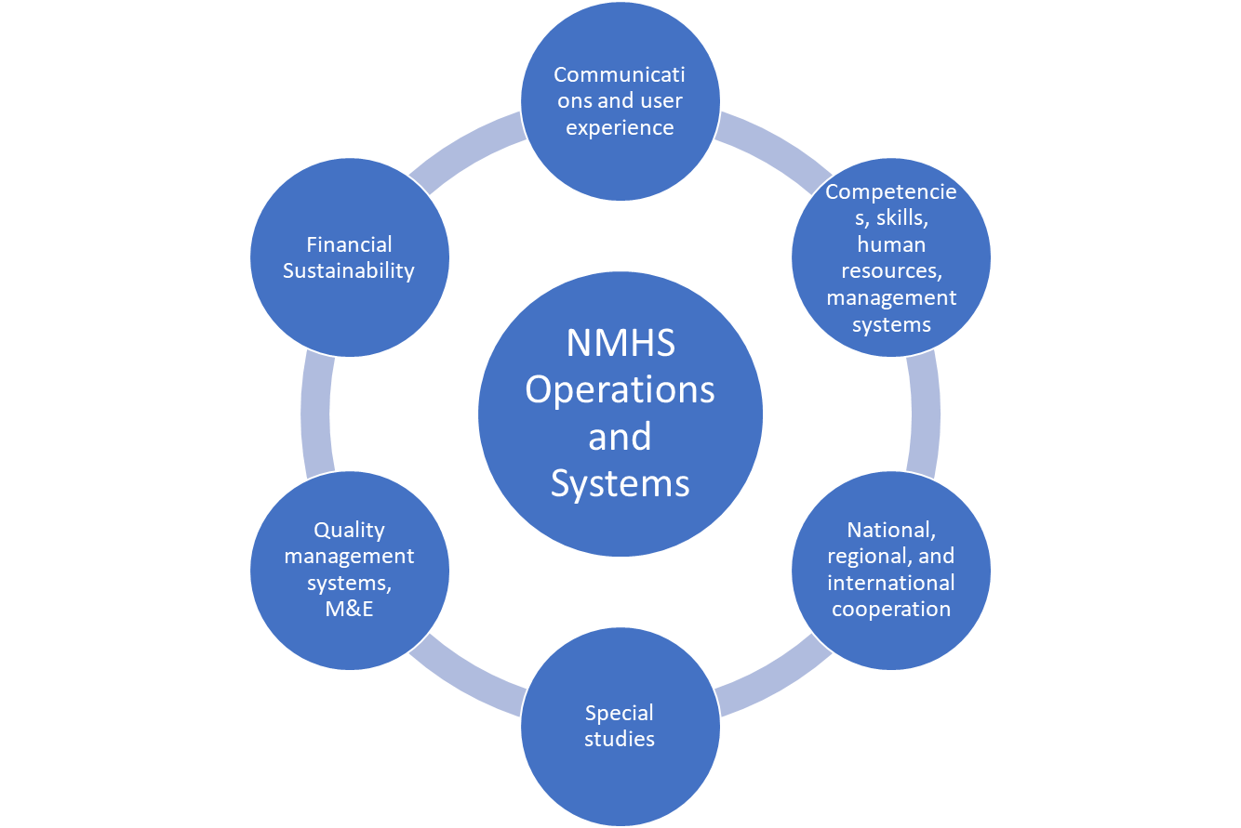
Figure 6.4 – NMHS’s Operations and Systems

6.6.1 Communications and user experience
Most NMHSs maintain a relationship with the national media as a channel of communication with the general public on weather services, and – at times – climate, hydrologic, and other environmental services. This relationship, while important, is not sufficient for the NMHSs to achieve its full potential as a service delivery organization. This work area focuses on practical steps to transform the NMHS into an organization that listens and responds to the users’ feedback and requests. This work area also discusses practical steps to raise the profile of the NMHS in the eyes of users and funders to help mobilize the financial resources needed to deliver and improve its services.
This work area also focuses on the user experience, namely the ease and simplicity that users encounter when they approach the NMHS to look for data, products, and services. In many NMHSs, the internal organizational silos may make the navigation across different services and the understanding of the various NMHS’s service offerings difficult. A continuous organizational process to break internal silos and to reflect this seamless operation into the way users experience the NMHS’s services is critical to keep the organization on par with the best-in-class service providers.
Goal 6.1: The NMHS has an effective communication function that: (i) informs the media, citizens, government agencies, non-governmental organizations, and private enterprises about the NMHS’s services; (ii) facilitates access to NMHS’s services in a seamless user-friendly manner; (iii) receives feedback on the services; (iv) reaches vulnerable and hard-to-reach communities; (v) connects with National Disaster Management Authority and other Government agencies for coordinated and consistent messages on policy issues of mutual interest and/or responsibility; and (vi) educates users about the inherent uncertainty in NMHS products requiring informed risk management approaches to their specific uses.
Long-term Outcome 6.1: Informed citizens, private enterprises, vulnerable communities, and other stakeholders understand, use, and make decisions based on NMHS’s services thanks to its communications function and ease of access.
Long-term Outcome 6.2: Effective user feedback loops lead to a continuous process of NMHS’s service improvement in quality and ease of access.
The steps proposed for this work area are:
1) Design and implement a communications and user feedback program with specific messages to different target audiences and users. The user feedback program should be closely connected with the services improvement plan and quality assurance program to ensure the services improvement loop is closed leading to improved services.
2) Continuously improve ease of access, seamless interface, and inter-operability with diverse platforms preferred by users.
3) Establish, test through drills, and improve after events, communications protocols with Disaster Response and Management Agencies prior, during, and after hazardous hydrometeorological and climatic events that cause disasters.
4) Establish communications protocols with other Government agencies for coordinated and consistent messages on policy issues of mutual interest and/or responsibility.
5) Monitor results on the communications and user feedback program, ease of access initiatives, and various communications protocols to improve diverse aspects of NMHS’s services; share progress with NMHS’s funders; extract lessons and shared knowledge gained with peer NMHSs.

6.6.2. Competencies, Skills, Human Resources, Management Systems
The quality and effectiveness of the NMHS’s systems are as good as the staff and management systems of the organization. While the NMHS has many functions and responsibilities, it needs to hire, retain, plan for succession, and upskill staff and managers to become a service-oriented user-centric organization. In addition to excellent technical skills, the organization needs to have a wider range of skills and areas of expertise in its ranks, from service experience to communications, social sciences, and public-private engagements.
Goal 6.2: The NMHS has a clear competency framework, a fit-for-purpose human resources plan, competent staff with the needed skills, and effective management systems to fulfill the NMHS’s service-oriented mission
Long-term Outcome 6.3: The NMHS is recognized as a high-performing, agile, transparent, collaborative, and effective organization fit to deliver 21st century services responsive to all user needs leading to well understood socio-economic and environmental benefits
The WMO has a variety of guidance documents and guidelines to support NMHSs in this process, including competency frameworks, capacity building, and strategic planning. The general steps proposed for this work area are:
1) Develop competency framework for the NMHS in the services areas.
2) Prepare and implement a staffing and human resources plan (commensurate with budget availability and service requirements) needed to achieve the Services Delivery Improvement Plan (Section 6.7) and Quality Management Systems (Section 6.6.5). The plan should include an upskilling component for existing NMHS staff to stay abreast of technological and other trends impacting the evolution of the organization’s services.
3) Continuously improve management systems to oversee and lead the performance of the NMHS as a service-oriented and user-focused organization.

6.6.3 National, Regional, and International Cooperation
Every NMHS worldwide can provide lessons of service improvements and, at the same time, learn from experiences gained by peer NMHSs. The WMO has a unique role in the facilitation of exchange, curation, and dissemination of these lessons. Given the rapid change in diverse trends affecting NMHS’s services, as discussed in Section 4 of this document, the diverse experiences and innovations developed by NMHSs around the world are an invaluable resource to each other. This work area focuses on practical steps to improve the national, regional, and international cooperation on service delivery and improvement.
Furthermore, the cascading nature of global-to-regional-to-national-to-local information in weather and climate monitoring and prediction should be optimally integrated into the operational arrangements of NMHSs. This integration required strong national, regional and global cooperation.
Goal 6.3: The NMHS has an effective cooperation plan that includes: (i) two-way knowledge sharing with peers; and (ii) capacity building support (provided or received)
Long-term Outcome 6.4: NMHS’s services are:
(i) informed by global and regional lessons of experience from peer NMHS and WMO structures such as Regional Centers; and – as appropriate
(ii) enhanced by the capacity building support from more advanced NMHSs and the WMO.
The steps for this work area will have different emphasis depending on the capacity and experience of the NMHSs. However, even the most advanced NMHSs can learn from other peers, and they have a unique opportunity and responsibility to support the development of peers with less capacity and experience in the services area. The proposed steps for this work area are:
1) Prepare, implement, and upgrade a Knowledge Management plan that includes: (i) lesson capture from the NMHS’s services experience; (ii) active sharing of experience with peer NMHSs; and (iii) clear identification of challenges in the services area to help with the search of knowledge and experiences from peer NMHSs and the WMO.
2) Prepare, implement, and upgrade a capacity and skills building plan that includes both offers and requests from peer NMHSs and the WMO in the growth areas identified in the staffing and upskilling plan (Section 6.6.2).
3) Actively support the engagement of NMHS’s services staff in the capacity building and knowledge sharing opportunities offered by WMO structures and groups.

6.6.4 Special Studies for Horizon Scanning
The NMHS needs to stay abreast of the latest trends in services, understand specific needs of groups of users, collect information on impacts and benefits achieved thanks to its services, and a variety of other topics that can help the organization be efficient and innovative in the development of new services and the improvement of existing ones. This work area proposes the NMHS to identify topics for specific studies of direct relevance to its work on services. The number of studies will depend on the financial resources available, but even NMHSs in low-income countries may find resources from development partners if good topics for analysis are proposed to them.
Goal 6.4: The NMHS has a well-functioning system to commission studies that allows the organization to stay abreast of the latest developments and have up-to-date information for NMHS management to make the best strategic choices.
Long-term Outcome 6.5: The NMHS’s services are delivered with the best highly specialized information resulting in high quality delivery with greater benefits to users
For this work area, the Strategic Roadmap proposes two steps:
1) Periodically identify strategic and highly relevant topics to commission specialized studies. Engage with WMO and advanced peer NMHSs to identify these topics. Some examples include:
- assessment of socio-economic value of services;
- horizon-scanning exercises to identify next-generation technologies and applications that may be considered by the NMHSs;
- detailed impact studies of benefits to vulnerable communities; or
- research to determine better ways to deliver services to influence behavior change and better decisions by users.
2) Define a specific work program to identify follow-up actions based on the insights and recommendations from the commissioned special studies.

6.6.5 Quality Management Systems (Including Monitoring and Evaluation)
The WMO Guide to the Implementation of Quality Management Systems for National Meteorological and Hydrological Services and Other Relevant Service Providers (WMO-No. 1100) provide guidance to WMO Members on how to develop and implement a quality management system (QMS). This publication intends to further the WMO Quality Management Framework (WMO, 2016, Decision 76). This Guide details the steps required to obtain certification of compliance with the ISO standard ISO 9001:2015, Quality Management System.
While the publication is focused on NMHSs, it is also a useful guide for other service providers. A Quality Management System is fundamental to enhance the quality of NMHS’s activities including streamlining and optimizing the processes and procedures applied and the products and services provided.
This work area incorporates the recommendations and proposed steps in the WMO Guide for Quality Management Systems. The reader is referred to that publication for further details.
Goal 6.5: The NMHS has a well-functioning and properly organized quality system comprising procedures, processes, and resources necessary to provide for the quality management of the NMHS’s services in accordance with the ISO 9000 series of quality assurance standards and certified by an accredited organization.
Long-term Outcome 6.6: The NMHS’s services are delivered with the quality characteristics specified to meet customers’ expectations and statutory/regulatory requirements
Following the guidance of WMO-1100 and the ISO standard ISO 9001:2015, the following steps are proposed:
  - Gain formal commitment and endorsement of top leadership/management
  - Select a professional quality manager, and a recognized training provider and/or where possible utilize the WMO QM mentor/twinning to provide introductory QM training
  - Conduct a gap analysis and an initial Quality Management Review Meeting
  - Commence work on rectifying identified gaps
  - Identify processes and develop procedures
  - Establish levels of customer satisfaction and tools to acquire and measure this information
  - Conduct internal audits to be followed by Quality Management Review Meetings
  - Select a third-party organization to perform the ISO 9001:2015 certification of compliance
  - Continue the cycle of internal audits and Quality Management Review Meeting

6.6.6. Financial Sustainability
In countries with fiscal constraints, NMHSs do not always receive the necessary resources from the central government budget to expand or improve its services, sometimes leading to a downward spiral of quality and trust in the services and the organization. In other countries, the central budget authority may not know enough about the multiple socio-economic and environmental benefits of the NMHS’s services provided. As a result, the financial resources provided to the NMHSs are sub-optimal.
This work area focuses on practical steps to enhance the cost-effectiveness of the NMHS’s operations, products, and services; demonstrate the socio-economic and environmental benefits of its services; and mobilize a variety of financial sources not only to provide high-quality services, but to continuously improve and expand those services for the benefit of its users.
Goal 6.6: The NMHS has adequate financial resources to cover efficient provision of their services through: (i) timely government transfers for public goods services; (ii) specific payment for private goods services by stakeholders benefiting from them; and (iii) mobilization – where appropriate – of project funding from development partners.
Long-term Outcome 6.7: Predictable financial sustainability of the NMHS that supports a gradual expansion of priority services, technological upgrades, and highly qualified staff,
The specific form and sequence of the proposed steps below for this work area will vary greatly according to the national circumstances, including budget processes, revenue sharing options with the private sector, active development partners able to provide financial support, among many other factors. Therefore, the following steps are described in general terms and the NMHS needs to prepare a well-designed plan of action in this work area.
1) Develop a strong financial management system for the NMHS that allows the organization to demonstrate efficiency of spending and cost-effectiveness of services provision.
2) Prepare annual (or multi-annual if allowed) budget estimates closely linked to the Services Delivery Improvement Program (see Section 6.7) and the Quality Management System (Section 6.6.5) with a clear plan to demonstrate cost-effectiveness and efficiency of operations.
3) Prepare full or simplified socio-economic benefit estimates, using the information obtained from the results reporting and estimates associated with new or expanded services, to substantiate budget requests.
4) Engage early and proactively with the budget authority to demonstrate results of NMHS’s services, benefits to users, and cost-effectiveness of NMHS’s services operations.
5) Continuously explore – as appropriate and as allowed – ways in which Public-Private Engagements could be a source of revenue for the NMHS, including through revenue sharing agreements.
6) Engage proactively with development partners to mobilize funding for capital projects related to NMHS’s services.
7) Explore, as part of engagements and partnerships in the National Framework for Climate Services (Section 6.4) or other platforms, opportunities for joint mobilization of funding with other government agencies and institutional partners.

6.7. Services Delivery Improvement Plan
The final step in this Strategic Roadmap builds the evidence and provides the analysis to start the improvement cycle again. The proposed Services Delivery Improvement Plan is a practical approach to compile the results of the monitoring and evaluation system (part of the quality management system), feedback from users through the two-way communications system, results from special studies commissioned, and specific actions identified for each of the users and partner categories.
To be effective, the Services Delivery Improvement Plan needs the highest level of managerial attention and leadership in the NMHS. The quality of these plans are also important elements in the mobilization of financial resources (from the central budget or from development partners). Finally, these plans are critical to provide clear directions and course corrections during their implementation period.
Goal 7: The NMHS has a periodic service delivery improvement cycle that leads to increasingly effective NMHS’s services (and specialized services) that are progressively identified, developed, expanded, and improved, in a way that allows these services to reach a growing number of government agencies, priority economic sectors, and vulnerable communities.
Long-term Outcome 7.1: All users – broadly defined - can access, understand, and make informed choices based on the NMHS and related services, leading to significant socio-economic and environmental benefits and a recognition of the value, impact, quality, and cost-effectiveness of the NMHS’s work.
The proposed steps for this work area are:
1) Based on the identified gaps, opportunities, and action plans for each of the users and partners categories (institutional, private, not-for-profit, and general public), and taking into account the capacity of the NMHS’s systems (on communications, human resources, managerial systems, and budget envelope), prepare a Services Delivery Improvement Plan (with a multi-year horizon and an annual work program) with specific activities, deliverable, and performance targets.
2) Prepare a monitoring and evaluation framework to measure progress in the implementation and results of the Services Delivery Improvement Plan. This framework will be a critical input for the Service Assessment and Evaluation (Section 6.3).
A summary of the strategic roadmap for the improvement of service delivery is presented in Table 6.1 and shows the prioritized areas of work in relation to the phases of the services value cycle to better îllustrate the continuous improvement processes and steps.

Table 6.1 Strategic roadmap for the improvement of service delivery 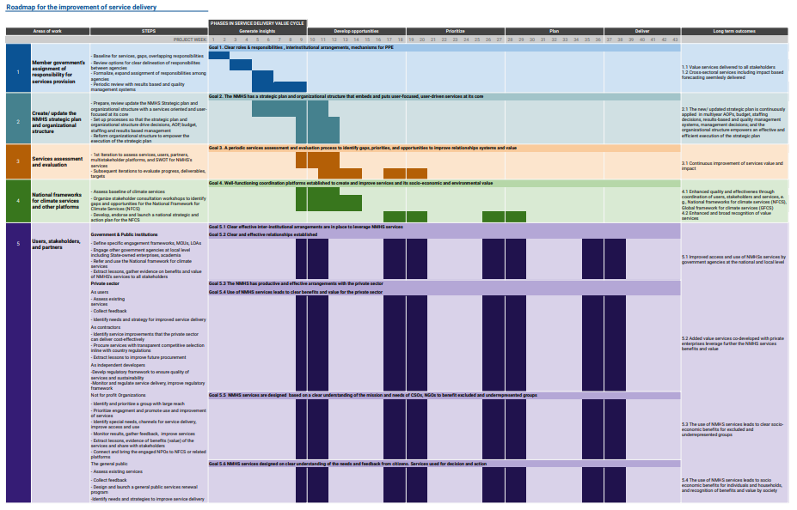
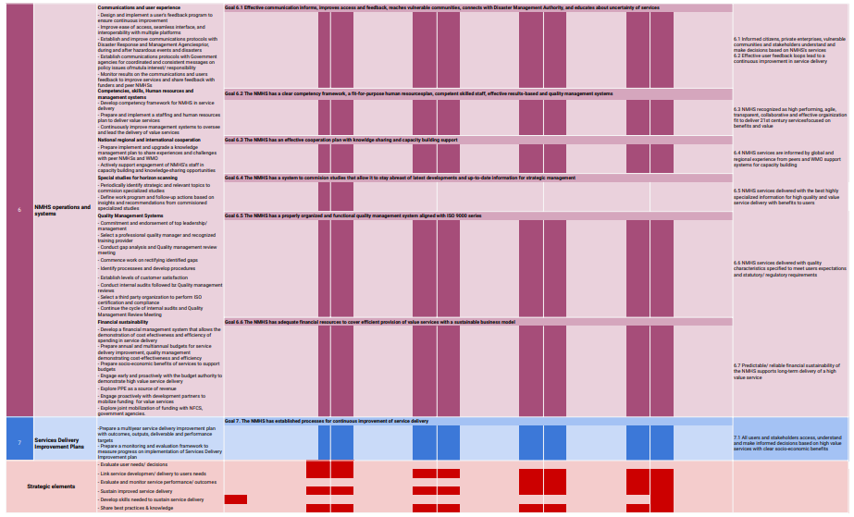

Table 6.1: Summary of Goals and Long-Term Outcomes of the Strategic Roadmap for NMHS Services Improvement
Section | Goal | Long-term outcome
1. Member Government’s Assignment of Responsibility for Services Provision | Clear assignment of roles and responsibilities at the national and sub-national level for services, as well as clear inter-institutional arrangements for derived and specialized services in various services of the economy (add explanatory footnote for second part). The assignment of roles and responsibilities includes those of the private sector, as discussed in Section 5.6. | A wide range of services are provided to all society stakeholders thanks to the clarity in institutional responsibilities. Cross-sectoral services – including impact-based forecasting – are seamlessly produced and shared through efficient and collaborative inter-agency arrangements and public-private partnerships, as applicable
2. NMHS Services Mission | The NMHS has an organizational mission statement that embeds and puts user-focused, user-driven services at its core | The NMHS mission, with services at its core, is continuously applied in in its multi-year and annual work programmes, budget and staffing decisions, results framework, quality management system, and management decisions.
3. Services Assessment and Evaluation | NMHS has a periodic process to assess and evaluate its services, users, partners, and systems that allows the organization to identify gaps, priorities, and opportunities | The periodic Services Assessment and Evaluation and the Services Delivery Improvement Program led to a continuous expansion and betterment of services that reach all users – broadly defined - who, in turn, can access, understand, and make informed choices based on the NMHS and related services.
4. National Frameworks for Climate Services and Other Platforms | Well-functioning coordination platform(s) – such as the National Framework for Climate Services – that identify user needs, bring the providers and users of services together, develop capacity for generating and using services, and build services targeted to support all types of decision-makers in using such services for enhanced socio-economic and environmental benefits. | Enhanced quality and effectiveness -through reduced institutional overlap and increased stakeholder coordination - of NMHS and related services that benefit all users and lead to significant socio-economic and environmental benefits.  Enhanced and broad recognition of the value provided by the NMHS to society through its data, information, and services.
5. Clients, stakeholders, and partners
5.1. Institutional relations | Clear and effective inter-institutional arrangements are in place for data sharing, inter-operability of systems, leverage of NMHS’s services, and co-design of new services based on the clear arrangements set up by the Member Government  Clear and effective institutional relations are established with government agencies and academic institutions whose mission and functions can benefit from NMHS’s services and which can expand and/or leverage NMHS’s services | Government agencies at the national and sub-national level can access and use the NMHS’s services relevant for their functions, including to develop their own specialized services and/or to co-produce joint services with the NMHS
5.2. Private sector | The NMHS has productive and effective arrangements with the private sector in three possible areas: (i) private enterprises are able to access and use NMHS and related services to improve their operations; (ii) specialized private enterprises are able to leverage the NMHS data, information, and services to develop added-value services under a clear regulatory framework that ensures the quality of those services; and (iii) specialized private enterprises co-develop services with the NMHS under a clear PPP arrangement. | Use of NMHS’s services by private enterprises leads to higher productivity, higher climate resilience, and reduced losses due to extreme hydrometeorological and climatic events, and these benefits are recognized and valued by the private sector.  Added-value services developed by private enterprises (or co-developed with NMHS) leverage further the NMHS data, information, and services for greater socio-economic and environmental benefits.
5.3 non-governmental organizations, with special emphasis on organizations working with women, youth, and vulnerable communities | NMHS’s services are: (i) designed (or co-designed where appropriate) based on a clear understanding of the mission and needs of CSOs, NGOs, and social entrepreneurs working on the areas of environment, women, youth, and vulnerable populations and (ii) used for decision and action by these organizations and the women, youth, and vulnerable populations they serve | The use of NMHS’s services by non-governmental organizations leads to: (i) a wide range of socio-economic benefits to the environment, women, youth, and vulnerable populations; and (ii) establishment of trusted communication partners to reach NMHS outputs to the grassroot levels and promote applications including capacity building.
5.4. The general public | NMHS’s services are designed based on a clear understanding of the needs, desires, and feedback of citizens, and these services are used for decision and action | The use of NMHS’s services by the general public leads to: (i) a wide range of socio-economic benefits to individuals and households; and (ii) recognition of these benefits by society in general.
6. NMHS operations and systems
6.1 Communications, and user experience | The NMHS has an effective two-way communication function that: (i) informs the media, citizens, government agencies, non-governmental organizations, and private enterprises about the NMHS’s services; (ii) facilitates access to NMHS’s services in a seamless user-friendly manner; (iii) receives feedback on the services; (iv) reaches vulnerable communities; (v) connects with Disaster Management agencies and other Government agencies for coordinated and consistent messages on policy issues of mutual interest and/or responsibility; and (vi) educates users about the inherent uncertainty in NMHS products requiring informed risk management approaches to their specific uses. | Informed citizens, private enterprises, vulnerable communities, and other stakeholders know about, use, and make choices based on NMHS’s services thanks to its communications function and ease of access.  Effective user feedback loops lead to a continuous process of NMHS service improvement in quality and ease of access.
6.2. Competencies, skills, human resources, management systems | The NMHS has a clear competency framework, a fit-for-purpose human resources plan, competent staff with the needed skills, and effective management systems to fulfill the NMHS service-oriented mission | The NMHS is recognized as a high-performing, agile, transparent, collaborative, and effective organization fit to deliver 21st century services responsive to all user needs leading to well understood socio-economic and environmental benefits
6.3 National, regional, and international cooperation | The NMHS has an effective cooperation plan that includes: (i) two-way knowledge sharing with peers; and (ii) capacity building support (provided or received) | NMHS’s services are: (i) informed by global and regional lessons of experience from peer NMHS and WMO structures such as Regional Centers; and – as appropriate - (ii) enhanced by the capacity building support from more advanced NMHS and WMO structures.
6.4 Special studies | The NMHS has a well-functioning system to commission studies that allows the organization to stay abreast of the latest developments and have up-to-date information for NMHS management to make the best strategic choices. | The NMHS’s services are delivered with the best highly specialized information resulting in high quality delivery with greater benefits to users
6.5 Quality management systems (including monitoring and evaluation) | The NMHS has a well-functioning and properly organized quality system comprising procedures, processes, and resources necessary to provide for the quality management of the NMHS’s services in accordance with the ISO 9000 series of quality assurance standards and certified by an approved organization. | The NMHS’s services are delivered with the quality characteristics specified to meet customers’ expectations and statutory/regulatory requirements
6.6. Financial Sustainability | The NMHS has adequate financial resources to cover efficient provision of their services through: (i) timely government transfers for public goods services; (ii) specific payment for private goods services by stakeholders benefiting from them; and (iii) mobilization – where appropriate – of project funding from development partners. | Predictable financial sustainability of NMHS that supports gradual expansion of priority services, technological upgrades, and high-caliber staff
7. Services Delivery Improvement Plans | The NMHS has a periodic service delivery improvement cycle that leads to an increasingly  effective NMHS’s services (and related services) that are progressively identified, developed, expanded, and improved, in a way that allows these services to reach a growing number of government agencies, priority economic sectors, and vulnerable communities. | All users – broadly defined - can access, understand, and make informed choices based on the NMHS and related services, leading to significant socio-economic and environmental benefits and a recognition of the value, impact, quality, and cost-effectiveness of the NMHS work.

7. WMO and Service Delivery
WMO provides a variety of support functions to NMHSs of relevance to the provision of services. Through its Technical Commissions, Research Board, Panels and other governance substructures, Programmes, Projects, and Regional Offices, as well as its public-private partnerships, WMO facilitates and coordinates the development and delivery of value services in the areas of weather, climate, and water. WMO assists Members with technology transfer, training for capacity development, collaboration on research and the provision of services. WMO also contributes to policy formulation in areas related to weather, climate, hydrology, and related environmental issues at national and international levels.

Most notably, the Commission for Weather, Climate, Water and Related Environmental Services & Applications (Services Commission) contributes to the development and implementation of globally harmonized weather, climate, water, ocean and environment related services and applications.

The Services Commission promotes mutually beneficial (win-win) public-private engagement and partnerships as the strategy for services and service delivery improvement. It also assists Members to apply:

- risk-based decision-making in support of disaster risk preparedness and reduction;
- a service-oriented culture; a strong user focus with ‘fit-for-purpose’ services;
- quality management in service delivery;
- standards for competence and qualification of personnel;
- accelerated uptake of advanced technology for service delivery; and
- systematic evaluation of socio-economic benefits and other relevant market-oriented evaluations of products and services.
WMO produces a variety of guidelines, best practices, and other documents related to services that provide critical support to NMHSs worldwide. These documents are constantly evolving, and a full list is provided in the WMO website.

Annex 1
Areas of the 2011 WMO Strategy for Service Delivery Relevant to the 2023 Strategy

The 2011 WMO Strategy for Service Delivery puts forward a robust framework for service delivery by National Meteorological and Hydrological Services (NMHSs). The goal of the 2011 WMO Strategy for Service Delivery – to help NMHSs raise their service delivery standards in the provision of products and services to users and other stakeholders – remains relevant and more urgent than ever. The four stages of a continuous, cyclical process for developing and delivering services defined by the 2011 WMO Strategy for Service Delivery have been helpful during the last decade. These four stages – user engagement and partnerships, service design and development, delivery, and evaluation and improvement – remain relevant and applicable.
The 2011 WMO Strategy for Service Delivery’s approach to considering the unique needs of Members from developed and developing countries has been a useful platform. The 2011 WMO Strategy for Service Delivery foresaw that, as users’ needs evolve, the capabilities of NMHSs and other stakeholders had to adapt over time. It called for Members to remain agile and ready to respond to these changes. It is in this spirit that the 2011 WMO Strategy for Service Delivery is being updated, namely, to reflect on the changes in users’ needs, the new science and technologies available, the evolving role of the private sector as provider of some services, and the evolving institutional capabilities of WMO in this area.
The 2011 Strategy defines services as a product or activity that meets the needs of a user or can be applied by a user. To be effective, services should be:
- Credible: for the user to confidently apply to decision-making
- Available and timely: on the time and space scales required by the user
- Dependable and reliable: delivered on time and according to the required user specification
- Usable: presented in user-specific formats so that the client can fully understand
- Useful: able to respond appropriately to user needs
- Expandable: applicable to different kinds of services
- Sustainable: affordable and consistent over time
- Responsive and flexible: adaptable to evolving user needs
- Authentic: guaranteed to be accepted by stakeholder in a given decision context
The 2011 Strategy describes a continuous cycle of four stages, which define the framework for service delivery, and identifies six elements that detail the activities required for high-quality service delivery.
The four stages of a continuous, cyclical process for developing and delivering services are updated as follows:
Process | WMO Strategy for service delivery 2023 | WMO strategy for service delivery 2011
1 | Generate insights | User engagement and developing partnerships
2 | Develop opportunities | Service design and development
3 | Prioritize | Delivery
4 | Plan | Evaluation and improvement
5 | Deliver value services

The six elements necessary for moving towards a more service-oriented culture are:
- Evaluate user needs and decisions
- Link service development and delivery to user needs
- Evaluate and monitor service performance and outcomes
- Sustain improved service delivery
- Develop skills needed to sustain service delivery
- Share best practices and knowledge
Finally, the 2011 Strategy recognizes that the degree of maturity and formality of service delivery among NMHSs varies significantly. Further, NMHSs operate differently due to a combination of factors. For example:
• Some NMHSs are completely government owned and offer services only to other government areas and the public. Some are fully privatized and offer commercial services. Many lie somewhere in between;
• Some NMHSs act as data suppliers to private forecast providers, while some undertake fully commercial operations in direct competition with these private organizations. Some play both roles;
• Some NMHSs use their own NWP models and forecasting and production systems. Others use those supplied by external organizations;
• Most NMHSs only provide services to their own country, but some may offer their services outside of national boundaries.
The bottom line is that a one-size-fits-all implementation approach will not be effective. Members need flexibility to develop their own unique approaches.

The Guide for Service Delivery is the first output under the Terms of Reference of SC-DRR (Res. 1 SERCOM-1) and the Strategy is referenced in the Terms of Reference of the SERCOM approved in annex 1 Res.7 Cg-18(2019).
In this document, specialized services are defined to be services that leverage the data, information, and services of the NMHS to provide additional services to different stakeholders in society. For example, a private company may produce tailored data or products to specific clients leveraging the NMHS’s services.
According to the WHO, stunting is the impaired growth and development that children experience from poor nutrition, repeated infection, and inadequate psychosocial stimulation.
Excluded groups are groups of citizens that confront diverse barriers in society. These barriers may include formal ones through the legal system, or the land and labor markets. They also include discriminatory attitudes or beliefs. The exclusion is often based on gender, age, location, occupation, race, ethnicity, religion, citizenship status, and/or disability, among other factors (World Bank. 2013. Inclusion Matters: The Foundation for Shared Prosperity).
Also called “disruptive technologies,” defined as innovations that significantly alter the way that consumers, industries, or businesses operate.
Examples of specialized services include tailored data, products, and information provided by private sector companies to respond to specific user needs, such as weather derivatives, pollen forecast, wave forecast for surfers, or irrigation advisories for farmers, to name a few.
Ancillary data and information refer in this document to domains that are related but go beyond weather, climate, hydrological, and related environmental data, and information. For example, soil, topographic, and crop data, among others, are needed for impact-based forecasting in the agriculture sector or for precision farming applications.
Water agencies includes all agencies related to the water sector - National Hydrological Services, the Water Management Authorities, plus irrigation agencies, hydropower agencies, etc.
Adapted from publication WMO-No. 1153.
Decision markers or end-users of services are broadly divided into two categories. First, “informed users,” who have some basic knowledge and/or understanding of the meteorology/climate. This category includes pilots, hydrologists, engineers, etc. Second, “uninformed users,” who have very limited knowledge and understanding. The design of services needs to take into consideration these two categories of decision makers or end-users.
See Step-by-step Guidelines for Establishing a National Framework for Climate Services, https://library.wmo.int/index.php?lvl=notice_display&id=20216#.Yp7t8KhBxxQ
See WMO Integrated Strategic Planning Handbook, https://library.wmo.int/index.php?lvl=notice_display&id=19709#.Yp7t5qhBxxQ
Including government agencies, private enterprises, not-for-profit organizations, communities, households, women, youth, and vulnerable groups
With special consideration of the characteristics of an “effective service” as described in WMO-1129: available, timely, dependable, reliable, usable, useful, expandable, sustainable, responsive, flexible, authentic, and credible.
With special attention to level of satisfaction and specific uses and benefits of the services
With special attention to National Framework for Climate Services
Including communications, cooperation, quality systems, human resources, finance, and management systems
Publication not available at the time of this document finalization and approval
National Climate Outlook Forums (NCOFs) and National Climate Forums (NCFs) can provide very effective platforms in this context.
WMO has published guidelines on Multi-hazard IBFWS (WMO-No 1150, Part I & Part II) to assist NMHSs and stakeholder agencies on implementation and strengthening of IBFWS.
The general public includes not only individuals and households, but also communities. NMHSs should provide public services in a coordinated fashion for overall societal benefit, and not view their role simply as an aggregation of services to individuals.
For example, in shared water resources such as transboundary rivers, lakes and aquifers.
The recent Climate Services Information System (CSIS) of the GFCS, and the Global Data Processing and Forecasting System (GDPFS) are leading examples of this cascading cooperation.
Including government agencies, private enterprises, not-for-profit organizations, communities, households, women, youth, and vulnerable groups
including decision-makers, policy makers, government agencies, civil society, vulnerable communities, the private sector, technical partners, researchers, sector experts, and development partners.
And other public agencies, research institutes, State-owned enterprises, etc.
With clear financial mechanisms authorized by the Member Government
Including: (i) reductions in losses of life, illnesses, and assets among vulnerable populations after extreme hydrometeorological events, and (ii) improvement in livelihoods and reduction of poverty among women, youth, and vulnerable communities.
Including not only the provision of services, but all the associated organizational costs
Other entities, such as the Regional Climate Centers or the private sector also develop products and deliver services. However, as most services are delivered at the country level, NMHSs have a particularly important role to play.
World Meteorological Organization, 2014: The WMO Strategy for Service Delivery and Its Implementation Plan (WMO-No. 1129), Geneva. Available at: https://library.wmo.int/index.php?lvl=notice_display&id=16002#.XVSQ65NKhTY
WMO Strategic Plan – https://library.wmo.int/index.php?lvl=notice_display&id=21525
World Meteorological Organization, 2021: Climate Indicators and Sustainable Development - Demonstrating the Interconnections (WMO-No. 1271), Geneva. Available at: https://library.wmo.int/?lvl=notice_display&id=21953#.Ypg1v-5By5c
World Meteorological Organization, 2015: Valuing Weather and Climate: Economic Assessment of Meteorological and Hydrological Services (WMO-No. 1153), Geneva. Available at: https://library.wmo.int/doc_num.php?explnum_id=3314
World Meteorological Organization, 2015: WMO Guidelines on Multi-hazard Impact-based Forecast and Warning Services (WMO-No. 1150), Geneva. Available at: https://library.wmo.int/index.php?lvl=notice_display&id=17257#.YsaZa2BBy5c
World Meteorological Organization, 2019: Geneva Declaration – 2019: Building Community for Weather, Climate and Water Actions, Geneva. Available at: https://library.wmo.int/index.php?lvl=notice_display&id=21763#.Ysa0PmBBy5e
World Meteorological Organization, 2018: Step-by-step Guidelines for Establishing a National Framework for Climate Services (WMO-No. 1206), Geneva. Available at: https://library.wmo.int/index.php?lvl=notice_display&id=20216#.Ypg2nO5By5c
World Meteorological Organization, 2019: Compendium of WMO Competency Frameworks (WMO-No. 1209), Geneva. Available at: https://library.wmo.int/index.php?lvl=notice_display&id=21607#.Ypg3Ce5By5c
World Meteorological Organization, 2019: Compendium of WMO Competency Frameworks (WMO-No. 1209), Geneva. Available at: https://library.wmo.int/index.php?lvl=notice_display&id=21607#.YsesrGBBy5c
World Meteorological Organization, 2017: Guide to the Implementation of Quality Management Systems for National Meteorological and Hydrological Services and Other Relevant Service Providers (WMO-No. 1100), Geneva. Available at: https://library.wmo.int/index.php?lvl=notice_display&id=15574#.Ypg3W-5By5c

